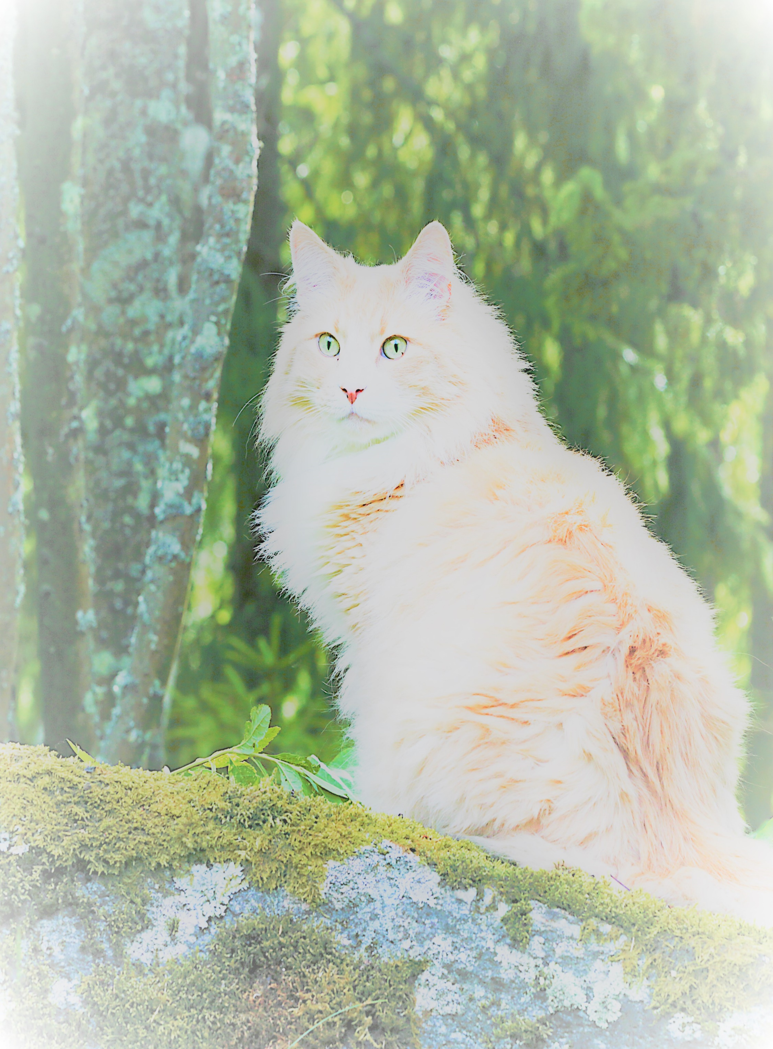
VikingTails
VikingTails
Norwegian Forest Cats
Purchase Agreement
STOP!! Proceed no further until reading PHILOSOPHY page on website.

KITTEN OR CAT
Name: Vikingtails____________________ Breed: Norwegian Forest Cat
Date of birth: _______________________ Sex: _______________________________ Color: ______________________________ Vet Clinic: Cottonwood Veterinary Clinic
Weight: _____________________________ Windom, MN 56101 (507) 831-1473
TICA Litter Registration #: Health: (See attached health record.)
Dam name:_______________________ Sire name: NFCParadise Fyrste VikingTails Dam TICA Registration #:__________ Sire TICA Registration #: SBT 022118057
Date of transfer of cat: _________________ Breeder:__BJ Kauffman of VikingTails___
Deposits: ____ date _____ $_____ date___
PET: $1250 For BREEDING: $2500 Balance paid: $_________ Date _________
BUYER
Name(s) (print): ___________________________________________________________________________
Address: __________________________________________________________________________________
Phone: ________________________ Email: ________________________________________________
Veterinarian/clinic, phone: ____________________________________________________________________

SELLER
Name: Betty Jean Kauffman of VikingTails, 415 10th St. N., Mountain Lake, MN 56159
Phone: 507-427-3043 Email: bjkauffman@vikingtails.com __________________________________________________________________________________________ TERMS
- Buyer’s response to Philosophy page on website (www.vikingtails.com): ____________________________ ______________________________________________________________________________________________________________________________________________________________________________
Buyer must have pet surgically altered as soon as is age appropriate. TICA Cat Ownership Transfer Form will be sent from VikingTails when documentation is received from veterinarian of pet alter surgery (spay/neuter – does not apply to kittens for breeding).
- Parent cats tested negative on 5/19/19 for feline leukemia virus (FeLV), feline immunodeficiency virus (FIV), and heartworm (HW). Documentation available upon request.
- Documentation of first and second vaccinations, deworming, and wellness will be included at transfer.
- Buyer will plan timing of third vaccination and discuss pros, cons, timing, and legalities of rabies shots with cat’s new veterinarian.
- Buyer has 5 work days from delivery date to have the cat examined by a licensed veterinarian at buyer’s expense. If cat is found to be seriously (life altering) medically deficient, buyer may return cat with written statement by vet for full refund or replacement.
- If cat dies from an inherited defect within a year of purchase, and buyer provides a veterinarian’s signed diagnosis, cat will be replaced free as soon as possible.
- Buyer’s plan if unable to provide care for cat temporarily or permanently: ___________________________
_______________________________________________________________________________________
- Buyer’s response to Philosophy page on website (www.vikingtails.com): ____________________________ ______________________________________________________________________________________________________________________________________________________________________________
- Cat must be taken home in a safe carrier.
- Buyer will provide regular veterinary care including recommended course of vaccinations.
- Buyer will provide high protein, parasite-free food and constant supply of clean water.
- Buyer will provide safe, healthy, smoke-free environment with ample light and space for exercise.
- Buyer will never declaw, will groom to keep coat clean and matt-free.
- Buyer will periodically send photos online of cat’s new life and milestones. Report back to VikingTails with records of show awards. The VikingTails website will feature cat’s photos and awards if buyer agrees.
- Without VikingTails’ written consent, cat will not be given away or sold for any reason. VikingTails has first right of refusal to receive back cat and all registration and health records. Buyer will pay for testing the same week for ringworm, FELV/FIV, and fecal parasites, with documentation, before returning cat.

FEE SCHEDULE

$ 100.00 initial deposit for a kitten when available, refundable if buyer chooses not to make a purchase. Date of deposit guarantees place in line, deposit is included in total fee. In case of illness or death of kitten, all payment will be refunded or applied to another kitten in this litter if available, or future
litter, at buyer’s discretion.
Balance: due 3 weeks before taking ownership of kitten.

Total fee: $ 1250.00 for pet kitten/cat, plus transportation expense
$ 2500.00 for breeder kitten/cat, plus transportation expense

- Payment is to be made by cashier’s check or money order to Betty Jean Kauffman.
- A boarding fee of $10.00 per day will be charged if kitten is boarded beyond agreed delivery date.
- Variations to this schedule may be negotiated depending on breeder/kitten exchange, stud services for pick of litter, cat age, etc.

The signers accept and agree to be bound by these terms regarding the sale, purchase, and lifelong care of the cat.

(Buyer) Date: ________________ Signature: _____________________________________________
(Seller) Date: ________________ Signature: _____________________________________________
( Purchase Agreement serves as a receipt for buyer and a copy for seller.)

