WANTED
All Forest Defenders!
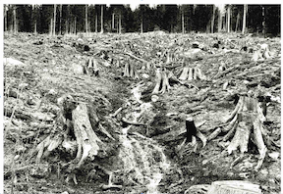
Join Province-Wide
Broken Promises Protest
Tuesday, November 18, 11 AM
Insert Local Location info here: | 

Join Province-Wide
Broken Promises Protest
Tuesday, November 18, 11 AM
Insert Local Location info here:
WANTED
All Forest Defenders!
Join Province-Wide
Broken Promises Protest
Tuesday, November 18, 11 AM
Insert Local Location info here:
Join Province-Wide
Broken Promises Protest
Tuesday, November 18, 11 AM
Insert Local Location info here:

