**DEBATE EVALUATION FORM** 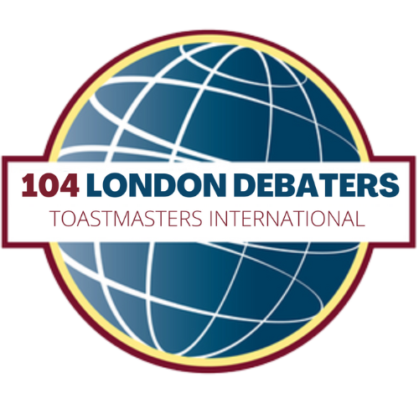

104 London Debaters

* Prepare for the evaluation by getting familiar with the topic and preferably the common arguments on both sides.
* During the debate listen for the **motion definition**, look for the **argument structure** with reasoning, and **identify clashes**.

Reading up on the topic must be done in advance. The following form will help you with what needs to be done *during* the debate.

**A KEY QUESTION to ask yourself as you prepare your evaluation is: WHY did the Proposition / Opposition win the debate? (Although you obviously will not know the answer until the end)**

**Questions to keep in mind during the debate:**

What is the MAIN argument of the PROPOSITION?

How did the Opposition try to REBUT it?

Was the motion set out clearly enough?

Any fallacies? (strawman / ad hominem / false cause / false choice /appeal to authority, etc.)

If not mentioned already, do you have any specific recommendations for the debaters?

**THE REBUTTAL/CLASH – Use this section to make notes during the debate**

Jot down the main points and rebuttals - listen out for claims, warrants for these claims, clashes and effective refutation (do NOT try to retell the debate, that’s boring).

|  |  |  |
| --- | --- | --- |
|  | **PROP** | **OPP** |
| **First speakers** |  |  |
| **Second**  **speakers** |  |  |
| **Summary**  **speakers** |  |  |

Which side do YOU think had the strongest case?

Proposition Opposition

Did that side win? Yes No Why not?

Tick all that apply:

|  |  |
| --- | --- |
|  | They aligned themselves better with the VALUES the audience cared about |
|  | They were able to FRAME the debate on THEIR terms |
|  | The losing side was NOT able to REBUT the most convincing argument of the other team |
|  | The losing side was NOT able to make their argument CLEAR and/or STRONG enough |
|  | Anything else - what? |