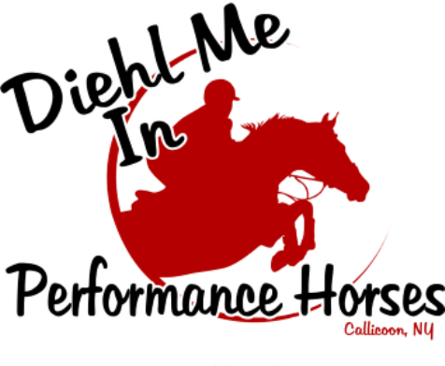

**DMI Counselor Expectations & Contract**

!

**Responsibilities**:

1. Group supervision of campers with attention to all the following: program, health, happiness, discipline, cleanliness, safety, routine duties, character, and skill development.

2.Think outside the box. Be creative!

3. Help campers plan, carry out, and evaluate projects and activities.

4. Promote camper participation in ALL activities.

5. Take turns with other counselors for various responsibilities in preparation for daily activities and clean up. Pick up that piece of garbage, haybale string, sweep up a mess, hang up a lead rope or halter…etc.!!

6. Assist with camp programs and encourage camper participation.

7. Exhibit positive personal habits in health, dress, speech, table etiquette, and relationships with other staff that serve as a beneficial model to campers.

8. Set a good example in ALL you do at camp. Camp is a fun learning experience.

9. Work with the camp directors and other camp staff to iron out difficulties with facilities, programs, and campers.

10. Help develop, carry out, and evaluate a camp program that reflects the goals of DMI and good horsemanship.

11. Wear DMI t-shirt or polo everyday with jeans and boots. Friday is tank top day! Bring your Counselor three ring binder everyday with activities/lessons/games

12. Before camp:

* Bring in lesson horses.
* Make sure activities for horse knowledge, stable management and games are prepared.

13. After camp:

* All lesson horses out.
* Grooming supplies wiped down.
* Bathroom disinfected and swept, make sure there are paper towels and toilet paper, soap filled, garbage empty, all area wiped down(toilet, sink, door knobs)
* Hand sanitizers are filled
* Lesson tack hung and organized
* Arts & Crafts picked up/organized
* Group area/table clean and organized
* Indoor manure and equipment picked up
* Left behind items into lost & found
* Prepare next day activities
* Aisle Swept/lunch hay & water to stalled horses UB & LB

**DMI Horsemanship Program Counselor Contract:**

As a horsemanship program counselor, I agree to fulfill the responsibilities listed above, comply with the rules and regulations listed and meet the following behavior expectations:

1. Counselor hours are from Tues-Friday 8:30-3:30, Mondays 8:00-1:30.

2. Counselors are always to supervise children in their groups.

3. Counselors will not use inappropriate language.

I, _____________________________________, accept my appointment to the position of DMI Horsemanship program CAMP COUNSELOR at Diehl Me In Performance Horses, LLC and will try to the best of my ability, to fulfill the responsibilities outlined and discussed in contract and counselor meetings.

___________________________________________ ________________

Signature date