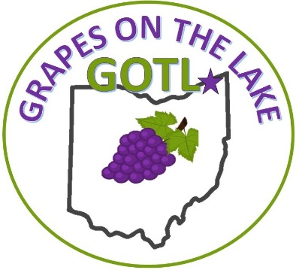
GOTL GRAPES ON THE LAKE FESTIVAL PARADE FORM

Geneva on the Lake Convention & Visitors Bureau
5540 Lake Rd E Geneva, OH 44041
440-466-8600

Participating Organization: ____________________________________________
Contact Person: _____________________________________________________
Mailing Address: ____________________________________________________
Email Address:___________________________Phone #: ____________________
Type of Entry: (Please Check)
Float Marching Band
Car/Truck/Van Equestrian
Political Motorcyle/Golf Cart
Additional Information (if needed):
___________________________________________________________________
___________________________________________________________________
Length of Float (if applicable): _________________________________________

Please complete the Front and Back Side of this form and submit to info@gotfestival.com or drop it off at the Geneva on the Lake Convention & Visitors Bureau

PARTICIPANT WAIVER OF LIABILITY AND HOLD HARMLESS AGREEMENT
I hereby make application for myself and my participants including those who may be minors and or business/club/organization, to voluntarily participate in the Grapes on the Lake Parade held on Saturday September 28th in Geneva on the Lake, Ohio. We understand that providing automobile, accident, personal injury and personal liability insurance is our responsibility and in lieu of providing an Insurance Coverage Certificate, we hereby certify that in the case of an accident, personal injury or death, we will not hold the Village of Geneva on the Lake, Geneva on the Lake Convention & Visitors Bureau, Its officers, agents, employees and volunteers responsible for any bodily injury, death or property damage and hereby release any officer, agent, contractor, trustee employee or volunteer of the Grapes on the Lake Parade for any claim or claims that might arise as a result of bodily injury, death or property damage or as a result of applicants participation in parade. We further agree to abide by the rules of the parade and in support of the Grapes on the Lake Parade we require all participants of our organization to use good safety precautions during our participation. The Undersigned expressly acknowledges that the activities of the parade (including pre-and post-parade activities) may be dangerous and may involve the risk of serious injury, death and/or property damage. The undersigned agrees to indemnify, defend and hold harmless the Village of Geneva on the Lake, Geneva on the Lake Convention & Visitors Bureau, any officer, agent, contractor, trustee employee or volunteer of the Grapes on the Lake Parade. This Waiver of Liability and Hold Harmless Agreement shall be governed by the laws of the State of Ohio and jurisdiction shall be proper only in the County of Ashtabula, State of Ohio. The invalidity or unenforceability of any of the provisions hereof shall not affect the validity or enforceability of the remainder of this Agreement. By signing below, the participant has read and understands the waiver as described above and agrees to hold harmless the Village of Geneva on the Lake, Geneva on the Lake Convention & Visitors Bureau , its officers, agents, employees and volunteers associated with the Grapes on the Lake Parade of any liability. I also represent that I am authorized to sign this document on behalf of myself and my participants including minor children and or business/club/organization.
Signature: ________________________________________________ Date: _______________________
Printed Name: ________________________________________________________________________
Business/Club/Organization: _____________________________________________________________
Phone #: _____________________________________________________________________________

