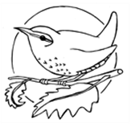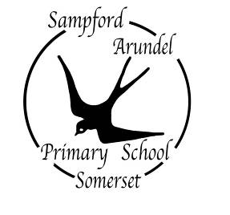

Children choose the resources they wish to use when they come into pre-school. Resources are clearly labelled and they are able to access these themselves. This ensures that as their play develops, they can add extra resources to extend their learning.

Each focus child spends time with their keyworker discussing the photographs sent in from home. Their words are recorded with their photos. As they become more confident, children begin to record their own words using independent mark making.

Skilled practitioners scaffold and extend children’s learning by playing alongside them, modelling behaviour as well as identifying next steps which are addressed immediately by teaching ‘in the moment’.

Practitioners identify opportunities to build on focus children’s previous interests and areas for development where appropriate.

This allows for all levels of development to be catered for at an appropriate level and for all children to be continuously challenged.

I

**What does planning, teaching and assessment look like at the WARF pre-schools?**

Each child is a ‘focus child’ at least once a term. Parents fill in a focus child sheet, which gives us information about anything which is going on in the child’s life at home. They also send in photographs of anything the child has done that they want to share with us and ask any questions/raise concerns that we may not yet be aware of.

Information from parents, the children’s learning journey books and ‘Personal Pathway’ documents are used to identify future focus areas and areas of interest.

Following an interaction with a child, any teaching and/or WOW moments are recorded by the practitioner, highlighting the teaching, WOW moments and the child’s voice. These are recorded on labels and attached to the learning journey sheet for the focus children alongside photographs. For non-focus children, these are later added to their learning journey books.

Photographic displays are updated frequently, giving the children the opportunity to talk about their experiences with each other and with their parents/carers.

Cohort trackers and ‘Personal Pathway’ documents are used to track progress across the areas of learning and clearly show any areas which need further input during focus weeks.