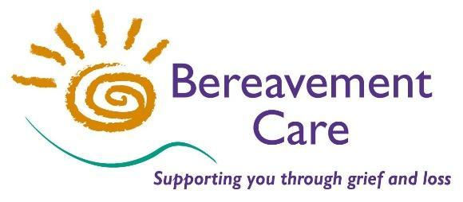

**INITIAL BEREAVEMENT TRAINING COURSE – TBA**

A course which covers basic listening and responding skills. It also explores the pattern of grieving, grief and ritual and other aspects to help those who may wish to offer support to

people who have experienced bereavement in their community or place of work.

**This course is held over two consecutive days**

**DATE:** TBA 2025

**TIME:** 10.00am - 3.30pm **VENUE:** The Lodge, Pinner Road, HA1 4HZ

**COST OF COURSE:** £100.00 for non – Members

£ 65.00 for Members

Please make payment by Bank Transfer to: Bereavement Care

Sort Code: 23-05-80 Account Number: 43231545 Reference: IBT

or by cheque payable to: Bereavement Care

**Please return applications as soon as possible to secure your place**

**(no later than TBA)**

**PLEASE NOTE: *It is our policy not to accept on these courses, anyone who has had a close bereavement within the last two years.***

**------------------------------------------------------------------------------------------------------------------------------------**INITIAL BEREAVEMENT TRAINING COURSE – Tuesday 6th May & Wednesday 7th May 2025

**NAME: …….…………………………………………………………………………………………………………….....**

**ADDRESS: ….………………………………………………………………………………………………….................**

**..........………………….................................................................................. POSTCODE: ………………………**

**PHONE NO(s): …………………………………………………………………………………………………………….**

**EMAIL ADDRESS: ………………………………………………………………………………………………………..**

**ORGANISATION: ……………………………………………………….…………………………………………….......**

**If your Organisation is a Corporate Member of Bereavement Care, you do NOT need to complete the Address, Telephone Number & Group Leader/Sponsor details below.**

**GROUP LEADER/SPONSOR: ……………………………….……………… SIGNED: …………………………….**

**ADDRESS: ………………………………………………………………………………………………………..……….**

**…………………………………………………………………………………. PHONE NO: ……….……....………….**

**Please detach and return completed form to the Course Administrator at the above address** 