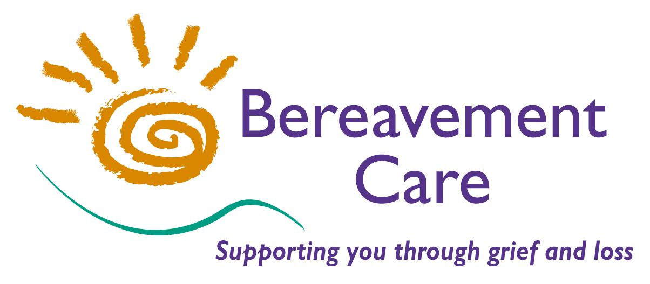
Bereavement Care
The Lodge, 64 Pinner Road
Harrow, Middlesex HA1 4HZ
Telephone: 020 8427 5720
Email: admin@bereavementcareandsupport.co.uk
www.bereavementcareandsupport.co.uk

Registered Charity Number: 1157002

CHILDREN AND GRIEF COURSE

This course is designed for those who would like to consider working with bereaved children. It is aimed at
developing an understanding of the emotional impact of bereavement on children and young people, and identifying ways of supporting them in their grief. Depending on previous experience, additional training may
be required.

Learning objectives:
To gain and develop an understanding of issues that affect bereaved children and their families.
To learn the skills of working with bereaved children.
To develop awareness of children’s needs in school and to promote education in bereavement.
To acquire listening skills using play to facilitate grief work.

Wednesday 15th May 2024 (This is a one day course)

TIME: 9.15am – 3.30pm

VENUE: The Lodge, 64 Pinner Road, Harrow HA1 4HZ

COST: £90.00 (£45.00 for Bereavement Care Individual/Corporate Members)

Please make payment by Bank Transfer to: Bereavement Care
Sort Code: 23-05-80 Account Number: 43231545 Reference: Children and Grief
or by cheque payable to: Bereavement Care (or Schools/Colleges may request an Invoice)

Please return this form as soon as possible, and preferably by Tuesday 7th May 2024

PLEASE NOTE:
It is our policy not to accept on these courses, anyone who has had a close bereavement within the last two years.

CHILDREN & GRIEF TRAINING COURSE – Wednesday 15th May 2024

NAME: …….…………………………………………………………………………………………………………….....

ADDRESS: ….………………………………………………………………………………………………….................

..........………………….................................................................................. POSTCODE: ………………………

PHONE NO(s): …………………………………………………………………………………………………………….

EMAIL ADDRESS: ………………………………………………………………………………………………………..

ORGANISATION: ……………………………………………………….…………………………………………….......

If your Organisation is a Corporate Member of Bereavement Care, you do NOT need to complete the Address, Telephone Number & Group Leader/Sponsor details below.

GROUP LEADER/SPONSOR: ……………………………….……………… SIGNED: …………………………….

ADDRESS: ………………………………………………………………………………………………………..……….

…………………………………………………………………………………. PHONE NO: ……….……....………….

Please detach and return completed form to the Course Administrator at:
I have made payment of £_____ by BACS

I enclose £_____ cheque/cash
Bereavement Care, The Lodge, 64 Pinner Road, Harrow HA1 4HZ
Please invoice my school/organisation

