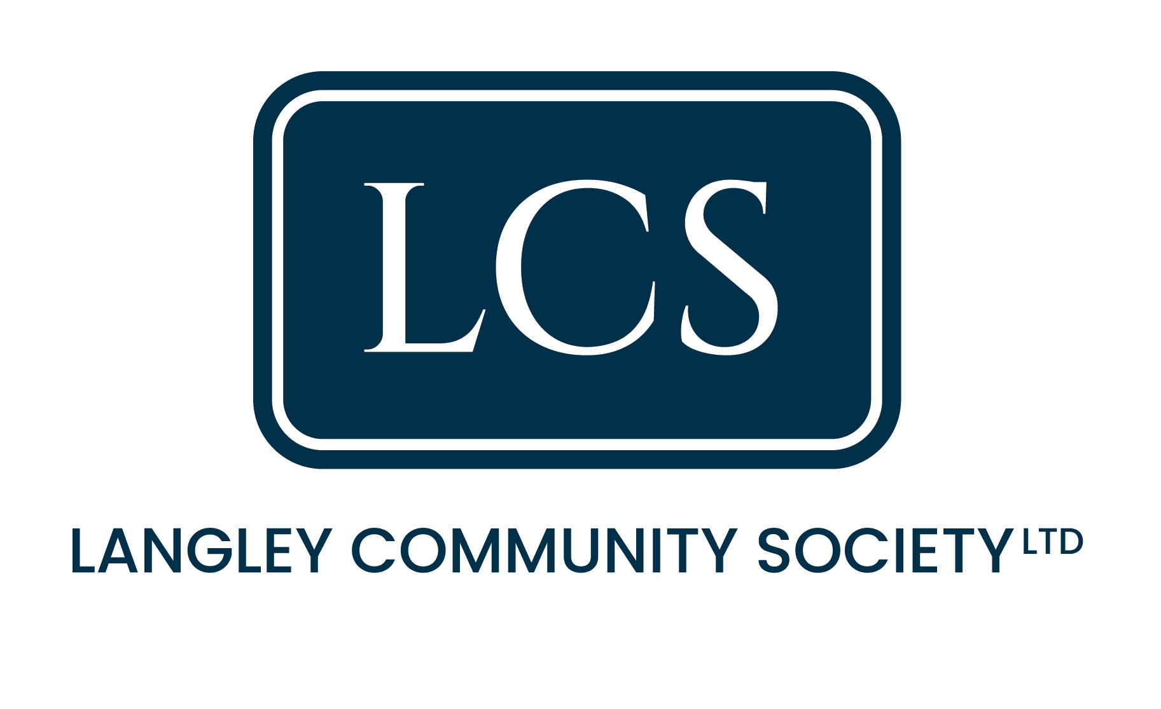

Share Application Form
Please return completed application forms to: Langley Community Society Limited
FAO Society Secretary – Andrea Wright –Email - savethedunny@gmail.com
Or post to – 17 Cricketers Way, Langley, Cheshire, SK11 0AX

NAME
ADDRESS

POSTCODE

EMAIL

PHONE

NUMBER OF SHARES YOU WISH TO AQUIRE (1 SHARE= £250)
VALUE OF SHARES
PAYMENT METHOD | Preferred payment method is electronic bank transfer.  Please contact the Society Treasurer for payment by any other method
BANK DETAILS TO MAKE PAYMENT TO | Please make bank transfer to:  Barclays Bank  Account name: Langley Community Society Limited  Sort code: 20-82-13  Account Number: 80780952  Payment Reference: Please use your full name + Shares.  or write below the reference used.
By applying for membership of Langley Community Society Limited I agree to be bound by its Rules. I understand that my investment is at risk and that shares are non-transferable.

Applicant Signature Date 20/12/2025

