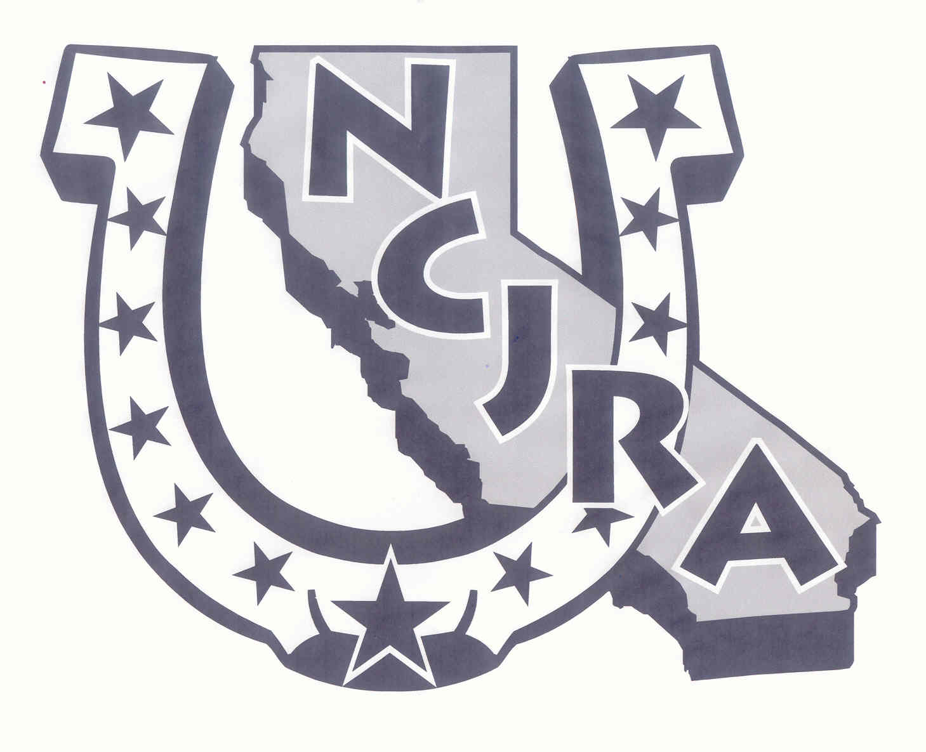
Northern California Junior Rodeo Association, Inc.
PO Box 1457, Oakdale, CA 93561
A 501(c)(3), Non-Profit Organization
Tax-Exempt Corporation #68-0160787

Email Address: ______________________________________________________

First Name:________________________ Last Name:________________________

Address:___________________________________________________________

City, State Zip:_______________________________________________________

Best Contact Phone Number:_____________________________________________

Date of Birth:_______________________ Age as of Jan. 1st:____________________

Division (Circle One):

Jr Boys (6-13) Sr Boys (14-18) Jr Girls (6-13) Sr Girls (14-18)

Rookie Year in Sr Division: Yes No

Parent 1 Name:______________________ Parent 1 Phone Number:_______________

Parent 2 Name:_____________________ Parent 2 Phone Number:________________

Emergency Contact Name (if different than parent):_____________________________

Emergency Contact Phone Number (if different than parent):_______________________

Insurance Company Name:_______________ Insurance Policy Number:____________

Associate Member
An Associate Member is a person of at least 19 years of age (relative or non-relative of the contestant) designated to represent the Contestant Member in all NCJRA business. The Associate Member votes in the annual NCJRA Election and is eligible to serve on the NCJRA Board of Directors.

Associate Member Name:_______________________________________________

Associate Member Phone Number:_________________________________________

NCJRA Publications
Do you consent to NCJRA using rodeo photographs of you on our website, in newspaper articles, and other NCJRA publications?

Circle One: Yes No

Finals Jacket Size
In the event that your child should qualify for the 2018 NCJRA finals, we would like to know your jacket size in advance! Additional Cost may apply!

Circle One: Youth XS S M L XL
Adult XS S M L XL

Participant Agreement
The undersigned agrees, as a condition of participation in this activity, to release, save harmless, defend, protect and indemnify any person and or organization in any way associated therewith and their agents, members, officers, and directors from loss, damages, or liability in any sort arising out of, or in any way relating to my participation in said activity. If the participant is a minor, the undersigned parent or guardian acknowledges that they have read this Agreement and agrees to be bound by its terms as a releaser and as a guarantor and indemnitor or said persons and/or organizations and their agents, members, officers and directors, for the minor and in the minor’s place and stead. I waive all rights which I now or may have by virtue of Section 1542 of the California Civil Code which reads: “A general release does not extend to the claims which a creditor does not know or suspect to exist in his favor at the time of executing the release, which if known by him, must have materially, affected his settlement with the debtor.” I further agree to abide by all of the rules and regulations of the Northern California Jr. Rodeo Association. I understand this membership fee is non-refundable.

_______ I agree (Please Initial)

Birth Certificate
Birth Certificates are carried over when possible. Sanctioned Rodeo Committees rely on NCJRA for age verification of our members. Committees reserve the right to require age verification with entries at their sanctioned rodeos. NCJRA can require a prospective or current member to submit a certified copy, if the information received is questionable. If a birth certificate is not sent with a new membership application, fees will be returned. This may delay accumulation of points.

_______ I agree (Please Initial)

Member & Parent Work Program
Work Program - All junior and senior NCJRA Members are required to participate in the Work Program at the NCJRA fundraiser rodeos. Members will sign-up for a job at the first rodeo of the year, this will be their job for the entire season. Failure to complete your assigned task will result in loss of points for that day of rodeo. It is acceptable for a Contestant to arrange for an alternate to work in place of them, BUT it is the contestant’s responsibility to ensure that their “Work Program” requirements have been met.

_______ I agree (Please Initial)

NCJRA is 100% operated by Parent Volunteers. The NCJRA Board of Directors is requiring one adult per family to participate in a Parent Work Program this year, in order for NCJRA remain one of the best Junior Rodeo Associations in the state. There are a variety of ways that parents can volunteer - from timing, to arena help, to something behind the scenes to prepare for the rodeo.

_______ I agree (Please Initial)

Parents are required to participate in a Parent Work Program. Please choose 3 areas you would like to work.

- Friday Preparation
- Roughstock
- Pole Bending
- Barrel Racing
- Goat Tying
- Roping Events
- Timing
- Sunday Breakdown

W-9 required for Membership
All Contestant Members will be required to complete a W9 Form as part of the Membership requirement for 2021. Contestant Members earning $600 or more at the NCJRA sponsored rodeos throughout the year will be issued a 1099 for these earnings. Contestant Members will be responsible for filing their own tax return.

_______ I agree (Please Initial)

Membership Applications Completion
Membership applications will be submitted via mail. Your membership application will not be considered complete until the application is completely filled out, membership fee is paid and required documents are mailed in. REQUIRED DOCUMENTS ARE W-9, RELEASE OF LIABILITY AND BIRTH CERTIFICATE (if not on file).

_______ I agree (Please Initial)

Minimum Sponsorship
Each member is responsible for a Minimum Sponsorship to NCJRA of $100.00 DUE JUNE 5th. This is an opportunity to ask businesses in your community to help support youth rodeo through making a cash donation to NCJRA or sponsoring Finals buckles or prizes.

_______ I agree (Please Initial)

Rulebook
All NCJRA contestants and parents are expected to read and become familiar with the NCJRA Rulebook. Contact the Membership Secretary to get a printed copy of the rulebook or access the NCJRA Rulebook at www.ncjra.com on the Membership page.

_______ I agree (Please Initial)

Payment Due of $120.00 for first child and $110.00 for additional children.

Please make checks payable to: NCJRA.

