Northern California
Junior Rodeo Association
2021 Rulebook

A 501 (c)(3) Non-Profit Corporation
CA Corporate Organization # C1528563
Tax-Exempt Corporation #68-0160787

NCJRA
OAKDALE, CA 95361
www.NCJRA.com
2021 NCJRA Rulebook Changes
Approved 5.3.16

NCJRA Adopted Rule Book Changes 2017

GENERAL RODEO RULES
(Page 8-One contestant shall constitute a contest) 1. The entry of one or more contestants shall constitute a contest.

NON-SANCTIONED EVENTS
(Page 45-Family Team Roping Changed to JR/SR Team Roping) JR/SR TEAM ROPING
NCJRA Team Roping Rules apply except for the following:
2. Contestant may enter once with an adult age 25 years or older.
TABLE OF CONTENTS

Contents: | Page #
Preface | 4
Purpose & Goals | 5-6
Sanctioned Events | 7
Membership Requirements | 7-9
Entry Fees | 9
Conduct Code | 9-11
Dress Code | 11-12
Points & Payback | 12-13
Finals Rodeo & Year-End Awards | 13-14
Grievance Procedure | 14-15
Med and Vet Outs | 15
General Rodeo Rules | 16
Timing | 16-17
Timing Equipment | 17-18
Judges | 19-20
Bull Riding/ Steer Riding | 21-25
Calf Riding | 26
Chute Dogging | 26-31
Bareback Riding and Saddle Bronc | 31-47
General Rules for Roping/Timed Cattle Events | 47-48
Team Roping | 48-56
Steer Stopping | 56-57
Steer Wrestling | 57-68
Tie Down Roping | 68-76
Breakaway Roping | 76-82
Goat Tying | 83-87
Barrel Racing | 87-92
Pole Bending | 92-96
Non-sanctioned Events | 97
Quick Reference Table | 98

PREFACE

In 1982, eight established Jr. Rodeo committees exhibited the inspiration, motivation and cooperation, which provided for the formation of the Northern California Junior Rodeo Association. The original purpose of this cooperative venture was to establish and maintain standards, which would enable the promotion and production of a Finals Rodeo at this level of competition. Pursuant to the original purpose, the growth of the NCJRA has provided for the expansion of the guidelines and goals of this organization. The overwhelming interest and response created the establishment of the NCJRA and has additionally enabled this association to better encourage, promote and advance Youth Rodeo. The Board of Directors has approved this Rule Book as the Official guidelines and rules by which all NCJRA rodeos shall be governed. . If a rule is not covered in the Northern California Junior Rodeo Association rule book, then officials will refer to the California High School Rodeo Association rule book, then the National High School Rodeo Association rule book, and then to the Professional Rodeo Cowboys Association rule book. If a given situation is not covered therein, the judges’ decision shall be final.
PURPOSE & GOALS
Northern California Junior Rodeo Association, Inc.
(A 501 (c)(3) Non-Profit Corporation) CA Corporate Organization # C1528563
Article I:
- Maintain order and standards set up by the Northern California Junior Rodeo Association among its members at their functions.
- Encourage and promote Junior Rodeo on a regional scale and work towards national recognition for this association and its contestant Membership.
- Promote the highest type of conduct and sportsmanship by setting up standards to be met to reach this end.
- Secure competent, honest judges and officials in all events.
- Promote and keep the Western Heritage alive in America.
- Increase and maintain interest in Rodeo at this level of competition.
- Assist and work in cooperation with the National High School Rodeo Association, the National Intercollegiate Rodeo Association, the Professional Rodeo Cowboys Association, the Canadian Rodeo Cowboys Association, and/or other organized Junior Rodeo Associations.
- Promote a closer relationship among the people interested in this activity and the organizations they represent.
- Work toward a better quality of competition, betterment of conditions and governing rules.
- Elect or appoint officers and agents of this association, who may be directors or members and define their duties.
- Promote and provide a finals Rodeo and awards program befitting this level of competition.
- Promote responsibility, good conduct, sportsmanship and scholastic achievement among all contestant members.
- Have and exercise all powers necessary or convenient to affect any or all of the purposes for which this association was organized.

SANCTIONED EVENTS

- Sr. Boys Bull Riding 16-18
- Jr. Boys Bull Riding 14-16
- Jr. Open Steer Riding 11-13
- Jr. Open Calf Riding 6-10
- Sr. Open Chute Dogging 14-18
- Jr Open Chute Dogging 6-13
- Sr. Boys Saddle Bronc Riding 14-18
- Sr. Boys Bareback Riding 14-18
- Open Team Roping 6-18
- Sr. Open Steer Stopping 14-18
- Jr. Open Steer Stopping 6-13
- Sr. Boys Steer Wrestling 14-18
- Sr. Boys Calf Roping 14-18
- Sr. Girls Breakaway Roping 14-18
- Jr. Girls Breakaway Roping 6-13
- Jr. Boys Breakaway Roping 6-13
- Sr. Girls Goat Tying 14-18
- Jr. Girls Goat Tying 6-13
- Jr. Boys Goat Tying 6-13
- Sr. Girls Barrel Racing 14-18
- Jr. Girls Barrel Racing 6-13
- Sr. Girls Pole Bending 14-18
- Jr. Girls Pole Bending 6-13

GENERAL MEMBERSHIP REQUIREMENTS

In order to apply for regular membership, member must be 6 years old or older on or before January 1st of this year, and no more than 18 years of age as of the same date. Membership categories are:

JUNIOR members are those 6-13 years old as of January 1st of this rodeo year.

SENIOR members are those 14-18 years old as of January 1st of this rodeo year.

Membership dues will be payable on the Entry Closing Date of the rodeo at which the member wishes to begin earning points. A completed membership application and a copy of Birth Certificate or Proof of Age, if this is member’s first year in the Association, must accompany membership dues. The membership fees will be set each year by the Board of Directors. All current paid members will be put on the master mailing list for entries provided by the NCJRA Membership Secretary to each of the sanctioned rodeo committees. Each current member’s points earned at the sanctioned rodeos will be tabulated for the season by the point chairperson. Any event not covered by this rule-book will follow all rules and policies of the Northern California Junior Rodeo Association.

Work Program is required of all Junior and Senior Members. Failure to complete the assigned work program duties and return work card to rodeo office will result in the loss of points for that day of competition and may result in ineligibility to compete at the next scheduled rodeo.

A member may move up to the next age category, but all points accumulated will be forfeited, and once member moves up, member may not move down. When member moves up, his or her points will start at zero.

Membership fees are Non-Refundable. Hardship cases may be considered by the NCJRA Board of Directors prior to the start of the rodeo season.

ENTRY FEES

All rodeo entry fees are to be paid in full by the Entry Closing Date for the respective rodeo. All fees must be accompanied by the rodeo entry form for the corresponding rodeo. Rodeo entry fees will be deposited upon receipt by the designated NCJRA board member. If funds paid by check are NSF, the contestant will be deemed ineligible to compete until said funds are paid. Under these circumstances, the party issuing the check will be notified to make arrangements to pay entry fees, including any bank fees incurred, either by cash, cashier's check, or money order prior to check-in.

CONDUCT CODE

Northern California Junior Rodeo Association (NCJRA) Membership, and any accumulated points will be revoked for the current rodeo, and there will be no refund of any entry fees due to infraction of any of the following rules of conduct:

- Having any association with alcoholic beverages, narcotic or any other non-medicinal drugs while in attendance at any approved NCJRA Rodeo, whether at a motel or on rodeo grounds or going to or from the rodeo or at any rodeo functions.
- Rowdyism, quarreling or fighting in the actual domain of the arena at any time, or any place during the duration of the rodeo.
- Conduct or speech of any kind detrimental to the best interests of the NCJRA or the sport of rodeo while in attendance, or coming to and going home from a rodeo.
- Vandalism at any place or any time.
- Cheating or attempting to cheat.
- Attempting to fix, threaten, bribe, influence, harass or coerce the judges, arena director, secretary or any rodeo committee person at any time between opening and closing of a rodeo by a contestant or parent.
- Inhumane treatment of horses or livestock, either in or on the rodeo premises will be grounds for disqualification.
- The selective or discretionary sorting of cattle for the benefit or detriment of any one or multiple contestants is strictly prohibited. In the event, it is found that a particular animal or animals has been selectively sorted, for the benefit of one or more contestants in particular, or for the purposes of providing an unfair advantage/disadvantage to any one or more Contestants will result in the immediate disqualification of contestant(s) set to benefit from said activities for all events of the entire rodeo in question. Any individual participating in said activities will be prohibited from volunteering for Roping Events/Timed Cattle Events for the remainder of the rodeo season. Any contestant(s) found to be benefiting from such activities may have his or her membership revoked for the remainder of the season, at the discretion of the Board of Directors.
- Unsportsmanlike conduct, in any form, is strictly prohibited.
- Where appropriate this code shall apply to parents, guardians, or others associated with any contestant.

DRESS CODE

- All contestants (while competing at any sanctioned Rodeo) must wear western attire. Western boots, western trousers, western hat, long sleeved wrist length shirt with collar and cuffs shall be the approved attire. NCJRA approved protection gear allowed where applicable (protective vests, helmets, etc.). In inclement weather the rodeo Committee, at the ground rules meeting may include additional attire.
- The only exception of the above rule will be in the roughstock riding events where a rider may roll up shirt sleeves two rolls, not to exceed the elbow on the riding arm only, while competing.
- All contestants must have shirttails tucked in at the start of their competition.
- Contestant’s hat must remain on their head until the contestant crosses the plane of the arena. If the contestant’s hat comes off and falls outside of the plane of the arena or gate, the contestant will be considered out of dress code and therefore will receive a NO TIME.
a. For all roping events, the roping boxes are considered part of the arena
b. In Rough Stock events the bucking chutes and catwalks are considered part of the arena
c. In Gymkhana and Goat Tying, only the perimeter of the arena fence is considered part of the arena.
- A 5 second penalty will be assessed for INTENTIONAL removal of a hat by a contestant during competition in the arena.
- Disqualification may result for any infraction of the above stated rules.
- Contestant must have their assigned back number on while competing.

POINTS & PAYBACK

The point system for all events is as follows: First Place = 10 points; Second Place = 9 points; Third Place = 8 points; Fourth Place = 7 points; Fifth Place = 6 points; Sixth Place = 5 points; Seventh Place = 4 points; Eighth Place = 3 points; Ninth Place = 2 points; Tenth Place = 1 point. When calculating the points for NCJRA Member, points will be rolled up and redistributed to members only.

Payback will be at least 50% of the entry fee in each event. Payback will be according to the number of entries: Under 5 entries 60%/40%; 5 to 10 entries 50%/30%/20%; 11 to 15 entries 40%/30%/20%/10%; More than 15 entries 30%/25%/20%/15%/10%/. The exception is in roughstock when there are no qualified rides. No payout will be awarded when there are no qualified rides. There will be no ground split.
In the event of a points tie for the All Around, the contestant who earned the most money at that rodeo will win the title of All Around, the second place money earner will receive the Reserve All Around title. If the amount of money won is equal, a coin flip will break the tie.

FINALS RODEO & YEAR END AWARDS

The Finals will consist of two full goes. Points will be awarded for two goes and an average. Points will be tabulated in each of the sanctioned events, at each of the sanctioned rodeos toward year-end standings. The top 10 contestants in each event will then be invited to participate in the Finals Rodeo held at the end of the year. Should there be a tie in the 10th place position, all members having the same points as the 10th place position will be invited. The team roping at the Finals Rodeo shall consist of 10 teams, 20 contestants. Contestants can only qualify as a header or heeler not both. If contestant has enough points to qualify for both, he or she must choose one. Should there be a tie for 10th place, both contestants will be taken, and the 11th place header or heeler will roll up to allow for an 11th team.

The member with the most points in each of the 23 events (including points from the Finals Rodeo) will be declared the Year-End Champion in that event. The Junior Boy, Junior Girl, Senior Boy and Senior Girl with the most accumulated points in all events will win the Year-End All-Around Awards. Ties in events at the Finals Rodeo will be broken by a run, ride or rope off. Regarding the Year-End Champion in each event and Year-End All-Around, in case of a tie, the award will be given to the person leading in points coming into the finals. All contestants in the first go will have fresh stock.

Year End Awards are issued after finals rodeo points are tabulated. Members will receive Year End Awards based on accumulative year end points for the current rodeo season. To receive year end awards, contestant must be a paid contestant of the finals in good standing regardless if they Med or Vet out.

GRIEVANCE PROCEDURE

If a contestant has a problem, the contestant ONLY must go to the appropriate NCJRA Event Director and ask for a resolution of the problem before the contestant exits the arena in which the question arose. Under no circumstances is a contestant to go to the Judge or Arena Director without the permission of the Event Director. This procedure is set for contestants only. A parent or other interested person, who gets involved with the Event Director, Judges, or other rodeo official, runs the risk of having the person whom they are trying to assist disqualified. If there is an infraction of a rule, the event director will confer with the judges prior to the next contestant competing or at the first convenient opportunity. Such protest shall be made if the Director and /or Judge determines that the protest is based upon a possible misinterpretation of an event rule. The Director shall describe the protest and the interpretation of the rule upon which it is based to the judge. If the judge agrees that an erroneous ruling was made and that the error is correctable, then the judge shall modify the ruling accordingly. Otherwise, the decision shall stand. If a rule is not covered in the Northern California Junior Rodeo Association rule book, then officials will refer to the California High School Rodeo Association rule book, then the National High School Rodeo Association rule book, and then to the Professional Rodeo Cowboys Association rule book. If a given situation is not covered therein, the judges’ decision shall be final.

VET or MED OUTS

If a contestant notifies the rodeo secretary 72 hours prior to the rodeo, all but the Office Fee will be refunded. A notified Vet/Med Out that takes place less than 72 hours prior to the rodeo up to the start of the rodeo will result in a fee refund minus Stock, Ambulance, and Office Fees. Documentation, in either case, must be provided within seven days after the end of the rodeo. Only documentation from a licensed Medical doctor or Veterinarian will be accepted. Vet or Med Out monies will be deducted from the payback for that event. Refund checks will not be issued until after the next Board of Director’s meeting.

GENERAL RODEO RULES

- The entry of one or more contestants shall constitute a contest.
- All positions of go in every event must be drawn for.
- All stock must be numbered.
- Roughstock and Goats shall be drawn.
- Advanced Life Support Services will be on the rodeo grounds at all times during the rodeo.
- Events with 30 second/one minute time limit may have penalties which will exceed the 30 second/one minute time limit.
- Trading of positions (trade-outs) will be left up to the committee, and rodeo secretary.
- Stock will be drawn for by Rodeo Secretary and one (1) judge or two (2) board members may be present in place of the judge.
- A copy of the draw must be posted prior to the event
- A complete go-round must be drawn at one time.
- In Rough Stock events the bucking chutes and catwalks are considered part of the arena.
- For all roping events, the roping boxes are considered part of the arena.
- In Gymkhana and Goat Tying, only the perimeter of the arena fence is considered part of the arena.

TIMING

TIMING PERSONNEL
- Timers must have prior experience with electric and manual timers.
- Timers must work from the same position in all performances of that go-round.
- Management must provide a place for official timers and announcers to work without obstruction or interference.
- Management must position timers at a place that will facilitate for good communication with the Arena Director, judges, and announcers.
- Timers for the go-round may not be changed after the first performance except for sickness or injury, or by the request of an Association official because of timer’s incompetence, or through agreement of the rodeo committee and Association officials.
- Timed Events: Time should be taken with the head timer as official time and back-up timers at all rodeos.

TIMING EQUIPMENT
- Electric Timers:
  - Equipment necessary: Twin units of battery-power electric eyes with one electric-power digital clock and one battery-power digital clock and two (2) hand-held battery-power digital watches in hundredths shall be used, with the time indicated by the electric eye timers, or, if necessary, the backup manual timers (head timer) to be the official time.
  - Manual timers will not average times. Head timer will be official time unless head timer missed the start or finish times, in which case the backup timers time will be official time.
  - When the electric eye fails to work for one or more contestants during a performance, the manual backup time will be used for those electronically missed. The electric eye controlled times will remain unaltered.
  - Complete electric timer must be backed up by a flag man. One timer will record the times that appear on the electric eye controlled readout. Back-up timers will operate the digital watches and record the time which is shown thereon. These two timers will operate from the flagman’s signals.
  - Permanent markers should be put in the ground for the electric eyes. Electric eyes should be placed on the starting line no closer together than the width of the first two barrels and for the electric eyes to be centered on the pattern for each performance.
  - Line on fence for flagman should be well marked. These markers should be checked every performance along with the barrel markers and re-staked if pulled out. A record of these measurements shall be kept.
  - Set timer beforehand in the same height and position and lock the legs.
  - Barrels are not to be used as stands for the electric eye timer devices.
- In the gymkhana events a back-up flagger and timer will be used in addition to the electronic timing unit.
- Events with 30 second/one minute time limit may have penalties which will exceed the 30 second/one minute time limit.
- Electronic Timer Failures:
  - The battery digital clock will be the first backup time and digital hand-held watches to be second back up time.
  - When both the clocks malfunction and no time was recorded from digital watches, contestant will be given a re-run at a time designated by the Judges and the Arena Director.

JUDGES

- Judges and flagmen for rodeos shall be chosen with regard to their integrity, ability and availability.
- Judges must be approved by NCJRA Board of Directors.
- All judges will meet with Directors before the rodeo and discuss their respective events, and judging procedure.
- Judges must read and be knowledgeable of the NCJRA rule book before judges’ meeting with Directors and officials.
- No barrier judge, field flag judge, or riding judge may be changed during the course of a go- round, except in the case of sickness or incompetence and then by the request of an Association official in agreement with rodeo committee.
- Judges must be present and supervise drawing of stock and changing of positions.
  - Stock will be drawn for by Rodeo Secretary and one (1) judge or two (2) board members may be present in place of the judge
- Judges must remain available at all times.
- President, Event Directors, and Judges will meet and discuss problems encountered during any event.
- Judges must remain available to the rodeo office until the rodeo secretary has made a final check of the rodeo books.
- The decision of judges or flagmen will be final, and no protest by contestant will be permitted, except through the Grievance Procedure.
- A judge shall conduct himself in a manner fitting and proper to one afforded the honor of officiating at any NCJRA approved contest.
- Any misconduct on the part of the judge at any NCJRA approved rodeo, such as drinking immediately prior to or during the contest, or use of abusive language, showing obvious favoritism to, or discrimination against, either an individual or a horse performing in the contest, or any misconduct unbecoming to one in his position, will make him subject to a complete and impartial hearing of the cause of the complaint before the Board of Directors.
Judges Scoring:
- Judges are required to keep a record book and mark all penalties, no-times, and any change or working order of contestants in all events they are judging.
- After each performance, judges will check their records with the recording secretary in the events he or she is judging and make necessary changes if error has occurred.
- Judges score sheets will be turned in to the Rodeo Secretary and posted after each performance.
- Markings must be totaled by the judges and checked by the secretary, in the presence of the judges.
- Scores will not be changed once turned in, except for an obvious mathematical error, and judges only will make these changes.
- Judges are required to mark on their books any turned out stock and report it to the Rodeo Secretary and the Event Director.
Officials:
- All personnel contracted are subject to approval by the NCJRA Board of Directors.

SR BULL RIDING(ages 16-18), JR BULL RIDING (ages 14-16), JR STEER RIDING (ages 11-13)

- Time Limit:
  - Bulls and steers will be ridden eight (8) seconds.
  - Time to start when the animal’s inside front shoulder passes the plane of the chute.
- Equipment:
- Rope must have bell. No bell, no marking.
- Hooks, rings or posts shall not be used on bull ropes.
- Protective gear shall be worn (mouthpiece, vest, helmet and face mask).
- General Rules:
- All livestock will be numbered and drawn for.
- Contestant is not to use sharp spurs. No part of spur may have sharp edges including rowels and wire locks. Contestant shall be disqualified for using sharp spurs, edges, or rowels.
- Spurs must turn at least a ¼” and must not be locked down. Contestant shall be disqualified for locking down spurs.
- Contestant will have the right to call judge to pass on whether or not animal is properly flanked to buck the best of its ability.
- Fall - If chest, brisket, belly, side or rump contacts the ground animal will be considered fallen. Knee is not considered fallen.
- No contestant will ride two head in the same event during a performance except for re- rides.
- Contestants may pull ropes from either side.
- Contestant must compete on the stock drawn for them. In the event of a mistake, stock drawn for must be run during that performance, and only that time or score taken.
- All bulls will be run through the chutes prior to the start of the rodeo.
- During the Jr. and Sr. bull riding, no one will be allowed behind the bucking chutes besides the contestant and two helpers and must be in full dress code.
- Riding events (all rough stock) – It is mandatory to have two Bullfighters.
- Steer-Riding – 11-13 is an open event. The points do count towards the Boys and Girls All-Around at each rodeo. Points also count towards the year-end finals points for Boys and Girls.
- A turnback pen is required during bull riding. NCJRA Roughstock director may elect to modify this requirement upon review of the facility.
- Event Rules:
- Bell must be under belly of animal.
- Riding is to be done with one hand and loose rope, with or without handhold.
- No finger wraps no knots or hitches to prevent rope from falling off bull when rider leaves him.
- No more than two men may be on the chute to pull contestant’s rope.
- All steers in steer riding will be flanked.
- Scoring and Penalties:
- Ride and animal to be marked separately.
- Figures used in marking the riding events shall range from 1 to 25 on both bucking animal and contestant and the use of full spread.
- No bell, no marking.
- If contestant makes qualified ride with any part of rope in riding hand, he is to be marked.
- Contestant will receive no score for any of the following offenses:
- Being bucked off.
- Touching animal with free hand.
- Using sharp spurs.
- Placing spurs or chaps under the rope when the rope is being tightened.
- Judge may disqualify a rider who has been advised he is next to go if he is not above the animal with his glove on when the previous animal leaves the arena.
- Re-rides:
  - The matter of the re-rides shall be decided by the judges.
  - Contestants shall not influence the judges by asking for a re-ride at any time.
  - If re-ride is given, judge shall inform the contestant immediately of his marking and an option of a re-ride.
  - Contestant may refuse re-ride and take his marking.
  - Contestant must make his decision immediately.
  - If stock contractor’s equipment breaks, contestant has the option of a re-ride or the marking.
  - No re-ride will be given due to faulty or broken equipment furnished by contestant in any event.
  - If an animal that is drawn for a re-ride in the same go-round, the contestant with the animal drawn will take it before the man who draws the animal for a re-ride.
  - If an animal that is drawn for a re-ride is already drawn for another contestant in a later go-round, the contestant with the re-ride in the prior go-round will take the animal first.
  - When a final head is to be ridden in riding events, at least two additional head of stock will be available for re-rides.
  - Re-rides may be given only when stock fails to break, stops for a full second or more, or fouls the rider.
  - If, in the opinion of the judges, a rider makes two honest efforts to get out on a chute-fighting animal and is unable to do so, he may have a re-ride drawn for 1.
  - Contestants who are fouled at chute and declare themselves will be entitled to a re-ride at judges’ discretion.
  - Declaring – Contestant must double grab and pull their wrap at first safe opportunity and dismount.
  - If animal falls down out of chute, contestant will be entitled to a re-ride at the discretion of the judges.
  - If animal loses flank, fails to break, stops, or fouls rider, rider may take same animal back, providing stock contractor is willing, or he may have re-ride drawn.
  - If an animal that runs off is already drawn for another contestant, that contestant must take the animal already drawn.
  - If that is the second consecutive time the animal has run off, he must be taken out of the draw and an animal drawn for the contestant out of the re-rides.
  - If the pickup man or horse comes in contact with the animal before qualified time has elapsed, re-ride will be given on the same animal drawn. Only exception to this rule is if it is that rodeo’s last day. The last day, contestant may have same animal back if stock contractor is willing, or re-ride drawn if requested. If stock contractor is not willing re-ride will be drawn.
  - If the flank comes off prior to the completion of the 8 second ride, the contestant must have made a qualified ride to get an option for a re-ride.
  - If at any time the rider is fouled, they must declare him or herself if able. If you are fouled and you go ahead with the ride you must make a qualified ride or no re-ride will be offered.
- Stock:
- No hot shots will be used on an animal in the rough stock events after rider sits down on an animal unless rider requests such use.
- Hot shot may be used when animal turns his head out of the chute.
- All horned bulls and steers must have horns tipped, cut back to size of a U.S. 25 cent piece, or kept out of the draw. This is the responsibility of the Stock Contractor at the discretion of the Judges, Arena Director or Event Director.
- In STEER RIDING only, animals must be of uniform weight and size. Weight not to exceed 700 lbs. They may be all bulls, steers, or heifers or a combination of steers and heifers only.

Open CALF RIDING ages 6-10

- Time Limit:
- Calves must be ridden six (6) seconds.
- Time starts when the animal’s inside front shoulder passes the plane of the chute.
- General Rules:
  - Two hands are optional. If the ride starts with one hand, contestant must finish with one hand.
  - All calves must be flanked. Flank strap must be applied by an official (Stock Contractor, Judge, Etc.)
  - All re-rides will be up to the decision of the judge.
  - All other rules apply as with Senior Boys Bull Riding where applicable.
  - Protective gear shall be worn (mouthpiece, vest, helmet and face mask).
- Stock:
- Calves must weigh a minimum of 300 lbs. and a maximum of 400 lbs.
JR Open CHUTE DOGGING (ages 6-13), SR Open CHUTE DOGGING (ages 14-18)

Senior boys may choose to participate in Chute Dogging or Steer Wrestling. If a participant earns points in one event then changes events, he forfeits the points earned in the other event. He may only change events once during a season.

- Time Limit:
- There will be a thirty (30) second time limit.
- General Rules:
- Bucking chute shall be part of the arena during dogging events.
- Once score line (gypsum line) has been set it will not be changed in that go.
- Score line will be parallel to bucking chutes. It will be set at ten (10) feet in front of bucking chute. The measurement will be made with chute gate in the closed position.
- The line (barrier) judge will flag the start when the animal's’ nose crosses the score line.
- Steer belongs to contestant when he calls for it, regardless of what happens, with the following exceptions:
  - In any timed event, if animal escapes from the arena, field judge will drop flag and all watches will be stopped. Contestant will receive original animal back with a lap and tap start. Time already accumulated will be added to time used to complete the qualifying run.
  - In cases of mechanical failure.
  - If in the opinion of the line judge contestant is fouled by chute, contestant shall get his steer back, providing contestant declares himself by pulling up.
- Time shall be taken between two flags.
- It shall be the contestant's’ responsibility to see that they are competing on the stock drawn for them. In the event of a mistake, stock drawn for must be run during that performance and only that time or score taken.
- This event shall not be conducted with an open catch pen gate at any rodeo.
- All steers shall be turned out in the same direction and the same chute will be used.
- Event Rules:
  - A left delivery chute must be used and all chute dogging runs must be made from the same chute.
  - With steers loaded in bucking chute, dogger gets beside the steer, right hand in front of or behind right front shoulder. When dogger calls for the steer the chute gate will be opened. Dogger must keep right hand in front of or behind shoulder until the steer’s nose crosses the score line. If dogger moves into throwing position or touches either horn before steer’s nose crosses score line there will be a ten (10) second penalty added to time. If steer is thrown before crossing the score line, the dogger will be disqualified.
  - Chute Dogger must allow steer to maintain forward motion to the score line. Chute Dogger may not choke steer.
  - It is the contestant’s responsibility to check for broken horns.
  - There will be a designated helper assigned by the Arena Director. The helper cannot pass the plane of the chute gate.
  - Contestant is considered working the steer when the steer leaves the chute.
  - If steer gets loose, dogger may take no more than one step to catch steer.
  - After crossing the start line, wrestler must bring it to a stop or change its direction and twist it down.
  - If steer is accidentally knocked down or thrown before being brought to a stop or is thrown by wrestler putting animal’s horns into the ground, it must be let up to all four feet and then thrown.
  - Steer will be considered thrown down only when it is lying flat on its side, or on its back with all four feet and head straight.
  - Wrestler must have hand on steer when flagged.
  - Contestant is required to turn steer’s head so that he can get up.
  - A steer falling in the opposite direction the steer wrestler is attempting to throw him (dog fall) the contestant may choose to turn the steer’s head to correspond with the leg position to make this a legal fall.
- Scoring and Penalties:
- Timed event judge will not flag contestant out until time is recorded.
- Judge is to flag time, then flag contestant out if run is not legal.
- Contestant will be disqualified for any abusive treatment of steer.
- Contestant will be disqualified if he attempts in any way to tamper with steers or chute.
- Dogger will be disqualified if animal is thrown before start line.
- If steer falls on its own before nose crosses line, steer must be let up and not thrown until steer’s nose crosses line.
- There will be a 10 second penalty added if dogger moves right arm to the right horn (throwing position) before start line. This will be referred to as breaking the barrier.
- Re-Runs:
- No re-run will be given due to faulty or broken equipment furnished by contestant.
- If the judge sees he has made an error in flagging, he must declare a re-run before the contestant leaves the arena.
- A steer must be re-run before it is used by another contestant. Fresh steers may be added to the herd after they have been released from the bucking chute and thrown down. It is the responsibility of the steer wrestlers to throw the cattle, at a time mutually agreed upon with the stock contractor.
- When both the digital clocks malfunction and no time was recorded from digital watches, if stock was qualified on in the field, contestant will be given a re-run at a time designated by the Judges and the Arena Director, plus any barrier penalties. If barrier penalties, then
- The fairness of the catch and throw will be left to the judges, and their decision will be final.
- Officials:
- There shall be two or more timers, a field flag judge, and a barrier judge.
- The fairness of the catch and throw will be left to the judges, and their decision will be final.
- Field flagger is required to watch contestant and the steer until animal is turned loose.
- Barrier judge will stand on the start line on right side of the steer and flag when the animal’s nose crosses the line indicating the start of the run.
- Field flagger will flag when the animal in legally thrown indicating the end of the run.
- Optional Rule:
- A whistle may be used to signal when the steer has crossed the start line.
- The same judge can be used to flag the start and the finish.

SR Boys Bareback & SR Boys Saddle Bronc (Ages 14-18)

- Events may be cancelled if NCJRA deems qualified pick up men or satisfactory facilities are not available.
- No less than 2 pick-up men and no more than 4 pick-up men (or other riders) are allowed inside the arena during bucking horse events.

SR Boys BAREBACK RIDING (Age 14-18)

- General Rules:
- Contestant is not to use sharp spurs.
- Contestant will have the right to call judges to pass on whether or not animal is properly flanked to buck the best of his ability.
- Fall - If chest or brisket, belly, side or rump contacts the ground animal will be considered fallen. Knee is not considered fallen.
- No contestant will ride two head in the same event during a performance except for rerides.
- Contestants may pull riggings from either side.
- Contestant must compete on stock drawn for them. In the event of a mistake, stock drawn for must be run during that performance and only that time or score taken.
- Time Limit:
- Horses must be ridden for 8 seconds.
- Time to start when the animal’s inside front shoulder passes the plane of the chute.
- Event Rules:
- This event is open to boys only.
- To qualify, the rider must have spurs over the break of the shoulders and touching horse when horse’s front feet hit the ground on its initial move out of the chute.
- Contestants will have the right to call judges to pass on whether or not horse is properly flanked and cinched.
- Rigging must lie flat on horse's back while rigging is being cinched.
- Stock contractor may call on judge to pass on whether rigging is being set or cinched in a manner that might hurt horse’s back.
- Judges may require contestant to take his hand out of rigging after a horse is cinched. If handhold is too tight, rigging will be declared illegal. Stock contractor may request to take such action.
- One arm must be free at all times.
- The judge on the latch side of the chute gate shall serve as a back-up timer in the bareback riding event or a person assigned by the Arena Director may serve as the back-up timer. The judge’s stopwatch reading shall be used as a means of verification when the length of the qualified ride is in question. The judge shall stop his watch when, in his opinion, the contestant has been disqualified for any reason, or when he hears the whistle or horn, whichever comes first. In either instance, the judge will refer to his watch for a time verification on each ride. In any instance where the time is eight seconds or more on the judge’s watch, the contestant shall be entitled to a marking without penalty. In the instance the whistle blows before the eight seconds, the judge must go with the whistle.
- Scoring and Penalties:
- Ride and animal to be marked separately.
- Mark the ride according to how much the contestant spurs the animal.
- Figures used in making the riding events shall range from 1 to 25 on both bucking animal and contestant and use the full spread.
- If a horse stalls coming out of the chute, either judge may tell contestant to take his feet out of the horse’s neck and first jump qualification will then be waived.
- Contestant shall receive no score for not following judges’ instructions to take feet from neck of horse stalled in chute.
- If the rigging comes off horse, touching anything with free hand or if contestant is bucked off, contestant will receive a no score.
- In the opinion of the judges, if a contestant is riding with rowels too sharp or riding with locked rowels, he will receive a no score.
- Contestant will be disqualified for taking any kind of finger tuck, or finger wrap.
- Judges may disqualify contestant who has been advised he is next to go if he is not above the animal with his glove on when previous horse leaves the arena.
- Rerides:
- The matter of rerides shall be decided by the judges.
- Contestants shall not influence the judges by asking for a reride at any time.
- If reride is given, judge shall inform the contestant immediately of his marking and an option of a reride.
- Contestant may refuse re-ride and take his marking.
- Contestant must make his decision immediately.
- No reride will be given due to faulty or broken equipment furnished by contestant in any event.
- If an animal that is drawn for a reride is already drawn for another contestant in the same go-round, the contestant with the animal drawn will take it before the man who draws the animal for a reride.
- If animal that is drawn for a reride is already drawn for another contestant in a later go-round, the contestant with the re-ride in the prior go-round will take the animal first.
- When a final head is to be ridden in the riding events, at least two additional head of stock will be available for rerides.
- Rerides may be given only when stock fails to break, stops, or fouls the rider.
- If, in the opinion of the judges, a rider makes two honest efforts to get out on a chute-fighting animal and is unable to do so, he may have a reride drawn for.
- Contestants who are fouled at chute and declare will be entitled to reride at judge’s discretion, or the spurring out rule may be waived.
- If animal falls down out of chute, contestant will be entitled to a re-ride at the discretion of the judges.
- If animal loses flank, fails to break, stops, or fouls rider, rider may take same animal back, providing stock contractor is willing, or he may have reride drawn.
- If an animal that runs off is already drawn for another contestant, that contestant must take the animal already drawn.
- If that is the second consecutive time the animal has run off, he must be taken out of the draw and an animal drawn for the contestant out of the rerides.
- If the pickup man or horse comes in contact with bucking horse before qualified time has elapsed, reride will be given on same animal drawn. Only exception to this rule is if it is that rodeo’s last day. The last day, contestant may have same animal back if stock contractor is willing, or reride drawn if requested. If stock contractor is not willing, reride will be drawn.
- A contestant will only have the option of a reride if the flank comes off the animal and the contestant did not complete a qualified ride but was qualified up to the point of the flank coming off.
- Equipment
- Riding to be done with one-handed rigging and contestant must supply own rigging.
- Rigging shall be leather and shall not be more than ten (10) inches in width at the handhold and not over six (6) inches wide at the “D” ring. Latigo cannot be blocked in the “D” ring. Riggings will use a standard “D” ring to be set to sit flat on horse's back when cinched. No freaks will be allowed. Only rawhide may be used under the body of the hand-hold. There will be no rawhide restrictions with the exception of no rawhide may be within one (1) inch of the back of the rigging body excluding the “D” ring wrap which may be no more than two (2) inches up from the bottom of the body. The rigging body must also be spread nine (9) inches apart at the back of the rigging four (4) inches down from the center. The handle bars under the rigging body must be tapered down to at least one-fourth (1/4) inch at the end of the handle bar.
- Rider may have a single layer of leather under handhold which will extend at least one inch on both sides of the center of the handhold not to be skived and shall be glued down.
- No fiberglass or metal will be allowed in riggings or hand-holds. Only leather or rawhide is allowed for hand-hold, with a maximum of three-fourths (3/4) inch of rawhide allowed. Flat-head rivets and/or screws and “t” nuts are allowed to secure hand-hold. The only other metal allowed will be in the “D” rings.
- Quick release buckle is optional on bareback rigging.
- Cinches on bareback riggings shall be made of mohair or neoprene and shall be at least eight (8) inches in width at the center, but may be tapered to accommodate cinch “D” or rings. Latigos may be of leather or nylon.
- Required bareback pads are to completely cover the underside of the riggings and are to extend a full two inches behind the rigging.
- Pads used under riggings must be leather covered on both sides. No hair pads will be allowed. If a foam pad is used, it must be high density foam at least ¾ of an inch thick. In addition, the pad must have leather over the bars one-eighth (1/8) inch thick extending at least one-half (1/2) inch on either side or the back of the handle bars.
- In addition to the pad, a piece of leather a minimum of 1/8 inch thick and 4” square must be glued or sewed to the pad and centered in comparison to the total body length of the rigging. This piece of leather shall be placed so that 1/2 of it extends behind the rigging and the remaining 2” is under the rigging.
- The rider’s glove will be a plain glove with no flaps, rolls, wedges or gimmicks. An extra piece of leather may be used at the base of the little finger only. It must be on the inside of the glove and is not to extend out from the seam more than 5/8 inch and can be no more than 5/8 inch thick. On the outside of the glove, there are to be no horizontal cuts from the second knuckle back. On the inside (palm side), only vertical cuts or slits allowed on fingers only. The photos display an example of a legal glove. No cuts are allowed below the black line (below the fingers in the palm area) on the bottom photo. A palm piece may be used in glove which will be at least once inch wide and three inches long and will be glued in.

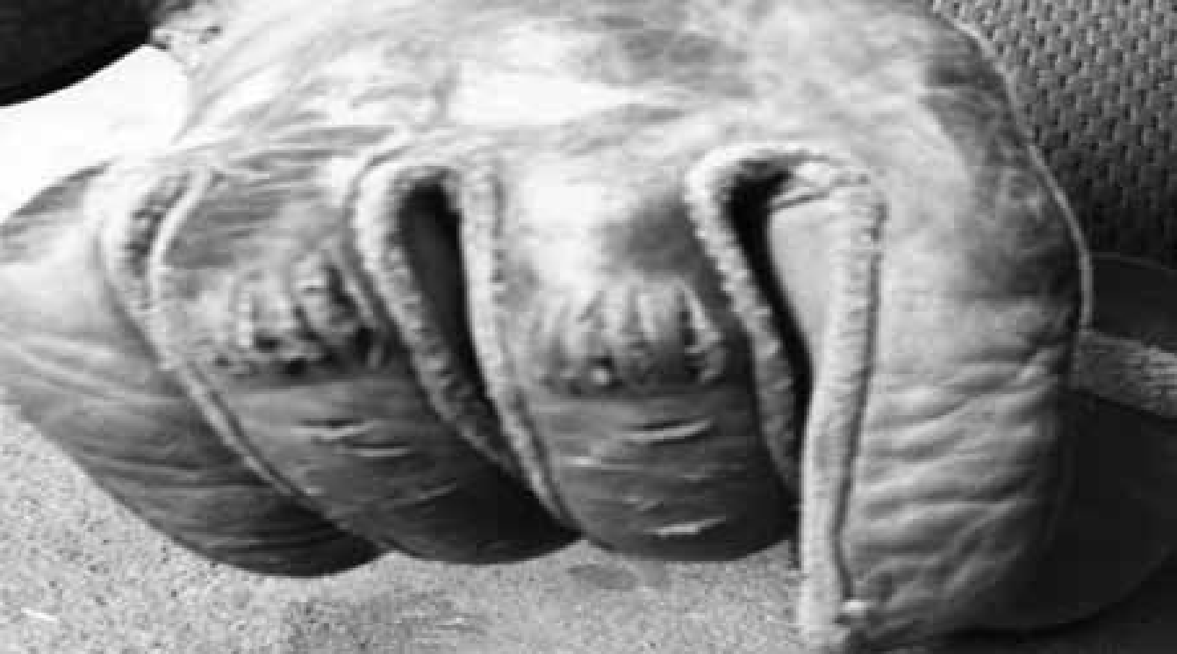
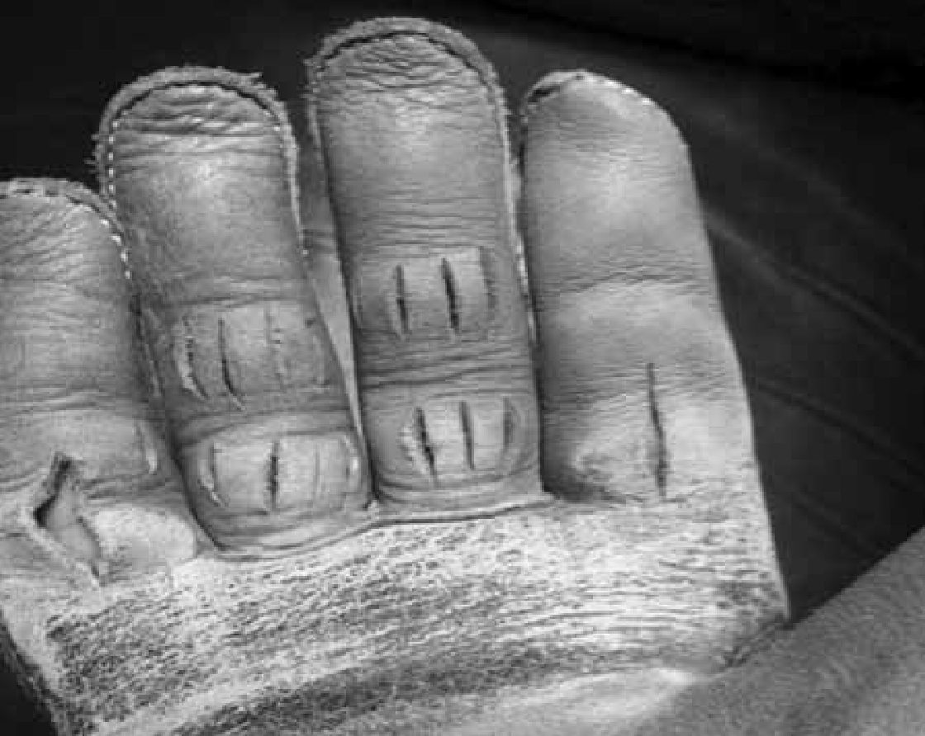

.
- There will be no adhesive material other than dry resin used on rigging or on rider’s glove. Benzoin may be used.
- Stock contractors will have the right to have judges pass on whether riggings are objectionable. Judges are to decide on all riggings and pads.
- All contestants must wear an Athletic Protective Mouthpiece while contesting. Mouth piece may not be trimmed any smaller than the size required to cover all teeth.
- All contestants must wear a vest designed to protect the chest and back while contesting in the Bareback Riding Event. The vest shall be one manufactured for rodeo/equestrian events and sold by retailers.
- No locked rowels or rowels that will lock on spurs or sharpened spurs may be used on bareback or saddle bronc horses. Spur rowels must have five or more points.

SR Boys SADDLE BRONC RIDING (Age 14-18)

- General Rules:
- Contestant is not to use sharp spurs.
- Contestant will have the right to call judges to pass on whether animal is properly flanked to buck the best of its ability.
- Fall - If chest or brisket, belly, side or rump contacts the ground animal will be considered fallen. Knee is not considered fallen.
- No contestant will ride two head in the same event during a performance except for rerides.
- Contestants may pull riggings, and cinch saddle from either side.
- Time Limit:
- Saddle bronc riding shall be timed for eight (8) seconds.
- Time to start when animal’s inside front shoulder passes the plane of the chute.
- Event Rules:
- This event is open to boys only.
- Either stock contractor or contestant has the right to call the judges to pass on whether or not horse is properly saddled and flanked to buck its best.
- Riding rein and hand must be on the same side.
- Horses to be saddled in chute.
- Rider may cinch own saddle.
- Saddles shall not be set too far ahead on horses wither.
- Middle flank belongs to rider but contractor may have rider put flank behind curve of horse’s belly.
- Flank cinch may be hobbled.
- To qualify, rider must have spurs over the break of the shoulders and touching horse when horse’s front feet hit the ground on its initial move out of the chute.
- One arm must be free at all times and must not touch animal with the free hand.
- The judge on the latch side of the chute gate shall serve as a back-up timer in the saddle bronc riding event or a person assigned by the Arena Director may serve as the back-up timer. The judge’s stopwatch reading shall be used as a means of verification when the length of the qualified ride is in question. The judge shall stop his watch when, in his opinion, the contestant has been disqualified for any reason, or when he hears the whistle or horn, whichever comes first. In either instance, the judge will refer to his watch for a time verification on each ride. In any instance where the time is eight seconds or more on the judge’s watch, the contestant shall be entitled to a marking without penalty. In the instance the whistle blows before the eight seconds, the judge must go with the whistle.
- Scoring and Penalties:
- Ride and animal to be marked separately.
- Mark the ride according to how much the contestant spurs the animal.
- Figures used in marking the riding events shall range from 1 to 25 on both bucking animal and contestant and use the full spread.
- If a horse stalls coming out of the chute, either judge may tell contestant to take his feet out of the horse’s neck and first jump qualification will then be waived.
- Contestant shall receive no score for not following judges’ instructions to take feet from neck of horse stalled in chute.
- A rider will be given a no score for any of the following reasons:
  - Being bucked off.
  - Changing hands on reins.
  - Wrapping rein around hand.
  - Pulling leather.
  - Losing stirrup.
  - Touching self, animal, saddle, rein, etc., with free hand.
  - Riding with locked rowel or rowels that will lock on spurs.
- Anyone using any foreign substance other than dry resin on chaps and saddle shall be disqualified. The judges will examine clothing, saddle, rein and spurs and exception be made if local rules make it necessary for the covering of spur rowels.
- Judges may disqualify bronc rider who has been advised he is next to go if he is not above the animal with his glove on, if used, when previous horse leaves arena.
- Rerides:
- The matter of rerides shall be decided by the judge.
- Contestants shall not influence the judges by asking for a reride at any time.
- If reride is given, judge shall inform the contestant immediately of his marking and an option of a reride.
- Contestant may refuse re-ride and take his marking.
- Contestant must make his decision immediately.
- If halter comes off, rider must have reride providing contestant has made a qualified ride up to the time the halter comes off. Rider must re-ride or take no score for that ride.
- No reride will be given due to faulty or broken equipment furnished by contestant in any event.
- If an animal that is drawn for a reride is already drawn for another contestant in the same-go-round, the contestant with the animal drawn will take it before the man who draws the animal for a reride.
- If an animal that is drawn for a reride is already drawn for another contestant in a later go-round, the contestant with the re-ride in the prior go-round will take the animal first.
- When a final head is to be ridden in riding events, at least two additional head of stock will be available for rerides.
- Rerides may be given when stock fails to break, stops, or fouls the rider.
- If, in the opinion of the judges, a rider makes two honest efforts to get out on a chute-fighting animal and is unable to do so, he may have a reride given.
- Contestants who are fouled at chute and declare will be entitled to a re-ride at judges’ discretion, or the spurring out rule may be waived.
- If animal falls down out of chute, contestant will be entitled to a re-ride at the discretion of the judges.
- If animal loses flank, fails to break, stops, or fouls rider, rider may take same animal back, providing stock contractor is willing, or he may have reride drawn.
- If rider takes same animal back, he must take that marking given on reride.
- If an animal that runs off is already drawn for another contestant, that contestant must take the animal already drawn.
- If that is the second consecutive time the animal has run off, he must be taken out of the draw and an animal drawn for the contestant out of the rerides.
- If the pickup man or horse comes in contact with bucking horse before qualified time has elapsed, reride will be given on the same animal drawn.
- The last day, contestant may have same animal back if stock contractor is willing or reride drawn if requested. If stock contractor is not willing, reride will be drawn.
- If in the opinion of the judges, a saddle bronc deliberately throws himself, the rider shall have the choice of that horse again or he may have a horse drawn for him from the re-ride horses.
- A contestant will only have the option of a reride if the flank comes off the animal and the contestant did not complete a qualified ride but was qualified up to the point of the flank coming off.
- Equipment
- Riding to be done with a plain halter, one rope-rein and committee saddle and contestant must supply own saddle.
- Standard halter must be used unless agreement is made by both contestant and stock contractor.
- Stock contractors may furnish their own halters and contestants may use them. If contestant borrows halter, he accepts the equipment as his own.
- Dry resin may be used on chaps and saddle.
- Contestant saddle specifications:
- Rigging:
        - 3/4 double-front edge of “D” ring must pull not further back than directly below center point of swell.
        - Standard E-Z or ring type saddle “D” must be used and cannot exceed 5 3/4 inch outside width measurement.

- Swell Undercut:
    - No more than two inches--one inch on each side.
- Gullett:
- Not less than four inches wide at center of fork of covered saddle.
- Tree:
- Saddles must be built on standard tree.
- Specifications:
      - Fork -- 14” wide.
      - Height -- 9” maximum.
      - Gullett -- 5 3/4” wide.
- Cantle:
- 5” maximum height.
- 14” maximum width.
- Stirrup leather must be hung over bars.
- Saddle should conform to the above measurements with a reasonable added thickness for leather covering.
- No freaks allowed.
- Front cinch on bronc saddle shall be mohair or neoprene and shall be at least eight (8) inches in width at the center, but may be tapered to accommodate cinch “D” or rings. Latigos may be of leather or nylon.
- All contestants must wear an Athletic Protective Mouthpiece while contesting. Mouth piece may not be trimmed any smaller than the size required to cover all teeth.
- All contestants must wear a vest designed to protect the chest and back while contesting in the Saddle Bronc Riding Event. The vest shall be one manufactured for rodeo/equestrian events and sold by retailers.
- No locked rowels or rowels that will lock on spurs or sharpened spurs may be used on bareback or saddle bronc horses. Spur rowels must have five or more points.

GENERAL RULES for all Roping/Timed Cattle Events

- Choice of “drawing cattle” or “chute running of cattle without a stock draw” for all roping/timed cattle events will be at the discretion of the NCJRA Board of Directors or Member Committee. In the event of such decision, all roping/timed cattle events must be run as such. Chute run cattle become assigned to the contestant when the contestant rides in the box in their drawn position. When a contestant turns out the steer will NOT be turned out.
- The ear tag number of the stock needs to be documented as the contestant enters the roping box for the purpose of identification, re-run, or in the case of an escaped animal.
- An NCJRA Director, Member Committee Director, or designated representative for either must be present during all sorting of cattle for chute-run roping/timed cattle events. At no time is the sorting of cattle to be performed at the discretion of volunteers, parents, or contestants, including those contestants performing Work Program duties
- All roping events must have a barrier string. Choice of neck rope or electric eye must be approved by the Roping Director.
- Lap and Tap — No barrier to be used. If barrier judge is used to flag the start, he shall flag the animal when animal’s nose crosses the starting line.
- For all roping events, the roping boxes are considered part of the arena.
- No encouragement can take place by the assistant after the contestant calls for the calf or steer. If the helper starts the horse or holds the horse in any way that affects the scoring process, contestant will receive a no time.

Open TEAM ROPING (Ages 6-18)

- Time Limit:
- One (1) minute time limit.
- Equipment:
- All roping events must have a barrier string. Choice of neck rope or electric eye must be approved by the Roping Director. A barrier will be set up for all roping events.
- If used, all cattle neck ropes must be tied with string or rubber bands. The same type of string or rubber bands are to be used throughout the rodeo. Adjustable slide shall be used on all cattle neck ropes for cattle used in team roping event. No metal snaps or hardware shall be used on cattle neck ropes in the team roping event.
- General Rules:
- Contestant may change horses in team roping.
- Roping Box - Shall be part of the arena during team roping.
- Recommended formula for score in roping: At least two-third of the length of the roping box. Example: An eleven – (11) foot score, for a sixteen – (16) foot box.
- Arena conditions will determine score, length to be set by arena director and timed event spokesperson if present.
- Once score line has been set in timed events it will not be changed in that go nor can length of box be changed.
- Lap and Tap – No barrier to be used. Flagger to flag time when animal’s nose clears the gate.
- All roping events must have a barrier string. Choice of neck rope or electric eye must be approved by the Roping Director.
- In all timed events, a barrier will not be considered broken unless ring drops within ten (10) feet of the post to which the barrier string is attached.
- Should the barrier break at any point other than designated breaking point, the decision is up to the barrier judge, contestant obviously beats the barrier, but the stops are pulled or barrier rope is broken and string unbroken, barrier judge may assess a ten (10) second fine. Otherwise, this will not be considered a broken barrier.
- If automatic barrier does not work but time is recorded, team will get time, but there will be no penalty for broken barrier.
- If automatic barrier fails to work and official time has not started, contestant will get stock back if stock is qualified on in the field, therefore, entitling contestants to a re-run without penalties.
- If automatic barrier fails to work, and stock is brought back, contestant must take same animal over during or immediately after the same performance.
- If barrier equipment hangs on animal and contestants try the animal, they accept animal. If contestants pull up, they will receive the same animal back.
- Steer belongs to contestants when they call for it, regardless of what happens with the following exceptions:
- If the steer gets out of the arena, flag will be dropped and the contestants get the steer back lap and tap with the time added which was taken when the steer left the arena, plus any barrier penalties.
- In cases of mechanical failure.
- If, in the opinion of the line judge, contestant is fouled by barrier, contestants shall get their steer back, providing they declare themselves by pulling up.
- In team roping, a horse must clear the box before a loop is thrown.
- Time to be taken between two flags.
- Event Rules:
- This event is to be a header and heeler event. It may be entered by 2 boys, 2 girls or a combination. Contestant enters as a header or heeler. Which side of the roping box the contestant starts from will determine points.
- A dally team roper can only enter once at any rodeo with the partner of his or her choice.
- All changes in lists of roping order to split horses, etc., must be made before any stock for that event is loaded in chute.
- After stock is loaded, ropers must rope in order of Contestant Draw.
- Header will start behind barrier using either box, and must throw the first loop at head.
- Heeler must start from behind barrier line.
- Time will be taken when steer is roped, both horses facing steer in line with ropes dallied and tight, horse’s front feet must be on the ground.
- Each contestant will be allowed to carry only one rope.
- Each team allowed three loops in all.
- Roping steer without turning loose of the loop will be considered a no catch.
- Roper must dally to stop steer.
- No tied ropes allowed.
- The word “Dally” means one complete turn around the horn.
- Ropers must be mounted when time is taken.
- Steer must be standing up when roped by head or heels.
- No foul catches can be removed by hand.
- If steer is roped by one horn, roper is not allowed to ride up and put rope over other horn or head with his hands.
- If the heeler ropes a front foot or feet in the heel loop, this is a foul catch. Neither contestant may remove the front foot or feet from loop by hand. However, should the front foot or feet come out of the heel loop by the time the field flag judge drops his flag, time will be counted.
- In case the field judge flags out a team that still legally has one or more loops coming, the judge may give the same steer back lap and tap, plus time already lapsed and any barrier penalty.
- If contestant hangs his or her rope on any immovable object in the box or arena, it shall be considered one loop thrown.
- This event shall not be conducted with an open catch pen gate at any rodeo.
- Scoring and Penalties:
- In order for time to be considered official, barrier flag must operate.
- Time event judge will not flag contestants out until time is recorded.
- Judge is to flag time, then flag contestants out if run is not legal.
- There will be a ten (10) second penalty assessed for breaking the barrier
- Roping steer without releasing loop from hand will disqualify catch.
- Contestant will be disqualified for any abusive treatment of steer or their horses.
- There will be only three (3) legal head catches:
- Both horns
- Half a head
- Around the neck
- If hondo passes over one horn, the loop over the other, the catch is illegal.
- If loop crosses itself in head catch, it is illegal. This does not include heel catches.
- Any heel catch behind both shoulders is legal if rope goes up heels.
- One hind foot receives five (5) second penalty.
- The steer’s entire body must be turned and moving forward in tow for the heel loop to be legal. Any heel loop thrown in the switch is considered a cross-fire and is illegal and will receive a NO TIME.
- Steer must not be handled roughly at any time, and ropers may be disqualified if, in the opinion of the field judge, they have intentionally done so.
- In the event a team roper is disqualified or injured, that team will be eliminated from that event.
- If header accidentally jerks steer off his feet or steer trips or falls, header must not drag steer over eight (8) feet before steer regains his feet or team will receive no score.
- Broken rope or dropped rope will be considered no time.
- Re-runs:
- In any timed event, if an animal escapes from the arena, flag will be dropped and watches stopped. Contestant will get animal back with lap and tap start, and time already spent will be added to time used in qualifying. If the time is missed, or the run otherwise interrupted, and one loop has already been thrown, the contestant will come back lap and tap with 10 second penalty assessed.
- If time is not recorded, contestants will be given re-run on same animal.
- If rope is on animal, contestants will get animal lap and tap with rope on it in chute.
- No re-run will be given due to faulty or broken equipment furnished by contestant.
- If the judge sees he has made an error in flagging, he must declare a re-run before the contestants leave the arena.
- A steer must be re-run before it is used by another contestant.
- When there is an electric timer and a digital clock malfunction, contestants will be given a clean re-run at a time designated by the judges and arena director.
- If artificial horns are jerked off, contestants will receive re-run on the same steer, with no penalties other than barrier penalties.
- Officials:
- There shall be two or more timers, a field flag judge, and a barrier judge.
- A field flag judge must ask contestants if they want a second loop. Once contestants have been flagged out, they will receive no stock back.
- Barrier judge is responsible to change barrier string whenever it may have been weakened, or on request of next contestant.
- Barrier judge shall keep a record of the length of the barrier trip rope each performance to assure the same start for contestants, each performance.
- Barrier equipment must be inspected by the judge before each timed event. If equipment is faulty, it must be replaced.
- If barrier flagman is used, the animal is to be flagged when crossing starting or deadline, in front of flagman.
- Barrier judge shall be sure that nobody can stand close enough to barrier or barrier equipment to tamper with same.
- A ten-(10) foot tape must be on hand for the barrier judge to measure score line and check 10’ barrier ring rule.
- Height of barrier in timed events shall be from 32” to 36” measured at the center of the box.
- Adjusting length of barrier trip rope will be accomplished only by tying knots in the rope on either end.
- Any question as to catches in this event will be decided by the judge.
- Stock:
- Steers must be uniform is weights and breed.
- Animals used for this event should be inspected and objectionable ones eliminated.
- All steers shall have horns properly wrapped.
- During any performance, if an animal escapes the chutes or pens before it is called for by the contestant ropers, or if an automatic barrier fails to work and the stock is brought back, that animal will be returned by the arena director and the labor crew during or at the end of that performance in the same manner he was originally worked or brought to the pens for contesting. At least several head of animals will be brought back together. No animal may be re-penned by itself. Decisions will be made by the arena director about when stock is re-penned.

JR Open STEER STOPPING (ages 6-13), SR Open STEER STOPPING (ages 14-18)

- Time Limit:
- There will be a 30 second time limit.
- General Rules:
- The three legal head catch are:
- both horns
- half a head
- around the neck
- The flag will be dropped when the steer has been roped and dallied. All forward motion of the horse must be stopped. Horse must have all four (4) feet on the ground to receive the flag.
- The rope must be tight and the steers head and body must be facing the horse to receive the flag.
- One loop is permitted only.
- All stock must be numbered.
- Contestant may change horses in steer stopping.
- All roping events must have a barrier string. Choice of neck rope or electric eye must be approved by the Roping Director. A barrier will be set up for all roping events.
- Dally team roping rules shall apply where applicable.

- If contestant hangs his or her rope on an immovable object in the box or arena, they shall receive a no time.
- This event shall not be conducted with an open catch pen gate at any rodeo.

SR Boys STEER WRESTLING (Ages 14-18)
Senior boys may choose to participate in Chute Dogging or Steer Wrestling. If a participant earns points in one event then changes events, he forfeits the points earned in the other event. He may only change events once during a season.

- General Rules
- Contestant may change horses between Go’s in Steer Wrestling.
- All positions of go in every event must be drawn for.
- All stock must be numbered.
- Dogging Box--shall be part of the arena during dogging events.
- Score Line Diagram
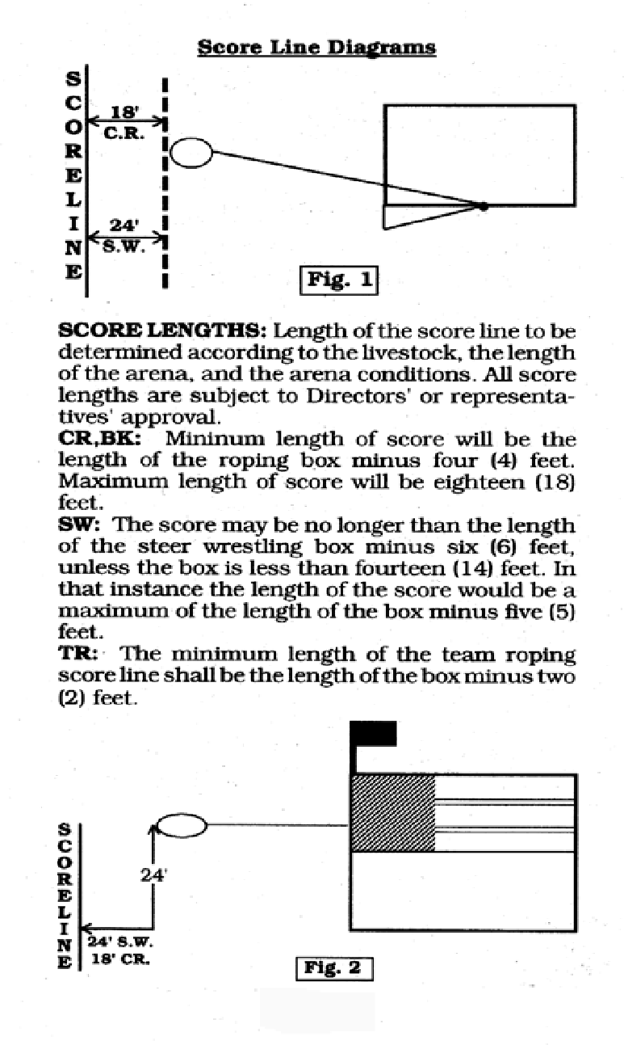
- Once score line has been set in timed events it will not be changed in that go, nor can length of box be changed.
- Lap and Tap - No barrier to be used. If barrier judge is used to flag the start, he shall flag the animal when animal’s nose crosses the starting line.
- The line judge must have a tape measure in his possession in case the short end of the barrier is carried. The pigtail of the barrier should not exceed 10 inches in length. A longer pigtail on a barrier will often be carried when the barrier should have been broken. If the pigtail is carried more than 10 feet from the pin, the barrier may be waived, providing the contestant did not obviously beat the barrier. However, if the contestant has obviously broken the barrier you may still impose a beating-the-barrier penalty.
- Should the barrier break at any point other than designated breaking point, the decision is up to the barrier judge. If contestant obviously beats the barrier, but the staples are pulled or barrier rope is broken and string unbroken, barrier judge may assess a ten-second fine. Otherwise this will not be considered a broken barrier.
- If automatic barrier does not work but time is recorded, contestant will get time, but there will be no penalty for broken barrier.
- If automatic barrier fails to work and official time has not started, contestant will get stock back if stock is qualified on in the field, therefore entitling contestant to a rerun without penalties.
- If automatic barrier fails to work and stock is brought back, contestant must take same animal over during or immediately after the same performance.
- If barrier equipment hangs on animal and contestant tries the animal, he accepts animal. If contestant pulls up, he will receive the same animal back.
- Steer belongs to contestant when he calls for it, regardless of what happens, with the following exceptions:
- In any timed event, if an animal escapes from the arena, the field judge will drop flag and all watches will be stopped. Contestant will receive original animal back with a lap-and-tap start. Time already accumulated will be added to time used to complete the qualifying run. If time is not recorded, the contestant will receive a 10-second penalty for any jump or any loop used.
- In cases of mechanical failure.
- If in the opinion of the line judge contestant is fouled by barrier, contestant shall get his steer back, providing contestant declares himself by pulling up.
- Time to be taken between two flags.
- It shall be the arena director’s responsibility to see that contestants compete on the stock drawn for them. In the event of a mistake, stock drawn for must be run during that performance and only that time or score taken.
- This event shall not be conducted with an open catch pen gate at any rodeo.
- Time Limit:
- There will be a sixty (60) second time limit. The judge will determine legitimate time allowed before contestant calls for animal.
- Event Rules:
- This event is open to boys only.
- This event should not follow girl’s pole bending event or barrel racing in the same arena. If so, arena must be dragged before steer wrestling event.
- Contestant must furnish own hazer and horse.
- Anyone jumping from the off side in the steer wrestling must notify the rodeo secretary when entering, and if possible, the barrier should be arranged on the off side for such contestants.
- Hazer must be a senior contestant or an adult. They are subject to contestant rules if acting as a hazer, a violation of rule by hazer will disqualify the contestant they are helping.
- Hazer must not render any assistance to contestant while contestant is working with steer.
- Contestant is considered working with steer when steer leaves the box.
- Steer must be caught from horse.
- If contestant jumps at steer, he accepts him as sound.
- If steer gets loose, dogger may take no more than one step to catch steer.
- After catching steer, wrestler must bring it to a stop or change its direction and twist it down.
- If steer is accidentally knocked down or thrown down before being brought to a stop or is thrown by wrestler putting animal’s horns into the ground, it must be let up to all four feet and then thrown.
- Steer will be considered thrown down only when it is lying flat on its side, or on its back with all four feet and head straight.
- Wrestler must have hand on steer when flagged.
- Contestant and hazer must use the same horse they leave chute with.
- Hazer will be allowed to catch dogger’s horse.
- If dogger misses or loses steer, flag judge must ask dogger if he wishes another jump. Dogger must reply at once.
- Dogger is entitled to as many jumps as he wants in the sixty (60) second time limit. A jump will be considered to have taken place if the steer wrestler has dismounted his horse.
- Contestant is required to turn steer’s head so that he can get up.
- A steer falling in the opposite direction the steer wrestler is attempting to throw him (dog fall) the contestant may choose to turn the steer’s head to correspond with the leg position to make this a legal fall.
- In case the field judge flags out a wrestler that still legally has one or more jumps coming, the judge may give the same steer back, lap and tap, plus time already lapsed and any barrier penalties. If time was not recorded, the contestant will receive a 10-second penalty for any jump used. Contestant to only get to use remaining jump.
- Scoring and Penalties:
- In order for time to be considered official, barrier flag must operate.
- Timed event judge will not flag contestant out until time is recorded.
- Judge is to flag time, then flag contestant out if run is not legal.
- There will be a ten second penalty assessed for breaking the barrier.
- Contestant will be disqualified for any abusive treatment of steer or his horse.
- Any violation of any rule by hazer will disqualify the contestant they are helping.
- Hazer must not render any assistance to contestant while contestant is working with steer. Failure to observe this rule will receive no time.
- If hazer bats steer, or contestant’s horse, contestant will receive no time.
- A ten second penalty will be assessed in any case in which barrier judge rules that dogger’s feet touch the ground before flag line is crossed.
- If any part of the pusher breaks the plain of the chute gate before the steer releases the barrier, the contestant receives a no time.
- No rattling of chute. A timed event contestant may not have someone rattle the chute for him. This applies in both the performance and the slack. The contestant and/or person rattling the chute shall be disqualified.
- When the contestant calls for the steer, no further assistance can take place after that. No encouragement can take place by the assistant after the contestant calls for the steer. If the helper starts the horse or holds the horse in any way that affects the scoring process, contestant will receive a no time.
- Contestant will be disqualified if he attempts in any way to tamper with steers or chute.
- Reruns:
- In any timed event if an animal escapes from the arena, flag will be dropped and watches stopped. Contestant will get animal back with lap and tap start, and time already spent will be added to time used in qualifying plus barrier penalties, if any.
- No rerun will be given due to faulty or broken equipment furnished by contestant.
- If the judge sees he has made an error in flagging, he must declare a rerun before the contestant leaves the arena.
- A steer must be rerun before it is used by another contestant. Fresh steers may be added to the herd after they have been bulldogged from horseback and thrown down. It is the responsibility of the steer wrestlers to throw the cattle, at a time mutually agreed upon with the stock contractor.
- If fresh steers are missed in the steer wrestling, any steer missed in competition must be thrown down immediately following the performance or section of slack in which the steer was drawn. Such steer shall be thrown down by a person appointed by the Roping Director. Each steer missed in competition is to be thrown no more than one time.
- When both the digital clocks malfunction and no time was recorded from digital watches, if stock was qualified on in the field, contestant will be given a rerun at a time designated by the Judges and the Arena Director, plus any barrier penalties. If barrier penalties, then lap and tap start.
- In steer wrestling, if an animal fails to break the neck rope and time is officially started by the contestant, that animal belongs to the contestant. However, if time is started by the animal and the steer wrestler and hazer remain behind the plain of the barrier for approximately 10 seconds that animal should be considered a sulking animal and replaced using the misdraw procedure.
- Optional Rules:
- Electric timers are optional.
- Equipment
- Choice of neck rope or electric eye must be approved by the Roping Director. A barrier will be set up for all roping events.
- If cattle neck ropes are used on steers must be tied with string, or rubber bands. All roping events must have a barrier string.
- No metal snaps or hardware shall be used on cattle neck ropes in the steer wrestling event.
- Adjustable slide shall be used on all cattle neck ropes in steer wrestling event.
- The steer wrestling chute must have at least 30 inches clearance inside the chute and at the gate when in an open position.
- In steer wrestling the score may be no longer than the length of the steer wrestling box, minus six feet, unless other arrangements are approved by the arena director.
- Length of box to be measured from center of back end of box to center of barrier.
- A mechanical barrier must be used and there must be at least a 12-foot box.
- Livestock Requirements:
- Cattle used for steer roping, or other events shall not be used for steer wrestling.
- Animals used for this event should be inspected and objectionable ones eliminated.
- No cattle can be held over from one year to the next for use in the Steer Wrestling.
- Fresh steers added to bunch that have not been used must be bulldogged from horseback and thrown down. It is the responsibility of steer wrestlers to throw the cattle at a time mutually agreed upon with the stock contractor.
- When fresh cattle are used, any fresh steer not thrown down during competition will be thrown down after completion of go-round. Contestants will be responsible to throw down such steers under the supervision of the arena director.
- Contestant will not be required to compete on a crippled steer or steer with broken horn.
- During any performance if a steer escapes the chutes or pens before it is called for by the contestant, or if an automatic barrier fails to work and the stock is brought back, that steer will be returned by the arena director and the labor crew during or at the end of that performance in the same manner originally worked or brought to the pens for contesting. At least several head of animals will be brought back together. No animal may be re-penned by itself. Decisions will be made by the arena director about when stock is re-penned.
- Boys Steer Wrestling Cattle:
- A minimum weight of 450 lbs.
- A maximum weight of 550 lbs.
- Officials:
- There shall be two or more timers, a field flag judge, and a barrier judge.
- A field flag judge must ask contestant if he wants a second jump. Once a contestant has been flagged out, he will receive no stock back.
- Barrier judge is responsible to change barrier string whenever it may have been weakened, or on request of next contestant.
- Barrier judge shall keep a record of the length of the barrier trip rope each performance to assure the same start for contestants each performance.
- Barrier equipment must be inspected by the judge before each timed event. If equipment is faulty, it must be replaced.
- Barrier judge shall be sure that nobody can stand close enough to barrier or barrier equipment to tamper with same.
- Height of barrier in timed events shall be from 32” to 36” measured at the center of the box.
- The fairness of catch and throw will be left to the judges, and their decision will be final.
- Field flagger is required to watch contestant and steer until animal is turned loose.

SR Boys TIE DOWN ROPING (Ages 14-18)

      - Time Limit:
  - There will be a 30 second time limit.
      - Equipment:
- Pigging String – A length of twisted nylon rope with a loop in one end, used to tie three legs of the calf.
- Neck Ropes – A length of rope encircling the horse's neck between the head and withers. The tail of the catch rope runs through it to the saddle horn, to assist in keeping the horse facing towards the calf at all times.
- All roping events must have a barrier string. Choice of neck rope or electric eye must be approved by the Roping Director.
- If Cattle neck ropes are used on calves, they must be tied with string. No metal snaps or hardware shall be used on the cattle neck ropes.
      - General Rules:
- More than one (1) contestant may use the same horse in this event.
- All positions of go in every event must be drawn for.
- All stock must be numbered.
- Roping Box shall be part of the arena during this event.
- Recommended formula for the score shall be at least two/thirds of the length of the roping box.
- Arena conditions will determine the score length. Score to be set by the arena director and timed event director.
- Once the event has begun, neither the score line or box length can be changed.
- Lap and Tap – No barrier to be used. Flagger to begin time when animal’s nose clears the gate.
- In all timed events, a barrier will not be considered broken unless ring drops within ten feet of the post to which the barrier string is attached.
- Should the barrier break at any point other than the designated breaking point, the decision is up to the barrier judge. If contestant obviously beats the barrier, but the stops are pulled or barrier rope is broken and string unbroken, barrier judge may assess a ten second penalty. Otherwise, this will not be considered a broken barrier.
- If automatic barrier fails to work and official time is recorded, contestant will get that time and there will be broken barrier penalty.
- If automatic barrier fails to work and official time has not started, contestant will get stock back if stock is qualified on in the field. Thus contestant is entitled to a return without penalties.
- If automatic barrier fails to work and stock is brought back, contestant must take same animal over during or immediately after the same performance.
- If barrier equipment hangs on animal and contestant tries the animal, he accepts that animal. If contestant pulls up, he will receive the same animal back.
- If contestant hangs up his rope on an immovable object at the chute and is unable to use that loop, it will be considered to be his first loop.
- Calf belongs to contestant when he calls for it, regardless of what happens, with the following exceptions:
- If the calf gets out of the arena, flag will be dropped and the roper gets the calf back lap and tap with the time added which was taken when the calf left the arena plus any barrier penalties.
- In cases of mechanical failure.
- If, in the opinion of the line judge, contestant shall get his calf back providing contestant fouled by barrier. Contestant shall get his calf back, providing he declares himself by pulling up.
- In tie down roping, a horse must clear the box before a loop thrown.
- Time to be taken between two flags.
- It shall be the arena directors’ responsibility to see that contestants compete on the stock drawn for them. In the event of a mistake, stock drawn for must be run during that performance and only that time or score taken.
- This event shall not be conducted with an open catch pen gate at any rodeo.
      - Event Rules:
- A neck rope must be used. Contestants must adjust rope and reins in a manner that will prevent the horse from dragging the calf. (see equipment)
- Calves may be pushed out by contestant’s assistant provided they are ready. If not, arena director will have workers to push calves.
- Two loops will be permitted.
- If roper intends to use two loops, he must carry two ropes.
- No loops can be rebuilt.
- If second rope falls from saddle before used, it cannot be rebuilt.
- Contestant cannot receive any assistance after crossing starting line.
- Contestant must rope calf, dismount, go down the rope and throw the calf by hand. Cross and tie any three legs.
- Any catch is legal, catch as catch can rule.
- If calf is down when roper reaches it, calf must be stood on at least three feet. (Calf must be elevated high enough that he could regain his feet) and calf must be re-thrown.
- If roper’s hand is on calf when calf falls, calf is considered thrown by hand.
- Rope must hold calf until roper gets hand on calf.
- To qualify as a legal tie, there shall be one or more wraps, and a half hitch or hooey (“hooey” is a half hitch with a loop, the tail of the string may be partly or all the way pulled through).
- The tie must hold six (6) seconds, and three legs remain crossed until passed on by the judge.
- Six second time will start when roper has remounted and his horse has taken one step forward.
- If roper’s rope comes off calf as roper starts to work with tie, the six second time will start when roper finishes tie and steps back from calf.
- Rope will not be removed and rope must remain slack until field judge has passed on the tie.
      - Scoring and Penalties.
- In order for time to be considered official, barrier flag must operate.
- Timed event judge will not flag contestant out until time is recorded.
- Judge is to flag time, then flag contestant out if run is not legal.
- There will be a ten-second penalty assessed for breaking the barrier.
- If a contestant jerks the calf down, a three second penalty shall be added to this time. “Jerking a calf down” is defined as over backwards, with the calf landing on his back or head with all four feet in the air. Whether the jerk down was intentional or unintentional, the penalty will be assessed.
- Roping calf without releasing loop from hand will disqualify catch.
- Contestant will be disqualified for any abusive treatment of calf or horse.
- If the horse excessively drags the calf after roper has dismounted, ten second penalty will be added to time by field judge.
- Roper will be flagged no time for touching calf, or string after giving finish signal or for dragging calf after he remounts horse.
      - Re-runs:
- In any timed event if an animal escapes from the arena, flag will be dropped and watches stopped. Contestant will get animal back with lap and tap start, and time already spent will be added to time used in qualifying. If the time is missed, or the run otherwise interrupted, and one loop has already been thrown, the contestant will come back lap and tap with 10 seconds assessed. Providing they had two loops.
- If time is not recorded, roper will be given return on same animal.
- If rope is on animal, contestant will get animal lap and tap with rope on it in chute.
- No re-run will be given due to faulty or broken equipment furnished by contestant.
- If the judge sees he has made an error in flagging, he must declare a re-run before the contestant leaves the arena.
- A calf must be re-run before it is used by another contestant.
- When there is an electric timer and a digital clock malfunction, contestant will be given a clean re-run at a time designated by the judges and arena director.
- If there must be a re-run of calves to complete a go-round, all calves must be tied down before any stock is re-drawn
Officials:
- There shall be two or more timers, a field flag judge, and a barrier judge.
- A field flag judge must ask contestant if they want a second loop. Once a contestant has been flagged out, he will receive no stock back.
- Barrier judge is responsible to change barrier string whenever it may have been weakened, or on request of next contestant.
- Barrier judge shall keep a record of the length of the barrier rope each performance to assure the same start for contestants each performance.
- Barrier equipment must be inspected by the judge before each timed event. If equipment is faulty, it must be replaced.
- If barrier flagman is used, the animal is to be flagged when crossing starting, or deadline, in front of flagman.
- Barrier judge shall be sure that nobody can stand close enough to barrier or barrier equipment to tamper with same.
- A ten-foot tape must be on hand for the barrier judge to measure score line and check 10’ barrier ring rule.
- Height of barrier in timed events shall be from 32” to 36” measured at the center of the box.
- Adjusting length of barrier trip rope will be accomplished only by tying knots in the rope on either end.
- Flagger must watch calf during the six-second period.
- Judge will start watch when roper signals for tie if roper’s rope had come off calf, or when roper has remounted and his horse has taken one step forward.
- Rope will not be removed and rope must remain slack until field judge has passed on tie.
- Start watch, and then watch calf, counting to six seconds.
- If the horse excessively drags the calf after roper has dismounted, ten second penalty will be added to time by field judge.
- If a calf kicks loose, the judge will stop watch and check time to determine if tie was legal.
- Untie man must not touch calf until judge has passed on tie.
      - Stock:
- Calves must be uniform in weight and breed.
- Animals used for this event should be inspected and objectionable ones eliminated.
- If after one go-round has been completed, a fresh calf has to be used, the calf must be roped and tied before the drawing, but if extra calves have been tied at that rodeo they will not be considered fresh.
- During any performance if an animal escapes the chutes or pens before it is called for by the contestant, or if an automatic barrier fails to work and the stock is brought back, that animal will be returned by the arena director and the labor crew during or at the end of that performance in the same manner he was originally worked or brought to the pens for contesting. At least several head of animals will be brought back together. No animal may be re-penned by itself. Decisions will be made by the arena director about when stock is re-penned.
- Tie Down Roping Calves:
- Minimum weight 180 lbs.
- Maximum weight 225 lbs.

BREAKAWAY ROPING
JR Boys (Ages: 6-13); JR Girls (Ages: 6-13); SR Girls (Ages 14-18)

- Time Limit:
- There will be a 30 second time limit.
- Equipment:
  - A barrier will be set up for all roping events. All roping events must have a barrier string. Choice of neck rope or electric eye must be approved by the Roping Director.
  - No metal snaps or hardware shall be used on cattle neck ropes in the Breakaway Roping event.
  - Adjustable slide shall be used on all cattle neck ropes for cattle used in Breakaway Roping event.
  - Western-type equipment must be used.
- General Rules:
  - Contestant may change horses in Breakaway Roping.
  - All positions of go in every event must be drawn for.
  - All stock must be numbered.
  - Roping Box-Shall be part of arena during roping events.
  - Recommended formula for score in roping: At least two-thirds of the length of the roping box.
Example: An eleven – (11) foot score for a sixteen – (16) foot box.
  - Arena conditions will determine score, length of score to be set by arena director and timed event director.
  - Once score line has been set in timed events, it will not be changed in that go, nor can length of box be changed.
  - Lap and Tap – No barrier to be used. Flagger to flag time when animal’s nose clears the gate.
  - In all timed events, a barrier will not be considered broken unless ring drops within ten (10) feet of the post to which the barrier string is attached.
  - Should the barrier break at any point other than designated breaking point, the decision is up to the barrier judge. If contestant obviously beats the barrier, but the stops are pulled or barrier rope is broken and string unbroken, barrier judge may assess a ten – (10) second penalty. Otherwise, this will not be considered a broken barrier.
  - If automatic barrier does not work, but time is recorded, contestant will get time, but there will be no penalty for broken barrier.
  - If automatic barrier fails to work and official time has not started, contestant will get stock back if stock is qualified on in the field, therefore entitling contestant to a re-run without penalties.
  - If automatic barrier fails to work and stock is brought back, contestant must take same animal over during or immediately after the same performance.
  - If barrier equipment hangs on animal and contestant tries the animal, he or she accepts animal. If contestant pulls up, he or she will receive the same animal back.
  - Calf belongs to contestant when he or she calls for it, regardless of what happens, with the following exceptions:
      - If the calf gets out of the arena, flag will be dropped and the roper gets the calf back lap and tap with the time added which was taken when the calf left the arena plus any barrier penalties.
      - In cases of mechanical failure.
      - If, in the opinion of the line judge, contestant is fouled by barrier, contestant shall get their calf back, providing contestant declares themselves by pulling up.
      - In Breakaway, a horse must clear the box before a loop is thrown.
      - Time to be taken between two flags.
      - It shall be the arena director’s responsibility to see that contestant competes on the stock drawn for them. In the event of a mistake, stock drawn for must be run during that performance and only that time or score taken.
- This event shall not be conducted with an open catch pen gate at any rodeo.
- Event Rules:
- Two loops will be allowed if two ropes are carried.
- Ropes are to be tied to the saddle horn with a nylon string. A knot must be at the end of the rope with the string tied at the knot.
- The rope must be attached to the horn in such a manner as to allow the rope to be released from the horn when the calf hits the end of the rope. Contestant is responsible for securing string to saddle horn prior to entering the box.
- Rope must be tied to the horn with a nylon string and may not be run through bridle, tie down, neck rope or any other device. String will be provided by the Event Director and ties will be inspected by a designated official before each contestant competes. String may not be altered in any way.
- A white flag that is visible to the flagman or judge must be attached to the knot end of the rope. There will be no tail on the rope.
- The string must be tied to the horn at the same place that the flag is attached to the rope.
- String is to be broken and time signified when the calf reaches the end of the rope. If the string breaks by any other means, the contestant will receive a NO TIME. A NO TIME will be received should contestant break string away from the saddle horn by hand.
- If rope should dally around the saddle horn, the contestant may ride forward, un-dally the rope, and stop his/her horse allowing the calf to break the string.
- NO loops are to be rebuilt.
- If a second loop falls, it cannot be rebuilt and used.
- The catch-as-catch can rule shall apply after the loop has passed over the calf’s entire head.
- Rope must be released from contestants hand to be a legal catch.
- In case the field judge flags out a roper that still legally has one or more loops coming, the judge may give the same calf back lap and tap, plus time already lapsed and any barrier penalty.
- Scoring and Penalties:
- In order for time to be considered official, barrier flag must operate.
- Timed event judge will not flag contestant out if run is not legal. Judge is to flag time, then flag contestant out if run is not legal.
- There will be a ten – (10) second penalty assessed for breaking the barrier.
- Roping calf without releasing loop from hand will disqualify catch.
- Contestant will be disqualified for any abusive treatment of calf or horse.
- Re-runs:
- In any timed event, if an animal escapes from the arena, flag will be dropped and watches stopped. Contestant will get animal back with lap and tap start, and time already spent will be added to time used in qualifying. If the time is missed, or the run otherwise interrupted, and one loop has already been thrown, the contestant will come back lap and tap with 10 seconds assessed. Providing they had two loops.
- During any performance if an animal escapes the chutes or pens before it is called for by the contestant, or if an automatic barrier fails to work and the stock is brought back, that animal will be returned by the arena director and the labor crew during or at the end of that performance in the same manner he was originally worked or brought to the pens for contesting. No animal may be re-penned by itself. Decisions will be made by the arena director about when stock is re-penned.
- If time is not recorded, roper will be given return on same animal.
- If rope is on animal, contestant will get animal lap and tap with rope on it in chute.
- No return will be given due to faulty or broken equipment furnished by contestant.
- If the judge sees he has made an error in flagging, he must declare a return before the contestant leaves the arena.
- A calf must be returned before it is used by another contestant.
- When there is an electric timer and a digital clock malfunction, contestant will be given a clean return at a time designated by the judges and arena director.
- Officials:
- There will be two or more times, a field flag judge, and a barrier judge.
- Flag judge will make final decision.
A field flag judge must ask contestants if they want a second loop. Once a contestant has been flagged out, they will receive no stock back.
- Barrier judge is responsible to change barrier string whenever it may have been weakened, or on request of next contestant.
- Barrier judge shall keep a record of the length of the barrier trip rope each performance to assure the same start for contestants each performance.
- Barrier equipment must be inspected by the judge before each timed event. If equipment is faulty, it must be replaced.
- If barrier flagman is used, the animal is to be flagged when crossing starting, or deadline, in front of flagman.
- Barrier judge shall be sure that nobody can stand close enough to barrier or barrier equipment to tamper with same.
- A ten – (10) foot tape must be on hand for the barrier judge to measure score line and check 10’ barrier ring rule.
- Height of barrier in timed events shall be from 32” to 36” measured at the center of the box.
- Adjusting length of barrier trip rope will be accomplished only by tying knots in the rope on either end.
- Stock:
- Calves must be uniform in weight and breed.
- Animals used for this event should be inspected and objectionable ones eliminated.
- If the cattle have horns, length not to exceed 2 inches.
- Breakaway calves:
- Minimum weight 250 pounds.
- Maximum weight 400 pounds.

GOAT TYING
JR Girls (Ages 6-13), SR Girls (Ages 14-18)

- Time Limit:
- Juniors (ages 6-13) have a one minute time limit.
- Seniors (ages 14-18) have a 30 second time limit.
- Equipment:
- Leather, cotton, nylon pigging string or rope (Pigging String-A piece of rope used for securing animal).
- Western-type equipment must be used.
- General Rules:
- All stock will be numbered and drawn for prior to event.
- All fresh goats must be tied down three (3) times before the Rodeo.
- Starting lines in Goat Tying will be subject to ground rules.
- A clearly-visible starting line shall be provided.
- The stake and the starting line will be permanently marked for the entire go-round.
- Contestant may change horses in this event.
- A contestant may enter the arena at the speed of her choice.
- Gate will be in the center between the two goats allowing each contestant the same length run at the goat if arena conditions allow.
- Arena gate must be closed immediately after she enters the arena and kept closed.
- Time to be taken between start flag and ending flag.
- Timing will start when the horse’s nose crosses the starting line.
- Event Rules:
- There should be at least a 45 foot starting line.
- Starting line will be 100 feet from stake, arena permitting.
- Flagger will stand in identical places each run, behind goat being tied.
- Goats to be tied starting with the right goat, then left, right, and then left and so on. This will be reversed on next go. Contestant cannot draw same goat on two consecutive goes.
- Goats to be tied to a stake with a rope 10 feet in length.
- Stake must be completely under the ground so that no part of it is visible or above ground.
- The contestant must be mounted on a horse and must ride from the starting line to the goat, dismount and throw the goat by hand.
- If the goat is down when the contestant reaches it, goat must be elevated high enough that it has the opportunity to regain its feet. Goat is then thrown.
- A tie consists of crossing and tying any three legs together with a pigging string, or rope.
- Legs must remain crossed and secure for six (6) seconds after completion of the tie. Time will not start until contestant has moved 3 feet back from the goat.
- To qualify as a legal tie, there will be one or more wraps, and half hitch, hooey or knot.
- Time will stop when she signals the completion of the tie.
- Qualified persons not in that event will be used as goat holders.
- Order of go will be drawn for all contestants in this event.
- The contestant will make no gestures, motion or noises to distract the goat. This will be considered trying to make an unfair advantage and will result in a disqualification.
- Scoring and Penalties:
- Timed event judge will not flag contestant out until time is recorded.
- Judge is to flag time, then flag contestant out if run is not legal.
- To qualify as a legal tie, there must be at least one complete wrap around at least three legs, and a half hitch, hooey or knot. The contestant must tie the goat by hand with no pre-made wraps, coils, knots, hooeys or half hitch.
- The tie will be passed on by a field judge and if it is not secure for six (6) seconds, the contestant will receive no time. Time to be kept by judge and shown to contestant if flagged out.
- Contestant will receive a no time for touching the goat or tie string after signaling she is finished.
- If the contestant’s horse crosses over the rope or goat, or if the contestant’s horse comes in contact with the goat or rope prior to the contestant signaling for time, a ten (10) second penalty will be assessed.
- If the goat should break away because of the fault of the horse, contestant will receive a no time.
- If a goat gets loose from stake, contestant will have the same goat back before next contestant goes.
- Goats:
- Weight of goats for the Junior & Senior age divisions is a minimum of 40 pounds and a maximum of 60 pounds. All goats will be uniform in weight and size.
- A new pair of goats will be put out after no more than 10 runs. Each goat being tied only 5 times per event.
- Have collars the same and all on snugly, ropes the same length. Goats within each division should be uniform in size and height.
- Horns shall be tipped or cut back to the size of a U.S. 10 cent piece. This is the responsibility of the Stock Contractor at the discretion of the Judges, Arena Director or the Event Director.
- Re-runs:
- No return will be given due to faulty or broken equipment furnished by contestant in any event.
- If the goat should break away, it will be left to the judge's’ discretion whether she will get a re-run.
- If a re-run is awarded to a contestant, that contestant’s goat shall be brought back before the next contestant goes and the re-run shall occur immediately.

JR Boys GOAT TYING (Ages 6-13)

      - Rules shall be the same as for “JR and SR Girls Goat Tying” except:
- Goats must be tied with a pigging string.
- A legal tie shall be the same as the Sr. Boys Calf Roping. At least one wrap around all three legs and a half hitch or hooey. The tail of the string may be partly or all the way pulled thru the tie.

CLOVER-LEAF BARREL RACING
JR Girls (Ages 6-13), Sr. Girls (Ages 14-18)

- Time Limit:
- Contestants will be allowed 30 seconds from the time she enters arena gates until her time starts by field flagger or electric eye. Time to be kept with stopwatch by judge.
- Equipment:
  - Western-type equipment must be used.
  - Use of a hackamore or other types of bridles is the optional choice of the contestant.
  - Judge may prohibit the use of bits or equipment that may be considered severe.
  - Complete electric times must be backed up by a flagman who will stand directly behind one time post in the arena. One timer will record the time that appears on the electric eye controlled readout. Two timers will operate from the flagman’s signals. If one runs by clock, all must. If malfunctions occur or eye completely breaks, all girls will be flagger timed. Back up times shall be recorded.
  - Permanent markers should be put in the ground for the electric eyes. Electric eyes should be placed on the score line no closer than the width of the first two barrels, for the electric eye to be centered in each performance.
  - Line on fence for flagman should be well marked. These markers should be checked every performance along with the barrel markers and restaked if pulled out. A record of these measurements shall be kept.
  - Set timers beforehand in the same height and position and lock the legs.
  - Barrels are not to be used as stands for the electric eye timer devices.
  - Barrels will be standard 55 gallon metal barrel. NO plastic barrels will be used.
- General Rules:
  - Assistant helping contestant will not be allowed to go past the plane of the main arena gate when they are entering the arena or the contestant will receive a no time.
  - Starting lines in clover-leaf barrel racing will be subject to ground rules.
  - A clearly visible starting line shall be provided.
  - If an electric timer is available it must be used.
  - No horse shall be ridden by more than one contestant in this event, unless the contestants are siblings and are in separate age groups.
  - The time will start when the horse’s nose crosses the starting line.
  - There shall be a minimum of 75 feet allowed for stopping, from starting line in barrels back to arena fence.
  - The barrels and the starting line will be permanently marked for the entire go-round.
  - During barrel racing events, the arena will be dragged at regular intervals, every 10th rider, or sooner, at the discretion of the Committee.
  - Following barrel racing events, the pattern will be dragged or leveled if equipment is available.
  - A contestant may enter the arena at the speed of her choice.
  - Arena gate must be closed immediately after she enters the arena, and kept closed until pattern is completed and her horse is under control.
  - Contestant may change horses in this event.
  - Order of go position will be drawn for all contestants in this event.
4. Event Rules:
- All barrels must be twenty (20) yards or further apart. Nothing under (20) yards.
- The arena conditions will enable you to decide the distance over twenty (20) yards that you wish to place the barrels.
- The clover-leaf pattern is the only approved pattern in this event.
- The pattern to be run for the barrels is as followed (if arena conditions permit):
- The barrels must be twenty (20) feet at least, from the arena fence.
- The front two barrels shall be twenty (20) yards (60 feet) from the starting line.
- The distance between the two front barrels and the back barrel shall be (35) yards (105 feet).
- The contestant may start on either the right or left barrel:
        - When starting on the right barrel, there will be one right turn and two left turns around the barrels.
        - When starting on the left side, there will be one left and two right turns.
        - Touching the barrel is permitted by horse or contestant.
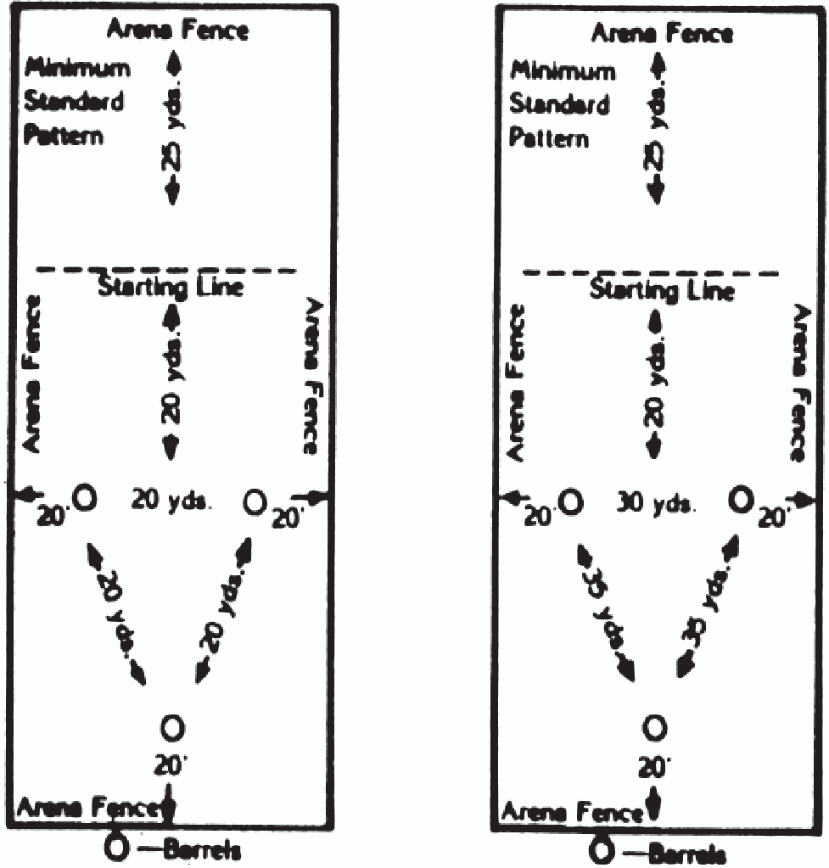
- Scoring and Penalties:
- Timed event judge will not flag contestant out until time is recorded.
- Judge is to flag time, then flag contestant out if run is not legal.
- Knocking over a barrel is a five (5) second penalty, per barrel.
- Not following the clover- leaf pattern will receive a no time. A broken pattern shall be defined as breaking their forward motion to retrace their tracks to finish the pattern and/or passing the plane of the barrel on the off side. Example: Should a contestant run by a barrel and have to back up or turn around and retrace their tracks, this would be considered a broken pattern.
- A five-(5) second penalty will be added to time for an infraction of the following time rule: Contestant will be allowed 30 seconds from the time she enters the arena gate until her time starts by field flagger or electric eye. Time to be kept by the judge with stopwatch.
- Judge will determine legitimate problem for pre-start time.
- If horse re-crosses starting line at any time before the pattern is completed, pattern will be considered broken and run will receive no time
- If contestant’s horse breaks timer light, by backing through starting pattern, time will be considered started.
- Re-runs:
- No re-run will be given due to faulty or broken equipment furnished by contestant.
- The battery digital clock will be the first backup and digital hand-held watches are the second back up time. When all the digital clocks malfunction, contestant will be given a clean re-run at a time designated by the judges and arena director.

POLE BENDING
JR Girls (Ages 6-13), SR Girls (Ages 14-18)

- Time Limit:
- Contestant will be allowed 30 seconds from the time she enters arena gates until her time starts by field flagger or electric eye. Time to be kept by judge with stopwatch.
- Equipment:
- Western-type equipment must be used.
- Use of a hackamore or other type of bridles is the optional choice of the contestant.
- If an electric timer is available it must be used.
- The judge may prohibit the use of bits or equipment that they consider severe.
- Complete electric timer must be backed up by a flagman who will stand directly behind one time post in the arena. One timer will record the times that appear on the electric eye controlled readout. Two timers will operate the digital watches and record the average time, which is shown thereon. These two timers will operate from the flagman’s signals. If one runs by clock, all must. If malfunction occurs, or eye completely breaks down, all girls will be flagger timed. Back up times will be kept by timers.
- Permanent markers should be put in the ground for the electric eyes.
- Line on fence for flagman should be well marked. These markers should be checked every performance along with the pole markers and re-staked if pulled out. A record of these measurements shall be kept.
- Set timers beforehand in the same height and position and lock the legs.
- Barrels are not to be used as stands for the electric eye timer devices.
- General Rules:
- Assistant helping contestant will not be allowed to go past the plane of the main arena gate when they are entering the arena or the contestant will receive a no time.
- Staring lines in pole bending will be subject to ground rules.
- A clearly visible starting line shall be provided.
- The time will start when the horse’s nose crosses the starting line.
- No horse shall be ridden by more than one contestant in this event, unless the contestants are siblings and are in separate age groups.
- There shall be a minimum of 75 feet allowed for stopping, from starting line in poles back to arena fence.
- The poles and the starting line will be permanently marked for the entire go-round.
- The poles and the starting line will be permanently marked for the entire go-round.
- During pole bending events, the arena will be dragged at regular intervals, every 10 riders or sooner, at the discretion of the Committee.
- A contestant may enter the arena at the speed of her choice.
- Arena gates must be closed immediately after she enters the arena, and kept closed until pattern is completed and her horse is under control.
- Contestant may change horses in this event.
- Order of go positions will be drawn for all contestants in this event.
- Event Rules:
- The pole bending pattern is to be run around six poles.
- No flags to be used on poles.
- The distance from the starting line to the first pole shall be 21 feet and spacing between poles will be twenty-one (21) feet apart.
- Poles shall be set on top of the ground, six (6) feet in height, and with no base larger than fourteen (14) inches or less than twelve (12) inches in diameter.
- Poles must be straight in line.
- Touching poles is permitted by horse or contestant.
- A horse may start either to the right or left of the first pole and then run the remainder of the pattern accordingly.
- Scoring and Penalties:
- Timed event judge will not flag contestant out until time is recorded.
- Judge is to flag time, then flag contestant out if run is not legal.
- Knocking over a pole is a five (5) second penalty, per pole. A broken pattern shall be defined as breaking their forward motion to retrace their tracks to finish the pattern and/or passing the plane of the pole on the off side. Example: Should a contestant run by a pole and have to back up or turn around and retrace their tracks, this would be considered a broken pattern.
- Not following the pole bending pattern will receive a no time.
- A five (5) second penalty will be added to time for an infraction of the following time rule: Contestant will be allowed 30 seconds from the time she enters arena gate until her time starts by field flagger or electric eye. Judge will determine legitimate problem for prestart time. Time to be kept by stopwatch by judge.
- If horse re-crosses starting line at any time before the pattern is completed, pattern will be considered broken and run will receive no time.
- If contestant’s horse breaks timer light, by backing through before starting pattern, time will be considered started.
- Miscellaneous.
- If two sets of poles are run, first contestant will start on the right set, thereafter alternate from right to left.
- Re-Runs:
- No re-run will be given due to faulty or broken equipment furnished by contestant.
- The battery digital clock will be the first backup time and digital held watches to be second backup time. When both the digital clocks malfunction and no average time was recorded from digital watches, contestant will be given a clean re-run at a time designated by the judges, and arena director.

Diagram of Pattern:
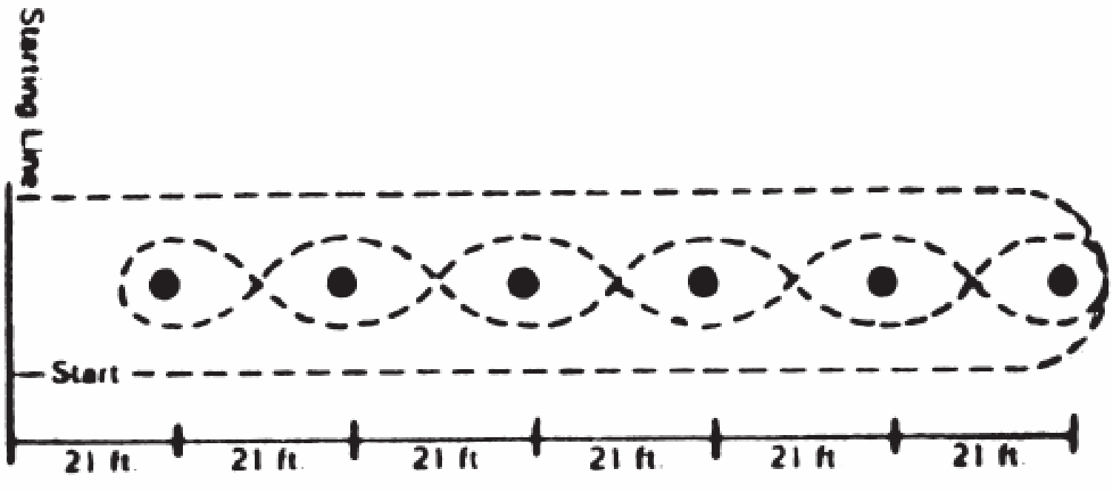

NON-SANCTIONED EVENTS

JR/SR TEAM ROPING
NCJRA Team Roping Rules apply except for the following:
- Each team is allowed only two loops.
- Contestant may enter once with an adult age 25 years or older.

JUNIOR/JUNIOR Events
NCJRA barrel racing, pole bending, and goat tying rules are in effect with the following exceptions:
  - Jr/Jr contestants are ages 6-9 on January 1 of the year of competition.
  - Parents in dress code may enter the arena, provided they do not cross the eye.
  - Contestants will not be flagged out for exceeding the one minute time limit to tie a goat.
  - Jr/Jr(6‐9) contestants may enter Family Team Roping, but may not participate in any other event.

SINGLE STAKE
  - Anything other than one right or left turn around the contestant’s designated pole results in No Time.
  - Knocking down the pole results in No Time.
  - When two courses are set up, it is considered off-course when the contestant runs around both poles.

Quick Reference Table

Event | Ride Time / Time Limit | Stock Weight | Loops Permitted
SR Bull Riding | 8 sec.
JR Bull Riding | 8 sec.
Steer Riding | 8 sec. | 700 lbs. max.
Calf Riding | 6 sec. | 300-400 lbs.
Saddle Bronc/Bareback | 8 sec.
Steer Wrestling | 60 sec. | 450-550 lbs.
Breakaway Roping | 30 sec. | 250-400 lbs. | 2 if 2 ropes are carried
Tie Down Roping | 30 sec. | 180-225 lbs. | 2 if 2 ropes are carried
Chute Dogging | 30 sec.
Sr. Girls Goat Tying | 30 sec. | 40-60 lbs.
Jr. Boys & Girls Goat Tying | 60 sec. | 40-60 lbs.
Steer Stopping | 30 sec. |  | 1
Team Roping | 1 min. |  | 3
Jr./Sr. Team Roping | 1 min. |  | 2
Events with 30 second/one minute time limit may have penalties which will exceed the 30 second/one minute time limit.

