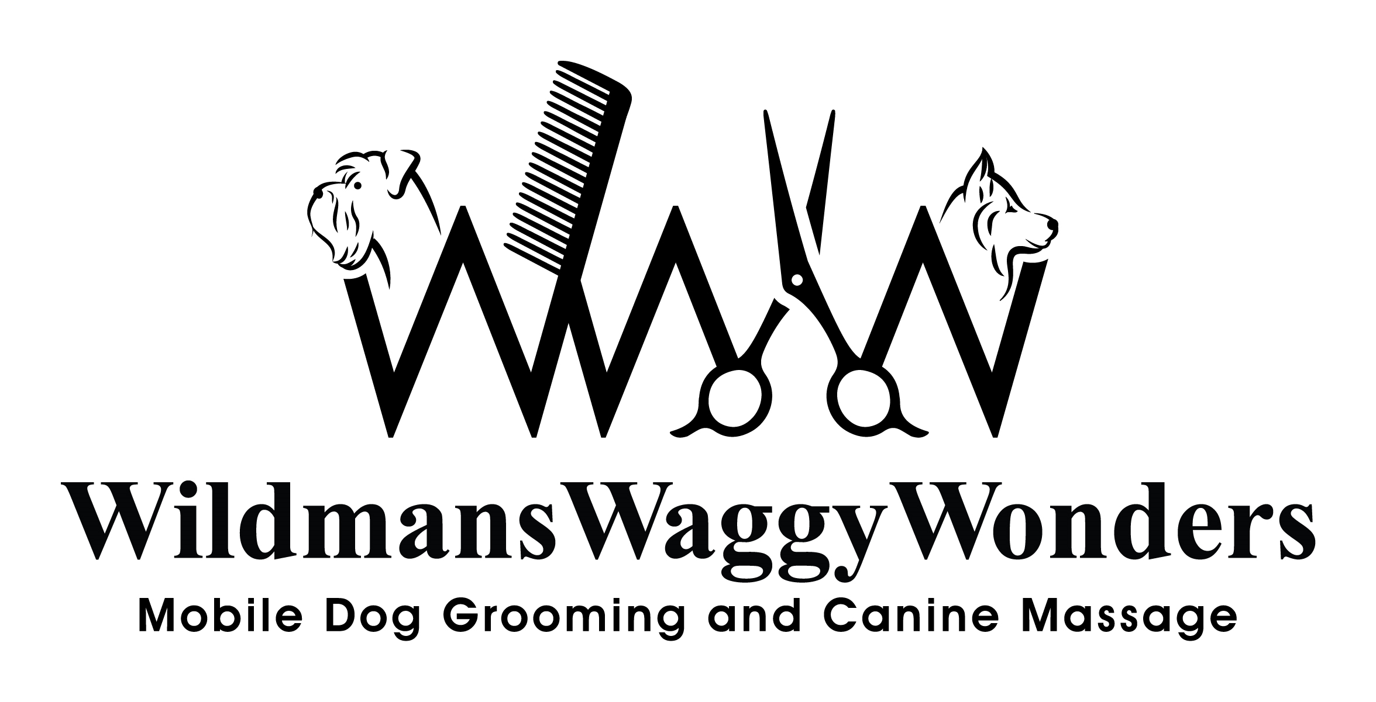

MATTED DOGS POLICY.
Are you still able to groom my matted dog?
We know that no owner deliberately lets their dog become matted, but it does happen quite easily and it can be very difficult to groom a dog with a matted coat. So we wanted to give you some information on how we deal with a matted coat and what you can expect from a groom if your dog does have a matted coat. The most important thing to understand is that we will always prioritise the welfare of your dog and that we will not inflict any excessive stress or discomfort to your dog whilst in our care.
When a dog’s coat is matted it may need to have a very short clip, this can cause irritation as the blades have to run below the matt very close to the skin which takes longer than a regular clip and means the clipper blades can get very hot so the groomer has to take regular breaks in order to let the blades cool to avoid burning your dog’s skin. It is also possible that we may uncover nicks, cuts or other potential problems which have been hidden by the matted hair. As the owner, we ask that you agree that Wildmans waggy wonders cannot be held liable for any after-grooming effects of matt clipping procedures or problems uncovered on a badly matted or neglected coat, which could include, but are not limited to, the following: itchiness, skin redness or self-inflicted irritations/abrasions from excessive rubbing. Please be aware that there is a much higher risk that the dog’s skin could be nicked with the clippers as we have to get the blade underneath the matt in order to remove it and although we will make every effort to avoid it, it does occasionally happen that we nick the skin. Wildmans Waggy Wonders cannot be held liable for any injuries or nicks that occur as a result of a clip off due to matting.
If a dog has excessively matted ears, bleeding at the tips of the ear can occur when the matting is removed, this is because the delicate blood vessels have been restricted by the tight matted hair and releasing this pressure means blood rushes to the tips of the ears and can cause the ears to split at the tip. Obviously, we will do everything we can to avoid this happening but it is sometimes unavoidable, so please be aware that there is a possibility it could happen. If it does happen we would recommend taking your dog to the vet for a check-up, explaining that the ears have been trimmed due to excessive matting.
Wildmans Waggy Wonders will always act in the best interests of your dog and we reserve the right to interrupt or abandon the groom of any dog for the safety of the groomer and the dog, as we believe that no dog should be subjected to undue stress or discomfort during a groom.
Please also take into consideration the damage that is caused to our scissors and clipper blades when we have to rescue a dog from matting. If there is matting this will also extend the grooming time. So Wildmans Waggy Wonders will charge an extra £15.00 to the grooming appointment.

We highly recommend brushing your dog very regularly if they tend to become matted often. There are so many helpful tips and hints online with tutorials to follow.

