Wildwood Childcare
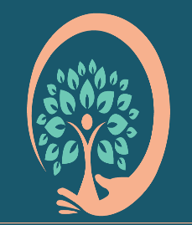

Wildwood Childcare

Live, Laugh, Love to Learn

Confidentiality
Review Date: Feb 2027

All information about children and their families is confidential and should never be discussed outside.

All the information kept on children will only be shared with the parents / carers. Occasionally it may be necessary to share records with outside agencies but parents would be consulted first

Records of progress across the Early Years Foundation Stage are usually passed to schools when the child leaves. If a parent prefers this not to happen the their wishes will be respected.

No information will be passed on to other agencies without permission form the parents / carers. Where there is an issue about child protection then the child’s welfare will be put first and the Safeguarding Policy put in place. In accordance with the ICO, is there is a significant safe-guarding risk, outside bodies within the children’s safeguarding framework may be contacted.

Parents and carers have free access to all information kept on their own child. (Except in exceptional cases where Data Protection Act 1998 stipulates it is against the best interests of the child to do so). We also have regard to the Freedom of Information Act 2000.

The organisation is registered with the ICO and works in accordance with GDPR.

