Wildwood Childcare
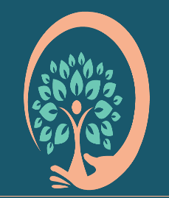

Wildwood Childcare

Live, Laugh, Love to Learn

Equal Opportunities Policy
Review date Nov 2026

I work in accordance with all relevant legislation including the Equality Act 2010. I believe in promoting equal opportunities for everyone and value diversity in children, parents, carers and visitors. I believe that all children have an entitlement to have equal access to a broad balanced, relevant and differentiated curriculum. This relevance includes, where appropriate, consulting with speech and language services as well as other NHS services as appropriate. I strive to ensure that all children can develop self-confidence and high esteem whilst recognising and valuing differences between themselves and others.

The diversity of individuals and communities is valued and respected. No child, or family is discriminated against. Everyone is respected and nurtured.

I promote Equal Opportunities by:

- Creating diverse play sessions which encompass are from differing cultures
- Attending suitable training
- Encouraging children to recognise their own unique qualities
- Work with families to ensure that individual information is gained for each child about such things as family customs and beliefs, home language, dietary requirements etc
- Monitoring the curriculum and use of resources to ensure a broad and balanced curriculum that reflects our culturally diverse society and which is suitable for both active and more passive children
- Promoting an anti-bias curriculum to actively challenge any negative feelings towards and stereotyping of others. This will be partly through meeting many people of different cultures and disabilities through play situations
- Celebrating a wide range of cultural experiences and festivals using appropriate teaching methods
- Writing notices in a variety of community languages
- All children, irrespective of ethnicity, culture or religion, home language, family background, learning difficulties or disabilities, gender or ability will have the opportunity to experience a challenging and enjoyable programme of learning and development
- Working with Dagoretti Rehabilitation Center, Nairobi, Kenya
- Supporting local children centres and local foodbanks

