* ’s book of A a

First, * wrote the sound ‘a’.

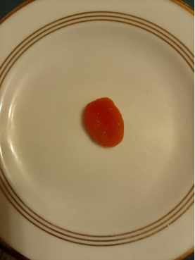
* ate some apricot.

* liked apricot the second time he tried it. Apricot is orange.
apricot
APRICOT
* stamped some yellow ‘a’ sounds:

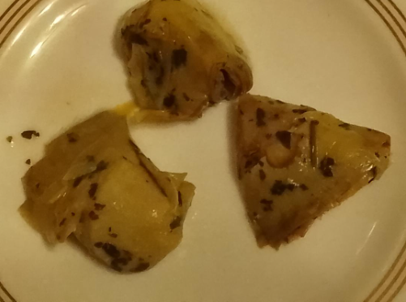
artichoke
ARTICHOKE

* likes artichokes. They are his favourite.

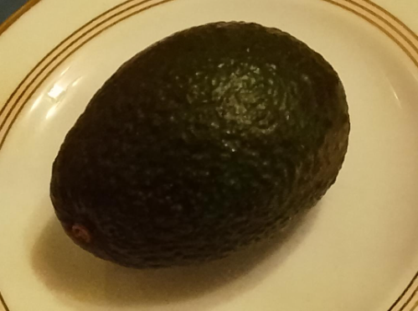
advocado
ADVOCADO.
* likes advocado. It feels slippery.

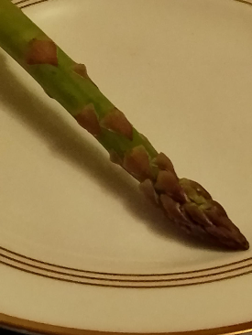
asparagus
ASPARAGUS

* made a funny sound when he tried to eat asparagus!

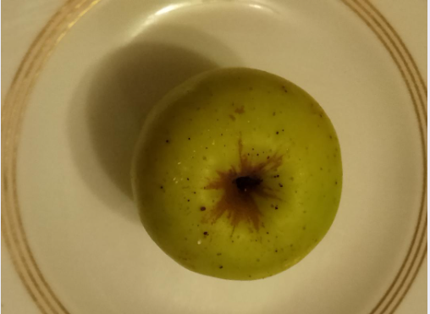
apple
APPLE

This apple came from a
tree in Stafford.
* likes apples. Oliver eats lots of apples at home.

aaaaaaaaaa

AAAAAAAA

