**Wildwood Childcare**

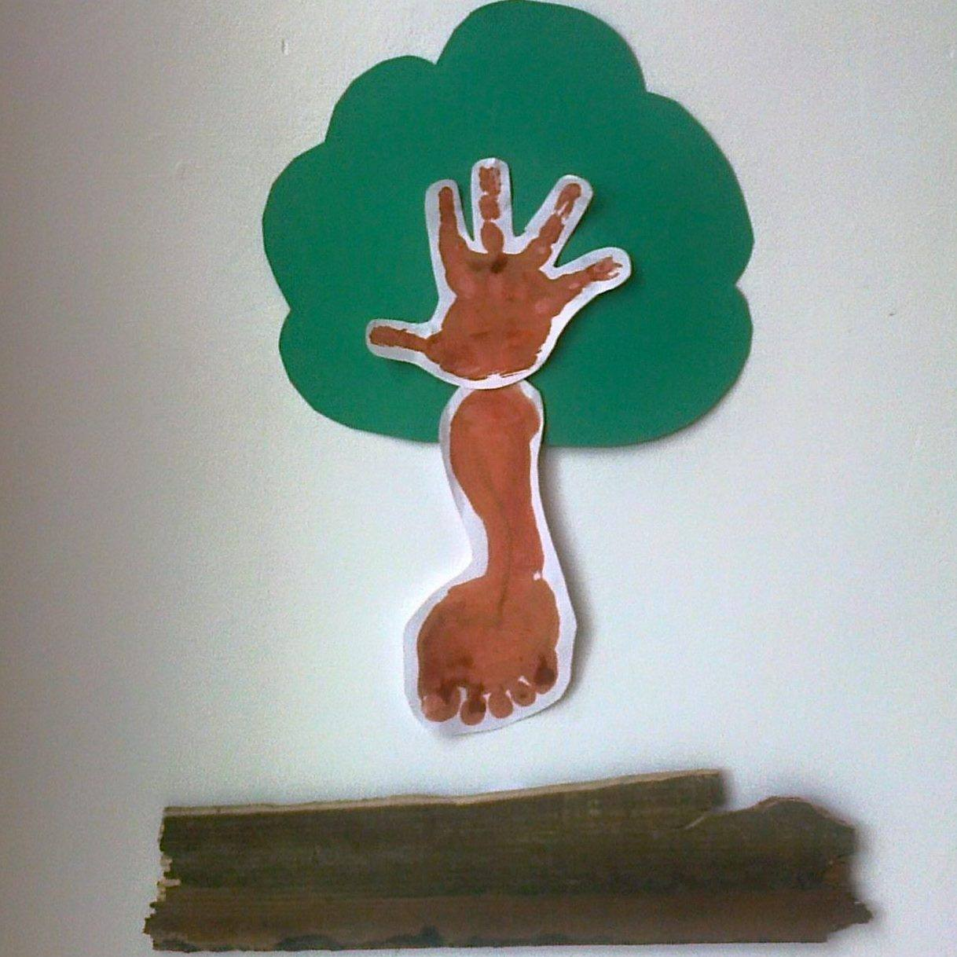

**laugh, live, love to learn**

**… naturally**

Reading scheme

**Muzzy Vocabulary Builder (in different langauages)**

Muzzy Spanish

Muzzy Chinese

Muzzy French

**Word books:**

Farms

First Words

First Words

Nursery Rhymes

Humpty Dumpty

Twinkl

**Jolly Phonics series**

Jolly stories

Jolly songs

The phonics handbook

Finger Phonics 1

Finger Phonics 2

Finger Phonics 3

Finger Phonics 4

Finger Phonics 5

Workbook 1

Workbook 2

Workbook 3

Workbook 4

Workbook 5

Workbook 6

Workbook 7

Phonics Activity book 1

Phonics Activity book 2

Phonics Activity book 3

Phonics Activity book 4

Phonics Activity book 5

Read and See: who’s in the box

Read and See: first words

Read and see: My Body

Read and see: I can

Read and see: Double Trouble

Read and see: At sea

Read and see: Eggs

Read and see: fish

Read and see: longer words

Read and see: ck words

Read and see: under the leaf

Read and see: on the road

**Usborne books:**

Usborne Phonics Readers: Big Pig

Usborne Phonics Readers: Goose on the loose

Usborne Phonics Readers: Ted’s shed

Usborne Phonics Readers: Sam Sheep can’t sleep

Usborne Phonics Readers: Frog on a log

Usborne Phonics Readers: Hen’s Pens

Usborne Phonics Readers: Toad makes a road

Usborne Phonics Readers: fox on a box

Usborne Phonics Readers: big pig on a dig

Usborne Phonics Readers: Mouse moves house

Usborne Phonics Readers: shark in the park

Fat Cat On A Mat

**Jolly Phonics Series:**

Jolly Readers: Star and Fish

Jolly Readers: Insects

Jolly Readers: Foxes

Jolly Readers: Snake

Jolly Readers: Moat Farm

Jolly Readers: Monsters

Jolly Readers: Inky

Jolly Readers: book week

Jolly Readers: A pig has piglets

Jolly Readers: The rocket

Jolly Readers: A shoal of fish

Jolly Readers: Helping

Jolly Readers: Slugs and Snails

Jolly Readers: The pong

Jolly Readers: The wind and Sun

Jolly Readers: Zack

Jolly Readers: Mud

**Biff Chip and Kipper Handbook: Helping your child to read**

Biff Chip and Kipper Level 1

Level 1 Oxford Reading Tree: Floppy Did this

Level 1 Oxford Reading Tree: Chip’s letter sounds

Level 1 Oxford Reading Tree: Up you go

Level 1 Oxford Reading Tree: Kipper’s Alphabet Eye Spy

Level 1 Oxford Reading Tree: Biff’s Wonder Words

Level 1 Oxford Reading Tree: Get On

Level 1 Oxford Reading Tree: Six in a Bed

Level 1 Oxford Reading Tree: Floppy’s Fun Phonics

Biff Chip and Kipper Level 2

Level 2 Oxford Reading Tree: Cat in a Bag

Level 2 Oxford Reading Tree: Funny Fish

Level 2 Oxford Reading Tree: The Snowman

Level 2 Oxford Reading Tree: The Fizz-buzz

Level 2 Oxford Reading Tree: I am Kipper

Level 2 Oxford Reading Tree: Dad’s birthday

Level 2 Oxford Reading Tree: Silly Races

Level 2 Oxford Reading Tree: The Red Hen

Biff, Chip & Kipper Level 3:

Level 3 Oxford Reading Tree: Super Dad

Level 3 Oxford Reading Tree: Shops

Level 3 Oxford Reading Tree: Such a fuss

Level 3 Oxford Reading Tree: The backpack

Level 3 Oxford Reading Tree: The sing song

Level 3 Oxford Reading Tree: Floppy and the bone

Level 3 Oxford Reading Tree: I can trick a Tiger

Level 3 Oxford Reading Tree: Poor Old Rabbit

Biff, Chip & kipper Level 4

Level 3 Oxford Reading Tree: The Raft Race

Level 3 Oxford Reading Tree: The Red Coat

Level 3 Oxford Reading Tree: The Moon Jet

Level 3 Oxford Reading Tree: Quick Quick!

Level 3 Oxford Reading Tree: Dragon Danger

Level 3 Oxford Reading Tree: Wet Feet

Level 3 Oxford Reading Tree: The moon Jet

Level 3 Oxford Reading Tree: The Spaceship

Level 5 Oxford Reading Tree: Egg Fried Rice

Level 5 Oxford Reading Tree: Seasick

Level 5 Oxford Reading Tree: Dolphin Rescue

Level 5 Oxford Reading Tree: Looking After Gran

Level 5 Oxford Reading Tree: Hungry Floppy

Level 5 Oxford Reading Tree: Trapped

Level 5 Oxford Reading Tree: Craig Saves the Day

Level 5 Oxford Reading Tree: Husky Adventure

Biff Chip and Kipper Level 6

Level 6 Oxford Reading Scheme: Ice city

Level 6 Oxford Reading Scheme: The lost voice

Level 6 Oxford Reading Scheme: Save Pudding Wood

Level 6 Oxford Reading Scheme: Gran’s New Blue Shoes

Level 6 Oxford Reading Scheme: Uncle Max

Level 6 Oxford Reading Scheme: Secret of the Sands

Oxford Reading Tree non fiction books

Handbook for parents

Barn Owls

Go to Bed

Men on the Moon

Bug Quiz

Fish and Ships

Looking After Dog

Eggs

Fun in the garden

A trip to the beach

How to Pond dip

Pets

Fun on the Canal

Kick it!

DR Seuss Books

The Sneetches and other stories

Fox in Socks

Oh the places you’ll go

And more ….

Jolly stories

Jolly songs

The phonics handbook