* ’s book of A a

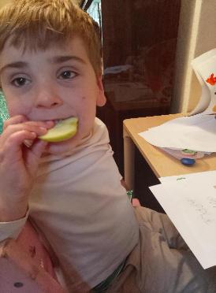

First, * wrote the sound ‘a’.

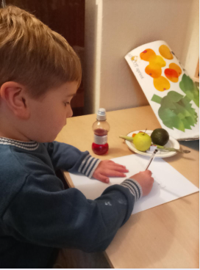

* wrote 10 ‘a’sounds and he wrote one ‘a’ sound all by himself.

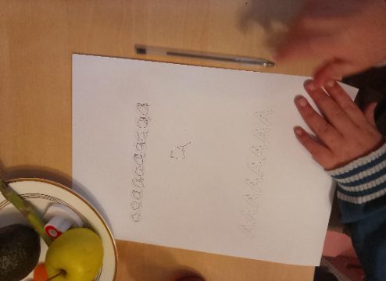

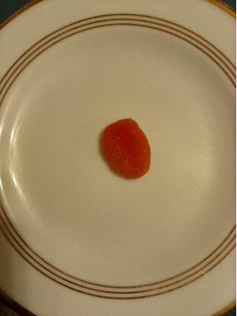

* ate some apricot.

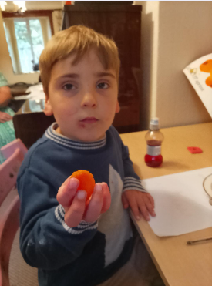

* liked apricot the second time he tried it. Apricot is orange.

**apricot**

**APRICOT**



**\* stamped some yellow ‘a’ sounds:**

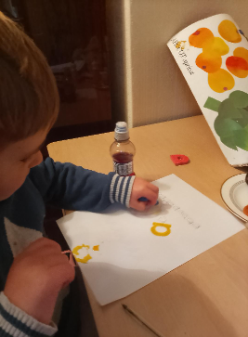

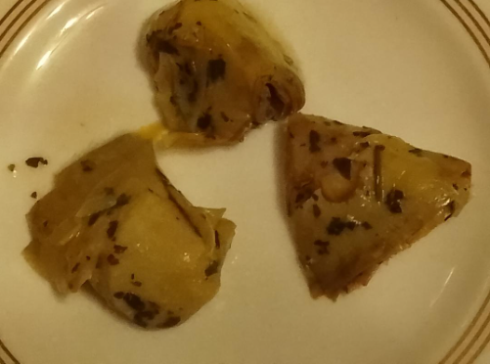

**artichoke**

**ARTICHOKE**

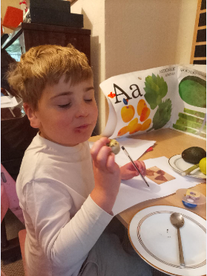

**\* likes artichokes. They are his favourite.**



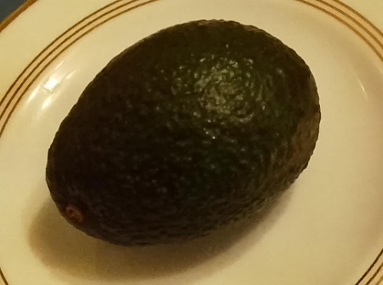

**advocado**

**ADVOCADO.**

**\* likes advocado. It feels slippery.**

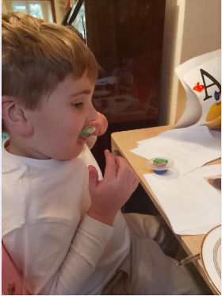

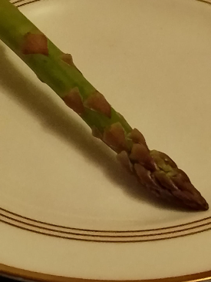

**asparagus**

**ASPARAGUS**

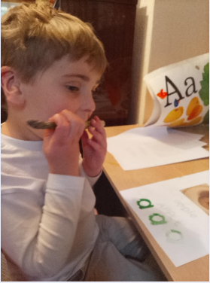

**\* made a funny sound when he tried to eat asparagus!**

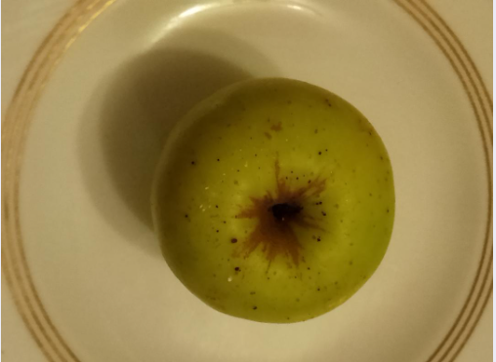

**apple**

**APPLE**



**This apple came from a**

**tree in Stafford.**

**\* likes apples. Oliver eats lots of apples at home.**

**aaaaaaaaaa**

**AAAAAAAA**