----’s book of Bb

BBBBBBBBBBBBBBBBB

bbbbbbbbbbbbbbbbbb

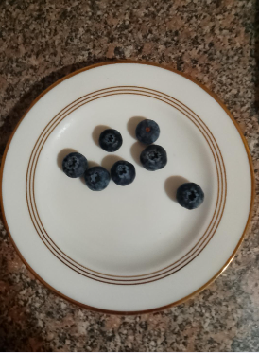

blueberry
BLUEBERRY

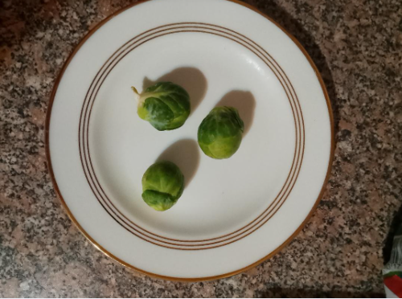
brussel sprouts
BRUSSEL SPROUTS

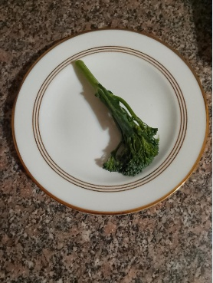

broccoli
BROCCOLI
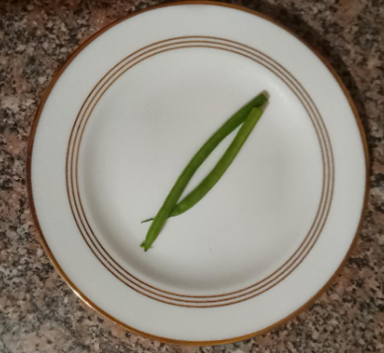
beans
BEANS

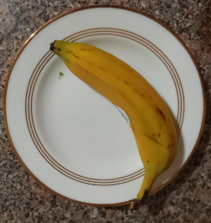
banana
BANANA

----’s book of Bb

BBBBBBBBBBBBBBBBB

bbbbbbbbbbbbbbbbbb

blueberry
BLUEBERRY

brussel sprouts
BRUSSEL SPROUTS

broccoli
BROCCOLI
beans
BEANS

banana
BANANA

