

Live, Laugh, Love to Learn

Planning Policy
Review Date Jan 2027
L Nixon
Play is planned in accordance with child development leaders such as: Reggio Emilio, Montessori, Skinner, Bruce, Piaget etc. It is in the moment and child led. Each child is encouraged to show independence and become exploratory learners.
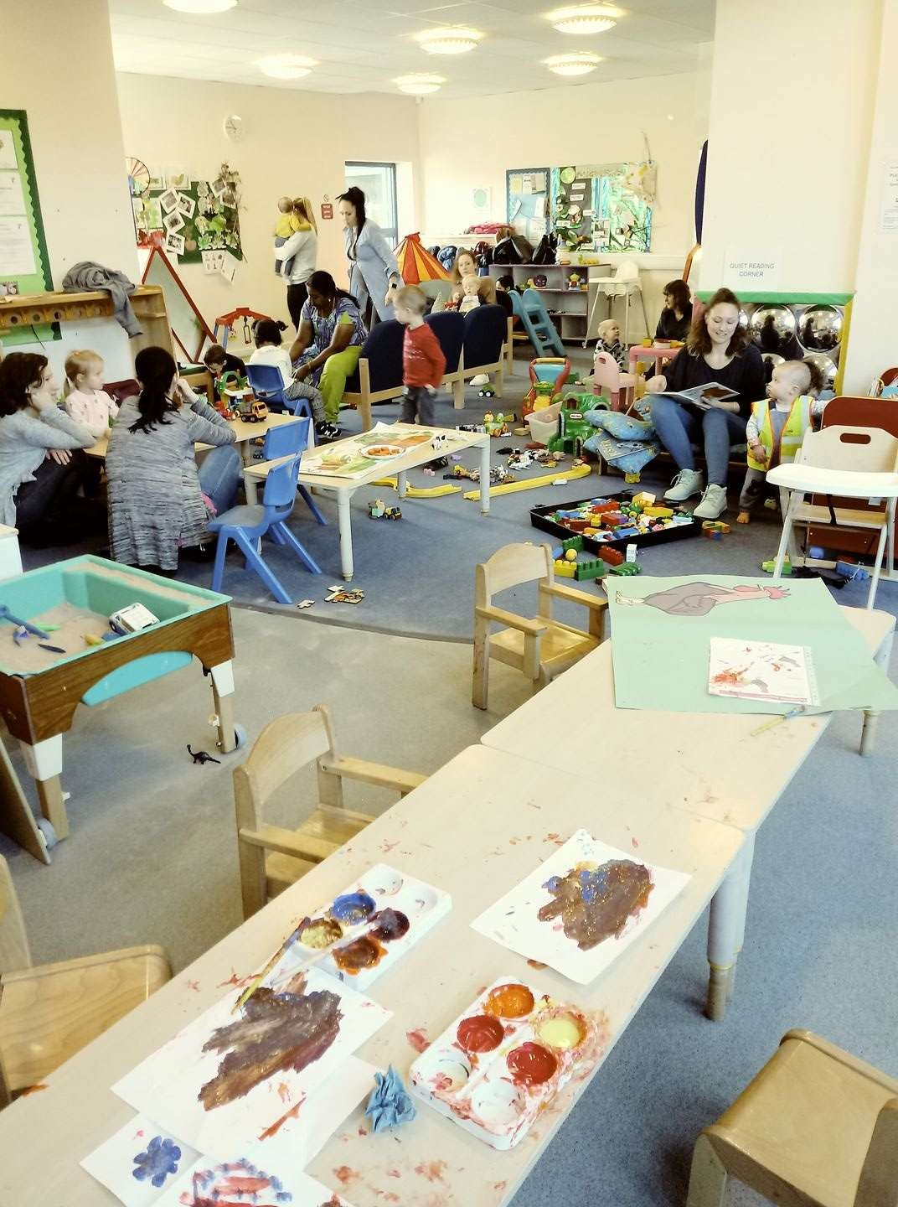

Planning for free-flow play
Here is an example of
friendship, social belonging,
esteem building,
transcendence, self-
actualization, security and
safety in action.

Through art and play, here
we experience customs and
cultures from all over the
world: China, New Zealand,
Australia, Africa, South
Africa, India, Poland,
Hungary, Bulgaria, Spain,
Italy, Croatia, Syria,
Scotland and Ireland to
name a few. The artwork in
progress was to celebrate
Chinese New Year
Wildwood Childminding Services “First Steps”

Areas of free flow play
 | Communication and Language.  (listening, understanding, attention, speaking | Physical  Development  (gross motor, fine motor, health and selfcare) | Personal, social and emotional (self confidence, self awareness,  feelings, behaviour, relationships | Literacy  (reading writing pre reading and  pre-writing skills and mark making) | Mathematics (numbers / shape / space / measure) | Understanding the World People communities, the world, technology | Expressive Arts and Design (exploring and using media and materials and being imaginative)
January  Topics:  New Year  Winter  Snowman Village  White  Dinosaur sack | Woodland Play  Allotments  Adventure Play  Music and  Singing time  Story time  Cooking time  BBC Series Muzzy – vocab builder of all  European  Languages | Woodland Play  Allotments  Adventure Play  Music and  Singing time  Story time  Cooking time | Woodland Play  Allotments  Adventure Play  Music and  Singing time  Story time  Cooking time  New Year’s Day  Burn’s night Braille  awareness | Play dough  Slime  Heuristic  Sensory  Jolly phonics | Water  Sand  Different shapes / sizes containers  etc  Counting  Daily routine | Fire service Computer  availability?  Keyboard  availability? CD player | Paints Sewing / threading Constucton  Junk modelling  Printing
February Topics:  Winter  Dinosaurs  Green and blue Technology and construction sacks | Woodland Play  Allotments  Adventure Play  Music and  Singing time  Story time  Cooking time Muzzy – vocab builder of all  European  Languages | Woodland Play  Allotments  Adventure Play  Music and  Singing time  Story time  Cooking time | Woodland Play  Allotments  Adventure Play  Music and  Singing time  Story time  Cooking time  Pancake Day Cancer, Autism and epilepsy awareness | Play dough  Slime  Heuristic  Sensory  Jolly Phonics | Water  Sand  Different shapes / sizes containers  etc  Counting  Daily routine | Police Service | Paints Sewing / threading Constucton  Junk modelling  Printing
March | Woodland Play | Woodland Play | Woodland Play | Play dough | Water | Planting | Paints

Topics:  Springtime  Growing  Yellow  Roleplay sack | Allotments  Adventure Play  Music and  Singing time  Story time  Cooking time Muzzy – vocab builder of all  European  Languages | Allotments  Adventure Play  Music and  Singing time  Story time  Cooking time | Allotments  Adventure Play  Music and  Singing time  Story time  Cooking time  Mother’s Day  St Patrick’s Day  St David’s day  Holi,  Last Supper  Palm Sunday  Wheelchair and  Down’ Syndrome | Slime  Heuristic  Sensory  Jolly Phonics | Sand  Different shapes / sizes containers etc  Counting  Daily routine |  | Sewing / threading Constucton  Junk modelling  Printing
April  Topics_  Springtime  Water  Blue  Allotment Sack Hungry  caterpillar sack | Woodland Play  Allotments  Adventure Play  Music and  Singing time  Story time  Cooking time Muzzy – vocab builder of all  European  Languages | Woodland Play  Allotments  Adventure Play  Music and  Singing time  Story time  Cooking time | Woodland Play  Allotments  Adventure Play  Music and  Singing time  Story time  Cooking time  St George’s day  April Fool’s day  Passover  Easter  Baisaki  Autism | Play dough  Slime  Heuristic  Sensory  Jolly Phonics | Water  Sand  Different shapes / sizes containers etc  Counting  Daily routine | Growing  Duck Pond  Shugborough  Amerton | Paints Sewing / threading Constucton  Junk modelling  Printing
May  Topics:  Springtime May day (may pole / Morris dancing Allotment and mini beast sacks | Woodland Play  Allotments  Adventure Play  Music and  Singing time  Story time  Cooking time Muzzy – vocab builder of all  European  Languages | Woodland Play  Allotments  Adventure Play  Music and  Singing time  Story time  Cooking time | Woodland Play  Allotments  Adventure Play  Music and  Singing time  Story time  Cooking time  Deaf | Play dough  Slime  Heuristic  Sensory  Jolly Phonics | Water  Sand  Different shapes / sizes containers  etc  Counting  Daily routine | Growing  Duck Pond  Shugborough  Amerton | Paints Sewing / threading Constucton  Junk modelling  Printing

June  Topics:  Summertime  Orange  Floating and sinking  Allotment and  Farm Sack | Woodland Play  Allotments  Adventure Play  Music and  Singing time  Story time  Cooking time Muzzy – vocab builder of all  European  Languages | Woodland Play  Allotments  Adventure Play  Music and  Singing time  Story time  Cooking time | Woodland Play  Allotments  Adventure Play  Music and  Singing time  Story time  Cooking time  Eid  Father’s Day | Play dough  Slime  Heuristic  Sensory  Jolly phonics | Water  Sand  Different shapes / sizes containers etc  Counting  Daily routine | Growing  Duck Pond  Shugborough  Amerton | Paints Sewing / threading Constucton  Junk modelling  Printing
July  Topics:  Summertime  Red  Hot  Dry sand Alotment and  holiday sack | Woodland Play  Allotments  Adventure Play  Music and  Singing time  Story time  Cooking time Muzzy – vocab builder of all  European  Languages | Woodland Play  Allotments  Adventure Play  Music and  Singing time  Story time  Cooking time | Woodland Play  Allotments  Adventure Play  Music and  Singing time  Story time  Cooking time  Samaritans | Play dough  Slime  Heuristic  Sensory  Jolly Phonics | Water  Sand  Different shapes / sizes containers etc  Counting  Daily routine | Growing Cooking | Paints Sewing / threading Constucton  Junk modelling  Printing
August  Topics:  Summertime  Hot  Pink  Sweaty  Pirate and Jungle sack | Woodland Play  Allotments  Adventure Play  Music and  Singing time  Story time  Cooking time Muzzy – vocab builder of all  European  Languages | Woodland Play  Allotments  Adventure Play  Music and  Singing time  Story time  Cooking time | Woodland Play  Allotments  Adventure Play  Music and  Singing time  Story time  Cooking time  Rakhi | Play dough  Slime  Heuristic  Sensory  Jolly Phonics | Water  Sand  Different shapes / sizes containers etc  Counting  Daily routine |  | Paints Sewing / threading Constucton  Junk modelling  Printing
September  Topics:  World Book Day | Woodland Play  Allotments  Adventure Play  Music and  Singing time | Woodland Play  Allotments  Adventure Play  Music and  Singing time | Woodland Play  Allotments  Adventure Play  Music and  Singing time | Play dough  Slime  Heuristic  Sensory  Jolly Phonics | Water  Sand  Different shapes / sizes containers etc |  | Paints Sewing / threading Constucton  Junk modelling

Fairy  Allotment and  Starting School  Sack | Story time  Cooking time Muzzy – vocab builder of all  European  Languages | Story time  Cooking time | Story time  Cooking time  Harvest  Heart |  | Counting  Daily routine |  | Printing
October  Topics:  Halloween  Harvest  Postman and toy story sack | Woodland Play  Allotments  Adventure Play  Music and  Singing time  Story time  Cooking time Muzzy – vocab builder of all  European  Languages | Woodland Play  Allotments  Adventure Play  Music and  Singing time  Story time  Cooking time | Woodland Play  Allotments  Adventure Play  Music and  Singing time  Story time  Cooking time  Halloween  Dyslexia  Cerebral Palsy  Arthritis  Sight ADHD | Play dough  Slime  Heuristic  Sensory  Jolly phonics | Water  Sand  Different shapes / sizes containers etc  Counting  Daily routine |  | Paints Sewing / threading Constucton  Junk modelling  Printing
November  Topics:  Bonfire Night  Safety  Firefighter and  policemen sack | Woodland Play  Allotments  Adventure Play  Music and  Singing time  Story time  Cooking time Muzzy – vocab builder of all  European  Languages | Woodland Play  Allotments  Adventure Play  Music and  Singing time  Story time  Cooking time | Woodland Play  Allotments  Adventure Play  Music and  Singing time  Story time  Cooking time  Bonfire Night  St Andrew’s Day  Diwali diabetes | Play dough  Slime  Heuristic  Sensory  Jolly Phonics | Water  Sand  Different shapes / sizes containers  etc  Counting  Daily routine |  | Paints Sewing / threading Constucton  Junk modelling  Printing
December  Christmas  Topics:  Winter  Chiristmas  Wacky | Woodland Play  Allotments  Adventure Play  Music and  Singing time  Story time  Cooking time  Muzzy – vocab | Woodland Play  Allotments  Adventure Play  Music and  Singing time  Story time  Cooking time | Woodland Play  Allotments  Adventure Play  Music and  Singing time  Story time  Cooking time  Hannukah  Christmas | Play dough  Slime  Heuristic  Sensory  Jolly Phonics | Water  Sand  Different shapes / sizes containers  etc  Counting  Daily routine |  | Going to work or school

Wildwood Childminding Service“First Steps” Daily Routine
Time | Babies | Todler
9.15 – 10 | Free flow play  Literacy / mathematical focus | Free flow play  Literacy / mathematical focus
10 – 10.30 | snack | snack
10.30 – 11 | sleep | storytime
11.15 – 11.45 | Creative focus | Creative focus
11.45 – 12.15 | lunchtime | lunchtime
12.15 – 12.45 | sleeptime | Outdoor play
12.45 – 1.15 | sleeptime | Outdoor play
1.15 – 1.45 | sleeptime | Outdoor play
1.45 – 2.15 | Outdoor play | Outdoor play
2.15 – 2.45 | Messy play | Messy play
2.45 – 3.15 | Picnic time | Picnic time
3.15 – 3.45 | PSHE focus | Pshe focus
3.45 - 4 | Preparing for home Daily diary | Preparing for home Daily diary

Trips Risk Assessment
And Operating Procedure
Allotments
Minimum Qualification of leader | PGCE
Miaximum group size | Minimum ratio 3:1
Risk assessment | Control Measures
Hazards | Stranger danger training
Water | The children will not play anywhere near the canal at the bottom of wooded / play area. It does have a deep surrounding of nettles and braken making it unavailable but this will be checked regularly. Discuss Water Safety
Roads | Discuss Road Safety  Use the road free route to the park. (You can access the park using only footpaths and an Underground tunnel
Carpark | Avoided by using underground access to the park

Trips Risk Assessment
 | snack, water and nappies
Date of review | Monthly review (1st of each month)
And Operating Procedure
Adventure Play
Minimum Qualification of leader | PGCE
Miaximum group size | ratio 3:1
Risk assessment | Control Measures
Hazards | Stranger danger training
Water | The children will not play anywhere near the canal at the bottom of wooded / play area. It does have a deep surrounding of nettles and braken making it unavailable but this will be checked regularly. Discuss Water Safety
Roads | Discuss Road Safety  Use the road free route to the park. (You can access the park using only footpaths and an Underground tunnel
Carpark | Avoided by using underground access to the park
Trips Risk Assessment
 | snack, water and nappies
Date of review | Monthly review (1st of each month)
And Operating ProcedureActvity:
Wooded play
Minimum Qualification of leader | PGCE
Miaximum group size | ratio 3:1
Risk assessment | Control Measures
Hazards | Stranger danger and dog awareness
Water | The children will not play anywhere near the canal at the bottom of wooded / play area. It does have a deep surrounding of nettles and braken making it unavailable but this will be checked regularly. Discuss Water Safety
Roads | Discuss Road Safety  Use the road free route to the park. (You can access the park using only footpaths and an Underground tunnel
Carpark | Avoided by using underground access to the park
Trips Risk Assessment
 | snack, water and nappies
Date of review | Monthly review (1st of each month)
And Operating ProcedureActvity:
Ball tarmac area
Minimum Qualification of leader | PGCE
Miaximum group size | Minimum ratio 3:1
Risk assessment | Control Measures
Hazards
Water | The children will not play anywhere near the canal at the bottom of wooded / play area. It does have a deep surrounding of nettles and braken making it unavailable but this will be checked regularly. Discuss Water Safety
Roads | Discuss Road Safety  Use the road free route to the park. (You can access the park using only footpaths and an Underground tunnel
Carpark | Avoided by using underground access to the park
 | snack, water and nappies
Date of review | Monthly review (1st of each month)
Trips Risk Assessment And Operating Procedure Actvity:
Duck Pond
Minimum Qualification of leader | PGCE
Miaximum group size | ratio 3:1
Risk assessment | Control Measures
Stranger Danger | Check individuals childminding reg
Water | Discuss Water Safety  Do not go near the edge of the pond  Mud can be slippy. Do not go near if muddy. Let the ducks go onto tarmac area
Roads | Discuss Road Safety  Use the road free route to the park. (You can access the park using only footpaths and an Underground tunnel
Carpark | Avoided by using underground access to the park
 | snack, water and nappies
Date of review | Monthly review (1st of each month)
Trips Risk Assessment And Operating ProcedureActvity:
Shugborough
Minimum Qualification of leader | PGCE
Miaximum group size | Minimum ratio 3:1
Risk assessment | Control Measures
Hazards
Roads | Discuss Road Safety when exiting vehicle. Wear safety tabard.  Hold hands. Be aware of cars and green cross code. (Stop, look, listen, think “is it safe?)
Animals | Wash hands thoroughly after touching animals. Some animals it may not be safe to touch? Discuss this with children. They might bite?
Emergency procedure | Safety equipment taken in the form of fluorescent tabard with the name of the group and 07494364316 written on. Mobile phone,

 | coded contact book and medication book taken on trips including snack, water and nappies
Date of review | Monthly review (1st of each month)

Trips Risk Assessment
And Operating ProcedureActvity:
Wacky | Check CRB status of staff with manager
Minimum Qualification of leader | PGCE
Miaximum group size | ratio 3:1
Risk assessment | Control Measures
Hazards
Stranger Danger | Wacky opens up to childminders. Check registrations. Be aware.
Roads | Discuss Road Safety. Wear safety tabard. Hold hands. Be aware of cars and green cross code. (Stop, look, listen, think “is it safe?)
Animals | Wash hands after touching animals
Emergency procedure | Safety equipment taken in the form of fluorescent tabard with the name of the group and 07494364316 written on. Mobile phone,
 | coded contact book and medication book taken on trips including snack, water and nappies
Date of review | Monthly review (1st of each month)

Trips Risk Assessment
And Operating ProcedureActvity:
Silkmore childminder centre
Minimum Qualification of leader | PGCE
Miaximum group size | Minimum ratio 3:1
Risk assessment | Control Measures
Hazards
Roads | Discuss Road Safety. Wear safety tabard. Hold hands. Be aware of cars and green cross code. (Stop, look, listen, think “is it safe?)
Emergency procedure | Safety equipment taken in the form of fluorescent tabard with the name of the group and 07494364316 written on. Mobile phone, coded contact book and medication book taken on trips including  snack, water and nappies
Date of review | Monthly review (1st of each month)

Permission slip

The parent of …………………………………………………………………………………………
Gives permission for Louise Nixon to go on the following educational play visits:

The allotments and areas of wildwood park
Wildwood duck pond
Catch corner wacky
Shugborough Park

I also give permission for photographs to be taken for assessment purposes.
This may / may not be used for social advertising and media
Details of insurance policy documents and risk assessment details have been provided

Signed ………………………………………………………….Date ………………………………………………………….
Personal Log

Name of child
Date of birth | Age
Address | Parental contact details
 | Do both parents have parental responsibility?
Medical Information | Any disabilities (use additional booklet if required)
Food preferences

Likes | Dislikes
Home routine | Comforter
Any additional Information?

Early Learning Goal Observation Date

Communication and Language
Listening and Attention Understanding

Early Learning Goal Observation
Physical Development

Moving and Handling Health and Self Care
Gross motor Fine motor

 | Insert photograph
What this demonstrates

What this demonstrates |  |  |  | Next Steps
Speaking

Date

Moving and Handling Health and Self Care
Gross motor Fine motor
 |  | Insert Photograph
[Type a quote from the document o the summary of an interesting point.  You can position the text box anywhere in the document. Use the Drawing  Tools tab to change the formatting of  the pull quote text box.] | r | Insert Photograph
 | r | Insert Photograph | [ | Type a quote from the document or the summary of an interesting point. You  can position the text box anywhere in the document. Use the Drawing Tools tab to change the formatting of the pull  quote text box.]
Including hygiene, dressing toilet

Early Learning Goal Date
Mathematics
Number Shape, Space and Measure
 | Insert photograph
What the photograph demonstrates |  |  |  | Next Steps

Understanding the world

People and Communities The World Technology
Past and present Animal and plant observation Select and Use Similarities and differences Environment
 | Photographs
What the picture shows

What the picture shows |  |  | Next Steps

Expressive Arts and Design Date

Singing Music Making Dance Materials Tools and Techniques

Colour Design Texture Form and Function Role Play
Photograph and next steps

Imagination Story Making

Observations
Child’s Name: |  |  |  |  | Date:
Social Context:

Observation Notes:

C&L | PSED | PD | L | M | UtW | EA&D
Characteristics of Effective Teaching and Learning
Playing and Exploring |  | Active Learning |  | Creating and Thinking Critically

Useful Numbers

First Response 0800 1313126 firstr@staffordshire.gov.uk
Ofsted 0300 123 1231
Early Years Support 07891 479005 or 07800626531
Stafford Police 101
Pacey 08458800044
Morton and Michelle 0845 2570900

Assessments
Daily diary
Learning Journey
Profile
Observations
Feedback from primary carer via Wow cards and discussion and parents meeting

