Louise Nixon: 2015 9796 January 2022

Introduction
This practise-based enquiry into discovering; does the use and creation of verb books enhance speech and language development in outdoor play in children aged 2 and under, is important, significant, feasible and will make an original contribution to the early years field because in 2019, a global lockdown occurred due to world-wide reports of a global Co-Vid 19 pandemic (Bhaskaran et al, 2021). This meant that early years practise needed to change because the pandemic has and will affect children’s development. Many of our cultural norms have changed overnight. This is important in terms of speech and language development because it is generally understood that children learn, through play, by engaging with their environment. Children aged 2 and under will find it difficult to learn to create words because there is now an increase in face mask use, increase in screen time usage and social distancing measures that have been introduced world-wide which have changed our environment and societal norms.

This study initially occurred because the researcher, a former special educational needs (SEN) teacher who later became an SEN parent, noticed a gap between the Early Years Foundation Stage (EYFS) and National Curriculum (NC) guidance from the 2000 frameworks and speech and language interventions over the course of 22 years of practise. (DfES 2001), (DfES 2007), (DfES 2017), (DfEE2020), (DfEE 2021a, b, c and d) and (DfE 2022). Her (my) comments were noted and publicly, placed on display. (Speech and Language Therapy noticeboard, 2012). SEN curriculum guidance was disputed by Nixon (2012) who stated: “speech, language and communication skills are the most important skills for our children to learn … It’s their key to life.” What she meant was, regardless of the age of the child, if a child cannot communicate, then that must be addressed first (or at least alongside) other curriculum considerations in line with speech therapy guidance. (She was observing a special needs school teach an upper KS1 / KS2 curriculum to children who were unable to communicate and felt that the government guidance needed a significant shift because it did not reflect the useful strategies the speech therapist was recommending). What is paramount, is that a curriculum should be relevant to the recipient. The personal professional significance for the researcher within the study is to restore the researcher’s sense of peace and well-being, since she noted an alarming contrast between the aims, understanding and objectives of SEND parents compared to SEND professionals within a practise. This highlighted the organisations development needs which made the working environment difficult. It is possible that this study is a necessary response to the need to improve speech and language development overall, as illustrated in data analysis (Green, 2018:7). This problem has now been compounded because of Co-Vid 19.

Literature Review

A contrast to the approach of using verb books to assist children with speech and language delay was cited in, Gamlin (1954:29) who categorised SEND children as:
“1 supernormal
2 normal but backward
3 dull
4a) mentally defective – feeble minded
4b) mentally defective – imbecile
4c) mentally defective – idiot
4d) mentally defective – moral defective”
This language alone is a complete contrast to the terminology within Bertram et al (2015) who celebrates the diversity of life, in all its forms, within his ethical document. Further, Gamlin (1954:291) provided photographs of SEND people, expressing how each category (1-4d) may be identified within physical characteristics of an individual. This is a useful starting point because it could be argued that our culture has come a long way since 1954, in changing society’s perceptions of SEND children.

However, much work still needs to be done to continue critical and reflective identification of personal, professional, and organisational needs via evidence-based practise to ensure this progression continues. A reflection of the terminology listed above demonstrates the importance of evidence-based practise, especially since it is likely that more children may now experience a speech delay. Jeffrey’s (2021:3-6) statement is not peer reviewed (which may invalidate the news report) but it does report that “There is growing evidence that the past year of lockdowns have had an impact on young children's language skills, according to research data from 50,000 pupils and a survey of schools across England which have shown an increased number of four- and five-year-olds needing help with language….
Jeffrey’s (2021:15-21) states:
- “76% said pupils starting school in September 2020 need more support with communication than in previous years
- 96% were concerned about pupils' speech-and-language development.”
Whilst the terminology used in 1954 could be considered as mentally abusive and damaging (a safeguarding issue) the terminology was acceptable only sixty-eight years ago. It is important that we develop working methodologies and approaches that empower and enable rather than abuse or reject. If successful, the strategy of using verb books during outdoor play could be considered a safeguarding mechanism, as it enables children with limited communication skills, an avenue to explore, to help them to communicate. This emphasises the relationship between theory and practise in changing attitudes within work-place practise, supporting the continuous development of organisations.

Why Focus on Speech and Language, in a practise-based enquiry into discovering; does the use and creation of verb books enhance speech and language development in outdoor play in children aged 2 and under?

One reason why this post lockdown study is linked to speech and communication development; is highlighted by the Staffordshire County Council Early Years District Profile (2017:2) This is the locality where the childminder will be carrying out the research. For many years, speech and language has remained a priority in Staffordshire. These targets remain, since our culture now has an increase in face mask use, social distancing measures in place and an increase in screen time usage generally, within our society, which makes leaning to speak more difficult. Play dates and visits to grandparents have also reduced. This means that speech and language development should be a priority as early years providers tackle the growing challenge between Co-Vid safety measures, early years theory (especially in terms of attachment theories) and practise.

There is a large volume of published, peer reviewed, studies describing the role of verbs in the development of children aged 2 who are developing normally. Previous research findings into this area have sometimes been inconsistent and contradictory such as Olguin (1993), Yuan (2012), Tardif (1997), Kroka (2018) and Waxman (2013). When considering “why focus on verbs?” different theories exist within the literature regarding the use of nouns and verbs in the development of early language and the academic literature on language development in two-year olds (above). This has revealed the emergence of several contrasting themes:
Waxman et al (2013:156) states: “early noun advantage is not a universal feature of human language, but a consequence of the particular language being acquired.” In this study, Waxman demonstrates that sometimes nouns are predominantly important and sometimes verbs are predominantly important. This is valid within the context of this study because one of the children speaks only English at the childminder setting and a mix of Mandarin and Catalan at home (at the mother’s request .) The mother’s choice was completely respected, considering Bertam (2015) and Committee on Human Rights (2010).

At the beginning of the study, two of the children had already been extensively exposed to English nouns during multi-sensory play activities and the use of ‘off the shelf’ first word books and the children demonstrated non-verbal understanding of everyday nouns. In contrast, this study represents the difference that acquiring verb phrases makes to the acquisition of verbal language skills. Waxman (2013) believes English to be an example of a language where nouns take the main importance. However, Tardif et al (1997:536) contradicts this stating “that many children learning languages use more verbs than nouns in their early spontaneous speech." Therefore, during data analysis, attention will be given to how many verbs and nouns are used by a 2-year-old child. Since one of the children is growing up in a multi-lingual setting, it will be interesting to note which of these claims are true within this context. Although this is important in theory, in practise, safeguarding remains the primary focus and so the ideology between theory and practise may need modification within the context of world-wide pandemic. Kroka (2018:2996) states: “English-speaking children typically pass through a developmental stage in which they inconsistently produce tense / agreement morphemes….. They may appropriately use a morpheme in one utterance (e.g. Mommy is sleeping) and then omit the same morpheme in the very next utterance (e.g. The dog running).” It is hoped that by using the verb books and being verbal within both the outdoor activity and during the creation of the verb books, this inconsistent stage of tense agreement may be resolved more quickly, with the effect of improving a child’s speech and language development overall.

Further inconsistencies and confusion lay within Bercow (2018:5) which states the “removal of speaking and listening from the National Curriculum and the removal of a judgement of communication from the Ofsted framework.” took place. If this is true, it will make it harder to evidence the needs for support for children more generally as less data will be available. Certainly, communication and language is listed in DfE (2021b:8, and 2020:3) and in the Current Inspection Framework DfEE (2021d) which states: “If children are not developing a good standard of spoken English, inspectors will consider the impact on their progress and whether this might lead to a judgement that the overall quality of the provision is inadequate.” Ofsted (2021:22,16-18). However, there is still a contrast between the statements in these documents and specific interventions provided by experienced speech and language therapists. Therefore, it is possible that this research project remains relevant because it listens to the voices of experienced speech therapists and looks at the data that is available whilst recognising where there are gaps in data, acknowledging the reasons why (the disruption due to Covid). In further contrast to Bercow’s (2018) statement, there is a communication and language judgement within the EYFS outcomes and evidence is available up to 2022 from the Early Years Foundation Stage Profile showing that speech development is important.

In practise, although speech is important, understanding often becomes apparent via non-verbal communication or symbolic communication before words are uttered. For example, a cry or a child poking or pulling on an adult’s arm. This can also occur when a child points at a picture in a book and the adult knows to respond by naming the picture. Notably, Kirkorian (2018:210) asks the question: “can the child understand the symbolic relation between on-screen images of objects and the real objects they represent, even when the objects look different?” Kirkorian (2018) showed that this is difficult during the first years of life because toddlers are less likely to generalize information across different contexts (e.g. from video to real objects) than within the same context (e.g. using only real objects). This theory within the literature review will be acknowledged within the study by acknowledging if the child can link the photographic verb books to reality within spoken words and if that understanding is more apparent when the activity has just happened or when the activity happened in the past and therefore is a memory?

Aussems and Kita (2021:124) state: “verbs are an important part of speech. Recognizing a verb is often a key step in understanding the meaning of a sentence.” As such, verbs play a vital role in children’s acquisition of vocabulary and grammar. Further, children’s early vocabulary skills and vocabulary size are major predictors of later school success. (Morgan et al 2015) and (Rowe et al 2012). It is crucial to investigate how children learn verbs and this study considers how gesture influences the process of speech, language and communication attainment in preschool-aged children by creating a running commentary during outdoor play which is photographed and later observed as a photographic book with captions.

Locally, the importance of improving speech, language and communication attainment have been highlighted in reports such as: City of Stoke on Trent. (2017:2-3). Figure 1. The City of Stoke on Trent is an area of severe disadvantage. (Figures 1 and 2). Notably, the figures in the graphs were before the pandemic. Now, social distancing or face mask use is likely to have exacerbated the problem of low speech and language attainment. Up to date figures are not currently available due to the disruption of the pandemic. Therefore, to assist children working towards school readiness the area of speech and language development is significant and relevant which makes this study worthwhile.

To conclude the literature review, Hindman et al (2016:134) states: “Children’s outcomes—and the nation’s well-being—could be improved by additional research into the mechanisms of vocabulary learning, as well as translational research that produces effective, feasible early-education practices in homes and schools.” This study sits within that ideological paradigm and the researcher completely agrees with this statement (which may suggest bias within the study).
However, the research topic “Does the use and creation of verb books enhance speech and language development in outdoor play?” remains important because without communication, life is extremely limited, perhaps even unbearable and so, within this study, the pedagogy of outdoor play is changing as a result of the in-direct effect of Co-Vid 19 because there is decreased social interaction between children, decreased outdoor play (during the lock-down period, remembering that the study began during a world-wide lockdown where we were only allowed outside for one hour each day) and a reduced communication and language usage generally. This theme is central to this research, combining theory and practise to support continuous professional development despite the challenges which we are now faced with.

Research Rationale, Design and Methodology:

Rationale:
Creating artwork for 50 photographic verb books with the children (Appendix A figure 5), with the overall aim of improving each child’s speech and language progress, is a strength within the study because it enables the children to communicate what is interesting to them whilst enabling the children to have an opportunity to consent to the study in the limited way they can. It is topical, because of the impact Co-VID 19 has had on our population’s changing norms, especially within services. The verb book, a new concept in response to the literature review, will be a book containing child-led photographic images and child-led artwork of the children during their outdoor play activity. This means that the children have a non-verbal vehicle; the opportunity to take photographs of what fascinates them and draw pictures of their day. Shortly after the activity, the children will create the books alongside the researcher (within a free-flow play ideology). As they do all of this, the researcher will provide a running commentary which will include gestures. This means, that as the child participates in the creation of the verb book, the verbs are reinforced as a secondary activity as well as a primary activity with the aim of improving understanding overall.

Ethics were of paramount importance during the Research Design
Parental consent was provided before the study took place. Care was taken to enable the children and their parents to do the study within the context of free-flow play and to keep the researcher’s influence on the study to a minimum, to empower the children to use democratic values despite their young age (i.e. they could either choose to do the activity or not to do the activity). Pseudonyms were used to conceal the identity of the children. It is important that young children feel empowered to express their truth and not feel intimidated or restricted. Ethical consent and ethical approval was provided before the start of the study in line with Bertram et al (2015) and the Committee of Human Rights (2010).

Methodology / Framework: which justifies, guides and evaluates the method:
Thought was taken to gather and analyse workplace evidence using suitable and well-justified data collection methods to discuss implications for future practice. The quantitative research methods produce results that create statistical, mathematical or computational results. This research methodology feels most comfortable with the researcher who has a scientific background. However, there is now a lean towards qualitative research methods because it provides richer, fuller information by being more descriptive and much thought was given into how to validate qualitative data

The researcher, was aware of the branch of philosophy that deals with questions concerning the nature, scope and sources of knowledge and power such as: Appleton and King (2002), Bertram et al (2015), Braun and Clarke (2021), Britten et al (1995), Carter and Little (2007), Coyne (1997), Larkin et al (2006), Malterud et al (2016), Meyrick(2006), Rowan (1998), Smith (1996), Syrett et al (2014), Williams et al (2019) and Yardley (2000) . The researcher was also aware of the position of power the childminder has within a small sample of very young children and the importance of carefully balancing that ethically. The philosophy within the initial thought is the nature, scope and sources of knowledge accumulated by using the methodologies chosen, may well bring about multiple truths. It is possible that those truths may become contradictory and complex in nature as children are not scientific instruments but unique. This thought takes account of ethics within the Bertram (2015) and UN committee on Human Rights (2010) facing the challenges set within those documents “head on”. As one of the children’s primary carer’s it would be possible for the researcher to influence the study with a hypothesis that speech and language strategies, provided by a speech therapist (focusing on verbs rather than nouns) would improve the children’s speech and communication ability. The multiple truth is revealed by listening to different voices – early years practitioners, speech therapists, parents and children. It is interesting to reflect on what the form and nature of reality is within the minds of children who are new to the world, unable to speak and who have experienced the world during a Co-Vid lockdown. What can be known about it? It is by looking at the world through the child’s eyes that the most effective practise occurs, sometimes that might mean mirroring the child to truly understand their perspective. When looking at the world through multiple perspectives, multiple truths arise.

The method of enabling the children to create artwork and photographs is used as a variety of methods to help to establish reality through the eyes of a child aged 2, in an ethically sound way (Boylan 2021) and (Murkerji and Albon 2018). From philosophy to methodology, multiple truths occur within studies and when creating design, methods and methodologies. (Appleton and King 2002), (Carter and Little 2007), (Meyrick 2006), (Murkerji and Albon 2018). (Pope and Mays 1995), (Sainsbury and Craig 2007), (Shakibazadeh 2019), (Tong et al 2007) and (Yoshikawa et al 2008). When designing the methodology; the researcher used the flow-charts figures 3 and 4 (Carter and Little 2007) when undertaking the decision-making process in selecting a research paradigm for the research study. A thorough understanding of the characteristics of each research paradigm was considered. A research paradigm was defined as: a philosophy, methodology, epistemology, and ontology that provides complete guidelines to conduct research (as illustrated in figure 3 and 4). This research paradigm gives direction and path to conduct the research. (Appleton and King 2002), (Larkin et al 2006) and (Malterud et al 2016).

Methodology: To establish the multiple truths involved within this study, the study design was a triangulation of predominantly qualitative methods. (Britten, 1995 a and b), (Hirokazu et al, 2008), (Mays and Pope, 1995), (Meyrick, 2006), (Morse, 2015), (Murkherji and Albon 2018), (Tong, 2007), (Williams et al, 2020a and b), (Yardley, 2000a, b and c) In order to provide rigour and validation to the results, health research material as well as early years research material was chosen to inform that decision, since speech therapy sits within health as well as education and the purpose of the study was to look at speech through the eyes of a health practitioner (a speech therapist) this reinforces the existence of multiple truths.

Setting, Participants and Selection
(discussed as part of the research design / framework)

The study has occurred because the researcher, a former SEN teacher, noticed a gap between the EYFS and NC guidance from the 2000 frameworks onwards and speech and language interventions. The idea for the study was provided by an experienced speech and language therapist, providing speech and language training for schools and childcare providers. This creates the possibility of bias within the study. 3 children aged 2 were involved in the study which was carried out in a childminding setting: Stafford (UK). The study occurred within the context of a Co-Vid 19 pandemic. Participants were initially selected who were part of the researcher’s cohort. More potential recruits were contacted through nurseries and social media. Contacts reported that the study was too much work to be repeated.

Methods:

The triangulation of methods were:
1 A Questionnaire
This was available both before and after the study. The questionnaire was used for both qualitative and quantitative data creation (Booth et al 2019) and (Britten et al 1995). Various methods of data collection were used within the study. Quantitative data was collected by creating a questionnaire that could be answered, by the parents, in the form of a scale (1-5). (Booth et al 2019), (Fabiane et al 2017), (Hirokazu et al 2008) and (Kalil et al 2008). In the context of a pandemic, it was difficult to get responses from the parents. Interim data was encouraged (as a modification) via an un-structured, door-step interview (Britten 1995a and b), (Carter and Little 2007), (Williams et al 2019), (Dowdell et al 2011), (Mays and Pope 1995), (Methley et al 2014) and Morse (2015).
using the prompting devices, for example:
silence, echoing what the person has said or hooking using sounds like “uh-huh and
tell me more” and the utterances were recorded within the childminder’s ethnography. Care was taken to avoid being over-empathetic, manipulative, leading as well as avoiding leading questions. It would have improved the study if an observer was present within the interview to mitigate against bias.

2. The Creation of Verb books:
By combining observation, discussion with the child’s family (in the form of a questionnaire and un-structured interview) and the use of cameras on walking tours of outdoor play (Murkherji and Albon, 2018: 329) the children were encouraged to document the people, places and events that had meaning / interest for them. The adult’s role allowed the children to decide where to go and what to document. The resulting photographs became a stimulus for the children to create artwork, used within the verb books, enabling the participation of young children who have not yet acquired the language skills to communicate their experiences and encourage their verbal responses. This method provided a medium by which the child could express their opinions to their parents / care givers.
These methods, described as a Mosaic approach, “encompasses a range of different tools that piece together to form a fuller picture of young people’s perceptions, [helping to enable] the views of all participants [to be] included [or heard].” (Mukherji and Albon 2018: 329:15-19) and (Clarke and Moss 2011).

This is seen as an important issue within a democratic process. The childminder took photographs with the intention of creating photographic images that created a verb book which the children shared with their parents, with the hope that this improved the child’s motivation and ability to communicate with meaning. The children were also given the opportunity to draw their activity and to record it as part of the verb book, (which included written commentary). By using this method along with free-flow play, drawings and artwork, it was hoped that this could be the most understandable way for the child to grasp that he or she has an option of engaging with the study (or choosing not to). Nothing was forced. The children were intrinsically motivated.

3 Ethnography:

The creation of an ethnography created thick description in the form of a journal. The journal recorded methodological decisions, rationale, process reflections, thoughts on the information arising in the data collection, records of thinking throughout the analysis, details of values and interests and how they were implicated in the decision making, enabling multiple truths to exist. (Ortlipp 2008).

Observing and recording 2-year old children within the context of their culture, society, social relation’s and natural setting, allows multiple truths to exist. The children involved in the study came from a mix of different cultures and genders and immersion in their natural home settings as well as their childminder setting. This aided the philosophy of each child’s unique truth to be discovered. This data was supplemented within an unstructured interview, within the style of a questionnaire, involving inductive analysis (and thick description).

The method of enabling the children to create artwork and photographs is used as a variety of methods to help to establish this reality through the eyes of a child aged 2, in an ethically sound way. (Murkerji and Albon 2018). The children were engaged in a running commentary during trips and were allowed to use the camera to take photographs of what was interesting to them. After the activity, the children were encouraged to draw what had happened on the trip. This reinforced the concept that we, culturally, make marks to create and reinforce meanings and the marks help us to understand our environment and was a research method which allowed the children to contribute to the verb books independently.

The Investigation / Study:
The children in the study were 3, two-year old children who attended a childminder setting, part-time. All 3 had minimal speech ability and were all chosen because they attended the childminder setting. The researcher attempted to recruit more childminders to repeat the study to enable the study to become statistically significant. However, of the 301 childminders that were contacted, only 7 responded and 0 childminders repeated the study. A nursery and school were also contacted but did not wish to participate. One childminder was found who agreed to do the study but withdrew because the extent of the work involved within the intervention.

The parent of one child insisted that the child would only use English at the childminder setting and a mixture of Romanian and Catalan at home. The sample was of two girls and one boy who lived within the locality of Stafford.
The children who participated in the study were taken on outdoor visits to different places within the childminders locality to explore the world around them. The parent later commented that the language the child chose to communicate in was English (at home as well as the childminder setting although the child only attended the setting 3 days a week).

Clear attempts were made to create artwork that understandably illustrated what was happening. For example, strawberries created by triangle and circle (pseudonyms) which clearly showed strawberries, despite their extremely young age (figure 10). The researcher believes that this demonstrates deep understanding despite the very young age of the children who participated in the study. The photographs and drawings were then used to create a “verb book” with captions. The children, keen to make their voices heard, could contribute to the captions in full spoken sentences.
The greatest example of this was circle who had barely said a single word previously, suddenly made comments such as:

“I am jumping in puddles,
There are two ducks,
Triangle throwing stones into the water,
Triangle looking at the sheep,
Circle sitting on the tractor.
There is triangle and circle.”
The phrases were not completely clear but clear enough to be fully heard and understood.

A pre and post questionnaire was carried out to provide a baseline and to establish how much progress had been made. This provided both qualitative and quantitative data. Since the cohort of children within the study created a small group of varying abilities, cultures and genders it is probable that saturation did not occur within that qualitative data (Braun and Clarke 2021), (Coyne 1997), (Emmel 2015), (Williams a and b 2020) and (Methley 2014). However, rich, valuable data was generated. In terms of the quantitative data, (Fabiane et al 2017) and (Hirokazu et al 2008).

Method Modification:
During the study, methods were modified because of Co-Vid 19. The data analysis method could be improved by recording the utterances the children made onto a video recording. However, within the context of a Co-Vid 19, this was too difficult and priority was given to Co-Vid safety. To further validate the result, a parental diary and ethnography was encouraged. To obtain richer information, the participants were each empowered and encouraged to provide qualitative methods that the non-verbal children were able to use as well as the parents, to enable the study to be built on ethically sound principles. Albon and Murkerji (2018) and Boylan (2021). This worked well to a point, but the parents were all front-line keyworkers who were mostly unable to give much of a response. A door-step un-structured interview was used to create more data. (Green and Britten 1998), (Dowdell et al 2011) and (Pope 2005).

The children were encouraged to access the study through free-flow outdoor play, access to art materials and access to a camera so that they could take photographs of what interested them. This enabled children to opt out of the study if they chose to. The opinion’s of the families of the children were consulted in the form of an ethnography. The study commenced following ethical approval and signed parental consent.

Data Analysis:
Coding and Categorising: was the most prevalent forms of data analysis. (Mays and Pope 1995). Appendix (C,D,Fand G) and (figures 11-12) show this in action. The data was scrutinized to identify themes. The themes were colour coded to look for overlaps and possible interpretations. The quantitative data from the questionnaire was tabulated and the results used to create bar charts and pie graphs (figures 11 and 12) which showed overall, that the study was successful.

Are the results valid?
There are contrasting thoughts on the validity of data. The initial quantitative results may not valid because of the small sample size and the potential of bias within the researcher. However, the qualitative data may be valid because of the richness of the data provided (Coyne 1997).
The qualitative data may be valid within the childminder’s cohort in accordance with Braun and Clarke (2021). The researcher believes that data saturation may occur at 6-10 participants because the initial cohort is diverse.

How the research was explained to participants:
Each participant was provided with a copy of the studies ethics certificate, permission slips and letter of application, participants permission of access letter, participant information letter. Participants were invited to look at the literature review and methodology before commencing the study. A pre and post-research questionnaire was provided.

Discussion and Interpretation of the Results:
Did the use of verb books improve speech and language development in outdoor play?

Evidence 1: Did creating and using the Verb Books enhance the children’s ability to speak?

Interpretation:

The results:
An example of a small verb book is shown in figure 6.
50 books (listed in Figure 5) were created altogether with around 75 photographs in each book. Artwork was included in addition to this. This means files are too big to pass through moodle. However, The Verb books and drawings can be seen at: www.wildwoodtuitionandchildcare.co.uk
code: 1975.

Figure 7. demonstrates that the progress made by all children as reported by both the childminder and parents reached 100%

The occurrence of phrases used when creating verb books such as:
· “Can I have some of that?
· I am on the swings.
· It is raining.
· What is that?
· Where is a tunnel?
· That’s at Trentham Gardens.
· Where is ….?”
appears to indicate that Krok and Leonard’s (2018) statement : “English-speaking children typically pass through a developmental stage in which they inconsistently produce tense/agreement morphemes…..” to be void in this instance. It is possible that by using the verb books and being verbal within both the outdoor activity and during the creation of the verb books demonstrated that the inconsistent stage of tense agreement may have been resolved more quickly.

Overall, the results appear to indicate that parental involvement is crucial to a child’s speech and language development and that the intervention provided by speech and language therapists but carried out by the researcher (to focus on verbs to improve speech and communication) was critical to that improvement. This was two-fold. Firstly, the creation of the photographic verb books encouraged and enabled very young children to share their day with their most significant adult (their parent). Secondly, the focus on verbs (rather than the traditional noun focus) had an immediate positive impact. This is clearly shown in the quantitative and qualitative data results. Parents communicated that the verb books improved the parent’s confidence to engage in spoken dialogue with their child. Further, the results appear to be sustained. Six months after the intervention, a parent reported that in her child’s next setting (a cohort of 8), only 2 children were speaking and they were six months older than her child. Those 2 children spoke one language whereas her child was multi-lingual.

On one occasion, I asked child square to draw square (using the pastels) running the orienteering Gruffalo trail at Birches Valley. Square had completed the 3 mile orienteering activity in 25 minutes. Afterwards square continued this energy burst for 90 minutes on the adventure playground. As the researcher observed square create the picture, the researcher really was astonished by what happened. When asked to: draw square running the Gruffalo trail, square expressed the same level of exertion and body language drawing, as square had, whilst running back and forth (figure 13). (Clearly communicating, accurately, what she had experienced). Square had literally drawn the explosion of energy with which square had run around the orienteering course. The researcher later demonstrated how to draw a representation of child square: with head, legs, body and arms to contain that energy in the form of a body with trees, grass etc in the background (figure 14) which square copied and said – “you taught me how to do that!” The child had been non-verbal previously both within the childminder setting and at home. The creation of the verb books had given the child the medium through which to be confident to verbalise her thoughts. This contradicts Bernard (2009) who believed that a child’s knowledge builds up slowly, beginning with speech imitation of particular words or phrases before understanding how to generalize in the way adults speak.

The children were keen to share their finished verb books, drawings and photographs with their parent. Parents expressed pleasure at being able to share their child’s day and could clearly see the level of engagement and planning involved in the activities.

The verbal responses from the children encouraged verbal communication overall and successfully improved the child's ability and enthusiasm for attempting to communicate via speech. Mostly, the parents fed this response back on the doorstep by expressing their pleasure at looking at the books with their child but more examples were shown within statements in the journal.

After coding, the statements were placed on a framework using categories:
positive comments, negative comments, neutral comments, transferable skills and cultural comments (appendix C,D and F).

In response to Kirkorian (2018:10) the children seemed to understand the symbolic relation between on-screen images and actual objects.
Conclusion 1:
The evidence from the creation and use of the verb books indicates that the creation and use of verb books help progress the children’s ability to speak.

Evidence 2: Ethnographic / Autoethnographic journal statements:
Did the journal statements from the parents and childminder suggest that creating and using the Verb Books enhanced the children’s ability to speak figures (8-9) and (16-19).
Ziebland et al (2013:20 25-28) “states a strength of ethnography is that it reduces the likelihood that important medical or policy decisions will be based on stereotypic oversimplifications and/or insufficient information”. In this instance the researcher would agree with this statement. At this point, it is worth noting that all parents whose children were in the study were front-line keyworkers during a CO-VID 19 pandemic. Understandably, they were reluctant to fill out journal statements although each mother contributed to a final statement. Much of the statements occurred during a door-step chat where the parent expressed delight at seeing the photographs of the child’s day. It was unclear how often the parent had had the time to sit with the child and look at the book with the child. During the doorstep, CO-VID19 safe, unstructured interviews – the participant’s parent had the opportunity to control the direction and content of the interview although the interviewer informed the participant that the researcher was interested to find out:

Accounts or stories of their experiences
What is most important to respondents
Their own perspectives and priorities using their own words
How and Why questions.

Conclusion 2:
The Ethnographic / Autoethnographic journal statements (Appendix F)
from the parents and childminder appeared to suggest that creating and using the Verb Books enhanced the children’s ability to speak and creating a running commentary during outdoor play which is photographed and later observed as a photographic book with captions assisted with this process.

Evidence 3: Quantitative data - Questionnaire Results:
Did the quantitative data from the questionnaire suggest that creating and using the verb books enhanced the children’s ability to speak?

The data compiled produced graphs and charts with calculations of percentages, mean, median and modal values where appropriate (figures 8 and 9). This was not always appropriate due to the small sample size.

The pie graph in figure 9. illustrates that all of the adults involved in the study of: the use of verb books to improve speech and language development in outdoor play, answering the overall question: does the use and creation of verb books enhance speech and language development in outdoor play? All stated a resounding “yes!”. It was very clear that following the study each of the children were able to speak in full sentences. What was interesting, was that at the start of the intervention, none of the children were speaking at home or at the childminder setting. After the intervention, all of the children were speaking in full sentences both at home and at the childminder setting. However, despite a clear result, there was a reluctance to assume that it was the intervention alone that had made this significant contribution. If the sample size had been bigger, it would have been possible to have had a control group. This would have indicated whether or not the change in speech was solely due to the intervention. Sadly, it was not possible to have a control group and this is a limitation of the overall result.

Conclusion 3: the quantitative data did appear to give the overall trend that the creation and use of verb books improved the children’s ability to speak. However, despite being provided with the questionnaire at the beginning of the study all 3 sets of parents appeared to have waited and answered both pre and post study sets of questions at the end and the researcher suspects this may have led to the overall results being less dramatic.

Evidence 4: Qualitative data – Questionnaire Results :
The coded transcripts of parental involvement can be seen at figure 8 and 9. The comments were mainly green (positive) and demonstrated that the books reflected both progression with transferable skills within a cultural context. None of the participants responded to the invitation to write extensively, qualitatively, on the questionnaire. Following the questionnaire, everyone did write that they believed that the intervention had had a positive impact on their child’s ability to speak.

Conclusion 4:
How does the Researcher know this is true?
The evidence from the qualitative data indicates that the creation and use of verb books help progress the children’s ability to speak. This is illustrated in figures (12) and appendix (F).

Overall Conclusion:

A study of the use of verb books to improve speech and language development in outdoor play, due to the hypothesis: verbs enhance speech development has been proven in 2/3 cases. The overall conclusion backed up with the literature review suggests that the use of verb books, in this context, had a positive impact in the child’s speech and language development. In contrast to Kirkorian (2018:10) on-screen images did not impair children’s understanding in this study and this was evidenced by the verbal communication that took place within the creation of the verb books and at home, with parents.

This most successfully occurred within the context of the girls' speech and language development. The boy in the study showed an ability to understand verbs and nouns and could create sentences such as “I splashed in the puddle” when prompted but not always consistently in spontaneous speech. (The study was interrupted by a holiday where the boy came back less communicative than he went). However, if non-spontaneous speech production is given the same authority as spontaneous speech production then it could be considered that the study was successful in 3/3 cases. Despite this small sample size, the result showed that the speech of the children had improved which in-line with the recommendations of the speech therapists who had been consulted before the study took place.

The overall conclusion drawn from the study is that it is important that EYFS practitioners listen to the voices of speech therapists and find ways to incorporate speech therapy practise within their settings to further enhance speech and language development in children aged 2.

The intervention, surprisingly, produced the results:
that the children in this sample, began the study as non-verbal speakers and finished as full sentence speakers after an intervention of the creation and use of 50 verb books.
(In practise, the study enabled the adult to look through and hopefully understand, the eyes of a child, whose words may be limited and helped parents gain confidence in communicating with their child).

In regards to the literature review:
- Staffordshire County Council Early Years District Profile (2017:2), the researcher believes that the intervention of using verb books would assist with the targets set within this document.
- Gamlin (1954:29), the researcher believes that terminology used within that framework to be unethical and by interventions can enable individual’s to communicate and make positive contributions to society.
- Olguin (1993), Yuan (2012), Tardif (1997), Kroka (2018) and Waxman (2013) show contradictory statements regarding the use of nouns and verbs within the development of language skills. This study showed that a positive contribution was made by focusing on verbs during outdoor play.
- Bercow (2018), DFE. (2017) DfES (2001), DfES (2007), DfEE. (2017), DfEE. (2020), DfEE (2021b) , DfEE (2021c) and DfEE (2021d) demonstrate the need to listen carefully to the voices of speech therapists who would contribute to those documents in a more meaningful way (as illustrated within this document)
- the toddlers in this sample contrasted with Kirkorian (2018) since the children appeared to understand and discuss the photographic images of themselves on a screen.
Implications for further practise:

Statutory Education Frameworks and Guidelines should champion the voices of speech and language therapists, allowing voices of multiple truths to be heard. However, the parent whose child was able to speak 3 languages in full sentences believed that her child was gifted and talented rather than the intervention was outstandingly successful, reinforcing the existence of multiple truths – children are not scientific instruments and a collection of different strategies would always advisable. We each have our own, unique, multiple truth.

Reference List:

Appleton, J.V., and King, L. (2002) Journeying from the philosophical contemplation of constructivism to the methodological pragmatics of health services research. Journal of Advanced Nursing, 40(6) pp. 641-648.
Aussems, S. and Kita, S. (2021) Seeing Iconic Gesture Promotes First- and Second-Order Verb Generalization in Pre-schoolers Child Development. Child Development, 92, pp.124-141.
Bannard, C., Lieven, E., Tomasello, M. and MCClelland, J. (2009) Modelling Children's Early Grammatical Knowledge. Source: Proceedings of the National Academy of Sciences of the United States of America. 106(41) pp. 17284-17289. Behrand, D. A. (1990) The Development of Verb Concepts: Children’s Use of Verbs to Label Familiar and Novel Events. Child Development, 92, pp. 681-696.
Bercow, J. (2018) Ten Years On: An independent Review of Provision for Children and Young People with Speech, Language and Communication needs in England. Royal College of Speech and Language Therapists. London: UK.
Bertram, T., Formoshino, J., Gray,C., Pascal, C. and Whalley, M. (2015) Ethical Code for Early Childhood Researchers REVISED VERSION EECERA. European Early Childhood Education Research. 24.
Bhaskaran, K., Rentsch, C.T,. MacKenna, B,. S.A,. Mehrkar, A,. Bates, C.J., Eggo, R.M., Morton, C.E,. Sebastian., C. Bacon. J., Inglesby,P. et al. (2021) HIV infection and COVID-19 death: a population-based cohort analysis of UK primary care data and linked death registrations within the OpenSAFELY platform. Lancett, 8, e24-e32.
Booth, A., Noyes, J,. Flemming, J,. Moore, G., Tuncalp, O. and Shakiazdeh, E. (2019). Formulating questions to explore complex interventions within qualitative evidence synthesis. BMJ Glob Health 4, pp.1-7.
Boylan, A-M (2021) O21C200B9Y Qualitative Research Methods. Nuffield Department of Primary Care Health Sciences Medical Sciences Division, Oxford University. Available through: httos://canvas.ox.ac.uk/courses/114794[accessed from 2 November 2021 onwards].
Braun, V. and Clarke, V. (2021) To saturate or not to saturate? Questioning data saturation as a useful concept for thematic analysis and sample-size rationales. Qualitative Research in Sport, Exercise and Health. 13(2) pp. 201-216.
Britten, N. (1995a) Qualitative interviews in medical research. BMJ: British Medical. 311(6999), pp. 251-253.
Britten, N., Jones, R., Murphy, E. and Stacy R. (1995b) Qualitative research methods in general practice and primary care. Family Practice.12(1), pp. 104-114.
Carter S.M. and Little, M. (2007) Justifying Knowledge, Justifying Method, Taking Action: Epistemologies, Methodologies, and Methods in Qualitative Research. Qualitative Health Research. 17(10), pp. 1316-1328.
City of Stoke on Trent. (2017) Speech and Language Data. Staffordshire County Council.
Clark, A. and Moss, P. (2011) Listening to young children : the mosaic approach. Second edition. London: NCB.
Committee on Human Rights (2010) The United Nations Convention on the
Rights of the Child: How legislation underpins implementation in England: Work in progress
Coyne, I.T. (1997) Sampling in qualitative research. Purposeful and theoretical sampling; merging or clear boundaries? Journal of Advanced Nursing. 26(3) pp. 623-630.
DFE. (2017) Statutory Framework for the EYFS: Setting the Standards for learning, development and care for children from birth to five published 3rd March 2017 effective until August 2020. London, UK.
DfE (2022) Early years foundation stage profile 2022 handbook, London, UK.
DfES (2001) The National Literacy Strategy; A Framework for Teaching. 3rd Edition Publisher Prentice Hall. pp.18-55 Crown Copyright.
DfES (2007) Letter and Sounds: Principles of High Quality Phonics. Pp.1-
DfEE. (2020) Development Matters – non-statutory guidance for the EYFS. Crown copyright.
DfEE. (2021a) Actions for Early Years and Childcare Providers during the Coronavirus (Co-Vid 19) Outbreak. Crown Copyright.
DfEE (2021b) Statutory Framework for the EYFS setting the standards for learning development and care for children aged 0-5. Published 31 March 2021 Effective from September 2021. Crown Copyright.
DfEE (2021c) Part of Education, Universities and childcare during Corona-virus. Early Years Inspection Handbook for Ofsted Registered Provision. Updated April 2021. Crown Copyright.
DfEE (2021d) Education Inspection Framework. Updated April 2021. Crown Copyright.
Dowdell, K., Gray, T. and Malone, K. (2011) Nature and its Influence on Children’s Outdoor Play. Australian Journal of Outdoor Education, 15, pp. 24-35.
Emmel, N. (2015) Themes, variables, and the limits to calculating sample size in qualitative research: a response to Fugard and Potts. International Journal of Social Research Methodology. 18(6) pp. 685-686
Fabiane F. R., Morgado., Juliana F. F., Meireles, Clara M., Neves., Ana C. S., Amaral, and Maria E. C. Ferreira (2017) Scale development: ten main limitations and recommendations to improve future research practices. Psicologia: Reflexão e Crítica. 30(3) pp.1-20.
Gamlin, R. (1954) Modern School Hygiene. London, Aberdeen University Press.
Green, V. (2018) Annual Childcare Sufficiency Summary. Staffordshire County Council: Early Education Team.
Green, V. (2017) Early Years District Profile: South Staffordshire. Staffordshire County Council: Early Education Team.
Green J. and Britten N. (1998) Qualitative research and evidence based medicine. BMJ. 316(7139) pp. 1230-1232.
Hindman, A. H., Wasik, B.A.A. and Snell, E.K. (2016) Closing the 30 Million Word Gap: Next Steps in Designing Research to Inform Practice. Child Development Perspectives, 10, pp.134-139.
Hirokazu, A., Kalil, A., Thomas, S.W. and Way, N. (2008) Mixing Qualitative and Quantitative Research in Developmental Psychology. 44(2) pp. 344-354.
Jeffreys. B. (2021) Lockdowns hurt child speech and language skills. Available at:
https://www.bbc.co.uk/news/education-56889035[accessed 27 4 2.
Kalil, A., Way, N., Weisner, TS. and Yoshikawa, H. (2008). Mixing Qualitative and Quantitative Research in Developmental Science: Uses and Methodological Choices. Developmental Psychology 44, pp. 344-354.
Kirkorian, H. L. (2018) When and How Do Interactive Digital Media Help Children Connect What They See On and Off the Screen? Child Development Perspective. 12, pp. 210-214.
Kroka, W.A.L. L. (2018) Verb Variability and Morphosyntactic Priming With Typically Developing
2- and 3-Year-Olds. Journal of Speech, Language, and Hearing Research, 61, pp. 2996-3009.
Kroka and Leonard (2018) Verb Variability and Morphosyntactic Priming with Typically Developing 2 and 3 year olds. Journal of Speech, Language and Hearing Research. 61(12), pp.2996-3009.
Larkin, M., Watts, S. and Clifton, E (2006) Giving voice and making sense in interpretative phenomenological analysis. Qualitative Research in Psychology. 3(2) pp. 102-120
Malterud, K., Siersma, V. D. and Guassora, A. D. (2016) Sample Size in Qualitative Interview Studies: Guided by Information Power. Qualitative Health Research, 26 pp.1753-1760.
Mani, N. A. (2018) Why Do Children Learn the Words They Do? Child Development Perspectives, 12, pp. 253-257.
Mays, N. and Pope, C. (1995) Rigour And Qualitative Research. BMJ: British Medical Journal, 311(6997), pp. 109-112.
Methley, A.M., Campbell, S., Chew-Graham, C., McNally, R., and Cheraghi-Sohi,
PICO, PICOS and SPIDER: a comparison study of specificity and sensitivity in three search tools for qualitative systematic reviews. BMC Health Services Research.14(1).
Meyrick, J. (2006). What is Good Qualitative Research? A First Step towards a Comprehensive Approach to Judging Rigour/Quality. Journal of Health
Psychology. 11, 799-808.
Morgan, P.L., Hillemeier, M.M. and Maczuga, S. (2015) 24-Month-Old Children With Larger Oral Vocabularies Display Greater Academic and Behavioural Functioning at Kindergarten Entry. Child Development 86(5), Number 5, pp. 1351–1370.
Morse, J.M. (2015) Critical Analysis of Strategies for Determining Rigor in Qualitative Inquiry.25(9) pp. 1212-1222.
Qualitative Health Research. 25(9) pp. 1212-1222.
Murkeerji, P.A. and Albon. D (2018) Research Methods in Early Childhood: An Introductory Guide. 3rd edn. Sage.
Nixon, L. (2012) Conversation with Speech Therapist’s during a clinic visit with her daughter Jessica-Louise who has Beckwith Wiedermann Syndrome. (Personal Communication September 2012).
Ofsted. (2021) Guidance: Education inspection framework. Crown Copyright.
Olguin, R., Michael. and Tomassell. (1993). Twenty-five-month-old children do not have a grammatical category of verb. Cognitive Development, 8, pp. 245-272.
Ortlipp, M. (2008) Keeping and Using Reflective Journals in the QRP. Qualitative Report 13(4) pp. 695-705.
Pope, C. & Mays, N. (1995). Qualitative Research: Reaching the parts other methods cannot reach: an introduction to qualitative methods in health and health services research. BMJ, 311, 42-45.
Pillow, P. A. (1985) Intellectual Realism: The Role of Children's Interpretations of Pictures and Perceptual Verbs. Research in Child Development., 56, pp. 664-670.
Pope (2005) Conducting ethnography in medical settings. Medical Education. 39(12) pp. 1180-1187
Raquel (1993) Twenty-five month old children do not have a grammatical category of verb. Cognitive Development. 8:3 pp. 245-272.
Rinaldi, C. (2006) In Dialogue with Reggio Emilia: Listening, Researching and Learning. Oxon: Routledge.
.
Roseberry, S., at al 2009. “Can Young Children Learn Verbs From Video?” Child Development, 80, pp. 1360-1375.
Roseberry, S., Hirch-Pasek, K. and Roberta, M. 2014. “Skype Me! Socially Contingent Interactions Help Toddlers Learn Language”. Child Development, 85, pp. 956-997.
Rowan, J. (1998). Maslow Amended. The Journal of Humanistic Psychology, 38.
Rowe, M., Stephen W., Raudenbush,L. and Goldin-Meadow, S. (2012) The Pace of Vocabulary Growth Helps Predict Later Vocabulary Skill. Child Development 83(2) pp. 508-525
Shakibazadeh, E. (2019). Formulating questions to explore complex interventions within qualitative evidence synthesis. BMJ Glob Health, 4, pp.1-7.
Smith, J.A. (1996). Beyond the divide between cognition and discourse: Using interpretative phenomenological analysis in health psychology. Psychology & Health. 11(2) pp. 261-271.
Speech and Language Therapy Board (2012) Display Board at Rising Brook Health Centre, Stafford, September 2012.
Staffordshire County Council, (2017a) Early Communication Screening Impact Report: Summer As part of School Readiness for 2017. Stoke-On-Trent.
Staffordshire County Council, (2017b) Early Years District Profile. Stoke-On-Trent.
Syrett, K., Arunachalam, S and Waxman, S. (2014) Slowly but Surely: Adverbs Support Verb Learning in 2-Year Olds. Language Learning and Development, 10:3
Tardif, T., Shatz, M. and Naigles, L. (1997) Caregiver speech and children's use of nouns versus verbs: A comparison of English, Italian, and Mandarin. Journal of Child Language, 24, pp. 535-565.
The Speech and Language Garden (2021) Speech Therapy Intervention. (Personal Communication. 3rd December and 15th January).
Tong, A., Sainsbury, P. and Craig, J. (2007). Consolidated criteria for reporting qualitative research (COREQ): a 32-item checklist for interviews and focus groups. International Journal for Quality in Health Care, 19, pp. 349-357.
Waxman, S., Xiolan, F., Arunachalam, S., Leddon, E., Geraghty, K. and Song, H. (2013) Are Nouns Learned Before Verbs? Infants Provide Insight into a Long-Standing Debate. Child Development Perspectives, pp.1-5.
Williams, V. Boylan A-M, and Nunan, D. (2019) Qualitative research as evidence: expanding the paradigm for evidence-based healthcare. BMJ Evidence-Based Medicine 24(5) pp.168-169
Williams, S., Armitage, C.J,. Tampe, T. and Dienes, K. (2020a) Public perceptions and experiences of social distancing and social isolation during the COVID-19 pandemic: a UK based focus group study. BMJ Open
Williams, V., Boylan A-M., and Nunan D. (2020b) Critical appraisal of qualitative research: necessity, partialities and the issue of bias. BMJ 25(1), pp. 9-11.
Yardley, L. (2000). Dilemmas in qualitative health research. Psychology & Health, 15, pp. 215-228.
Yoshikawa, H., Thomas S., Weisner, T. and Kalil, A. (2008) Mixing Qualitative and Quantitative Research in Developmental Science: Uses and Methodological Choices. Developmental Psychology, 44, pp. 344-354.
Yuan, S., Fisher, C. and Snedeker, J. (2012) Counting the Nouns: Simple Structural Cues to Verb Meaning. Child Development, 83, pp. 1382-1399.
Ziebland,S., Coulter,A., Calabrese, JD., and Locock, L (2013) Understanding and Using Health Experiences: Improving Patient Care. Oxford University Press.
Footnote:
I have endeavoured to use BCU Harvard referencing system. In using the system, I have noted there are gaps within the guidance and have attempted to use a “best-fit” approach. There was an alarming contrast between BCU Harvard Referencing and Oxford University Referencing where, during the course of this study, it was discovered that Oxford University allows their students to choose their referencing system and merely asks for “consistency”. I believe this empowers decision making and leadership skills. Although I have tried to only write down the journal articles, that are directly referred to in the study, there are still a couple of articles that have influenced my thinking while I have worked with the children and so, I felt I had to include them within the reference list. Altogether 138 journal articles were collected and read during the course of this study. Upon reflection, what the researcher likes about BCU Harvard Referencing system over Oxford University Referencing system is that it reminds us that we are all, always learning – the more you know, the more there is to know. That guards us all against being too “empowered”.

List of Figures and Appendices:

Figure 1. City of Stoke on Trent Speech and Language data
(Pre-pandemic)
This is local area of deprivation.
Figure 2. Bercow (2018) Graph to show National speech and language needs in areas of disadvantage
Figure 3. The Relationship between Epistemology, Methodology and Method
Source: (Carter and Little 2007)
Figure 4. The contributions of Method, Methodology and Epistemology to Qualitative Research
Source: (Carter and Little 2007).

Figure 5. sample of verb books with up to 75 photographs alone, in each book.
Appendix A. Smaller style verb book example. There were 50 books with up to 75 photographs in each book with supplementary artwork taken home to show parents.
Appendix B. Ethical consent in align with Bertram (2019) and Committee of Human Rights
(2010).
Appendix C Coding: Red – negative comments, orange neutral comments, green positive comments

Appendix D Coding: blue, transferable skills brown, a result contradicting the literature review, purple, cultural comments.
Appendix E. Questionaire sample
Figure 6. Bar graphs created from quantitative questionnaire results
Figure 7. Pye chart to report the progress made by all children as reported by both the childminder and parents
Figure 8. Child square’s artwork showing the orienteering trip at Birches Valley’s
Figure 9. The researcher’s interpretation of square’s explosion of energy

Figure 10. strawberry paintings following a day trip strawberry picking
Appendix F. Beth Morrant’s permission
Figure 11. Qualitative data visualisation Chart
Figure 12. Qualitative data coding
Visualisation demonstrating frequency of each category

Appendix G. Qualitative data

Figures:

Figure 1. City of Stoke on Trent Speech and Language data
(Pre-pandemic)
This is local area of deprivation.
(Staffordshire County Council 2017 a)
:
Bercow 2018 Graph to show National Speech and Language needs in areas of disadvantage.
Orange – 50% of children start school with delayed speech and language or other identified speech, language and communication need.
Blue – 50% of children do not start school with delayed speech and language or other identified speech, language and communication need.

Figure 2. Bercow (2018) Graph to show National speech and language needs in areas of disadvantage
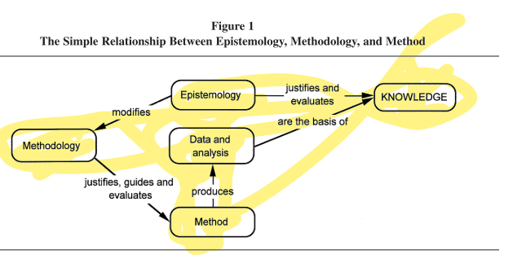
Figure 3. The Relationship between Epistemology, Methodology and Method
Source: (Carter and Little 2007)
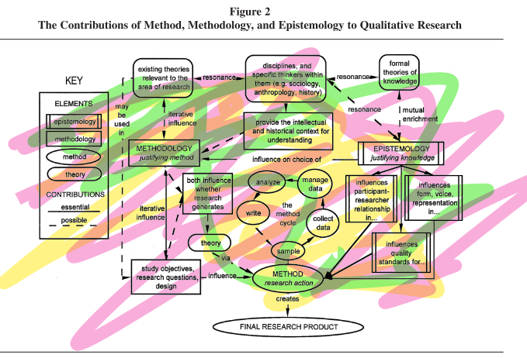
Figure 4. The contributions of Method, Methodology and Epistemology to Qualitative Research
Source: (Carter and Little 2007).

Example verb book (the books had up to 75 photographs in each book):
Each of the 50 books (below) have up to 71 pages of photographs and captions which could be shared with parents and the childminder to enable speech development. Each child was the star of the story which works well with a child’s egocentric viewpoint at this age. The books can be viewed in full online at:
Wildwood Tuition Childcare Stafford - Appendix 5 Verb books (wildwoodtuitionandchildcare.co.uk)
Username and password 1975 since the files are too big to upload on this document.

a trip to the allotment here
allotment drawings
a trip to Amerton Farm here
another trip to Amerton farm
Drawings from Amerton in pastel
Birches Valley photographs 1
Birches Valley photographs 2
trip to Birches Valley here
Birches Valley drawings
Birches Valley additional drawings
The energy of Birches Valley was really captured
by square
birthday celebration here
Building Bridges 6 7 21
Building bridges drawings
a trip to canalside farm here
1/ 7/21 strawberry picking at canalside farm drawings here
a trip to Charnley Park here
A trip to see the deer here
drawings of the deer on Cannock Chase
a trip to Derrington apple orchard here
drawings of Derrington apple orchard
drawings of Derrington apple orchard here
a trip to Doxey Marshes here
drawings of Doxey Marshes
3/7/21 On a frog hunt here
Why are frogs disappearing?
Holmcroft park 2 7 21
Holmcroft park photographs
Holmcroft park drawings
Holmcroft park paintings
Holmcroft park drawings
When the children were asked to paint a picture of themselves at the park,
they painted their sensory experience (the rain)
and the energy behind the experience.
a trip to the monkey forest here
An unusual trip to Radford Park and Charnley Park here what an experience!
a trip to Seven Springs here
Shugborough drawings in felt tip and pastel 7 2021
a trip to Shugborough here
a trip to Stafford Castle here
a trip to Stafford Castle and Victoria Park here
a trip to Trentham Gardens and sensory trail here
a trip to Victoria Park here
Wildwood Park during lockdown
Wildwood Park after lockdown
Wildwood Park in the sunshine
Wildwood Park drawings
Wildwood Park paintings
a trip to Wolsey Bridges here
Wolsey Bridges 2 here
Triangle at the park with 2 eyes, a nose and a smile
a trip to the allotment here
allotment drawings
a trip to Amerton Farm here
another trip to Amerton farm
Drawings from Amerton in pastel
Birches Valley photographs 1
Birches Valley photographs 2
trip to Birches Valley here
Birches Valley drawings
Birches Valley additional drawings
The energy of Birches Valley was really captured
by square
birthday celebration here
Building Bridges 6 7 21
Building bridges drawings
a trip to canalside farm here
1/ 7/21 strawberry picking at canalside farm drawings here
a trip to Charnley Park here
A trip to see the deer here
drawings of the deer on Cannock Chase
a trip to Derrington apple orchard here
drawings of Derrington apple orchard
drawings of Derrington apple orchard here
a trip to Doxey Marshes here
drawings of Doxey Marshes
3/7/21 On a frog hunt here
Why are frogs disappearing?
Holmcroft park 2 7 21
Holmcroft park photographs
Holmcroft park drawings
Holmcroft park paintings
Holmcroft park drawings
When the children were asked to paint a picture of themselves at the park,
they painted their sensory experience (the rain)
and the energy behind the experience.
a trip to the monkey forest here
An unusual trip to Radford Park and Charnley Park here what an experience!
a trip to Seven Springs here
Shugborough drawings in felt tip and pastel 7 2021
a trip to Shugborough here
a trip to Stafford Castle here
a trip to Stafford Castle and Victoria Park here
a trip to Trentham Gardens and sensory trail here
a trip to Victoria Park here
Wildwood Park during lockdown
Wildwood Park after lockdown
Wildwood Park in the sunshine
Wildwood Park drawings
Wildwood Park paintings
a trip to Wolsey Bridges here
Wolsey Bridges 2 here
Triangle at the park with 2 eyes, a nose and a smile

Figure 5: sample of verb books with up to 75 photographs alone, in each book.

Example of a smaller verb book:
A trip to canalside farm
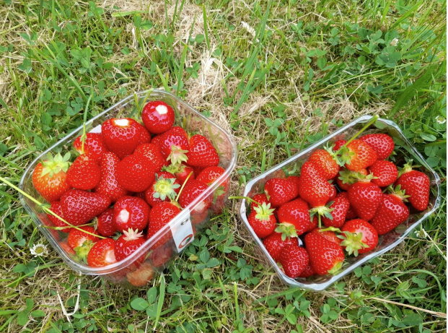

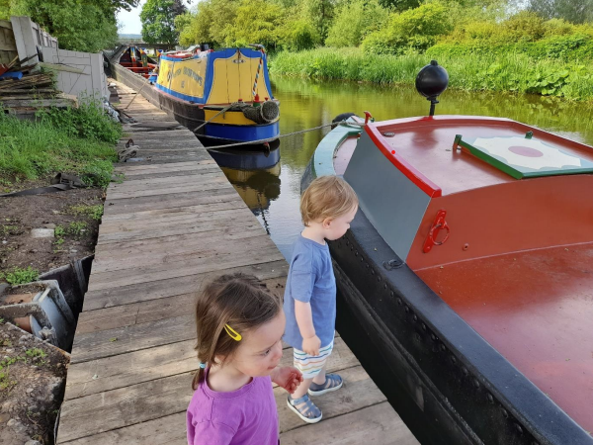
Canalside farm is next to the canal.
We had to be very careful not to get too close to the edge.
We stayed away from the water.

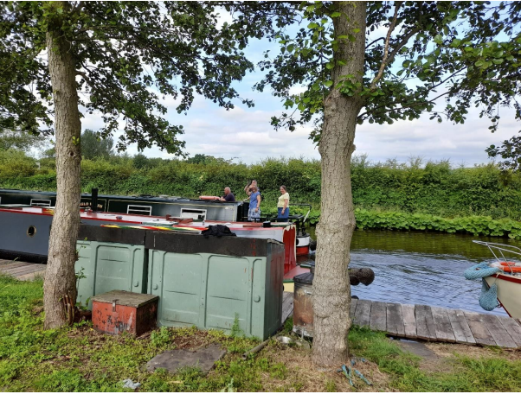

People on the canalboat waved to us.

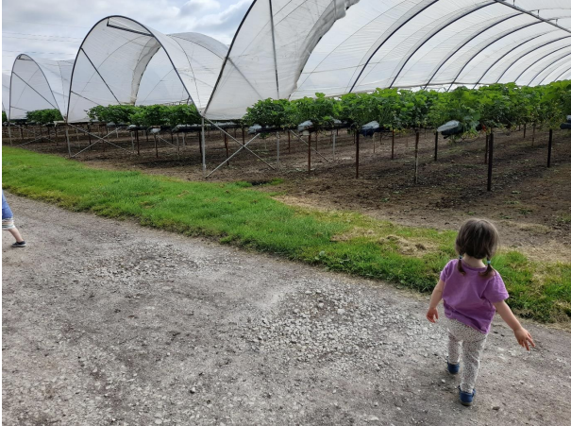

The farm had strawberry plants growing up high, in compost bags.

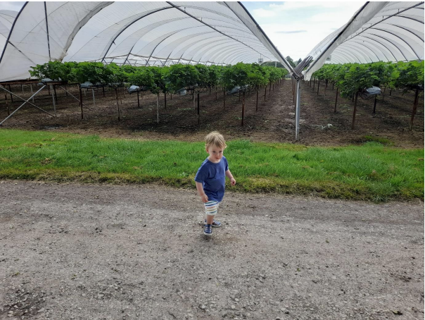
“What are we going to do?” asked ….
(14th June 2021) Well done xxx

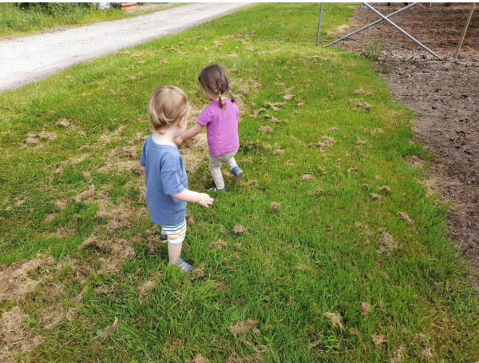
We played in the grass,
waiting for the farm to open so that we could pick some strawberries.

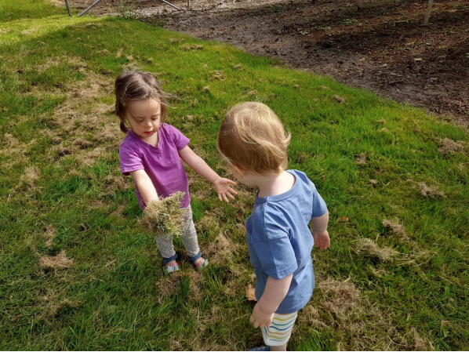

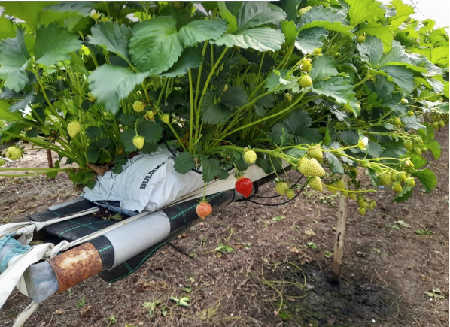

The strawberries were dangling but we couldn’t pick them yet.

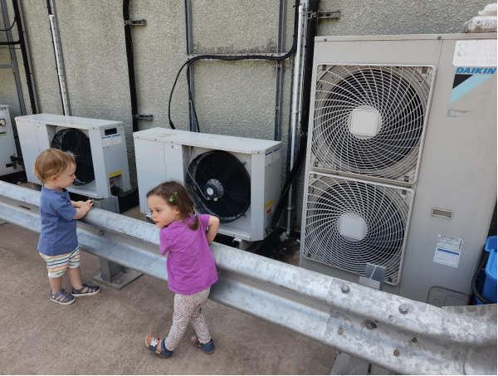

We looked at the fans that cooled the fridges at the farm.

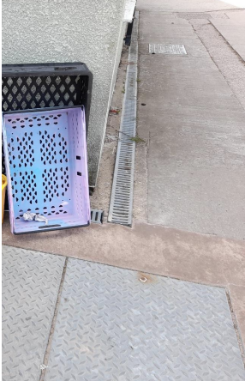

“What’s that?” asked … “They are for storing bread … replied….

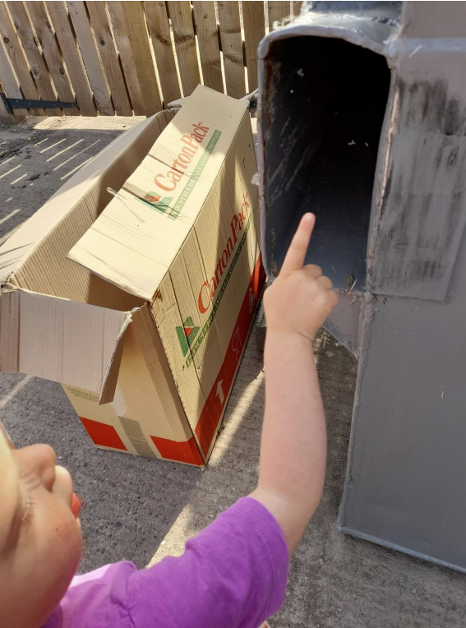

“Look a spider and web” whispered …

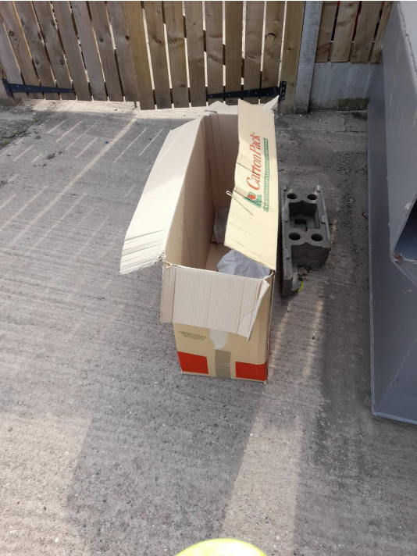

“What’s that?” asked … “It’s a box for storing things in answered …
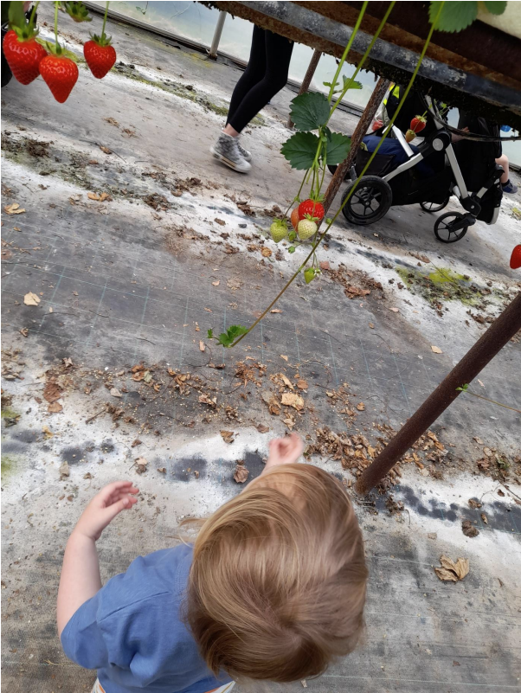

… picked the strawberries.

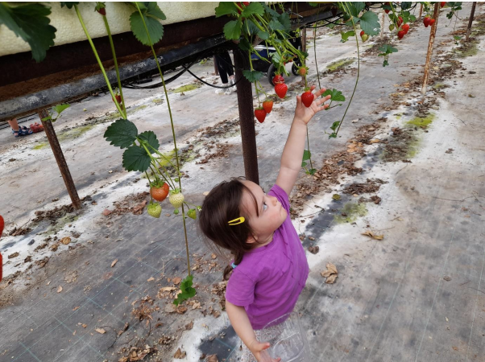 .

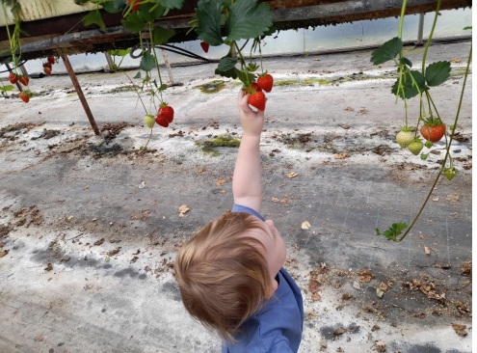

….. and …. picked strawberries.
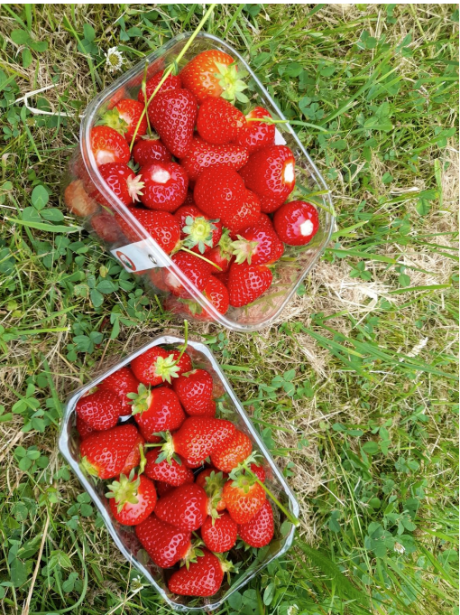..

The finished product – ready to eat or make jam!
(We made some lovely jam!)

Appendix A. Smaller style verb book example. There were 50 books with up to 75 photographs in each book with supplementary artwork taken home to show parents.

Ethical consent and ethical approval were provided before the start of the study (Bertram 2015) guidelines of ethical respect for:

- social contribution and cohesion will be demonstrated as the group of children is a mix of different genders and cultures. These differences will be celebrated and valued.

- the child, by using a free-flow play philosophy and allowing children’s families to influence play, for example, by bringing in objects from home of familial / cultural significance to enhance cultural freedom and acceptance.
- democratic values; are respected as the child remains in control of their play and exploration, at all times, by either choosing to engage or not to engage with an activity. This means: each person is celebrated and empowered with deep rooting respect for each child and family as in the UN convention on the Rights of the child (appendix 3).
- . justice and equity – by empowering the child to make their own decisions.
- knowing from multiple perspectives – by understanding that the information generated may produce multiple truths and perspectives.
- integrity, transparency and respectful interactions – being transparent whilst being aware of GSPR and ICO guidelines.
- academic scholarship, quality and rigor, which will be demonstrated throughout the study

Appendix B. Ethical consent in align with Bertram (2019) and Committee of Human Rights (2010).

Responses from Circles parents:

- Just took a look, he looks like he's having great fun and appears to be very interested in everything! Great to see, thank you for pulling that together.

- I knew I wasn't hearing things when he said two trains the other day!

This was quite a step forward because circle’s parents were quite formal and reluctant to share information.

Triangle’s family background was multi-cultural Spanish / Romanian mix where the parent expressed that the child would only use English at the childminder setting and Spanish / Romanian at home. It was interesting to use the ethnographic journal with this family because by learning and understanding different cultures you understand why people do things the way they do. When you identify with other people, you sympathize with their situation. Their ethnography was used in the hope of promoting understanding. Lots of problems can arise from misunderstandings, especially because we live in a multicultural world.

From the Researcher’s ethnography it was noted:

Triangle, who used English as a second language and yet was able to understand and follow simple instructions, speak in sentences, and ask thoughtful questions despite her age.

Examples of such questions and sentences:

· “Can I have some of that?
· I am on the swings.
· It is raining.
· What is that?
· Where is a tunnel?
· That’s at Trentham Gardens.
· Where is ….?”

The occurrence of these phrases appears to indicate Krok and Leonard 2018) statement : “English-speaking children typically pass through a developmental stage in which they inconsistently produce tense/agreement morphemes….. is void in this instance. It is possible that by using the verb books and being verbal within both the outdoor activity and during the creation of the verb books, the inconsistent stage of tense agreement may have been resolved more quickly.

This intervention has been brought about because of the high regard the researcher has towards diversity, disability, health practitioners and parental involvement.

Louise Nixon:
Today, I have noticed the immediate impact of verb books. The farm book created immediate sounds with child circle and sentences / questions with child triangle. Child circle transferred that learning into new contexts - noting bull, cat, sheep and dog from Spot's walk after looking at their own photographs in the farm verb book. This was the first time so many words had been uttered in one session. Child circle’s parents noted many more sounds being produced at home. Child triangle asks questions in clear sentences. The drawings provide opportunity to link sounds, ideas. Child triangle is accumulating meanings, understands that her drawings are representing what happened and discusses what the marks are representing in her picture.

Louise Nixon:
Looking at Holmcroft park verb book, circle said: climb, slide, hill, swing, step bridge slide trampoline snack and climbing the bridge. He was interested. triangle listened but wasn't as verbal. She can speak in sentences in two languages but wasn't the lead in this activity

From circle Mum: Hi Louise
Circle has said some sentences at the weekend, he said "where's he gone?" when daddy hid under the duvet and "there it is!" when he found his step stall he was looking for to brush his teeth, in a very stern voice told his doll to "sit down!" also the dreaded "no mum"

Louise Nixon
On Thursday and Friday Circle was clearly was able to talk in sentences which were understandable because I was looking at the photographs with circle. Triangle is confidently speaking in sentences and asking questions. Square is now talking in sentences to mum. There is a difference in communication and enthusiasm between looking at that days photographs and previous days photographs.

Louise Nixon:
Square had no words at the start of the study. By 20th July, having visited 1 day a week, square is asking questions, speaking in sentences and using verbs and adverbs confidently. Square's words are clear. Occasionally some words are unclear but that doesn't impact on the overall meaning. Square is able to follow instructions.

Louise Nixon:
Triangle can now ask questions and talk in sentences. The verb books help that process. Mum says that at home, Mum speaks in Catalan and Dad speaks in Romanian. At home, English is her preferred language and Mum reports that English is currently her strongest language.

With the childminder, circle engages with the photograph books confidently, clearly and in sentences. At home, triangle is keen to share the books with parents and talks but perhaps less than expected. Perhaps this is due to the fact that at the childminder setting only one language is used (at parental request) so that the child does not become confused. The childminder reports the child communicating confidently in English and able to follow intructions.

Louise Nixon:
After a weeks holiday, circle had regressed to making sounds instead of talking in sentences. Intervention required. This reminds me of of the importance of parental involvement.

Square’s autoethnography was verbal. Square’s parents were happy with the results of the intervention which was considered very successful.
The childminder noted their comments:

“Thank you, that is really interesting.
With me, when using the verb books, she talks in sentences with nouns, verbs, adjectives, adverbs and questions. We do use positional language during "action play which is reinforced by the photographs so yes she has learnt it here. When we started using the photographs, it helped us both to gain confidence in communicating together.
Thank you for your feedback, it is invaluable.”

On 2021-07-22 06:50, triangle’s mum wrote:
Hi Louise,
Here is my feedback, I hope it helps.
Her language has definitely improved since the introduction of the verb books but I don't know if it was because of the verb books or because of her natural speech development. Having said that though, she loves to read the verb books and see all her friends in the pictures. I think it's a great idea!
It is also worthy mentioning that is trilingual. She speaks Catalan with me, Romanian with her dad and English when we are all together or with other people.
At home, the language she speaks the most is Catalan. She might know verbs in English from the verb books that she hasn't mentioned to me (or her dad) because we use another language at home.
Nevertheless, I would like to point out that on the 13th July 2021, while we were on a walk, suddenly stopped and pointed to the path in front of her while saying "look mummy, down hill!" "down hill!". We have never used "down hill" at home, ever. So unless she learned if from watching TV - which I doubt - I think she learned it from you and maybe from the verb books :)

Following the intervention, a child, who had previously only uttered a few words, demonstrated an ability to speak in full sentences and questions and another child’s language skills progressed extremely rapidly following the intervention in such a way that it was possible to share a fluent conversation with the child who understood complex meanings and asked questions.

If the study were to be repeated, the researcher would advocate recording the child's utterances onto video tape and counting the verbs and nouns after the activity but this really was not necessary because in all 3 subjects, the children went from being non-verbal to complete sentence speakers extremely within the first activity.

Appendix C. Coding: Red – negative comments, orange neutral comments, green positive comments

Responses from Circles parents:

- Just took a look, he looks like he's having great fun and appears to be very interested in everything! Great to see, thank you for pulling that together.

- I knew I wasn't hearing things when he said two trains the other day!

This was quite a step forward because circle’s parents were quite formal and reluctant to share information.

Triangle’s family background was multi-cultural Spanish / Romanian mix where the parent expressed that the child would only use English at the childminder setting and Spanish / Romanian at home. It was interesting to use the ethnographic journal with this family because by learning and understanding different cultures you understand why people do things the way they do. When you identify with other people, you sympathize with their situation. Their ethnography was used in the hope of promoting understanding. Lots of problems can arise from misunderstandings, especially because we live in a multicultural world.

From the Researcher’s ethnography it was noted:

Triangle, who used English as a second language and yet was able to understand and follow simple instructions, speak in sentences, and ask thoughtful questions despite her age.

Examples of such questions and sentences:

· “Can I have some of that?
· I am on the swings.
· It is raining.
· What is that?
· Where is a tunnel?
· That’s at Trentham Gardens.
· Where is ….?”

The occurrence of these phrases appears to indicate Krok and Leonard 2018) statement : “English-speaking children typically pass through a developmental stage in which they inconsistently produce tense/agreement morphemes….. is void in this instance. It is possible that by using the verb books and being verbal within both the outdoor activity and during the creation of the verb books, the inconsistent stage of tense agreement may have been resolved more quickly.

This intervention has been brought about because of the high regard the researcher has towards diversity, disability, health practitioners and parental involvement.

Louise Nixon:
Today, I have noticed the immediate impact of verb books. The farm book created immediate sounds with child circle and sentences / questions with child triangle. Child circle transferred that learning into new contexts - noting bull, cat, sheep and dog from Spot's walk after looking at their own photographs in the farm verb book. This was the first time so many words had been uttered in one session. Child circle’s parents noted many more sounds being produced at home. Child triangle asks questions in clear sentences. The drawings provide opportunity to link sounds, ideas. Child triangle is accumulating meanings, understands that her drawings are representing what happened and discusses what the marks are representing in her picture.

Louise Nixon:
Looking at Holmcroft park verb book, circle said: climb, slide, hill, swing, step bridge slide trampoline snack and climbing the bridge. He was interested. triangle listened but wasn't as verbal. She can speak in sentences in two languages but wasn't the lead in this activity

From circle Mum: Hi Louise
Circle has said some sentences at the weekend, he said "where's he gone?" when daddy hid under the duvet and "there it is!" when he found his step stall he was looking for to brush his teeth, in a very stern voice told his doll to "sit down!" also the dreaded "no mum"

Louise Nixon
On Thursday and Friday Circle was clearly able to talk in sentences which were understandable because I was looking at the photographs with circle. Triangle is confidently speaking in sentences and asking questions. Square is now talking in sentences to mum. There is a difference in communication and enthusiasm between looking at that days photographs and previous days photographs

Louise Nixon:
Square had no words in February. By 20th July, having visited 1 day a week, square is asking questions, speaking in sentences and using verbs and adverbs confidently. Square's words are clear. Occasionally some words are unclear but that doesn't impact on the overall meaning. Square is able to follow instructions.

Louise Nixon:
Creating a running commentary during outdoor play which is photographed and later observed as a photographic book with captions seems to improve the language development process.
Triangle can now ask questions and talk in sentences. The verb books help that process. Mum says that at home, Mum speaks in Catalan and Dad speaks in Romanian. At home, English is her preferred language and Mum reports that English is currently her strongest language.

With the childminder, circle engages with the photograph books confidently, clearly and in sentences. At home, triangle is keen to share the books with parents and talks but perhaps less than expected. Perhaps this is due to the fact that at the childminder setting only one language is used (at parental request) so that the child does not become confused. The childminder reports the child communicating confidently in English and able to follow intructions.

Louise Nixon:
After a weeks holiday, circle had regressed to making sounds instead of talking in sentences. Intervention required. This reminds me of of the importance of parental involvement.

Square’s autoethnography was verbal. Square’s parents were happy with the results of the intervention which was considered very successful.
The childminder noted their comments:

“Thank you, that is really interesting.
With me, when using the verb books, she talks in sentences with nouns, verbs, adjectives, adverbs and questions. We do use positional language during "action play which is reinforced by the photographs so yes she has learnt it here. We started using the photographs in February and it has helped us both to gain confidence in communicating together.
Thank you for your feedback, it is invaluable.”

On 2021-07-22 06:50, triangle’s mum wrote:
Hi Louise,
Here is my feedback, I hope it helps.
Her language has definitely improved since the introduction of the verb books but I don't know if it was because of the verb books or because of her natural speech development. Having said that though, she loves to read the verb books and see all her friends in the pictures. I think it's a great idea!
It is also worthy mentioning that is trilingual. She speaks Catalan with me, Romanian with her dad and English when we are all together or with other people.
At home, the language she speaks the most is Catalan. She might know verbs in English from the verb books that she hasn't mentioned to me (or her dad) because we use another language at home.
Nevertheless, I would like to point out that on the 13th July 2021, while we were on a walk, suddenly stopped and pointed to the path in front of her while saying "look mummy, down hill!" "down hill!". We have never used "down hill" at home, ever. So unless she learned if from watching TV - which I doubt - I think she learned it from you and maybe from the verb books :)

Following the intervention, a child, who had previously only uttered a few words, demonstrated an ability to speak in full sentences and questions and another child’s language skills progressed extremely rapidly following the intervention in such a way that it was possible to share a fluent conversation with the child who understood complex meanings and asked questions.

If the study were to be repeated, the researcher would advocate recording the child's utterances onto video tape and counting the verbs and nouns after the activity but this really was not necessary because in all 3 subjects, the children went from being non-verbal to complete sentence speakers extremely within the first activity.

Figure D. Coding: blue, transferable skills brown, a result contradicting the literature review, purple, cultural comments.

Square’s questionnaire:

Please score the questions listed from a score 1 – 5
1 indicates a poor score
5 indicates a good score
Before the Introduction of verb books
What would you score your child’s non-verbal communication?
1 2 3 4 5
What would you score your child’s use of a mix of making sounds and non-verbal communication to communicate meaning?
1 2 3 4 5
What would you score your child’s overall speech and language development?
1 2 3 4 5
What would you score your child’s use of nouns?
1 2 3 4 5
What would you score your child’s use of verbs?
1 2 3 4 5
What would you score your child’s use of sentences?
1 2 3 4 5
After the Introduction of verb books
What would you score your child’s non-verbal communication?
1 2 3 4 5
What would you score your child’s use of a mix of making sounds and non-verbal communication to communicate meaning?
1 2 3 4 5
What would you score your child’s overall speech and language development?
1 2 3 4 5
What would you score your child’s use of nouns?
1 2 3 4 5
What would you score your child’s use of verbs?
1 2 3 4 5
What would you score your child’s use of sentences?
1 2 3 4 5
Overall, has the introduction of verb books to your child’s development had a positive impact on your child’s speech development? Yes (delete as appropriate)

Figure E. Questionaire sample

Quantitative data analysis:

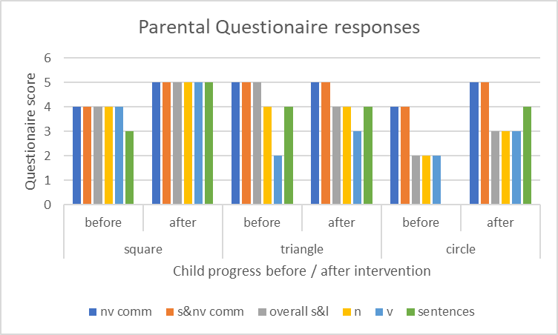

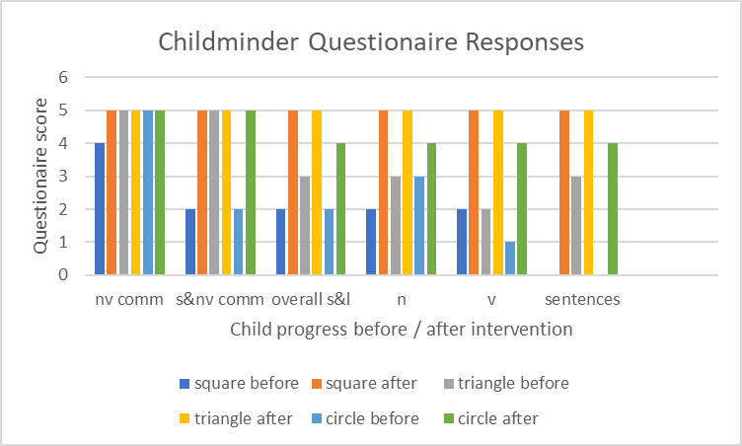

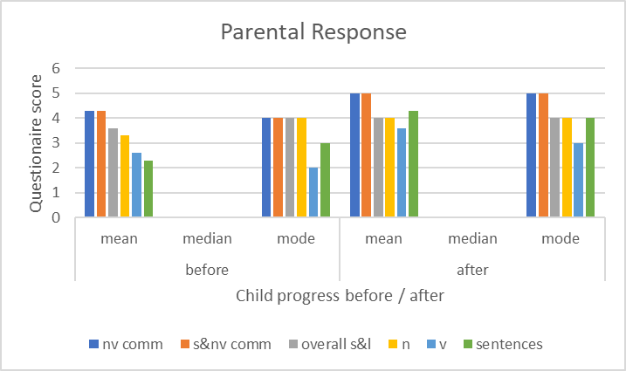

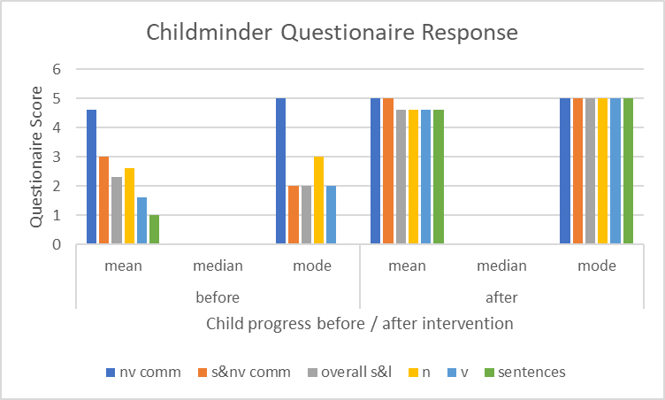

Figure 6 Bar graphs created from questionnaire results

pie graph showing the progress the children had made following the speech and language intervention (agreed by both childminders and parents following quantitative and qualitative data analysis).

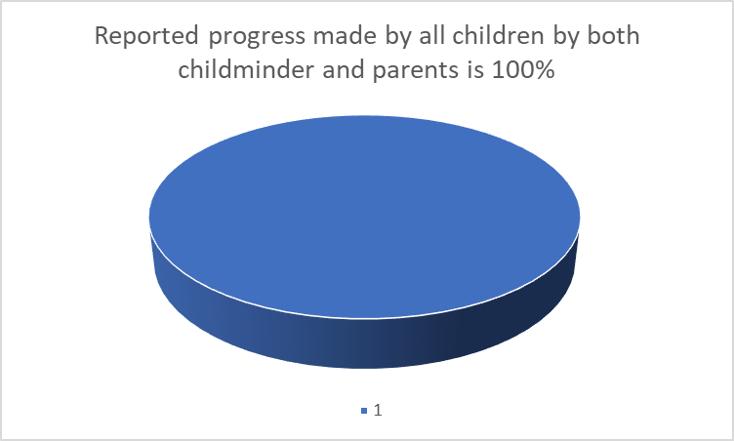
Figure 7. Pye chart to report the progress made by all children as reported by both the childminder and parents

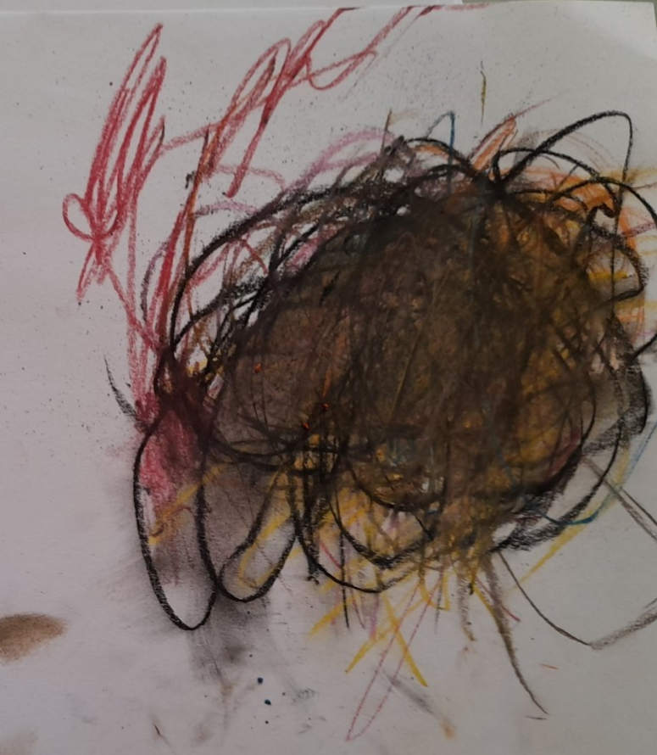

Figure 8. Child square’s artwork showing the orienteering trip at Birches Valley’s Gruffalo trail. The image perfectly described the energy that the child use when runining.

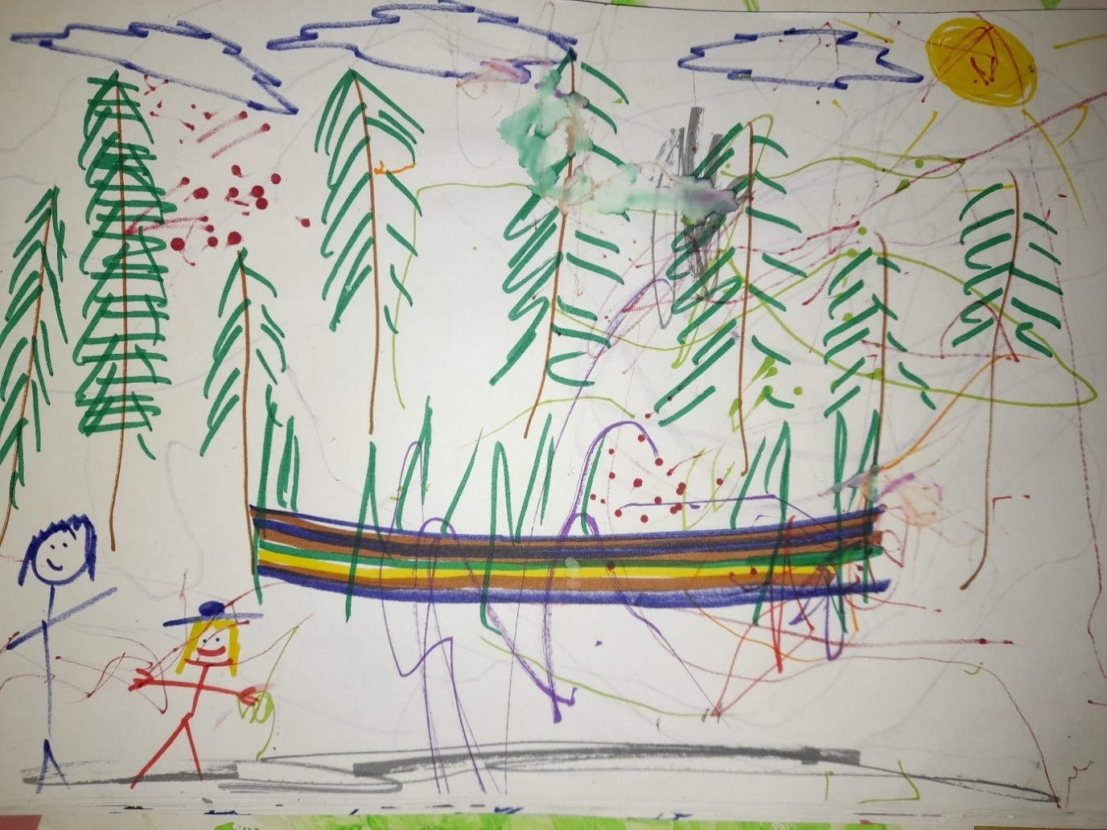
Figure 9: The researcher’s interpretation of square’s explosion of energy

Square observed this picture (a guided activity created with circle) but the researcher believes square’s depiction to be much more realistic than the one the researcher drew (with assistance from circle), especially in terms of communicating feelings and energy.

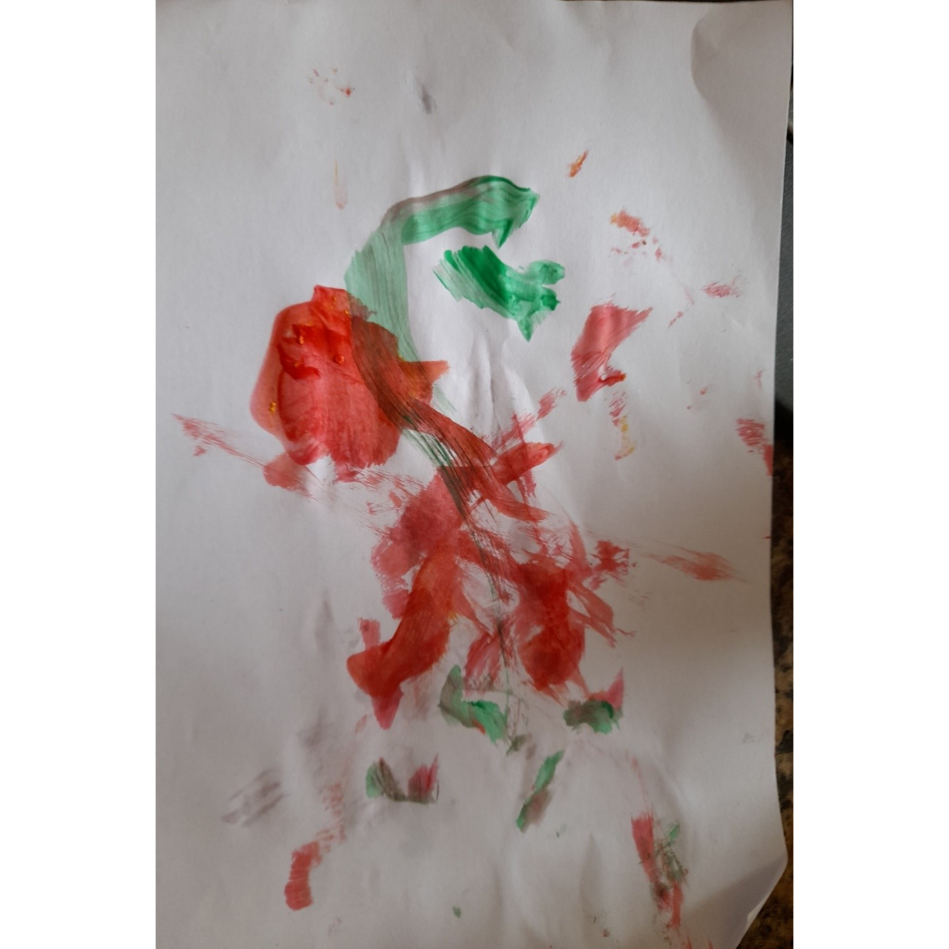
Triangle strawberries

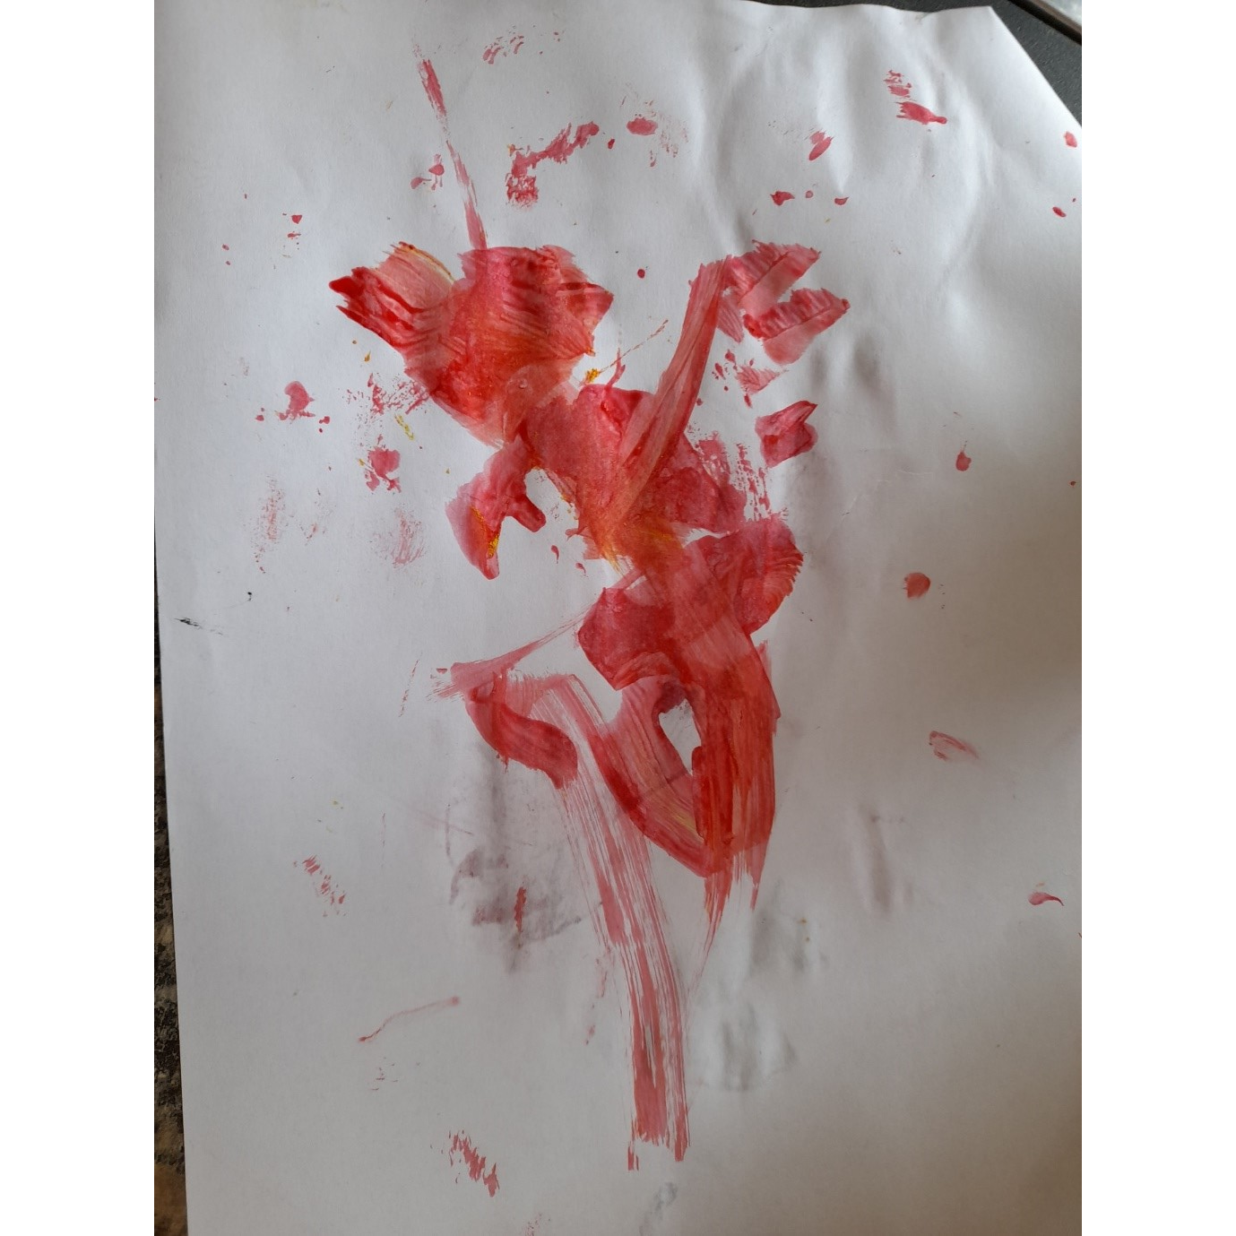
Triangle strawberries

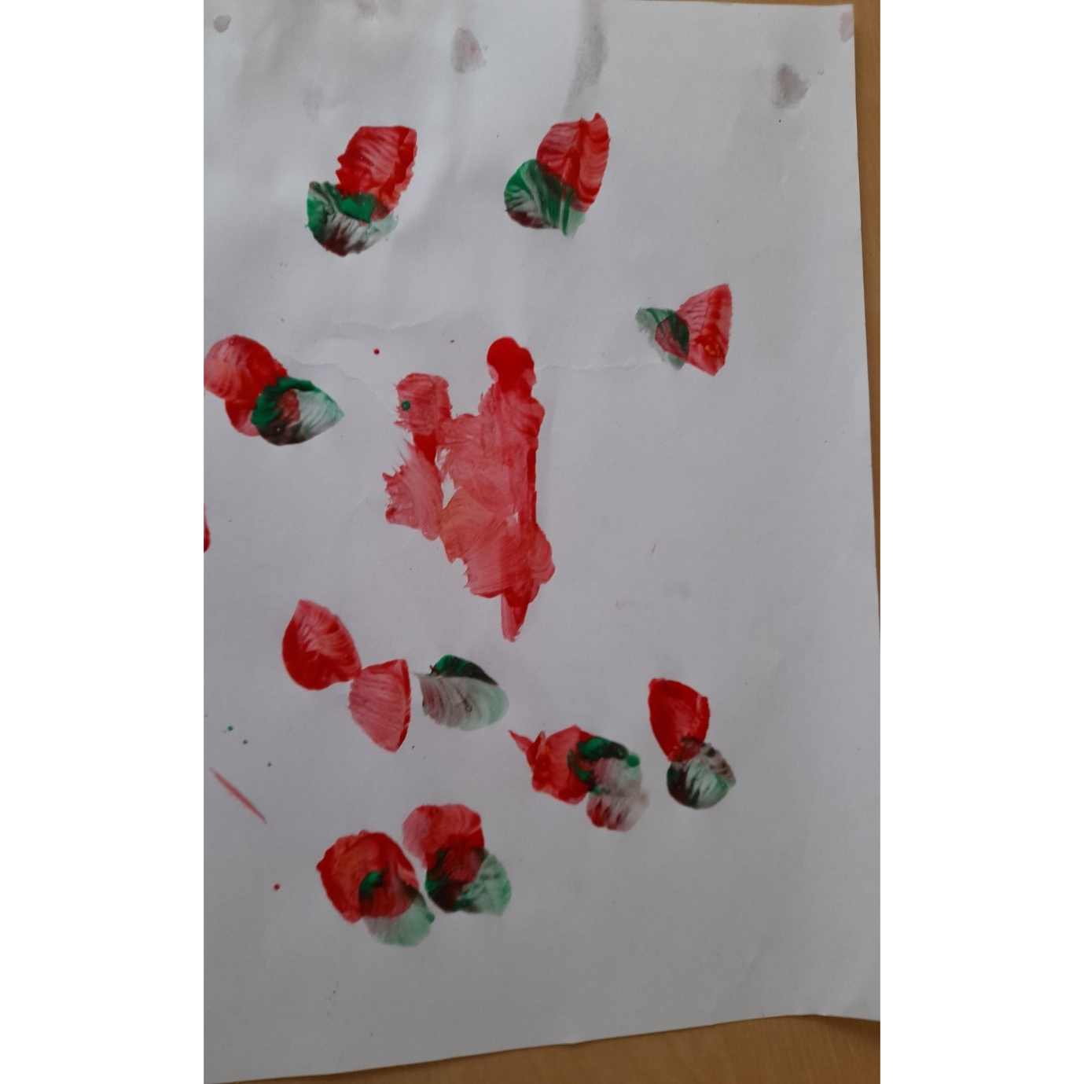
Circle strawberries

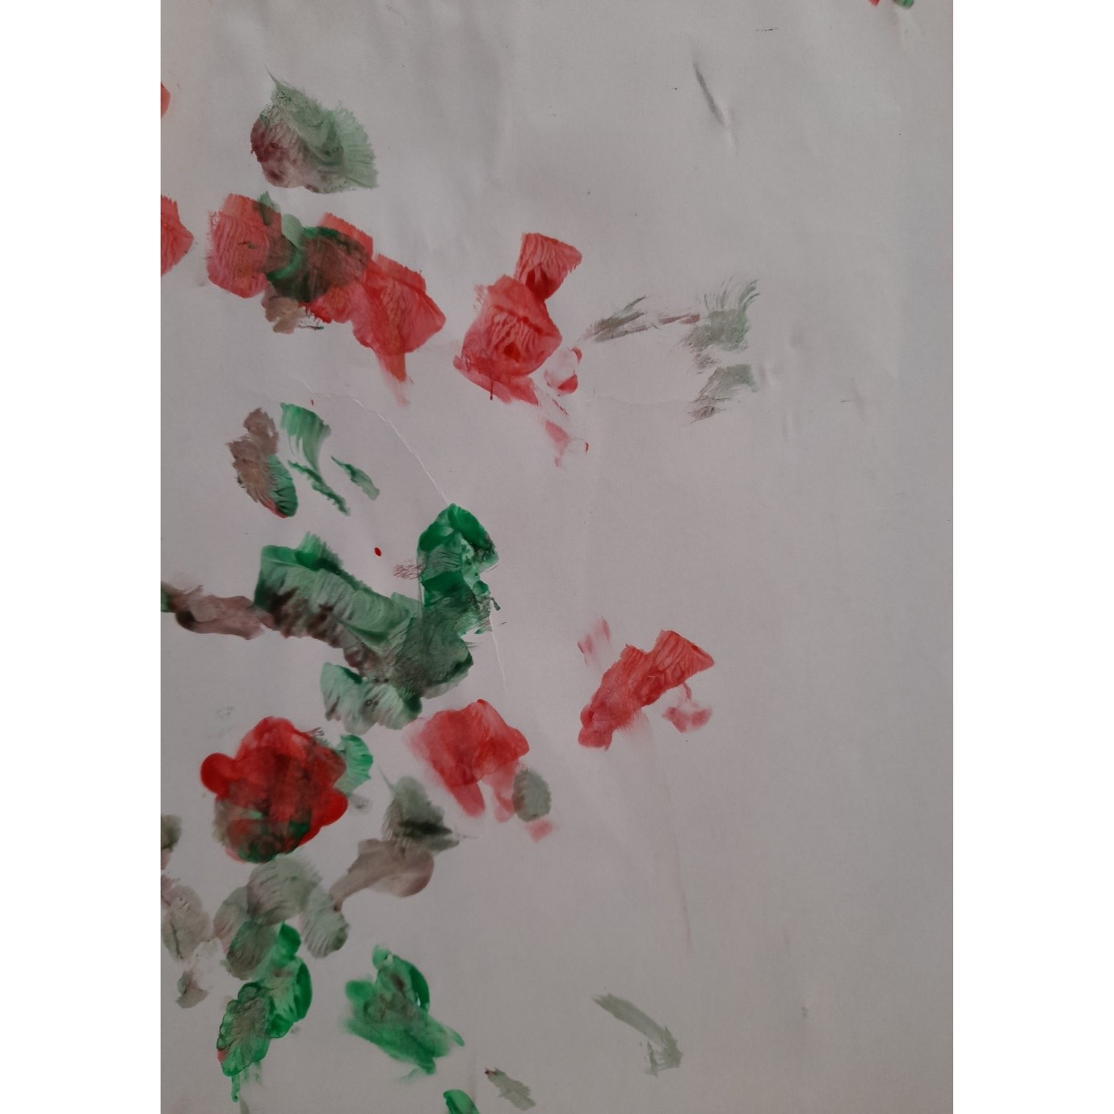 Circle strawberries
Figure 10: strawberry paintings following a day trip strawberry picking, which can be seen as lifelike despite the children’s young age.
Hi Louise,

I’m happy for you to reference the email communications although I’d recommend finding a peer reviewed article or piece of research to reinforce any of your opinions / ideas, especially as it’s for your masters.
Good luck! Beth (Highly Experienced SLT and University Lecturer) Figure Appendix F: Permission provided by Beth Morrant, speech therapist and University
Visualisation chart

Notability, gender was not discussed although culture and diversity was discussed. This may be because of the amount of work schools have done in terms of equality and LGBTQ recently.
The visualisation chart provides an impression of proportion within each node.
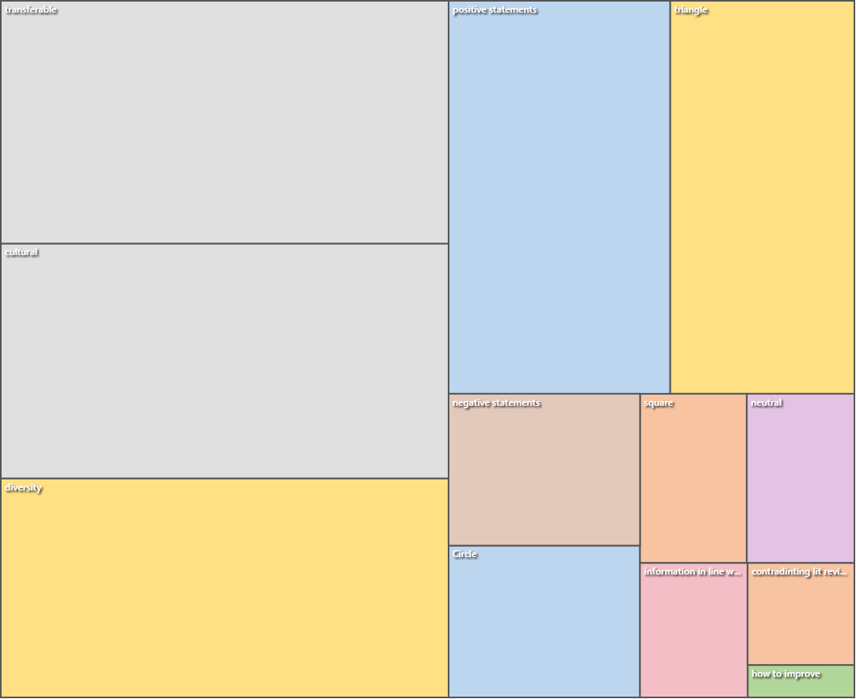

Figure 11: Coded Qualitative data visualisation chart
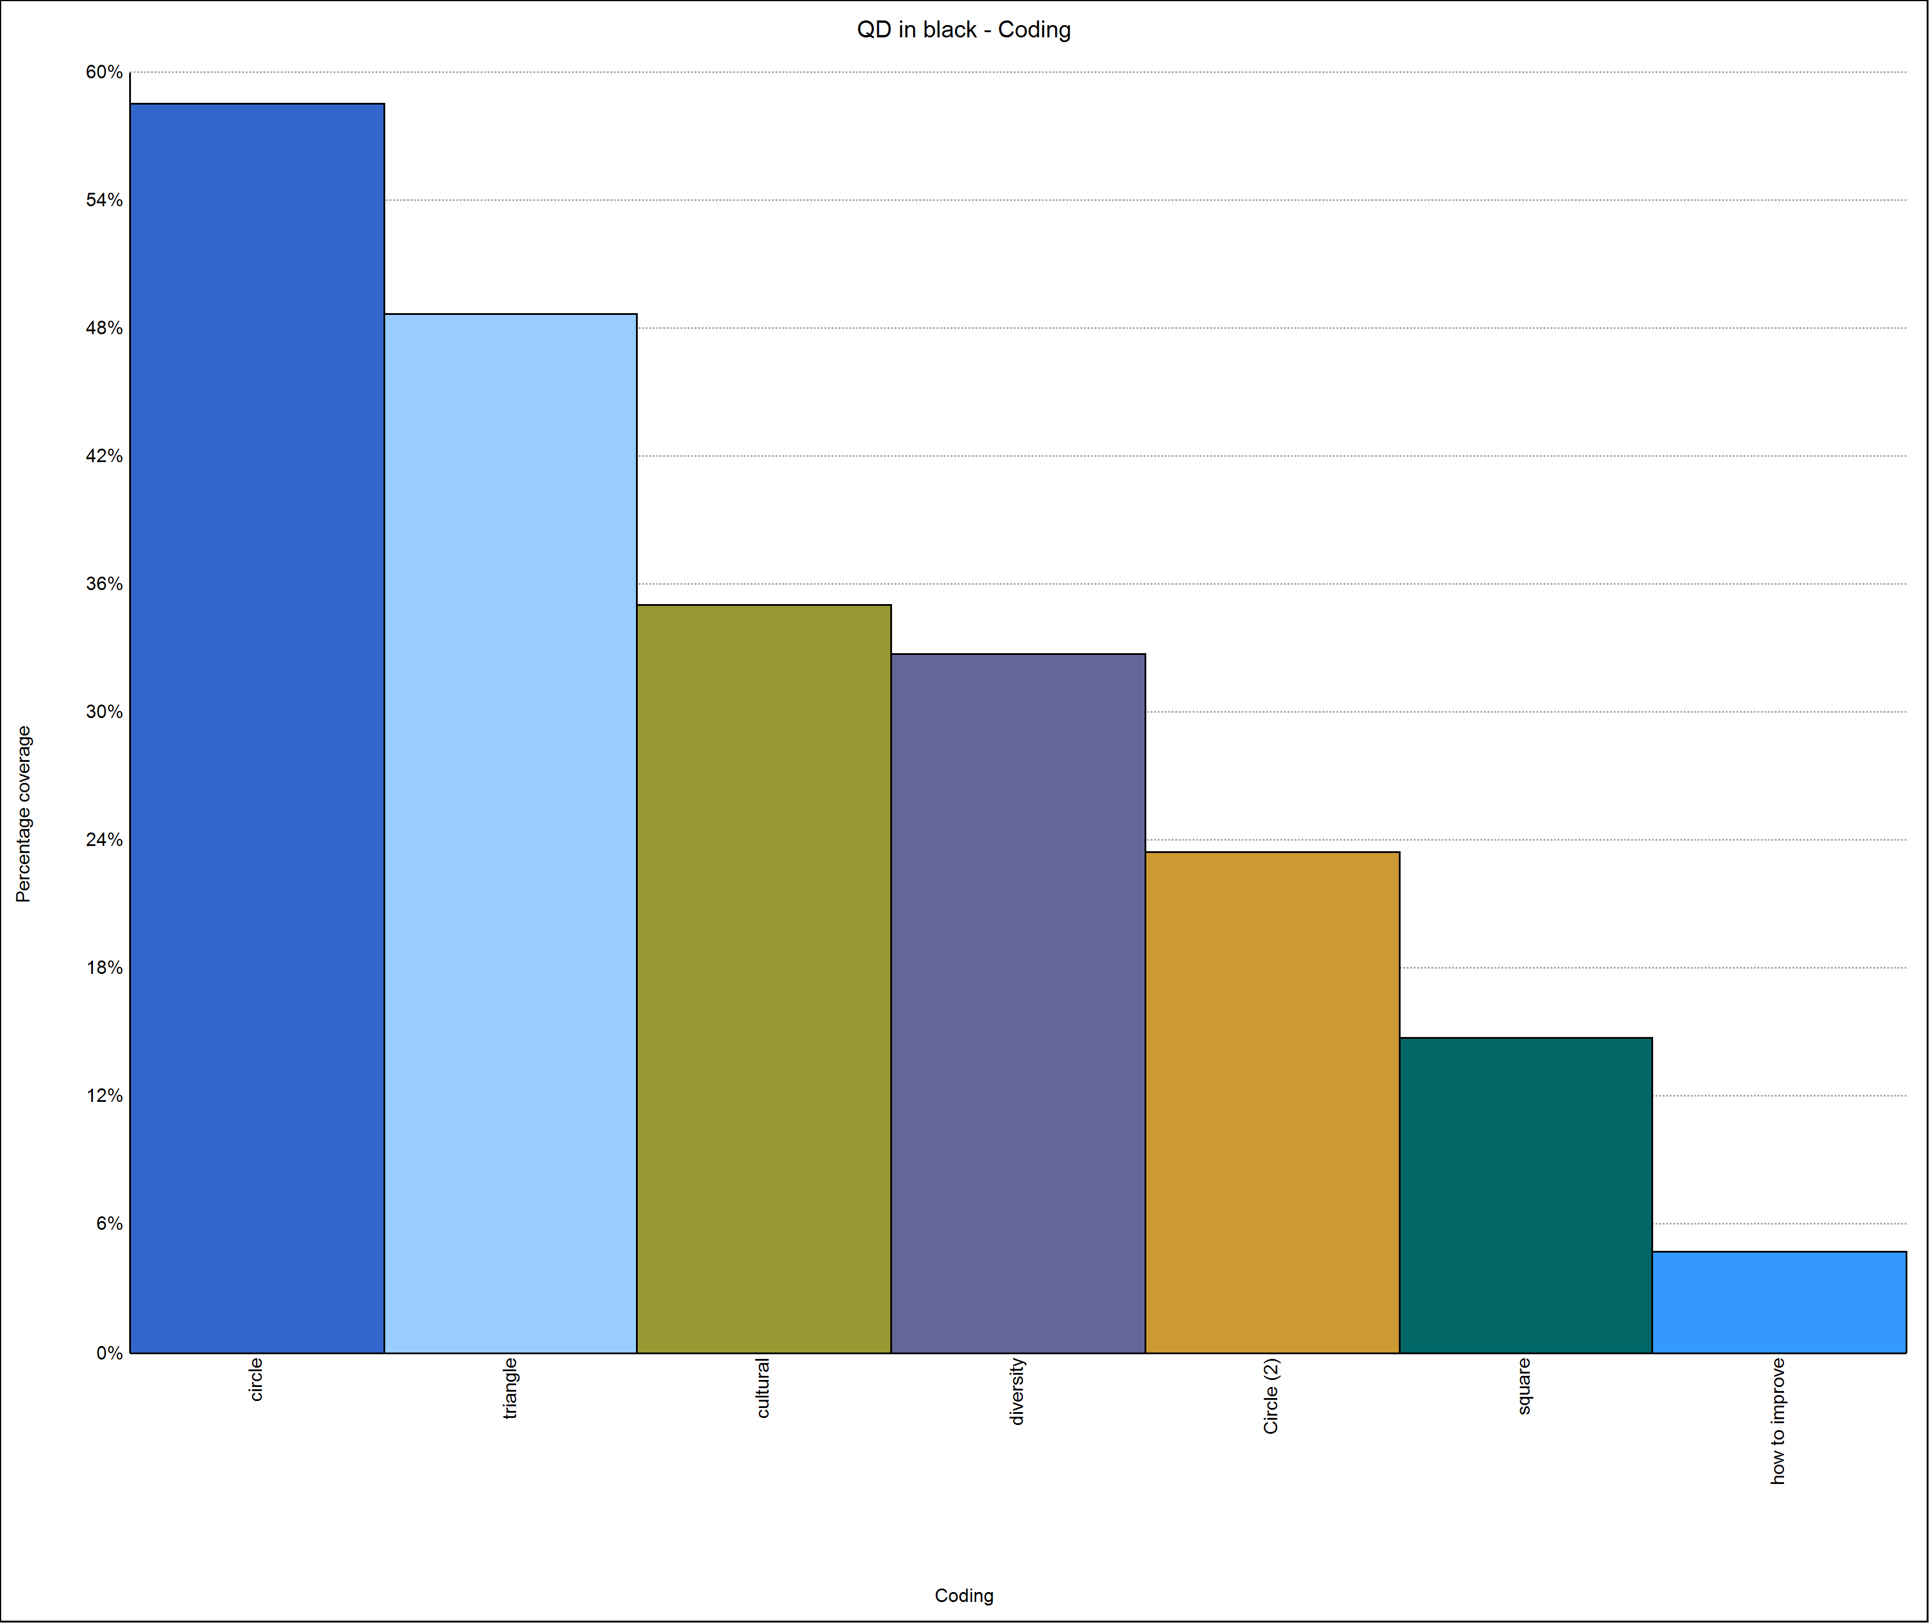
Graph to show Qualitative Data: coding

Figure 12. Coded Qualitative data bar chart

Transcript of all Qualitative data:

Responses from Circles parents:

- Just took a look, he looks like he's having great fun and appears to be very interested in everything! Great to see, thank you for pulling that together.

- I knew I wasn't hearing things when he said two trains the other day!

This was quite a step forward because circle’s parents were quite formal and reluctant to share information.

Triangle’s family background was multi-cultural Spanish / Romanian mix where the parent expressed that the child would only use English at the childminder setting and Spanish / Romanian at home. It was interesting to use the ethnographic journal with this family because by learning and understanding different cultures you understand why people do things the way they do. When you identify with other people, you sympathize with their situation. Their ethnography was used in the hope of promoting understanding. Lots of problems can arise from misunderstandings, especially because we live in a multicultural world.

From the Researcher’s ethnography it was noted:

Triangle, who used English as a second language and yet was able to understand and follow simple instructions, speak in sentences, and ask thoughtful questions despite her age.

Examples of such questions and sentences:

· “Can I have some of that?
· I am on the swings.
· It is raining.
· What is that?
· Where is a tunnel?
· That’s at Trentham Gardens.
· Where is ….?”

The occurrence of these phrases appears to indicate Krok and Leonard 2018) statement : “English-speaking children typically pass through a developmental stage in which they inconsistently produce tense/agreement morphemes….. is void in this instance. It is possible that by using the verb books and being verbal within both the outdoor activity and during the creation of the verb books, the inconsistent stage of tense agreement may have been resolved more quickly.

This intervention has been brought about because of the high regard the researcher has towards diversity, disability, health practitioners and parental involvement.

Louise Nixon:
Today, I have noticed the immediate impact of verb books. The farm book created immediate sounds with child circle and sentences / questions with child triangle. Child circle transferred that learning into new contexts - noting bull, cat, sheep and dog from Spot's walk after looking at their own photographs in the farm verb book. This was the first time so many words had been uttered in one session. Child circle’s parents noted many more sounds being produced at home. Child triangle asks questions in clear sentences. The drawings provide opportunity to link sounds, ideas. Child triangle is accumulating meanings, understands that her drawings are representing what happened and discusses what the marks are representing in her picture.

Louise Nixon:
Looking at Holmcroft park verb book, circle said: climb, slide, hill, swing, step bridge slide trampoline snack and climbing the bridge. He was interested. triangle listened but wasn't as verbal. She can speak in sentences in two languages but wasn't the lead in this activity

From circle Mum: Hi Louise
Circle has said some sentences at the weekend, he said "where's he gone?" when daddy hid under the duvet and "there it is!" when he found his step stall he was looking for to brush his teeth, in a very stern voice told his doll to "sit down!" also the dreaded "no mum"

Louise Nixon
On Thursday and Friday Circle was clearly was able to talk in sentences which were understandable because I was looking at the photographs with circle. Triangle is confidently speaking in sentences and asking questions. Square is now talking in sentences to mum. There is a difference in communication and enthusiasm between looking at that days photographs and previous days photographs.

Louise Nixon:
Square had no words at the start of the study. After 28 much less than 28 visits having visited 1 day a week, square is asking questions, speaking in sentences and using verbs and adverbs confidently. Square's words are clear. Occasionally some words are unclear but that doesn't impact on the overall meaning. Square is able to follow instructions.

Louise Nixon:
Triangle can now ask questions and talk in sentences. The verb books help that process. Mum says that at home, Mum speaks in Catalan and Dad speaks in Romanian. At home, English is her preferred language and Mum reports that English is currently her strongest language.

With the childminder, circle engages with the photograph books confidently, clearly and in sentences. At home, triangle is keen to share the books with parents and talks but perhaps less than expected. Perhaps this is due to the fact that at the childminder setting only one language is used (at parental request) so that the child does not become confused. The childminder reports the child communicating confidently in English and able to follow intructions.

Louise Nixon:
After a weeks holiday, circle had regressed to making sounds instead of talking in sentences. Intervention required. This reminds me of of the importance of parental involvement.

Square’s autoethnography was verbal. Square’s parents were happy with the results of the intervention which was considered very successful.
The childminder noted their comments:

“Thank you, that is really interesting.
With me, when using the verb books, she talks in sentences with nouns, verbs, adjectives, adverbs and questions. We do use positional language during "action play which is reinforced by the photographs so yes she has learnt it here. When we started using the photographs, it helped us both to gain confidence in communicating together.
Thank you for your feedback, it is invaluable.”

On 2021-07-22 06:50, triangle’s mum wrote:
Hi Louise,
Here is my feedback, I hope it helps.
Her language has definitely improved since the introduction of the verb books but I don't know if it was because of the verb books or because of her natural speech development. Having said that though, she loves to read the verb books and see all her friends in the pictures. I think it's a great idea!
It is also worthy mentioning that is trilingual. She speaks Catalan with me, Romanian with her dad and English when we are all together or with other people.
At home, the language she speaks the most is Catalan. She might know verbs in English from the verb books that she hasn't mentioned to me (or her dad) because we use another language at home.
Nevertheless, I would like to point out that on the 13th July 2021, while we were on a walk, suddenly stopped and pointed to the path in front of her while saying "look mummy, down hill!" "down hill!". We have never used "down hill" at home, ever. So unless she learned if from watching TV - which I doubt - I think she learned it from you and maybe from the verb books :)

Following the intervention, a child, who had previously only uttered a few words, demonstrated an ability to speak in full sentences and questions and another child’s language skills progressed extremely rapidly following the intervention in such a way that it was possible to share a fluent conversation with the child who understood complex meanings and asked questions.

If the study were to be repeated, the researcher would advocate recording the child's utterances onto video tape and counting the verbs and nouns after the activity but this really was not necessary because in all 3 subjects, the children went from being non-verbal to complete sentence speakers extremely within the first activity.

Coded data:
Circles responses:

Responses from Circles parents:

- Just took a look, he looks like he's having great fun and appears to be very interested in everything! Great to see, thank you for pulling that together.

- I knew I wasn't hearing things when he said two trains the other day!

This was quite a step forward because circle’s parents were quite formal and reluctant to share information.

Triangle’s family background was multi-cultural Spanish / Romanian mix where the parent expressed that the child would only use English at the childminder setting and Spanish / Romanian at home. It was interesting to use the ethnographic journal with this family because by learning and understanding different cultures you understand why people do things the way they do. When you identify with other people, you sympathize with their situation. Their ethnography was used in the hope of promoting understanding. Lots of problems can arise from misunderstandings, especially because we live in a multicultural world.

From the Researcher’s ethnography it was noted:

Triangle, who used English as a second language and yet was able to understand and follow simple instructions, speak in sentences, and ask thoughtful questions despite her age.

Examples of such questions and sentences:

· “Can I have some of that?
· I am on the swings.
· It is raining.
· What is that?
· Where is a tunnel?
· That’s at Trentham Gardens.
· Where is ….?”

The occurrence of these phrases appears to indicate Krok and Leonard 2018) statement : “English-speaking children typically pass through a developmental stage in which they inconsistently produce tense/agreement morphemes….. is void in this instance. It is possible that by using the verb books and being verbal within both the outdoor activity and during the creation of the verb books, the inconsistent stage of tense agreement may have been resolved more quickly.

This intervention has been brought about because of the high regard the researcher has towards diversity, disability, health practitioners and parental involvement.

Louise Nixon:
Today, I have noticed the immediate impact of verb books. The farm book created immediate sounds with child circle and sentences / questions with child triangle. Child circle transferred that learning into new contexts - noting bull, cat, sheep and dog from Spot's walk after looking at their own photographs in the farm verb book. This was the first time so many words had been uttered in one session. Child circle’s parents noted many more sounds being produced at home. Child triangle asks questions in clear sentences. The drawings provide opportunity to link sounds, ideas. Child triangle is accumulating meanings, understands that her drawings are representing what happened and discusses what the marks are representing in her picture.

Louise Nixon:
Looking at Holmcroft park verb book, circle said: climb, slide, hill, swing, step bridge slide trampoline snack and climbing the bridge. He was interested. triangle listened but wasn't as verbal. She can speak in sentences in two languages but wasn't the lead in this activity

From circle Mum: Hi Louise
Circle has said some sentences at the weekend, he said "where's he gone?" when daddy hid under the duvet and "there it is!" when he found his step stall he was looking for to brush his teeth, in a very stern voice told his doll to "sit down!" also the dreaded "no mum"

Louise Nixon
On Thursday and Friday Circle was clearly was able to talk in sentences which were understandable because I was looking at the photographs with circle. Triangle is confidently speaking in sentences and asking questions. Square is now talking in sentences to mum. There is a difference in communication and enthusiasm between looking at that days photographs and previous days photographs.

Louise

Triangle Comments:

riangle’s family background was multi-cultural Spanish / Romanian mix where the parent expressed that the child would only use English at the childminder setting and Spanish / Romanian at home. It was interesting to use the ethnographic journal with this family because by learning and understanding different cultures you understand why people do things the way they do. When you identify with other people, you sympathize with their situation. Their ethnography was used in the hope of promoting understanding. Lots of problems can arise from misunderstandings, especially because we live in a multicultural world.

Reference 2 - 5.74% Coverage

From the Researcher’s ethnography it was noted:

Triangle, who used English as a second language and yet was able to understand and follow simple instructions, speak in sentences, and ask thoughtful questions despite her age.

Examples of such questions and sentences:

· “Can I have some of that?
· I am on the swings.
· It is raining.
· What is that?
· Where is a tunnel?
· That’s at Trentham Gardens.
· Where is ….?”

Reference 3 - 6.08% Coverage

The occurrence of these phrases appears to indicate Krok and Leonard 2018) statement : “English-speaking children typically pass through a developmental stage in which they inconsistently produce tense/agreement morphemes….. is void in this instance. It is possible that by using the verb books and being verbal within both the outdoor activity and during the creation of the verb books, the inconsistent stage of tense agreement may have been resolved more quickly.

Reference 4 - 3.54% Coverage

Child triangle asks questions in clear sentences. The drawings provide opportunity to link sounds, ideas. Child triangle is accumulating meanings, understands that her drawings are representing what happened and discusses what the marks are representing in her picture.

Reference 5 - 1.60% Coverage

triangle listened but wasn't as verbal. She can speak in sentences in two languages but wasn't the lead in this activity

Reference 6 - 0.90% Coverage

Triangle is confidently speaking in sentences and asking questions.

Reference 7 - 3.72% Coverage

Louise Nixon:
Triangle can now ask questions and talk in sentences. The verb books help that process. Mum says that at home, Mum speaks in Catalan and Dad speaks in Romanian. At home, English is her preferred language and Mum reports that English is currently her strongest language.

Reference 8 - 19.04% Coverage

Hi Louise,
Here is my feedback, I hope it helps.
Her language has definitely improved since the introduction of the verb books but I don't know if it was because of the verb books or because of her natural speech development. Having said that though, she loves to read the verb books and see all her friends in the pictures. I think it's a great idea!
It is also worthy mentioning that is trilingual. She speaks Catalan with me, Romanian with her dad and English when we are all together or with other people.
At home, the language she speaks the most is Catalan. She might know verbs in English from the verb books that she hasn't mentioned to me (or her dad) because we use another language at home.
Nevertheless, I would like to point out that on the 13th July 2021, while we were on a walk, suddenly stopped and pointed to the path in front of her while saying "look mummy, down hill!" "down hill!". We have never used "down hill" at home, ever. So unless she learned if from watching TV - which I doubt - I think she learned it from you and maybe from the verb books :)

Following the intervention, a child, who had previously only uttered a few words, demonstrated an ability to speak in full sentences and questions and another child’s language skills progressed extremely rapidly following the intervention in such a way that it was possible to share a fluent conversation with the child who understood complex meanings and asked questions.

Square Comments:

Reference 1 - 2.20% Coverage

Square is now talking in sentences to mum. There is a difference in communication and enthusiasm between looking at that days photographs and previous days photographs.

Reference 2 - 0.90% Coverage

Louise Nixon:
Square had no words at the start of the study. After

Reference 3 - 3.76% Coverage

less than 28 visits having visited 1 day a week, square is asking questions, speaking in sentences and using verbs and adverbs confidently. Square's words are clear. Occasionally some words are unclear but that doesn't impact on the overall meaning. Square is able to follow instructions.

Reference 4 - 2.34% Coverage

Square’s autoethnography was verbal. Square’s parents were happy with the results of the intervention which was considered very successful.
The childminder noted their comments:

Reference 5 - 5.56% Coverage

“Thank you, that is really interesting.
With me, when using the verb books, she talks in sentences with nouns, verbs, adjectives, adverbs and questions. We do use positional language during "action play which is reinforced by the photographs so yes she has learnt it here. When we started using the photographs, it helped us both to gain confidence in communicating together.
Thank you for your feedback, it is invaluable.”

Responses Contradicting Lit Review:

he occurrence of these phrases appears to indicate Krok and Leonard 2018) statement : “English-speaking children typically pass through a developmental stage in which they inconsistently produce tense/agreement morphemes….. is void in this instance. It is possible that by using the verb books and being verbal within both the outdoor activity and during the creation of the verb books, the inconsistent stage of tense agreement may have been resolved more quickly.

reference 1 - 9.59% Coverage

with this family because by learning and understanding different cultures you understand why people do things the way they do. When you identify with other people, you sympathize with their situation. Their ethnography was used in the hope of promoting understanding. Lots of problems can arise from misunderstandings, especially because we live in a multicultural world.

<Files\\QD in black> - § 9 references coded [35.07% Coverage]

Reference 1 - 8.07% Coverage

Triangle’s family background was multi-cultural Spanish / Romanian mix where the parent expressed that the child would only use English at the childminder setting and Spanish / Romanian at home. It was interesting to use the ethnographic journal with this family because by learning and understanding different cultures you understand why people do things the way they do. When you identify with other people, you sympathize with their situation. Their ethnography was used in the hope of promoting understanding. Lots of problems can arise from misunderstandings, especially because we live in a multicultural world.

Reference 2 - 5.71% Coverage

From the Researcher’s ethnography it was noted:

Triangle, who used English as a second language and yet was able to understand and follow simple instructions, speak in sentences, and ask thoughtful questions despite her age.

Examples of such questions and sentences:

· “Can I have some of that?
· I am on the swings.
· It is raining.
· What is that?
· Where is a tunnel?
· That’s at Trentham Gardens.
· Where is ….?”

Reference 3 - 6.10% Coverage

The occurrence of these phrases appears to indicate Krok and Leonard 2018) statement : “English-speaking children typically pass through a developmental stage in which they inconsistently produce tense/agreement morphemes….. is void in this instance. It is possible that by using the verb books and being verbal within both the outdoor activity and during the creation of the verb books, the inconsistent stage of tense agreement may have been resolved more quickly.

Reference 4 - 2.15% Coverage

This intervention has been brought about because of the high regard the researcher has towards diversity, disability, health practitioners and parental involvement.

Reference 5 - 1.08% Coverage

She can speak in sentences in two languages but wasn't the lead in this activity

Reference 6 - 3.72% Coverage

Louise Nixon:
Triangle can now ask questions and talk in sentences. The verb books help that process. Mum says that at home, Mum speaks in Catalan and Dad speaks in Romanian. At home, English is her preferred language and Mum reports that English is currently her strongest language.

Reference 7 - 1.34% Coverage

The childminder reports the child communicating confidently in English and able to follow intructions.

Reference 8 - 2.32% Coverage

After a weeks holiday, circle had regressed to making sounds instead of talking in sentences. Intervention required. This reminds me of of the importance of parental involvement.

Reference 9 - 4.58% Coverage

It is also worthy mentioning that is trilingual. She speaks Catalan with me, Romanian with her dad and English when we are all together or with other people.
At home, the language she speaks the most is Catalan. She might know verbs in English from the verb books that she hasn't mentioned to me (or her dad) because we use another language at home.

Diversity responses:

Reference 1 - 9.59% Coverage

with this family because by learning and understanding different cultures you understand why people do things the way they do. When you identify with other people, you sympathize with their situation. Their ethnography was used in the hope of promoting understanding. Lots of problems can arise from misunderstandings, especially because we live in a multicultural world.

<Files\\QD in black> - § 8 references coded [32.75% Coverage]

Reference 1 - 8.07% Coverage

Triangle’s family background was multi-cultural Spanish / Romanian mix where the parent expressed that the child would only use English at the childminder setting and Spanish / Romanian at home. It was interesting to use the ethnographic journal with this family because by learning and understanding different cultures you understand why people do things the way they do. When you identify with other people, you sympathize with their situation. Their ethnography was used in the hope of promoting understanding. Lots of problems can arise from misunderstandings, especially because we live in a multicultural world.

Reference 2 - 5.71% Coverage

From the Researcher’s ethnography it was noted:

Triangle, who used English as a second language and yet was able to understand and follow simple instructions, speak in sentences, and ask thoughtful questions despite her age.

Examples of such questions and sentences:

· “Can I have some of that?
· I am on the swings.
· It is raining.
· What is that?
· Where is a tunnel?
· That’s at Trentham Gardens.
· Where is ….?”

Reference 3 - 6.10% Coverage

The occurrence of these phrases appears to indicate Krok and Leonard 2018) statement : “English-speaking children typically pass through a developmental stage in which they inconsistently produce tense/agreement morphemes….. is void in this instance. It is possible that by using the verb books and being verbal within both the outdoor activity and during the creation of the verb books, the inconsistent stage of tense agreement may have been resolved more quickly.

Reference 4 - 2.15% Coverage

This intervention has been brought about because of the high regard the researcher has towards diversity, disability, health practitioners and parental involvement.

Reference 5 - 1.08% Coverage

She can speak in sentences in two languages but wasn't the lead in this activity

Reference 6 - 3.72% Coverage

Louise Nixon:
Triangle can now ask questions and talk in sentences. The verb books help that process. Mum says that at home, Mum speaks in Catalan and Dad speaks in Romanian. At home, English is her preferred language and Mum reports that English is currently her strongest language.

Reference 7 - 1.34% Coverage

The childminder reports the child communicating confidently in English and able to follow intructions.

Reference 8 - 4.58% Coverage

It is also worthy mentioning that is trilingual. She speaks Catalan with me, Romanian with her dad and English when we are all together or with other people.
At home, the language she speaks the most is Catalan. She might know verbs in English from the verb books that she hasn't mentioned to me (or her dad) because we use another language at home.

Responses which Suggest How to Improve:

Reference 1 - 4.72% Coverage

If the study were to be repeated, the researcher would advocate recording the child's utterances onto video tape and counting the verbs and nouns after the activity but this really was not necessary because in all 3 subjects, the children went from being non-verbal to complete sentence speakers extremely within the first activity.

Information in line with Lit Review:

<Files\\circles resposnes> - § 1 reference coded [10.34% Coverage]

Reference 1 - 10.34% Coverage

Louise Nixon
On Thursday and Friday Circle was clearly was able to talk in sentences which were understandable because I was looking at the photographs with circle. Triangle is confidently speaking in sentences and asking questions. Square is now talking in sentences to mum. There is a difference in communication and enthusiasm between looking at that days photographs and previous days photographs.

Negative Statements:

Reference 1 - 12.03% Coverage

The occurrence of these phrases appears to indicate Krok and Leonard 2018) statement : “English-speaking children typically pass through a developmental stage in which they inconsistently produce tense/agreement morphemes….. is void in this instance. It is possible that by using the verb books and being verbal within both the outdoor activity and during the creation of the verb books, the inconsistent stage of tense agreement may have been resolved more quickly.

Reference 2 - 3.16% Coverage

triangle listened but wasn't as verbal. She can speak in sentences in two languages but wasn't the lead in this activity

Reference 3 - 3.23% Coverage

There is a difference in communication and enthusiasm between looking at that days photographs and previous days photographs.

Neutral Comments:

Reference 1 - 9.59% Coverage

with this family because by learning and understanding different cultures you understand why people do things the way they do. When you identify with other people, you sympathize with their situation. Their ethnography was used in the hope of promoting understanding. Lots of problems can arise from misunderstandings, especially because we live in a multicultural world.

reference 1 - 9.70% Coverage

Responses from Circles parents:

- Just took a look, he looks like he's having great fun and appears to be very interested in everything! Great to see, thank you for pulling that together.

- I knew I wasn't hearing things when he said two trains the other day!

This was quite a step forward because circle’s parents were quite formal and reluctant to share information.

Reference 2 - 10.90% Coverage

It was interesting to use the ethnographic journal with this family because by learning and understanding different cultures you understand why people do things the way they do. When you identify with other people, you sympathize with their situation. Their ethnography was used in the hope of promoting understanding. Lots of problems can arise from misunderstandings, especially because we live in a multicultural world.

Reference 3 - 4.54% Coverage

Triangle, who used English as a second language and yet was able to understand and follow simple instructions, speak in sentences, and ask thoughtful questions despite her age.

Reference 4 - 5.36% Coverage

Examples of such questions and sentences:

· “Can I have some of that?
· I am on the swings.
· It is raining.
· What is that?
· Where is a tunnel?
· That’s at Trentham Gardens.
· Where is ….?”

Reference 5 - 4.23% Coverage

This intervention has been brought about because of the high regard the researcher has towards diversity, disability, health practitioners and parental involvement.

Reference 6 - 19.47% Coverage

Louise Nixon:
Today, I have noticed the immediate impact of verb books. The farm book created immediate sounds with child circle and sentences / questions with child triangle. Child circle transferred that learning into new contexts - noting bull, cat, sheep and dog from Spot's walk after looking at their own photographs in the farm verb book. This was the first time so many words had been uttered in one session. Child circle’s parents noted many more sounds being produced at home. Child triangle asks questions in clear sentences. The drawings provide opportunity to link sounds, ideas. Child triangle is accumulating meanings, understands that her drawings are representing what happened and discusses what the marks are representing in her picture.

Reference 7 - 3.98% Coverage

Looking at Holmcroft park verb book, circle said: climb, slide, hill, swing, step bridge slide trampoline snack and climbing the bridge. He was interested.

Reference 8 - 7.59% Coverage

From circle Mum: Hi Louise
Circle has said some sentences at the weekend, he said "where's he gone?" when daddy hid under the duvet and "there it is!" when he found his step stall he was looking for to brush his teeth, in a very stern voice told his doll to "sit down!" also the dreaded "no mum

Reference 9 - 6.70% Coverage

On Thursday and Friday Circle was clearly was able to talk in sentences which were understandable because I was looking at the photographs with circle. Triangle is confidently speaking in sentences and asking questions. Square is now talking in sentences to mum

Square comments:

Reference 1 - 2.20% Coverage

Square is now talking in sentences to mum. There is a difference in communication and enthusiasm between looking at that days photographs and previous days photographs.

Reference 2 - 0.90% Coverage

Louise Nixon:
Square had no words at the start of the study. After

Reference 3 - 3.76% Coverage

less than 28 visits having visited 1 day a week, square is asking questions, speaking in sentences and using verbs and adverbs confidently. Square's words are clear. Occasionally some words are unclear but that doesn't impact on the overall meaning. Square is able to follow instructions.

Reference 4 - 2.34% Coverage

Square’s autoethnography was verbal. Square’s parents were happy with the results of the intervention which was considered very successful.
The childminder noted their comments:

Reference 5 - 5.56% Coverage

“Thank you, that is really interesting.
With me, when using the verb books, she talks in sentences with nouns, verbs, adjectives, adverbs and questions. We do use positional language during "action play which is reinforced by the photographs so yes she has learnt it here. When we started using the photographs, it helped us both to gain confidence in communicating together.
Thank you for your feedback, it is invaluable.”

Transferable skills:

Reference 1 - 4.87% Coverage

Responses from Circles parents:

- Just took a look, he looks like he's having great fun and appears to be very interested in everything! Great to see, thank you for pulling that together.

Reference 2 - 1.80% Coverage

- I knew I wasn't hearing things when he said two trains the other day!

Reference 3 - 2.82% Coverage

This was quite a step forward because circle’s parents were quite formal and reluctant to share information.

Reference 4 - 15.85% Coverage

Triangle’s family background was multi-cultural Spanish / Romanian mix where the parent expressed that the child would only use English at the childminder setting and Spanish / Romanian at home. It was interesting to use the ethnographic journal with this family because by learning and understanding different cultures you understand why people do things the way they do. When you identify with other people, you sympathize with their situation. Their ethnography was used in the hope of promoting understanding. Lots of problems can arise from misunderstandings, especially because we live in a multicultural world.

Reference 5 - 9.95% Coverage

Triangle, who used English as a second language and yet was able to understand and follow simple instructions, speak in sentences, and ask thoughtful questions despite her age.

Examples of such questions and sentences:

· “Can I have some of that?
· I am on the swings.
· It is raining.
· What is that?
· Where is a tunnel?
· That’s at Trentham Gardens.
· Where is ….?”

Reference 6 - 12.03% Coverage

The occurrence of these phrases appears to indicate Krok and Leonard 2018) statement : “English-speaking children typically pass through a developmental stage in which they inconsistently produce tense/agreement morphemes….. is void in this instance. It is possible that by using the verb books and being verbal within both the outdoor activity and during the creation of the verb books, the inconsistent stage of tense agreement may have been resolved more quickly.

Reference 7 - 4.18% Coverage

This intervention has been brought about because of the high regard the researcher has towards diversity, disability, health practitioners and parental involvement

Reference 8 - 19.06% Coverage

Today, I have noticed the immediate impact of verb books. The farm book created immediate sounds with child circle and sentences / questions with child triangle. Child circle transferred that learning into new contexts - noting bull, cat, sheep and dog from Spot's walk after looking at their own photographs in the farm verb book. This was the first time so many words had been uttered in one session. Child circle’s parents noted many more sounds being produced at home. Child triangle asks questions in clear sentences. The drawings provide opportunity to link sounds, ideas. Child triangle is accumulating meanings, understands that her drawings are representing what happened and discusses what the marks are representing in her picture.

Reference 9 - 7.49% Coverage

Louise Nixon:
Looking at Holmcroft park verb book, circle said: climb, slide, hill, swing, step bridge slide trampoline snack and climbing the bridge. He was interested. triangle listened but wasn't as verbal. She can speak in sentences in two languages but wasn't the lead in this activity

Reference 10 - 7.70% Coverage

From circle Mum: Hi Louise
Circle has said some sentences at the weekend, he said "where's he gone?" when daddy hid under the duvet and "there it is!" when he found his step stall he was looking for to brush his teeth, in a very stern voice told his doll to "sit down!" also the dreaded "no mum"

Reference 11 - 10.34% Coverage

Louise Nixon
On Thursday and Friday Circle was clearly was able to talk in sentences which were understandable because I was looking at the photographs with circle. Triangle is confidently speaking in sentences and asking questions. Square is now talking in sentences to mum. There is a difference in communication and enthusiasm between looking at that days photographs and previous days photographs.

Positive statements:

eference 1 - 9.70% Coverage

Responses from Circles parents:

- Just took a look, he looks like he's having great fun and appears to be very interested in everything! Great to see, thank you for pulling that together.

- I knew I wasn't hearing things when he said two trains the other day!

This was quite a step forward because circle’s parents were quite formal and reluctant to share information.

Reference 2 - 10.90% Coverage

It was interesting to use the ethnographic journal with this family because by learning and understanding different cultures you understand why people do things the way they do. When you identify with other people, you sympathize with their situation. Their ethnography was used in the hope of promoting understanding. Lots of problems can arise from misunderstandings, especially because we live in a multicultural world.

Reference 3 - 4.54% Coverage

Triangle, who used English as a second language and yet was able to understand and follow simple instructions, speak in sentences, and ask thoughtful questions despite her age.

Reference 4 - 5.36% Coverage

Examples of such questions and sentences:

· “Can I have some of that?
· I am on the swings.
· It is raining.
· What is that?
· Where is a tunnel?
· That’s at Trentham Gardens.
· Where is ….?”

Reference 5 - 4.23% Coverage

This intervention has been brought about because of the high regard the researcher has towards diversity, disability, health practitioners and parental involvement.

Reference 6 - 19.47% Coverage

Louise Nixon:
Today, I have noticed the immediate impact of verb books. The farm book created immediate sounds with child circle and sentences / questions with child triangle. Child circle transferred that learning into new contexts - noting bull, cat, sheep and dog from Spot's walk after looking at their own photographs in the farm verb book. This was the first time so many words had been uttered in one session. Child circle’s parents noted many more sounds being produced at home. Child triangle asks questions in clear sentences. The drawings provide opportunity to link sounds, ideas. Child triangle is accumulating meanings, understands that her drawings are representing what happened and discusses what the marks are representing in her picture.

Reference 7 - 3.98% Coverage

Looking at Holmcroft park verb book, circle said: climb, slide, hill, swing, step bridge slide trampoline snack and climbing the bridge. He was interested.

Reference 8 - 7.59% Coverage

From circle Mum: Hi Louise
Circle has said some sentences at the weekend, he said "where's he gone?" when daddy hid under the duvet and "there it is!" when he found his step stall he was looking for to brush his teeth, in a very stern voice told his doll to "sit down!" also the dreaded "no mum

Reference 9 - 6.70% Coverage

On Thursday and Friday Circle was clearly was able to talk in sentences which were understandable because I was looking at the photographs with circle. Triangle is confidently speaking in sentences and asking questions. Square is now talking in sentences to mum

Cultural Statements:
Reference 1 - 9.59% Coverage

with this family because by learning and understanding different cultures you understand why people do things the way they do. When you identify with other people, you sympathize with their situation. Their ethnography was used in the hope of promoting understanding. Lots of problems can arise from misunderstandings, especially because we live in a multicultural world.

<Files\\QD in black> - § 9 references coded [35.07% Coverage]

Reference 1 - 8.07% Coverage

Triangle’s family background was multi-cultural Spanish / Romanian mix where the parent expressed that the child would only use English at the childminder setting and Spanish / Romanian at home. It was interesting to use the ethnographic journal with this family because by learning and understanding different cultures you understand why people do things the way they do. When you identify with other people, you sympathize with their situation. Their ethnography was used in the hope of promoting understanding. Lots of problems can arise from misunderstandings, especially because we live in a multicultural world.

Reference 2 - 5.71% Coverage

From the Researcher’s ethnography it was noted:

Triangle, who used English as a second language and yet was able to understand and follow simple instructions, speak in sentences, and ask thoughtful questions despite her age.

Examples of such questions and sentences:

· “Can I have some of that?
· I am on the swings.
· It is raining.
· What is that?
· Where is a tunnel?
· That’s at Trentham Gardens.
· Where is ….?”

Reference 3 - 6.10% Coverage

The occurrence of these phrases appears to indicate Krok and Leonard 2018) statement : “English-speaking children typically pass through a developmental stage in which they inconsistently produce tense/agreement morphemes….. is void in this instance. It is possible that by using the verb books and being verbal within both the outdoor activity and during the creation of the verb books, the inconsistent stage of tense agreement may have been resolved more quickly.

Reference 4 - 2.15% Coverage

This intervention has been brought about because of the high regard the researcher has towards diversity, disability, health practitioners and parental involvement.

Reference 5 - 1.08% Coverage

She can speak in sentences in two languages but wasn't the lead in this activity

Reference 6 - 3.72% Coverage

Louise Nixon:
Triangle can now ask questions and talk in sentences. The verb books help that process. Mum says that at home, Mum speaks in Catalan and Dad speaks in Romanian. At home, English is her preferred language and Mum reports that English is currently her strongest language.

Reference 7 - 1.34% Coverage

The childminder reports the child communicating confidently in English and able to follow intructions.

Reference 8 - 2.32% Coverage

After a weeks holiday, circle had regressed to making sounds instead of talking in sentences. Intervention required. This reminds me of of the importance of parental involvement.

Reference 9 - 4.58% Coverage

It is also worthy mentioning that is trilingual. She speaks Catalan with me, Romanian with her dad and English when we are all together or with other people.
At home, the language she speaks the most is Catalan. She might know verbs in English from the verb books that she hasn't mentioned to me (or her dad) because we use another language at home.

Appendix G: Transcript of all Qualitative data

