

Live, Laugh, Love to Learn within equality of



opportunity



**Corgito, Ergo, Sum**

**With former guidance from Proffessor Chris Pascal (CREC) and**

**Beth Morrant (Speech and Language Garden)**

**I create daily verb books whenever appropriate.**

**This will improve your child’s skills in speech and language, reading, writing, school readiness, and all**

**EYFS or KS1 curriculum areas as appropriate. The idea is that it enables your child to share their speech and**

**language, reading and writing and their day with their most significant other (you). 24 June 2024**

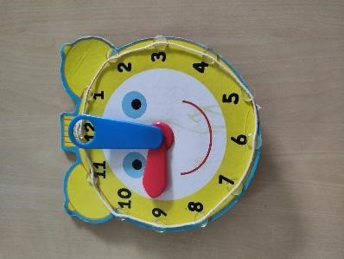

**At 9 o’clock, we came to Wildwood Childcare.**

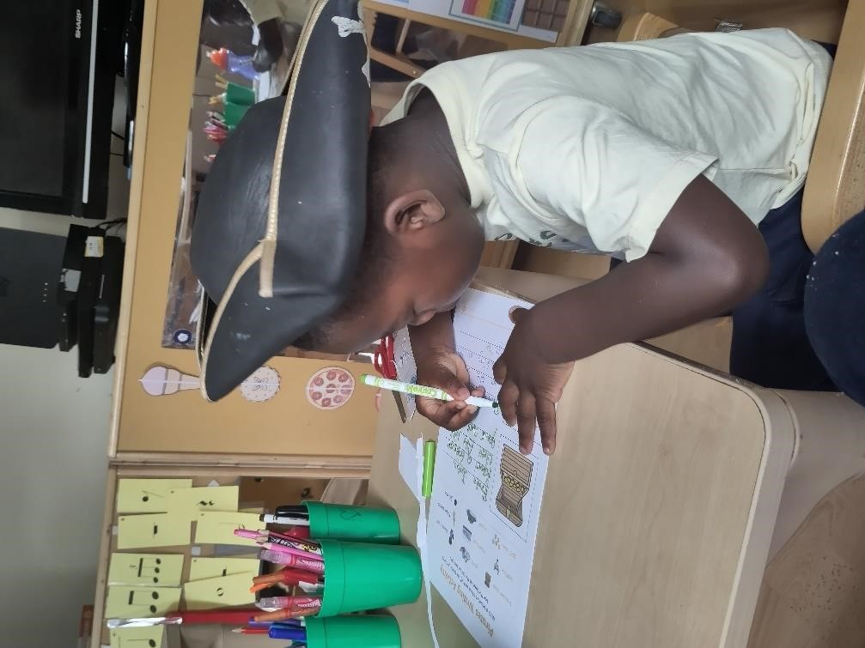

# **\*\*\* wrote a story about pirates.**

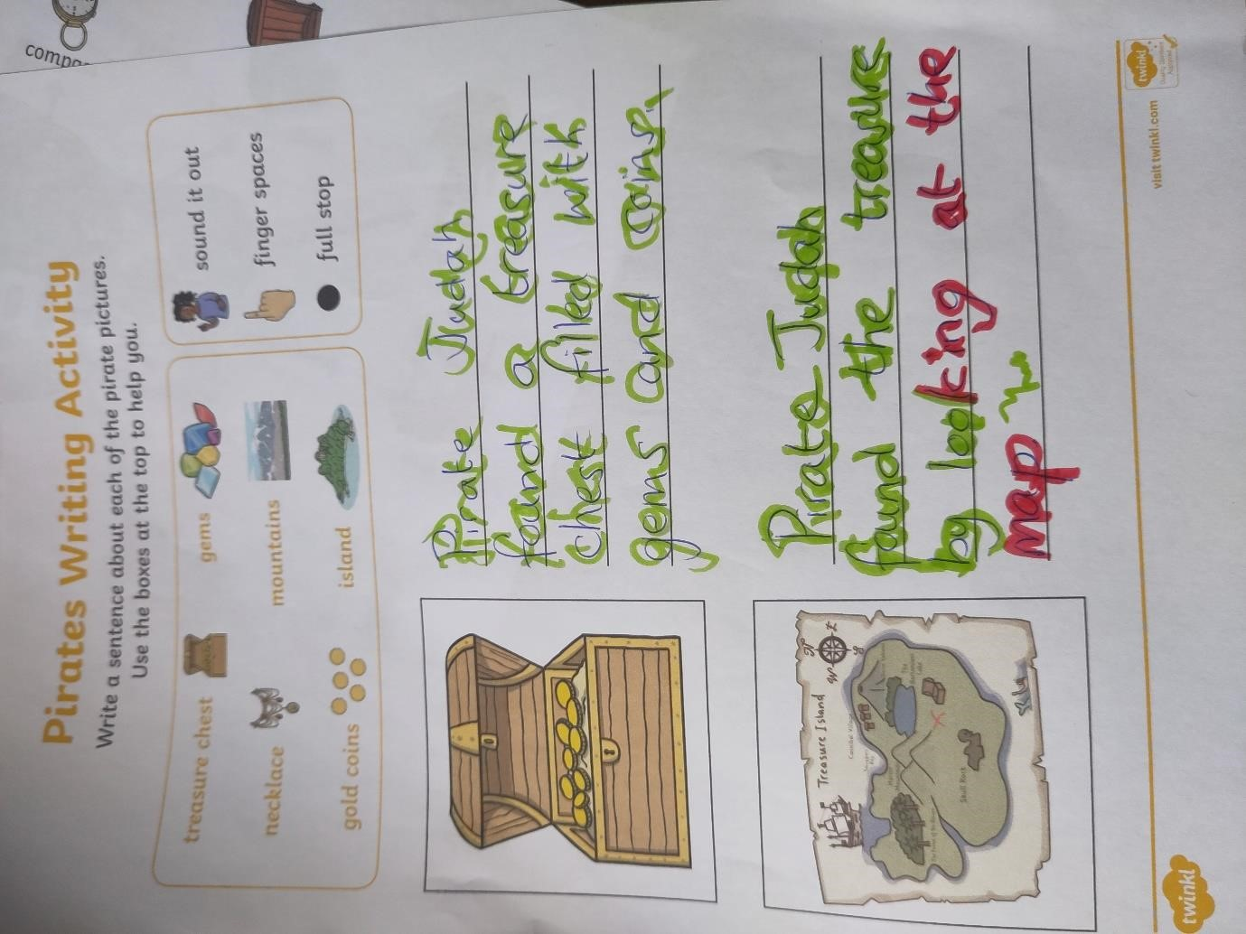

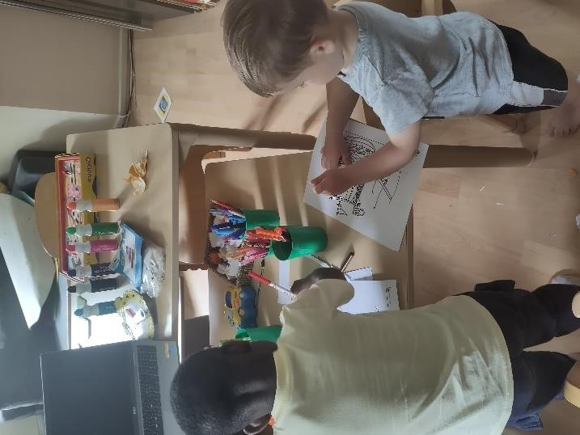

# **We made marks together.**

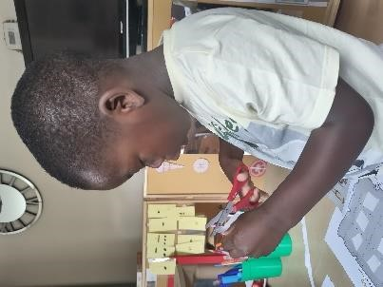

# *** carefully made marks with scissors.

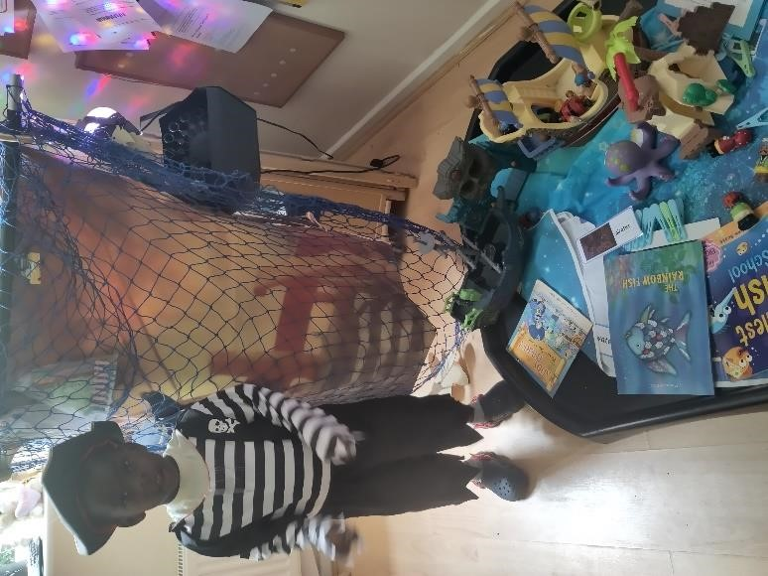

**We created a multi-sensory story.**

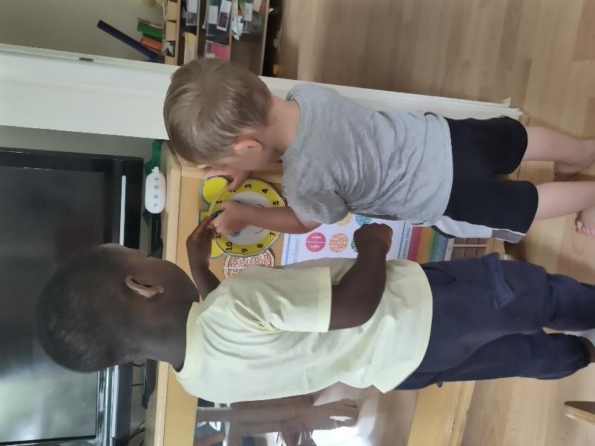

**We explored time together.**

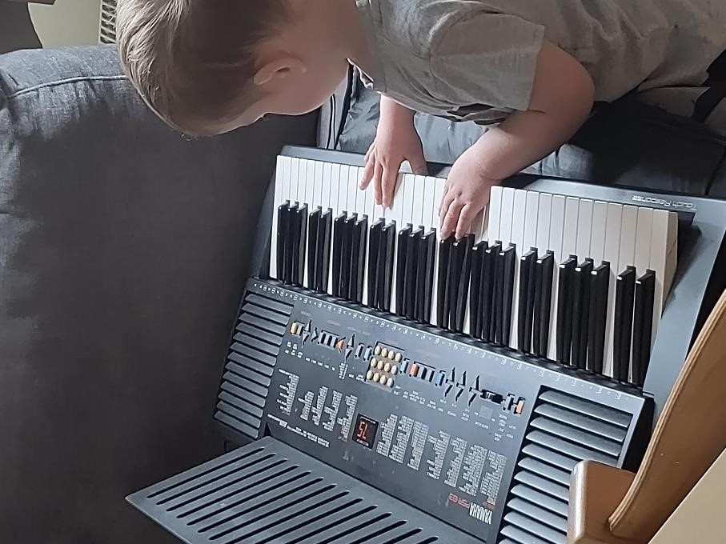

**We played keyboard.**

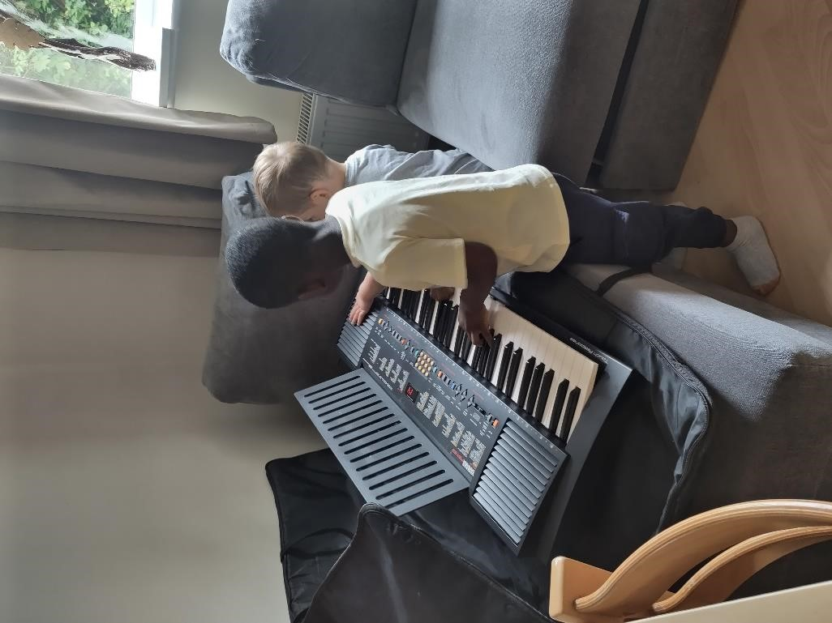

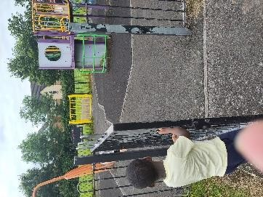



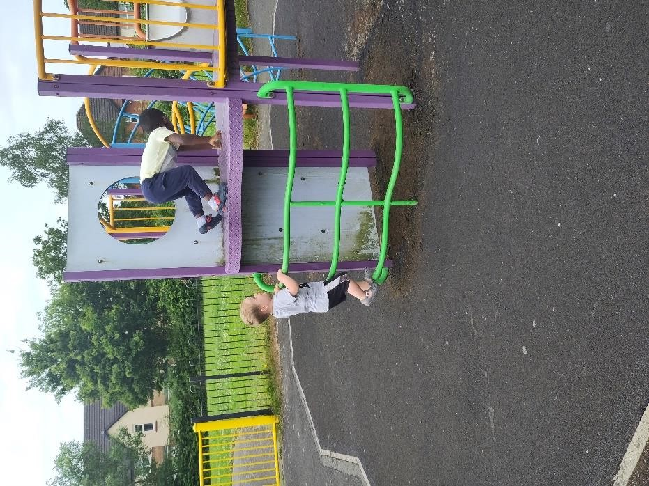

# **We climbed up.**

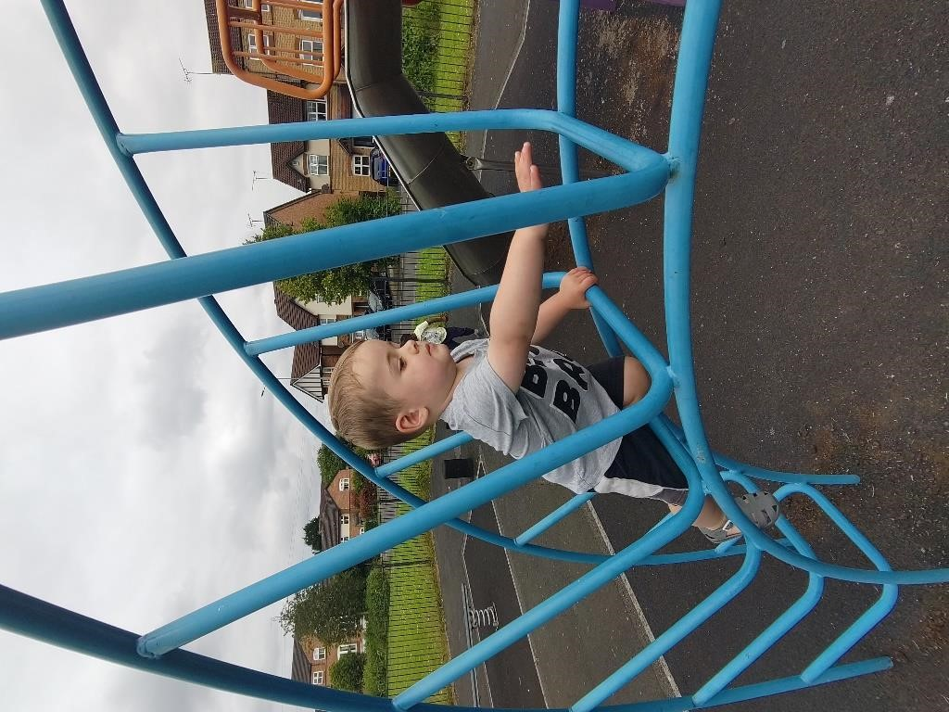



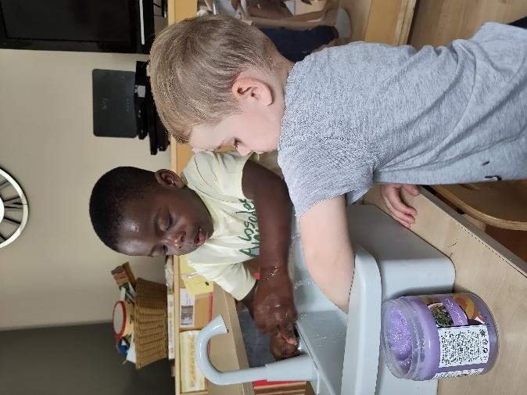

We washed our hands with soap and water.

**\*\*\* carefully poured drinking water.**

# 



# 



# 





 

