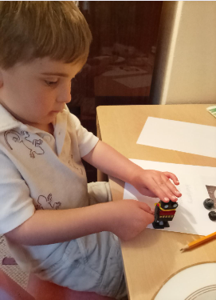

_____ used his fingers, carefully, to wind up a clockwork toy.

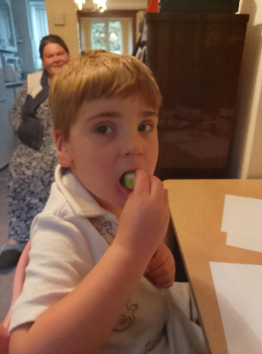

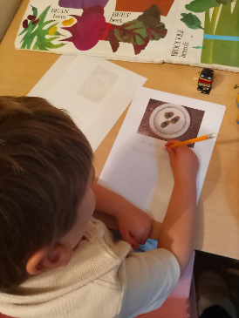
_____ used his fingers, carefully, to write with a pencil.

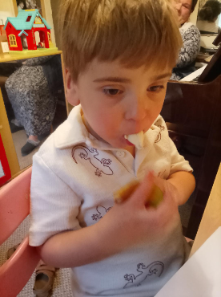

_____ tasted banana.

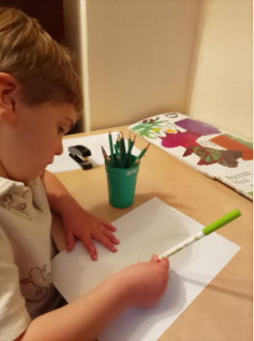

____ drew a bean with a green felt tip pen.

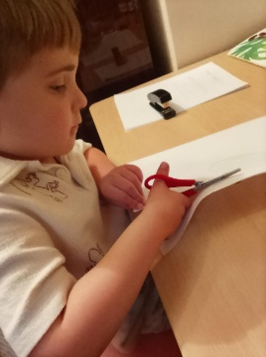

____ carefully used scissors.
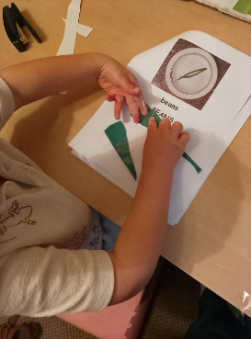
_____ used green paper to make some green beans.

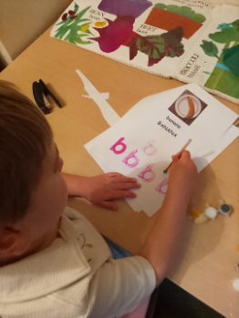

____ used a paintbrush and paint to make a banana

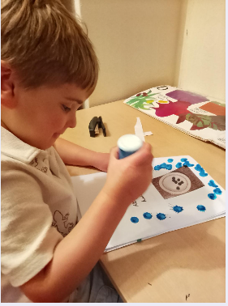

____ used paint in a dabber tub to make blueberries.

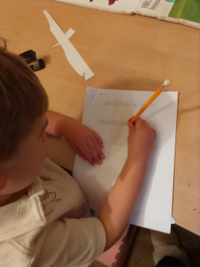
____, carefully, wrote B and b with a pencil.
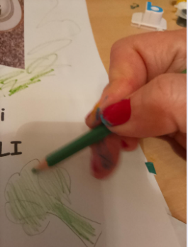
Louise, carefully, drew with her pencil too.

16 / 5 / 2025

Today we are thinking about the letter:

cccccccccccccccccccccccccccccccccccccccccccccccccccccccccccccc

CCCCCCCCCCCCCCCCCCCCCCCCCCCCCCCCCCCCCCCCCCCCCCCCCCCCCCCCCCCCCC
+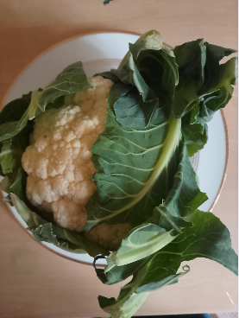

Cauliflower

CAULIFLOWER

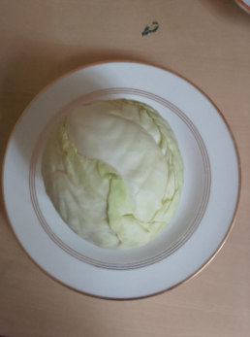

cabbage

CABBAGE

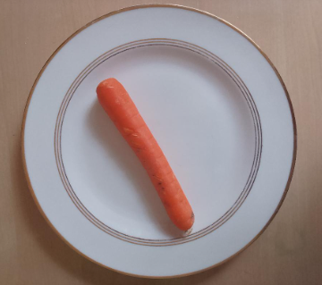

Carrot

CARROT

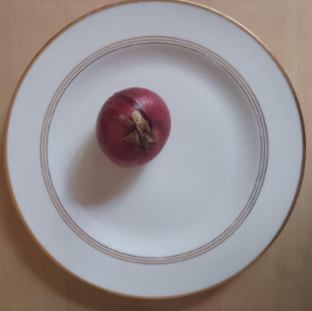

onion

ONION

Does onion begin with ‘ c ’ ?

Onion

ONION

---- used his fingers, carefully, to wind up a clockwork toy.

---- used his fingers, carefully, to write with a pencil.

---- tasted banana.

--- drew a bean with a green felt tip pen.

--- carefully used scissors.
---- used green paper to make some green beans.

---- used a paintbrush and paint to make a banana

----- used paint in a dabber tub to make blueberries.

-----, carefully, wrote B and b with a pencil.
Louise, carefully, drew with her pencil too.

16 / 5 / 2025

Today we are thinking about the letter:

cccccccccccccccccccccccccccccccccccccccccccccccccccccccccccccccccccccccc

CCCCCCCCCCCCCCCCCCCCCCCCCCCCCCCCCCCCCCCCCCCCCCCCCCCCCCCCCCCCCC

+

Cauliflower

CAULIFLOWER

cabbage

CABBAGE

Carrot

CARROT

onion

ONION

Does onion begin with ‘ c ’ ?

Onion

ONION

