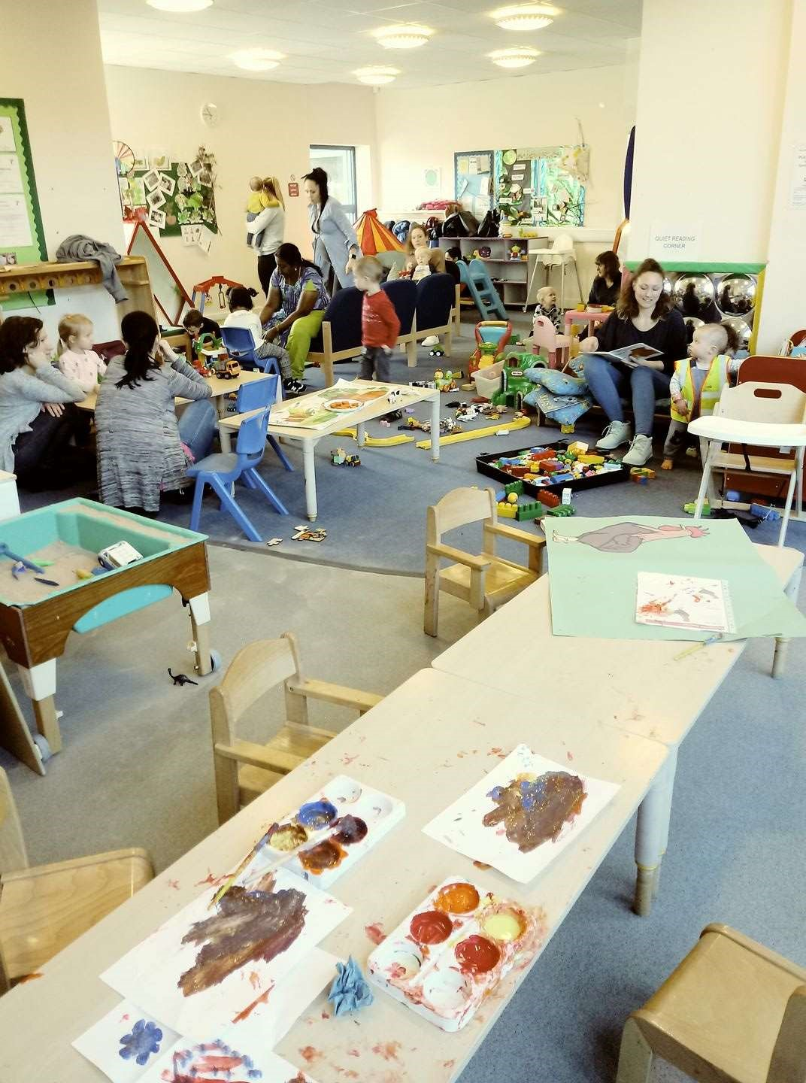

Planning for free-flow play

Here is an example of

friendship, social belonging,

esteem building,

transcendence, self-

actualization, security and

safety in action.

Through art and play, here

we experience customs and

cultures from all over the

world: China, New Zealand,

Australia, Africa, South

Africa, India, Poland,

Hungary, Bulgaria, Spain,

Italy, Croatia, Syria,

Scotland and Ireland to

name a few. The artwork in

progress was to celebrate

Chinese New Year

|  |
| --- |
| In addition I am a mother to three beautiful girls, each with unique gifts and talents. One is particularly musical, one is particularly content, one is exceptionally intelligent and physically unique (an occasional wheelchair user). All of our uniqueness are admired and loved. The disabilities listed in my long term planning refer to UK disability awareness days. (Best illustrated through play by visiting SNAP |

Wildwood Childminding Services “First Steps”

Areas of free flow play

|  |  |  |  |  |  |  |  |
| --- | --- | --- | --- | --- | --- | --- | --- |
|  | Communication and Language.  (listening, understanding, attention, speaking | Physical  Development  (gross motor, fine motor, health and selfcare) | Personal, social and emotional (self confidence, self awareness,  feelings, behaviour, relationships | Literacy  (reading writing pre reading and  pre-writing skills and mark making) | Mathematics (numbers / shape / space / measure) | Understanding the World People communities, the world, technology | Expressive Arts and Design (exploring and using media and materials and being imaginative) |
| January    Topics:  New Year  Winter  Snowman Village  White  Dinosaur sack | Woodland Play  Allotments  Adventure Play  Music and  Singing time  Story time  Cooking time  BBC Series Muzzy – vocab builder of all  European  Languages | Woodland Play  Allotments  Adventure Play  Music and  Singing time  Story time  Cooking time | Woodland Play  Allotments  Adventure Play  Music and  Singing time  Story time  Cooking time  New Year’s Day  Burn’s night Braille  awareness | Play dough  Slime  Heuristic  Sensory  Jolly phonics | Water  Sand  Different shapes / sizes containers  etc  Counting  Daily routine | Fire service Computer  availability?  Keyboard  availability? CD player | Paints Sewing / threading Constucton  Junk modelling  Printing |
| February Topics:      Winter  Dinosaurs  Green and blue Technology and construction sacks | Woodland Play  Allotments  Adventure Play  Music and  Singing time  Story time  Cooking time Muzzy – vocab builder of all  European  Languages | Woodland Play  Allotments  Adventure Play  Music and  Singing time  Story time  Cooking time | Woodland Play  Allotments  Adventure Play  Music and  Singing time  Story time  Cooking time  Pancake Day Cancer, Autism and epilepsy awareness | Play dough  Slime  Heuristic  Sensory  Jolly Phonics | Water  Sand  Different shapes / sizes containers  etc  Counting  Daily routine | Police Service | Paints Sewing / threading Constucton  Junk modelling  Printing |
| March | Woodland Play | Woodland Play | Woodland Play | Play dough | Water | Planting | Paints |

|  |  |  |  |  |  |  |  |
| --- | --- | --- | --- | --- | --- | --- | --- |
| Topics:  Springtime  Growing  Yellow  Roleplay sack | Allotments  Adventure Play  Music and  Singing time  Story time  Cooking time Muzzy – vocab builder of all  European  Languages | Allotments  Adventure Play  Music and  Singing time  Story time  Cooking time | Allotments  Adventure Play  Music and  Singing time  Story time  Cooking time  Mother’s Day  St Patrick’s Day  St David’s day  Holi,  Last Supper  Palm Sunday  Wheelchair and  Down’ Syndrome | Slime  Heuristic  Sensory  Jolly Phonics | Sand  Different shapes / sizes containers etc  Counting  Daily routine |  | Sewing / threading Constucton  Junk modelling  Printing |
| April    Topics_  Springtime  Water  Blue  Allotment Sack Hungry  caterpillar sack | Woodland Play  Allotments  Adventure Play  Music and  Singing time  Story time  Cooking time Muzzy – vocab builder of all  European  Languages | Woodland Play  Allotments  Adventure Play  Music and  Singing time  Story time  Cooking time | Woodland Play  Allotments  Adventure Play  Music and  Singing time  Story time  Cooking time  St George’s day  April Fool’s day  Passover  Easter  Baisaki  Autism | Play dough  Slime  Heuristic  Sensory  Jolly Phonics | Water  Sand  Different shapes / sizes containers etc  Counting  Daily routine | Growing  Duck Pond  Shugborough  Amerton | Paints Sewing / threading Constucton  Junk modelling  Printing |
| May    Topics:  Springtime May day (may pole / Morris dancing Allotment and mini beast sacks | Woodland Play  Allotments  Adventure Play  Music and  Singing time  Story time  Cooking time Muzzy – vocab builder of all  European  Languages | Woodland Play  Allotments  Adventure Play  Music and  Singing time  Story time  Cooking time | Woodland Play  Allotments  Adventure Play  Music and  Singing time  Story time  Cooking time  Deaf | Play dough  Slime  Heuristic  Sensory  Jolly Phonics | Water  Sand  Different shapes / sizes containers  etc  Counting  Daily routine | Growing  Duck Pond  Shugborough  Amerton | Paints Sewing / threading Constucton  Junk modelling  Printing |

|  |  |  |  |  |  |  |  |
| --- | --- | --- | --- | --- | --- | --- | --- |
| June    Topics:    Summertime  Orange  Floating and sinking  Allotment and  Farm Sack | Woodland Play  Allotments  Adventure Play  Music and  Singing time  Story time  Cooking time Muzzy – vocab builder of all  European  Languages | Woodland Play  Allotments  Adventure Play  Music and  Singing time  Story time  Cooking time | Woodland Play  Allotments  Adventure Play  Music and  Singing time  Story time  Cooking time  Eid  Father’s Day | Play dough  Slime  Heuristic  Sensory  Jolly phonics | Water  Sand  Different shapes / sizes containers etc  Counting  Daily routine | Growing  Duck Pond  Shugborough  Amerton | Paints Sewing / threading Constucton  Junk modelling  Printing |
| July    Topics:    Summertime  Red  Hot  Dry sand Alotment and  holiday sack | Woodland Play  Allotments  Adventure Play  Music and  Singing time  Story time  Cooking time Muzzy – vocab builder of all  European  Languages | Woodland Play  Allotments  Adventure Play  Music and  Singing time  Story time  Cooking time | Woodland Play  Allotments  Adventure Play  Music and  Singing time  Story time  Cooking time  Samaritans | Play dough  Slime  Heuristic  Sensory  Jolly Phonics | Water  Sand  Different shapes / sizes containers etc  Counting  Daily routine | Growing Cooking | Paints Sewing / threading Constucton  Junk modelling  Printing |
| August    Topics:  Summertime  Hot  Pink  Sweaty  Pirate and Jungle sack | Woodland Play  Allotments  Adventure Play  Music and  Singing time  Story time  Cooking time Muzzy – vocab builder of all  European  Languages | Woodland Play  Allotments  Adventure Play  Music and  Singing time  Story time  Cooking time | Woodland Play  Allotments  Adventure Play  Music and  Singing time  Story time  Cooking time  Rakhi | Play dough  Slime  Heuristic  Sensory  Jolly Phonics | Water  Sand  Different shapes / sizes containers etc  Counting  Daily routine |  | Paints Sewing / threading Constucton  Junk modelling  Printing |
| September    Topics:    World Book Day | Woodland Play  Allotments  Adventure Play  Music and  Singing time | Woodland Play  Allotments  Adventure Play  Music and  Singing time | Woodland Play  Allotments  Adventure Play  Music and  Singing time | Play dough  Slime  Heuristic  Sensory  Jolly Phonics | Water  Sand  Different shapes / sizes containers etc |  | Paints Sewing / threading Constucton  Junk modelling |

|  |  |  |  |  |  |  |  |
| --- | --- | --- | --- | --- | --- | --- | --- |
| Fairy  Allotment and  Starting School  Sack | Story time  Cooking time Muzzy – vocab builder of all  European  Languages | Story time  Cooking time | Story time  Cooking time  Harvest  Heart |  | Counting  Daily routine |  | Printing |
| October    Topics:    Halloween  Harvest  Postman and toy story sack | Woodland Play  Allotments  Adventure Play  Music and  Singing time  Story time  Cooking time Muzzy – vocab builder of all  European  Languages | Woodland Play  Allotments  Adventure Play  Music and  Singing time  Story time  Cooking time | Woodland Play  Allotments  Adventure Play  Music and  Singing time  Story time  Cooking time  Halloween  Dyslexia  Cerebral Palsy  Arthritis  Sight ADHD | Play dough  Slime  Heuristic  Sensory  Jolly phonics | Water  Sand  Different shapes / sizes containers etc  Counting  Daily routine |  | Paints Sewing / threading Constucton  Junk modelling  Printing |
| November    Topics:    Bonfire Night  Safety  Firefighter and  policemen sack | Woodland Play  Allotments  Adventure Play  Music and  Singing time  Story time  Cooking time Muzzy – vocab builder of all  European  Languages | Woodland Play  Allotments  Adventure Play  Music and  Singing time  Story time  Cooking time | Woodland Play  Allotments  Adventure Play  Music and  Singing time  Story time  Cooking time  Bonfire Night  St Andrew’s Day  Diwali diabetes | Play dough  Slime  Heuristic  Sensory  Jolly Phonics | Water  Sand  Different shapes / sizes containers  etc  Counting  Daily routine |  | Paints Sewing / threading Constucton  Junk modelling  Printing |
| December  Christmas    Topics:  Winter  Chiristmas  Wacky | Woodland Play  Allotments  Adventure Play  Music and  Singing time  Story time  Cooking time  Muzzy – vocab | Woodland Play  Allotments  Adventure Play  Music and  Singing time  Story time  Cooking time | Woodland Play  Allotments  Adventure Play  Music and  Singing time  Story time  Cooking time  Hannukah  Christmas | Play dough  Slime  Heuristic  Sensory  Jolly Phonics | Water  Sand  Different shapes / sizes containers  etc  Counting  Daily routine |  | Going to work or school |

Wildwood Childminding Service“First Steps” Daily Routine

|  |  |  |
| --- | --- | --- |
| Time | Babies | Todler |
| 9.15 – 10 | Free flow play  Literacy / mathematical focus | Free flow play  Literacy / mathematical focus |
| 10 – 10.30 | snack | snack |
| 10.30 – 11 | sleep | storytime |
| 11.15 – 11.45 | Creative focus | Creative focus |
| 11.45 – 12.15 | lunchtime | lunchtime |
| 12.15 – 12.45 | sleeptime | Outdoor play |
| 12.45 – 1.15 | sleeptime | Outdoor play |
| 1.15 – 1.45 | sleeptime | Outdoor play |
| 1.45 – 2.15 | Outdoor play | Outdoor play |
| 2.15 – 2.45 | Messy play | Messy play |
| 2.45 – 3.15 | Picnic time | Picnic time |
| 3.15 – 3.45 | PSHE focus | Pshe focus |
| 3.45 - 4 | Preparing for home Daily diary | Preparing for home Daily diary |
|  |  |  |

**Trips Risk Assessment**

**And Operating Procedure**

|  |  |
| --- | --- |
| Allotments |  |
| Minimum Qualification of leader | PGCE |
| Miaximum group size | Minimum ratio 3:1 |
| Risk assessment | Control Measures |
| Hazards | Stranger danger training |
| Water | The children will not play anywhere near the canal at the bottom of wooded / play area. It does have a deep surrounding of nettles and braken making it unavailable but this will be checked regularly. Discuss Water Safety |
| Roads | Discuss Road Safety  Use the road free route to the park. (You can access the park using only footpaths and an Underground tunnel |
| Carpark | Avoided by using underground access to the park |

Trips Risk Assessment

|  |  |
| --- | --- |
|  | snack, water and nappies |
| Date of review | Monthly review (1st of each month) |

And Operating Procedure

|  |  |
| --- | --- |
| Adventure Play |  |
| Minimum Qualification of leader | PGCE |
| Miaximum group size | ratio 3:1 |
| Risk assessment | Control Measures |
| Hazards | Stranger danger training |
| Water | The children will not play anywhere near the canal at the bottom of wooded / play area. It does have a deep surrounding of nettles and braken making it unavailable but this will be checked regularly. Discuss Water Safety |
| Roads | Discuss Road Safety  Use the road free route to the park. (You can access the park using only footpaths and an Underground tunnel |
| Carpark | Avoided by using underground access to the park |

Trips Risk Assessment

|  |  |
| --- | --- |
|  | snack, water and nappies |
| Date of review | Monthly review (1st of each month) |

And Operating ProcedureActvity:

|  |  |
| --- | --- |
| Wooded play |  |
| Minimum Qualification of leader | PGCE |
| Miaximum group size | ratio 3:1 |
| Risk assessment | Control Measures |
| Hazards | Stranger danger and dog awareness |
| Water | The children will not play anywhere near the canal at the bottom of wooded / play area. It does have a deep surrounding of nettles and braken making it unavailable but this will be checked regularly. Discuss Water Safety |
| Roads | Discuss Road Safety  Use the road free route to the park. (You can access the park using only footpaths and an Underground tunnel |
| Carpark | Avoided by using underground access to the park |

Trips Risk Assessment

|  |  |
| --- | --- |
|  | snack, water and nappies |
| Date of review | Monthly review (1st of each month) |

And Operating ProcedureActvity:

|  |  |
| --- | --- |
| Ball tarmac area |  |
| Minimum Qualification of leader | PGCE |
| Miaximum group size | Minimum ratio 3:1 |
| Risk assessment | Control Measures |
| Hazards |  |
| Water | The children will not play anywhere near the canal at the bottom of wooded / play area. It does have a deep surrounding of nettles and braken making it unavailable but this will be checked regularly. Discuss Water Safety |
| Roads | Discuss Road Safety  Use the road free route to the park. (You can access the park using only footpaths and an Underground tunnel |
| Carpark | Avoided by using underground access to the park |

|  |  |
| --- | --- |
|  | snack, water and nappies |
| Date of review | Monthly review (1st of each month) |

Trips Risk Assessment And Operating Procedure Actvity:

|  |  |
| --- | --- |
| Duck Pond |  |
| Minimum Qualification of leader | PGCE |
| Miaximum group size | ratio 3:1 |
| Risk assessment | Control Measures |
| Stranger Danger | Check individuals childminding reg |
| Water | Discuss Water Safety  Do not go near the edge of the pond  Mud can be slippy. Do not go near if muddy. Let the ducks go onto tarmac area |
| Roads | Discuss Road Safety  Use the road free route to the park. (You can access the park using only footpaths and an Underground tunnel |
| Carpark | Avoided by using underground access to the park |

|  |  |
| --- | --- |
|  | snack, water and nappies |
| Date of review | Monthly review (1st of each month) |

Trips Risk Assessment And Operating ProcedureActvity:

|  |  |
| --- | --- |
| Shugborough |  |
| Minimum Qualification of leader | PGCE |
| Miaximum group size | Minimum ratio 3:1 |
| Risk assessment | Control Measures |
| Hazards |  |
|  |  |
| Roads | Discuss Road Safety when exiting vehicle. Wear safety tabard.  Hold hands. Be aware of cars and green cross code. (Stop, look, listen, think “is it safe?) |
| Animals | Wash hands thoroughly after touching animals. Some animals it may not be safe to touch? Discuss this with children. They might bite? |
| Emergency procedure | Safety equipment taken in the form of fluorescent tabard with the name of the group and 07494364316 written on. Mobile phone, |

|  |  |
| --- | --- |
|  | coded contact book and medication book taken on trips including snack, water and nappies |
| Date of review | Monthly review (1st of each month) |

Trips Risk Assessment

And Operating ProcedureActvity:

|  |  |
| --- | --- |
| Wacky | Check CRB status of staff with manager |
| Minimum Qualification of leader | PGCE |
| Miaximum group size | ratio 3:1 |
| Risk assessment | Control Measures |
| Hazards |  |
| Stranger Danger | Wacky opens up to childminders. Check registrations. Be aware. |
| Roads | Discuss Road Safety. Wear safety tabard. Hold hands. Be aware of cars and green cross code. (Stop, look, listen, think “is it safe?) |
| Animals | Wash hands after touching animals |
| Emergency procedure | Safety equipment taken in the form of fluorescent tabard with the name of the group and 07494364316 written on. Mobile phone, |
|  | coded contact book and medication book taken on trips including snack, water and nappies |
| Date of review | Monthly review (1st of each month) |

Trips Risk Assessment

And Operating ProcedureActvity:

|  |  |
| --- | --- |
| Silkmore childminder centre |  |
| Minimum Qualification of leader | PGCE |
| Miaximum group size | Minimum ratio 3:1 |
| Risk assessment | Control Measures |
| Hazards |  |
|  |  |
| Roads | Discuss Road Safety. Wear safety tabard. Hold hands. Be aware of cars and green cross code. (Stop, look, listen, think “is it safe?) |
|  |  |
| Emergency procedure | Safety equipment taken in the form of fluorescent tabard with the name of the group and 07494364316 written on. Mobile phone, coded contact book and medication book taken on trips including  snack, water and nappies |
| Date of review | Monthly review (1st of each month) |

Permission slip

The parent of …………………………………………………………………………………………

Gives permission for Louise Nixon to go on the following educational play visits:

The allotments and areas of wildwood park

Wildwood duck pond

Catch corner wacky

Shugborough Park

I also give permission for photographs to be taken for assessment purposes.

This may / may not be used for social advertising and media

Details of insurance policy documents and risk assessment details have been provided

Signed ………………………………………………………….Date ………………………………………………………….

Personal Log

|  |  |
| --- | --- |
| Name of child |  |
| Date of birth | Age |
| Address | Parental contact details |
|  | Do both parents have parental responsibility? |
| Medical Information | Any disabilities (use additional booklet if required) |
| Food preferences |  |
| Likes | Dislikes |
|  |  |
| Home routine | Comforter |
| Any additional Information? |  |
|  |  |

Early Learning Goal Observation Date

Communication and Language

Listening and Attention Understanding

|  |  |  |  |  |
| --- | --- | --- | --- | --- |
|  | Insert photograph | |  |  |
| What this demonstrates |  |  |  |  |
|  | Next Steps |
|  |  |  |

Speaking

Early Learning Goal Observation Date

Physical Development

Moving and Handling Health and Self Care

Gross motor Fine motor

|  |  |  |  |  |
| --- | --- | --- | --- | --- |
|  |  | Insert Photograph |  |  |
| [Type a quote from the document o the summary of an interesting point.  You can position the text box anywhere in the document. Use the Drawing  Tools tab to change the formatting of  the pull quote text box.] | r |  |  |
| [ | Type a quote from the document or the summary of an interesting point. You  can position the text box anywhere in the document. Use the Drawing Tools tab to change the formatting of the pull  quote text box.] |
|  |  |  |
|  | |

Including hygiene, dressing toilet

Early Learning Goal Date

Mathematics

Number Shape, Space and Measure

|  |  |  |  |  |
| --- | --- | --- | --- | --- |
|  | Insert photograph | |  |  |
| What the photograph demonstrates |  |  |  | Next Steps |
|  |  |  |

Understanding the world

People and Communities The World Technology

Past and present Animal and plant observation Select and Use Similarities and differences Environment

|  |  |  |  |
| --- | --- | --- | --- |
|  | Photographs | |  |
| What the picture shows |  |  |  |
|  |  | Next Steps |

Expressive Arts and Design Date

Singing Music Making Dance Materials Tools and Techniques

Colour Design Texture Form and Function Role Play

|  |
| --- |
| Photograph and next steps |

Imagination Story Making

Useful Numbers

First Response 0800 1313126 firstr@staffordshire.gov.uk

Ofsted 0300 123 1231

Early Years Support 07891 479005 or 07800626531

Stafford Police 101

Pacey 08458800044

Morton and Michelle 0845 2570900

Assessment

Daily diary

Learning Journey

Profile

Observations

Feedback from primary carer via Wow cards and discussion and parents meeting