**Wildwood Childcare**

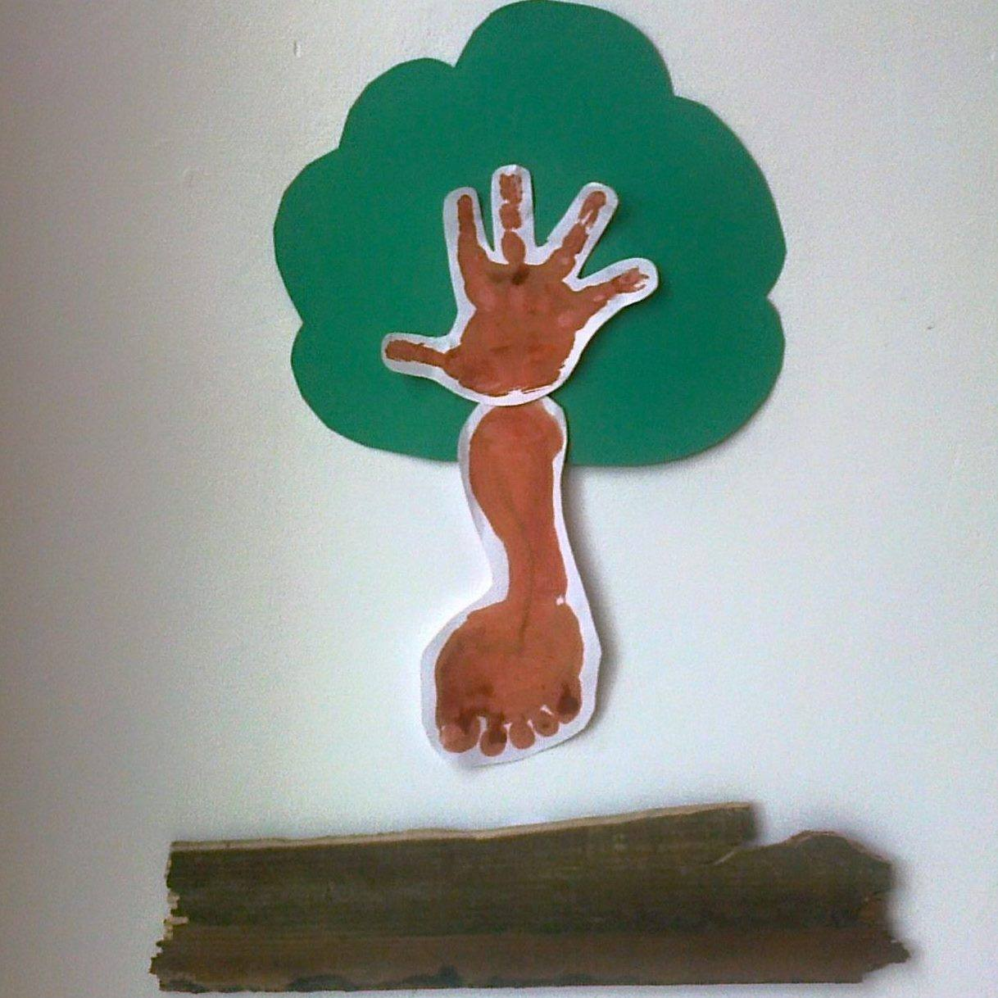

**laugh, live, love to learn**

**… naturally**

**Wildwood Childcare Ltd Library books**

**(plus Twinkl access)**

**Review date: Sept 2022**

**Multi -Story Sacks:**

**January: Chinese New Year**

**February: Little Nutbrown Hare: Summer, Autumn, Spring, Winter**

**March: Magic train-ride**

**Easter**

**May: Superworm**

**June: Oliver’s Vegetables**

**July: Rainbow Fish**

**August: Non-Fiction African Texts and Handa’s Surprise**

**October: The Scarecrow’s Wedding. Texts about Diwali**

**November: Guy Fawkes**

**December: The Nativity and Father Christmas needs a wee**

**Nursery**

**Actions: Toy Story 3 Pixar**

Duck in the Truck Jez Alborough HarperCollins

I love you this much Igloo books

My Daddy Neville Astley Ladybird

Peppa Pig Story Treasury Neville Astley Ladybird

Peppa Pig Loves Christmas Neville Astley Ladybird

Goodnight Peppa Neville Astley Ladybird

First Colours Usborne

Meeble’s Magic Box Wendy Body

First 50 words bright baby

Farm bright toddler

Hot fox Ladybird

Oh Dear! Rod Campbell

Busters Zoo Rod Campbell Ladybird

My little word book Priddy

My First farm Igloo

Numbers Eric Carle

We honestly can look after your dog Lauren Child Puffin

I am too absolutely small for school Lauren Child Puffin

Whoops but it wasn’t me Lauren Child Puffin

But excuse me that is MY book! Lauren Child Puffin

My Wobbly Tooth must not never fall out Lauren Child Puffin

I’m really ever so not well Lauren Child Puffin

Fox’s socks Julia Donaldson MacMillan

Penguin Polly Dunbar Puffin

Winston was Worried Pamela Duncan Edwards

Dinosaur’s in the Supermarket Timothy Knapman Scholastic

Spot’s Favourite Stories Eric Hill Puffin

Spot’s Noisy walk Eric hill Puffin

# The Incredible book eating boy Oliver Jefferson Harper Collins

Dear Bunny Michaela morgan

Whatever Next? Julia Murphy MacMillan

Ten Apples on Top Theo leSieg Random House

I don’t want to go to bed Tony Ross Harper Collins

The Night Before the Night Before Christmas Richard Scary’s Harper Collins

The Smallest Fish in School Matthew Scott Igloo books

Fox In Socks Dr Seus Harper Collins

Green Eggs and Ham Dr Seus Harper Collins

The Cat in the Hat Dr Seus Harper Collins

Hop on Pop Dr Seus Harper Collins

The Cat in the Hat comes back Dr Seus

The Three Little Pigs Chad Valley

Time for a Rhyme Bookstart

Ruby Flew Too Jonathan Emmett

Ten Little Princesses Mike Brownlow Orchard books

Playtime Rhyme Sally Gardner Dolphin Paperback

Where Does The Sea Go? Jan Godfrey t

Up and Down Oliver Jeffers Harper Collins

That’s not my Christmas Sticker Book Usborne

How to Catch a Star Oliver Jeffers Harper Collins

The way back home Oliver Jeffers Harper Collins

Helping your Child to Read Oxford Reading Tree

My Little Word Book Roger Priddy

Rainbow Magic: Shannon the Ocean Fairy Daisy meadows

A patch of Black Rooney MacMillan

Mother Goose’s Bedtime Rhymes Alex Scheffler MacMillan

Mother Goose’s Action Rhymes Alex Scheffler MacMillan

Dear Mother Goose Michael Rosen Walker Books

We’re Going on a Bear Hunt Michael Rosen

Humpty Dumpty CE

Hickory Dickory Dock CE

Incy Wincy CE

Skye’s got to fly Nickelodeon

Itty-Bitty Kitty Rescue Nickelodeon

That’s not my monster Watt

My Busy Books Nickelodeon

The Noisy Way to Bed Ian Whybrow MacMillan

Bath time with Humphrey igloo

Let’s sing Disney

Thomas the Tank Engine Egmont

The Three Billy Goats Gruff Gold Stars

Number Parade: A wildlife counting book Jackie Wood

Key Words with Peter and Jane Ladybird

My Little Pony: Princess Cadance’s Royal Holiday Orchard books

My Little Pony: Race Day in Rainbow fall Orchard books

My Little Pony: cutie, mark Crusaders forever Orchard books

My Little Pony: Magical baby furry heart Orchard books

My little Pony : the secret of gabby gems Orchard books

My little Pony: Twilight Sparkle and the Crystal empire Orchard books

Plus Stafford and Baswich library for non-fiction topic books

A Guide to Potty Training Usborne

Leadership and Management in the Early Years

**Infants**

Sticker Dolly Dressing Fairies Stella Baggott Usborne

Sticker Dolly Dressing Ballerinas Stella Baggott Usborne

Faster, Faster Benedict Blathway RedFox

Lucky Charlie Bucket Roald dahl Puffin

My Awesome Alphabet Book Make believe ideas

Stick Man sticker activity book Julia Donaldson Usborne

Stick man Julia Donaldson Usborne

Zogg Julia Donaldson Usborne

The Scarecrows Wedding Julia Donaldson Usborne

A Squash and a Squeeze Julia Donaldson Usborne

The Gruffalo Julia Donaldson Usborne

The Gruffalo Child Julia Donaldson MacMillan

Zog and the Flying Doctors Julia Donaldson MacMillan

Finding Dory Pixar

Cheeky Chimpanzees Sally Grindley Orchadbooks

Baboon on the Moon Ladybird

Old MacDonald Heard a Parp Olaf Falafel Harpercollins

Bear’s Reading Adventure Book Start

Sam Sheep Can’t Sleep Phil Roxbee Cox Usborne

Fairy Child Bob Graham Walkers

Rose Meets Mr Wintergarten Bob Graham Walkers

Max Bob Graham Walkers

Queenie the Bantam Bob Graham Walkers

Buffy and Adventure Story Bob Graham Walkers

Tooth Fairy Bob Graham Walkers

Magnus Mouse and the Treasure Chest Holmes

Wow said the Owl Tim Hopgood MacMillan

Santa Claus’ Helpers and the Nutcracker Miles Kelly

A Christmas Tree Adventure Miles Kelly

The First Christmas Tree Miles Kelly

Jimmieboy’s Snowman Miles Kelly

Making Angels in the Snow Miles Kelly

Christopher Nibble Middleton Oxford University Press

The Lorax Dr Seus Harper Collins

Oh, The Places You’ll Go Dr Seus Harper Collins

Sleep Book Dr Seus Harper Collins

One Fish, Two Fish, Red fish, Blue Fish Dr Seus Harper Collins

Sneetches Dr Seus Harper Collins

I can read with my eyes shut Dr Seus Harper Collins

How the Grinch Stole Christmas Dr Seus Harper Collins

Rhyming Rabbit Julia Donaldson MacMillan

The Smartest Giant in Town Julia Donaldson MacMillan

Superworm Julia Donaldson MacMillan

The Gruffalo Child Julia Donaldson MacMillan

Monkey Puzzle Julia Donaldson MacMillan

Splat Cat Ladybird

Buffy An Adventure Story Bob Graham Walker

Let’s Get Pup Bob Graham Walker

The Trouble with dogs Bob Graham Walker

The Emperor’s New Clothes Sue Graves Chad Valley

Jack and the Beanstalk Sue Graves Chad Valley

Hansel and Gretel Sue Graves Chad Valley

Mr Bump and the Runaway Skis Roger Hargreaves Egmont

Mr Noisy Colouring Book Roger Hargreaves Egmont

Little Miss Tiny’s Big Adventure Roger Hargreaves Egmont

Percy Purr Roger Hargreaves Egmont

Sam Squeak Roger Hargreaves Egmont

My Mr Small colouring book Roger Hargreaves Egmont

Complete Mr Men Series Roger Hargreaves Egmont

Mr Tickle colouring book Roger Hargreave Egmont

Goldilocks and the Three Bears Monica Hughes Chad Valley

Rapunzel Monica Hughes Chad Valley

Alfie Gives a Hand Shirley Hughes

Look and Find Spiderman Marvel

Minnie Booming Bells Disney

Jasmine Disney

Brave Disney

Beauty and the Beast Disney

Tangled Disney

Great Adventures Disney

Cinderella’s Royal Wedding Disney

Christmas Carols Ladybird

Shopping Poems Oxford Reading Tree

How to catch a mouse Philip Leathers Walker

Guess How much I love you Mc Bratney Walker

Peace at Last Jill Murphy

Royal Fairy Tales for Bedtime Mairi MacKinnon Usborne

My First 1000 words in French Susan Martineau B small publishing

The Large Family Collection Jill Murphy Walker

Gran and Grandpa Helen Oxenbury

Robots James Patterson

Bob Bushtail’s Adventure Perring Ladybird

My Best Friend Bob George Ripper MacMillan

Sheriff Showoff Ladybird

Peppa Goes Around the World Ladybird

Looking for Lossie hazel Townson Leapfrog

Stories for Bedtime Brown Watson

What does the fox say? Bard Ylvisaker picturebookden

My Little Pony: A Springtime Surprise orchardbooks

Adventure in everfree forest orchardbooks

Pets Deluxe Story book centum

Plus Baswich and Stafford library for non-fiction topic books

**Juniors**

Watership Down Richard Adams

Out of this World Ali Sparkes

The Mysterious Bendict Society Trenton Lee Stewart

Michael Morpurgo

Suffragette Dollie Baxter

Carrie’s War Nina Bawden YMC

The Peppermint Pig Nina Bawden YMC

Keeping Henry Nina Bawden YMC

Utterly Clarie Bean

Frozen Charlotte Alex Bell Red Eye

The Twins at St Clair’s Enid Blyton Egmont

The O’Sulivan Twins Enid Blyton Egmont

Summer Term at St Clair’s Enid Blyton Egmont

Second Form at St Clair’s Enid Blyton Egmont

Third Form at St Clair’s Enid Blyton Egmont

Christmas Stories Enid Blyton Egmont

The Mystery of the Pantomime Cat Enid Blyton Egmont

The Mystery of the Secret Room Enid Blyton Egmont

The Mystery of the Banshee Towers Enid Blyton Egmont

The Mystery of the Vanished Prince Enid Blyton Egmont

The Mystery of the Invisible Thief Enid Blyton Egmont

Tales of Brave Adventure Enid Blyton Egmont

The Enchanted Wood Enid Blyton Egmont

The Secret Seven Enid Blyton Egmont

The Naughtiest Girl in the School Enid Blyton Egmont

The three golliwogs Enid Blyton Egmont

The Mystery of the Burnt Cottage Enid Blyton Egmont

The Mystery of Holly Lane Enid Blyton Egmont

The Mister Meddle stories Enid Blyton

The Mystery of the Missing Man Enid Blyton Egmont

The Mystery of the Strange Bundle Enid Blyton Egmont

The Mystery of Tally Ho Cottage Enid Blyton Egmont

The Folk of the Faraway Tree Enid Blyton Egmont

Five on a treasure island Enid Blyton Egmont

The Brer Rabbit book Enid Blyton Egmont

Mystery of the disappearing cat Enid Blyton Egmont

The Mystery of the Hidden Horse Enid Blyton Egmont

More Wishing Chair Stories Enid Blyton Egmont

The Twins at St Clare’s Enid Blyton Egmont

Runaway Enid Blyton Egmont

The Famous Five Enid Blyton Egmont

Mallory Towers Enid Blyton Egmont

More About Paddington Michale Bond

As Old as Time: A Twisted Tale Braswell

Cathy Cassidy: Looking glass girl Cassidy Puffin

The Legend of Spud Murphy Collier

How to Speak Dragonese Cressida Cowell

How to be a Pirate Cressida Cowell

How to train your dragon Cressida Cowell

The BFG Roald Dahl Puffin

Charlie and the Chocolate Factory Roald Dahl Puffin

Charlie and The Great Glass Elevator Roald Dahl Puffin

Danny the Champion of the World Roald Dahl Puffin

Loralli Laura Duckrill

Oliver Twist Charles Dickens Vintage

The Christmas Story Doubleday

The Jolley-Rogers and the Monsters Gold Lindgren

The London Eye Mystery Dowd Corgi

The Twits Roald Dahl Puffin

Horrible Histories: Savage Stone Age Terry Dreary Scholastic

Horrible Histories: Terrifying Tudors Terry Deary Scholastic

Horrible Histories:Cruel Kings and Mean Queens Terry Dreary Scholastic

Horrible Histories: Awful Egyptians Terry Dreary Scholastic

Horrible Histories: The USA Terry Dreary Scholastic

Horrible Histories: Annual 2008 Terry Dreary Scholastic

Horrible Histories: The Blitzed Btitz Terry Dreary Scholastic

Horrible Histories: The Ruthless Romans Terry Dreary Scholastic

Horrible Histories: The Slimy Stuarts Terry Dreary Scholastic

Horrible Histories: The Stormin Normans Terry Dreary Scholastic

The Barmy British Empire Terry Dreary Scholastic

Fire and Roses Fiona Dunbar Orchard

Venus Rocks Fiona Dunbar Orchard

More Naughty Little Sister Stories Edwards Egmont

My Naughty Little sister’s friends Edwards Egmont

Gambledad Josephine Feeny

Once Morris Gleitzman

The Hex Factor Harriet Goodwin Stripes

Daisy and the trouble with kittens Gray red Fox

The Unbeatable Squirrel Girl Hale Scholastic

A boy called Christmas Haig

The Rescue Princess Harrison Noisy Crow

The rescue Princess: Shimmering Stone Harrison Nosy Crow

The Rescue Princess: The Wishing Pearl Harrison Nosy Crow

The Rescue Princess: The lost gold Harrison Nosy Crow

The rescue Princess: The Snow Jewel Harrison Nosy Crow

The Usborne Creative Writing Book Usborne

Set of 10 Beano Annuals

The Wimpy Kid: Do it Yourself Book Kinney Puffin

Diary of a Wimpy Kid: The Ugly truth Kinney Puffin

Diary of a Wimpy Kid: The Third Wheel Kinney Puffin

Diary of a Wimpy Kid: Old School Kinney Puffin

Diary of a Wimpey Kid Kinney Puffin

Diary of a Wimpy Kid: Cabin Fever Kinney Puffin

Diary of a wimpy Kid: hard Luck Kinney Puffin

Hanns Christian Anderson: His most beloved fairy tales Globe

A sister more like Me Brittney Lee Parragon

The Magician’s Nephew CS Lewis

The Lion the Witch and the Wardrobe CS Lewis

The Horse and His Boy CS Lewis

Prince Caspan CS Lewis

The Voyage of the Dawn Treader CS Lewis

The Silver Chair CS Lewis

The Last Battle CS Lewis

Mulan Parragon

Sleepless Lou Morgan red Eye

What do grown ups do all day? Virginie Morgland Wide Eyed

Billy the Kid Michael Morpurgo Harper Collins

Singing for Mrs Perrigrew Michael Morpurgo Harper Collins

Alone in a wide wide sea Michael Morpurgo Harper Collins

Why the Whale Came Michael Morpurgo Harper Collins

Stuff that Scares your pants off Glen Murphy

Judy Moody Declares Independence Megan McDonald Walker Books

Will Farts Destroy the Planet? Glen Murphy McMillan

Fun with the Worst Witch Murphy

The Adventures of Dotty and Bluebell Jools Oliver Puffin

Wonder Palacio Puffin

Mrs Pepperpot Alf Proysen Red Fox

Anna and Froga Anouk Ricard

Library of Souls Riggs

What’s so Special About Shakespeare? Michael Rosen Walkerson

Michael Rosen’s A-z Michael Rosen Walkerson

Banana’s in my ears Michael Rosen Walkerson

Horrid Henry’s Guide to Perfect Parents Francesca Simon Orion

Out of this World Ali Sparkes Oxford

Destination Earth Ali Sparkes Oxford

Frozen in Time Ali Sparkes Oxford

Wishful Thinking Ali Sparkes Oxford

Dark Summer Ali Sparkes Oxford

Dancing Show Noel Streatfield

The Mysterious Benedict Society Stewart Chicken Mouse

The Mysterious Benedict Society and the Prisoner’s dilemas Stewart Chicken Mouse

The Mysterious Benedict Society and the Perilous Journey Stewart Chicken Mouse

The Extraordinary Education of Nicholas Benedict Stewart Chicken Mouse

Sun, Moon and Starts Turnball

Do Goldfish play the Violin Wilson

Awful Auntie David Williams Harper Collins

Grandpa’s Great Escape David Williams Harper Collins

Demon Dentist David Williams Harper Collins

Blob David Williams Harper Collins

Bad Dad David Williams Harper Collins

Mr Stink David Williams Harper Collins

The World’s Worst Children David Williams Harper Collins

The Longest Whale Song David Williams Harper Collins

The Midnight Gang David Williams Harper Collins

Gangsta Granny David Williams Harper Collins

Billionaire Boy David William Harper Collins

Summer holidays Mystery Willoughberry Orion

The Werepuppy Jacqueline Wilson Double Day

Girls in Tears Jacqueline Wilson Double Day

The Diamond Girls Jacqueline Wilson Harper Collins

Butterfly Beach Jacqueline Wilson Doubleday

The Mum Minder Jacqueline Wilson Doubleday

My Sister Jodie Jacqueline Wilson Doubleday

Candyfloss Jacqueline Wilson Doubleday

Happy Holidays Jacqueline Wilson Doubleday

The Suitcase Kid Jacqueline Wilson Doubleday

Double Act Jacqueline Wilson Doubleday

Saphire Battersea Jacqueline Wilson Doubleday

Moon Clover Jacqueline Wilson Doubleday

Rent a Bridesmaid Jacqueline Wilson Doubleday

Little Stars Jacqueline Wilson Doubleday

Love Letters Jacqueline Wilson Doubleday

Midnight Jacqueline Wilson Doubleday

Wave Me Goodbye Jacqueline Wilson Doubleday

Paws and Whiskers Jacqueline Wilson Doubleday

Lily Alone Jacqueline Wilson Doubleday

Cooke Jacqueline Wilson Doubleday

Bad Girls Jacqueline Wison Doubleday

Emerald Star Jacqueline Wilson Doubleday

Vicky Angel Jacqueline Wilson Doubleday

Secrets Jacqueline Wilson Doubleday

Queenie Jacqueline Wilson Doubleday

Hetty Feather Jacqueline Wilson Doubleday

Clean Break Jacqueline Wilson Doubleday

Christmas Cracker Jacqueline Wilson Doubleday

The Worst Website Jacqueline Wilson Doubleday

The Lottie Project Jacqueline Wilson Doubleday

The Illustrated Mum Jacqueline Wilson Doubleday

Diamond Jacqueline Wilson Doubleday

Secrets Jacquiline Wilson

Horrible Histories: The Blitzed Brits

Horrible Histories:The Ruthless Romans

Horrible Histories: The Slimy stewarts

Horrible Histories: The terrible Tudors

Horrible Histores: The Awesome Egyptians

|School for Stars: Summer Holiday Mystery Willoughbury

A Princess Rescue Willoughbury

The Rescue Princess Wiloughbury

Holly and Kelly Willoughbury Orion

My Dad’s got an alligator Willoughbury orion

Third Term at L’Etoile Willoughbury Orion

First Term at L’Etoile Wiloughbury Orion

Second Term at L’Etoile Willoughbury Orion

Clockwork Sparrow Katharine Woodfire Egmont

Doctor Who 2016 Puffin

Doctor Who 2018 Puffin

Spellslinger Sebastien de Castell

My First Question & Answer book MK

Illustrated Stories from the Greek Myths Usborne

Hollow City

Miss Perigrinne’s home for perculiar children

Marve;’s Finest Secret Wars Marvel

Science Encyclopedia MP

Oxford Illustrated Dictionary and Thesaurus

English dictionary

Thesaurus

Hello Kitty Dictionary

What is happening to me (Usborne book about puberty)

Plus Baswich and Stafford library for non-fiction topic books