**Wildwood Childcare**

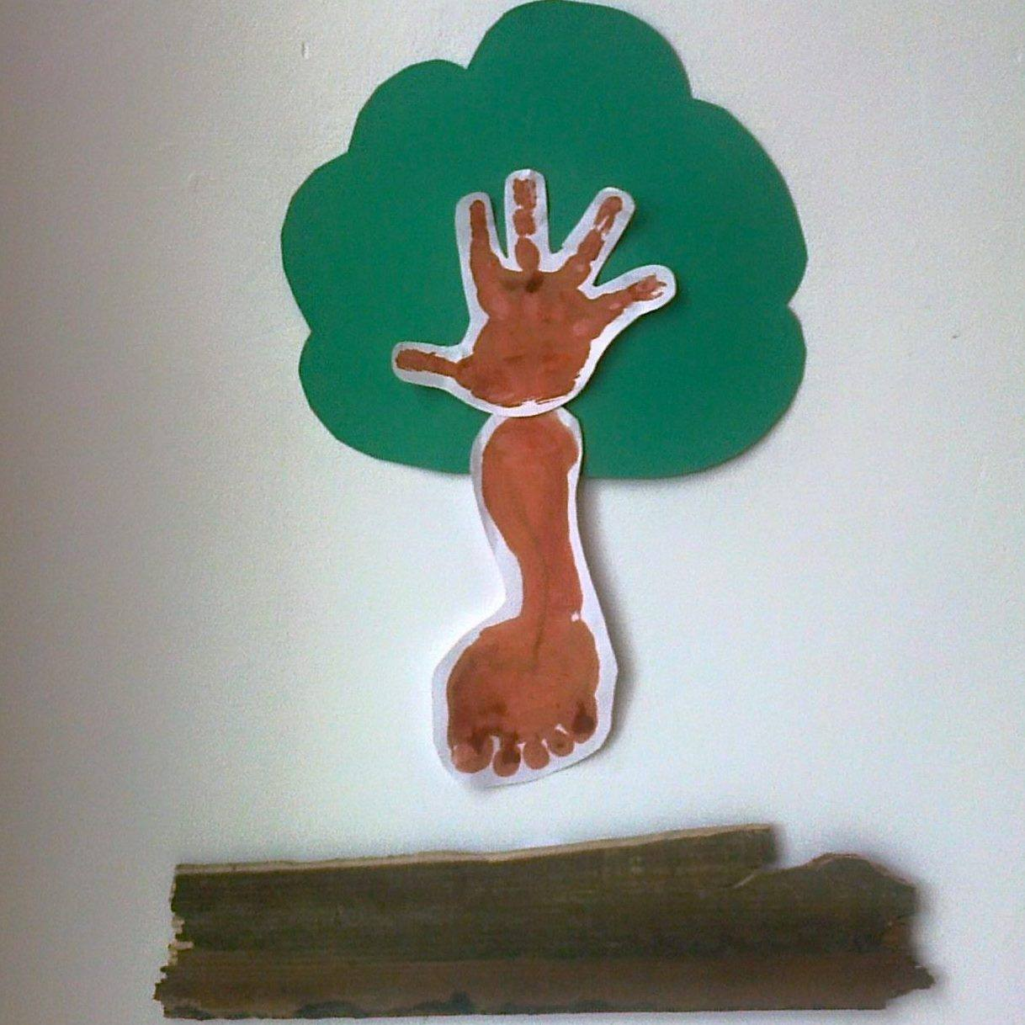

**laugh, live, love to learn**

**… naturally**

**Wildwood Childcare Resource List**

**September 2022**

**Wildwood Tuition and Childcare:**

**Multi-sensory equipment:**

Sensory dark room (put-up)

Snow machine

Fog machine and LED lights

2 x led disco light set

1x LED speaker set

1 x ocean sounds and lights / forest sounds and lights /

1 x bubble machine

1 x star and moon light and wand set

2 x glitter cannons

1 x chimineria

1 x double multi-sensory tray

1 x hose with sprinkler

2 x wormery / vegetable root see through

Flowie branches

1 x sound machine (womb and heartbeat sounds)

Mirrors of differing shapes

Moon and star light show

Aromatherapy oils

**Community Playthings Montesorri equipment to encourage exploration:**

Help yourself art trolley

Help yourself games cupboard

Welcome pegs

Welcome bench

Nappy wrack

3 x coracle

A4 file cupboard

Help yourself book store for reading scheme books plus wall mounted books to choose

Carpentry set with Balsa Wood

Toddler height games table which can double up as a carpentry bench

PSHE large toilet with two seats attached

Potty that looks like a toilet and flushes

2 x stoke high chairs

1 x stoke mealtime chair

2 x small chair and table

4 x community playthings mealtime chairs and table

3 x large community plaything chairs and table

Community playthings easel

Makaton DVD

Singing hands dvd 1 with nursery rhymes

Singing hand Christmas dvd

B squared assessment package

PECs symbols

A multicultural theme is blended in by establishing multi-cultural connections with refugees and people from all over the world at the play session at Families first which celebrates free flow play from each area of play. We have people from India, Russia, Poland, Kazachstan, war zones, Australia, New Zealand, Africa, Italy, Spain, China and more places. I use Twinkl and diaries to help connect with what is each person’s special festival / custom. We also have ethnic dolls. A world map floor rug celebrating people from all over the world.

I also have an African basket containing photograph from Kenya, the ‘jungle’, Mombasa including photographs and writing from orphans out there. There are some wooden African spoons, a wooden necklace, an African outfit, an African drum, 4 x CDs – African music plus teach yourself Swahili

Diwali: saris and music. Plus we join in with Stafford Indian Association’s Diwali Celebrations and celebrations at the local Sikh temple

Jewish, muslim, Islamic, hindu, Christian, Bahai & sikh are available to see and explore

The Sonrise Programme Manual from the Autism Treatment Centre of America. In 2010 I went on a residential training programme in London. No school in the whole of the UK supported this amazing event or used any of their strategies.

**3 x Pirate Sacks containing: August**

Stories: The Pirate cruncher, Captain Duck & The Highway Rat

Ship

Pirate hat & hook

Fine motor pirate pop-up game

Pirate water play

2 x pirate ships, 2 x islands, playmate and pirate characters

Don’t rock the boat game

Pirate sword and face paints

**Fire fighter and Policemen Sack: November**

Stories: Topsy and Tim meet the Fire Fighters, Barn on Fire

Fire engine

Fire Station

Fire men and car

2 x Police cars, station motorbike and policemen

Peppa pig fire fighting sack

**Dinosaur Sack January**

Jig saw

Sticker book

Dinosaur blocks

Dinosaur colouring in book

How to draw dinosaurs book

8 x dinosaur story books

Dinosaur excavation kit

9 mini dinosaur set

Bolted together dinosaur with spanner

2 x magnetic 3d dinosaurs

4 more dinosaur stories

Interactive noise making dinosaur book

Dinosaur sticker book

Happyland dinosaur set containing 2xdinosaurs plus island

Dinosaur jig-saw book

Nessie

**Hungry Caterpillar Sack June**

Hungry Caterpillar Story, Colouring book, & activity pad,

Butterfly Biome

Fuzzy Felts

Cocoon with 2 caterpillars, leaf, egg and fruit to count, jig saw

Butterfly storage net

Domino

Finger book

3 non-fiction books

Hungry caterpillar placement pad

**Allotment Sack March and April**

Oliver’s Vegetables

Gardening gloves

6 x children’s spades and gloves / tools 2nd x adult hand tools plus spade, rake, wheel barrow

Scardey cat

Flower press

2x watering cans

Beehive surprise

Apple harvest

Mini beast bug bingo

Selection of non fiction mini bug books (some from reading scheme)

Honey bee game

Superworm - book

**Seasons: Ongoing**

Things to do in the summer

Things to do in the winter

Things to do in the autumn

Things to do in the spring

Little nutbrown hare in the summer

Little nutbrown hare in the winter

Little nutbrown hare in the autumn

Little nutbrown hare in the spring

**Farm Sack September and October**

Farm

Windmill

Fence, farm animal, tractor

Fruit and Vegetable Big book for sensory experience linking fruit / veg with word / weaning

Sponges for painting each initial letter sound

Bee hive surprise game with ‘live’ bee (pretend)

Apple Harvest board game

Stinky pig game

Farm Compendium board game

Hickety Pickety board game

Sam Sheep can’t sleep - book

**Starting School Story Set Sept**

Happyland nursery set

Topsy and Tim story book

Charlie and Lola I am too absolutely small for school

**Art equipment Ongoing**

**‘**glass’ paints

21 bottles of ready mixed paint

PVA glue

6 sets of children’s scissors with different blades

7 paint brushes of different size

3 sets of adult scissors with different blades

9 glue spreaders

Glitter

Pritt stick

4 x dabber paints

Sellotape

Chalk

Painting pots

8x coloured sand for artwork

5x glitter

Chalk

Shape sponges

Coloured tissue paper

Coloured gum paper

Baker Ross Art Selection with a theme of multicultural art and festival activities

Chalk board and chalks

White board and chalks

Felt tips

Gum shapes

Tissue paper

Sock Creations art set

Puppet creation guidance from Northumbria University

Glow Art

The Patchwork Puppet

Making and Designing a puppet guidance

Face paint

Block paint

Baker Ross art equipment for seasonal activities

**Construction: Ongoing**

Lego of differing sizes (problem solving...)

Sand play buckets and spades

Plasticine plus moulds

Play dough plus moulds

Mighty Makers construction set

Glow pictures

Jewelry making set

Kangaroo game

**Jungle Story Sac August**

Jungle leapad

Dear Zoo

Jungle Colouring book

Jungle animal – need to regather

Jungle snap

Hungry Hippos

**Jolly Phonics Sack Ongoing**

Jolly phonics CD

30 children’s favourite nursery CD

Jolly phonics DVD

Sing and play everyday CD

Jolly Phonics Jolly Stories

Jolly Phonics finger phonics 1-5

Jolly phonics Activity book

7 jolly phonics activity books

13 lift the flap jolly phonics books

Jolly phonics blending series

Muzzy language series (BBC) learning English, Spanish, Italian, French and more

Selection of look cover say check cards

Oxford Reading Tree series 1 – 6

Plus non fiction Oxford Reading Tree

First set Jolly phonics reading books

Dfee guidance: playing with sounds – a supplement to progression in phonics

Letts Series for both Maths and English from years Reception to Y6

Oxford Cursive Writing Practise

Phonics leap frog game

Phonics bus

Plus a library of fiction and non-fiction books upstairs ...

Pencil practise book

Jolly phonic songbook

Fun writing

Mega English 5-7

Mega English 7-9

Leap ahead English

Make it easy maths and English 8-9

Grammar and punctuation ks2

Ks2 spelling bank dfee

Sound rhymes

The phonics handbook

How to achieve a dyslexia friendly classroom

I’m not reading

Write dance in the nursery

Practise and guidance for eyfs dfee

Sure start birth to three

Letters and sounds: principles and practise of high quality phonics

Cvc word builder

Speaking and listening activities

Foam letters

Magnetic letters and board

Clockwork toys (fine motor skill)

Threading – coton reels (fine motor skill)

ALS

English aged 5-6

English 9+

**Rainbow Fish sack**

Net with fish

Sensory smells

Ocean light display

Ocean instruments

**SATs**

Complete set of up to date 2xKS1 6 x grammar punctuation and spelling SAT paper for year 2 and 5x KS2 SATs papers

Maths resource set from R to y6 to match the requirements of Chase Grammar School

**Water and Sand Ongoing**

A really special ring binder filled with activities from University of Northumbria which identifies how to use sand and water play through all areas of Maths, English and Science

Water and Sand Tray

Spinner

Watering cans

Numbered stacker cups of varying shapes and sizes e.g. circle, square, star

Tubing, funnel, pulley’s buckets with and without holes and differing sizes

**Music: Ongoing**

Multicultural and historical CDs of different styles.

Piano It has a mechanism by which you can record on it and it can play by itself.

Piano teaching resources

Children’s song book

Keyboard,

2x violins,

1x flute,

guitar,

mandarin,

African drum,

2x recorders,

5 little monkey face masks

Humpty Dumpty puppet

Little Miss Muffet puppet

Mouse puppet

Incy wincy spider puppet

3x 5 little duck puppet

2x 3 speckled frog glove puppet

1x 5 currant bun glove puppet

Nursery rhyme ‘ choose’ picture cards

4 x Maraca

Triangle

Shaky egg

tambourine

2 x hitting wooden percussion

2 x firm shaking wooden percussion

2 bell sets

2 x African percussion

Glockenspiel

Music theory for little children

**Technology Toys February**

Phonics Peppa Pig

Leap pad for babies

3x 3DS machines plus games – Mario party, pokemon, mind craft, 2x hello kitty, moschi monsters, order up, mymi kingdom, tracey beaker, mytery stories, tinkerbell & baby club

Wee pirate games, mariokart, just dance, sonic sega racing, Doctor Who, another code, medieval games

Holly Robot

125 piece electronics sets making items such as buzzers, bubble machines and lights with wires, batteries and connectors (obviously for slightly older children and kept out of reach).

Mr Chatterbox voice recording soft toy

2xbird voice recording toys

Gadget shop electric circuits

Infant leap pad

**Role play: May and ongoing**

Two doctors coats

ID badge

3x stethoscope

x-ray plates

thermometer

pretend medicine

bandages

Elsa dress

Fireman and Fire engine suit

Hungry Caterpillar costumes

Witches costume

Snow flake

Wise man

Angel outfit

Nativity outfits

Plastic bakers shop / coffee shop / shop front

Til

Book containing shop inserts

Kitchen

4xbabies of differing ethnic origin

Baby bath

Baby push chair

Baby cot

Baby play mat and cube

Electric car (complete with music)

Electric go cart

Kitchen

Kettle which makes noises

Selection of plastic food (large)

Selection of Velcro food (fractions)

Pots, pans and utensils

**Postman: May**

Happy land postman, postbox, post office and houses postvan

Pop it in the post – matching game (object permanence)

Postman Pat Special Delivery board game

Post Office Set

**Customs: When appropriate**

Birthday Sac

Wrapping Paper

Book: birthday surprises

Spots Birthday Party

Masks (object permanence)

Peppa Pig Party Time Race Game

Wrapping paper / bags **/**

**Faith:**

2x Christian bibles

My favourite Bible stories and songs CD

Twinkl Resources activities covering every faith

Wooden Noah’s Ark complete with animals (in two)

Happyland church set

Ganash the elephant God, Hannukah candles, Budda, hindu outfits, sikh prayer may

**Holidays July**

Happyland airport

Happyland road works set

Garage with cars

How to draw things that go

Where does the sea go? - book

Faster, faster - book

Stick man - book

**Toy Story: May**

Mr and Mrs Potato Head

Woody

Jessie

Buzz

Dinosaur

Army men

Annuals

3 x DVD (complete series)

**Number Ongoing**

Number tray mat

Number cans and beanbags

Number foam

Number cutters

Bingo ball

Number songs

Your numbers up game

Numbers jigsaw

Letts Maths resources from R to Y6

Heinemann Maths Number Workbooks N – Y6

Goldstars Times tables

Fun with Shape and size Oxford

Heinmann Maths Activity books YN-6

The Little books of Maths from Stories

Number sand and water play guidance from Northumbria University

Ten in the bed board game

Frozen soundtrack

Junior songbook

Recorder world 1

Junior songbook children’s favourites

Heineman maths activity books yr to 6

LCP numeracy resource file – reception

Maths aged 5-6

Magnetic numbers and board

**Shape and Measure: Ongoing**

4x shape sorters

Square, round and circle stacking cups

Cooking material

Shape Water and Sand play from Northumbria University

**Multi sensory programme:**

My walls are painted white to avoid sensory overload

I have a multi sensory package created by Flo Longhorn

**Christmas: Dec**

2x Christmas sacks

Peppa pig loves Christmas – sack

Makaton Christmas dvd

**Kenwood Cooking application: Ongoing**

We can make both usual and unusual items like:

Pasta (In different colours by adding e.g. tomatoes or spinach)

Sorbet

Ice cream

Sausages

Smoothies

Juice

A variety of different breads

I have a liquidizer that puree’s anything ‘baby’

(I can make anything from scratch)

**Board Games (turn taking / co-operation/ coping with winning vs losing):**

Horrible History Roman Battle arena

(Complete with a full set of horrible history books series and backed up by resources from Twinkl)

The Magic Tooth fairy Game (science – lost teeth)

Draughts

Ludo

Othello

Snakes and ladders

Cludo

Racing games

Connect 4

Paw patrol frustration game

Jigsaws: paw patrol, horrid henry, frozen, Zombies, 2xMy Little Pony, 10 x magical world Rotten Romans

Chess

Game of Life

Tutem Lootem board game plus photographs and music from Egypt

Labyrinth

Life

Stratego

Surpriise slide

UFO alarm

Princess top trump match

**Science**

Horrible Science Explosive Experiments

**Gross Motor:**

**Access to Wildwood Park Adventure Play in the park opposite. Its use means that we can practise our road safety knowledge**

**Water and Sand table Ongoing**

Table for small play to encourage standing and strengthen leg muscles. Also to encourage stretching movements (naturally in play)

Baby walker (including bricks containing letters and numbers)

Football

Bikes – 3 different sizes to go from 2-11 age range

4 wheeler ‘bike’ for children who can support themselves

3 sets of outdoor safety equipement (helmet, knee and arm pads)

6 neon suncaps

A selection of different sized neon bibs (hope to get logo and phone number printed on them)

See saw

2x scooter

Hoolahoop

Skittles

Frisbee

Hoopla

Cricket set

Bows and arrows

Tennis equipment

Mini golf set

Hockey stick and ball

Ballet equipment plus CDs of all styles, ages and countries (list to follow)

Hoc

Balls – different shapes sizes and sensory experiences

Walker car for children who can walk

Swing

Wildwood Park

Wildwood wood

Wildwood allotment

Birches Valley

Wolsley Bridges

The stepping stones ... Cannock Chase

Local soft play centres

* And that’s the thinned out version!

**In 11 years of motherhood, genuinely, I have told my eldest girl off only once**

**my youngest girl has been told off once.**

**I have never needed to tell my middle girl off.**

**I lead by example.**

**I allow them to take risks and make mistakes.**

**They are all considered to be well-behaved by the outside world.**

**Their play is child-directed and child-centred.**

**I observe their play and when they come to me I find a way to extend it in some way.**

**I have a detailed understanding of child development for children aged 11 and under.**

**I enable them to be empowered decision makers who are in charge of their own learning experiences within the resources I have**

**Massive array of multi-sensory phonic material**

**Play dough and cutters**