Welcome Pack
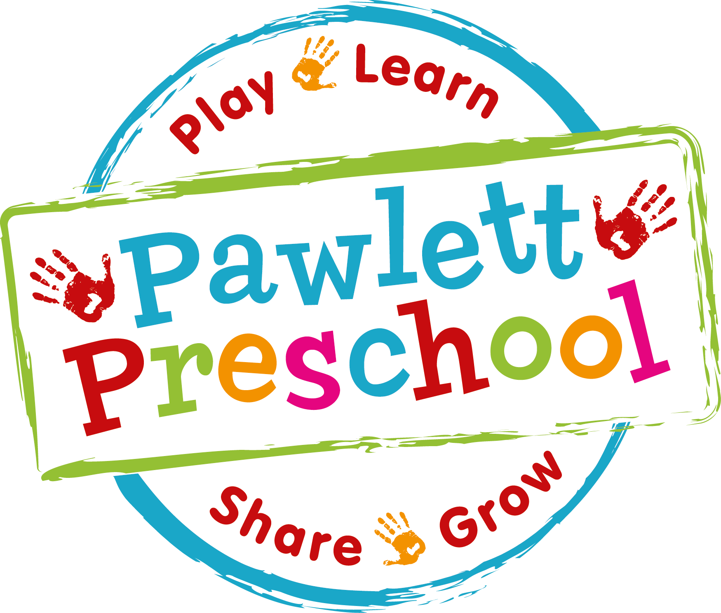
Pawlett Preschool, Pawlett Methodist Chapel, Chapel Road, Pawlett, Somerset, TA6 4SH
Telephone: 07561 257780 or 01278 574916 (Preschool hours)
Email: pawlettpreschoolstaff@hotmail.com
Web: www.pawlettpreschool.co.uk
Registered charity number 1030309

WELCOME
On behalf of all the staff and the committee we would like to welcome you to Pawlett Preschool. This welcome pack is an introduction to the Preschool and is a reference guide to where information can be found regarding life here.

OUR OBJECTIVES
Our aim is to provide high quality care and education in a safe, exciting, stimulating and carefully structured environment. We work in partnership with parents to help the children learn and develop. The staff provide planned activities alongside the free-play activities on a daily basis. All activities are planned in accordance with the EYFS (Early Years Foundation Stage), as recommended by the early year’s guidelines.

OUR PRESCHOOL
Here at Pawlett Preschool we are open five days a week during term time. Our morning sessions start at 9.00am and finish at 12.00pm. We also run a lunch club and afternoon session, where the children can bring in a packed lunch and stay until 1.00pm or 3.00pm. Below is an approximate timetable
showing how the day is structured. This is very flexible and should only be used as a guide.

9.00 – 10.00 Welcome and Free Play
Children self-register and choose an activity from those available or choose their own, and also have the option to take part in individual/group adult-led activities
10.00 – 10.30 Snack time
Children help to tidy up to ‘tidy up music’ before they wash hands, help themselves to snack and pour own drinks
10.30 – 10.45 Circle time
Group activities to include register board ‘who is here today?’, weather board, feelings board, number/letters and sounds activities, songs and stories.
10.45 – 12.00 Outdoor/Physical Play
Outdoor free play activities. If weather is very bad we have indoor physical activities e.g. dance, music and movement and small equipment
12.00 – 1.00 Lunch Club
Children wash hands, eat own packed lunches, then go to quiet corner to look at books and listen to story CDs
1.00 – 2.00 Free Play and Adult-Led Activities
As before
2.00 – 2.45 Tidy Up and Outdoor-Physical Play
As before
2.45 – 3.00 Home Time
Including show and tell, songs, rhymes, stories, and goodbye song

THE EARLY YEARS FOUNDATION STAGE (EYFS)
The EYFS is part of the governments ‘Every Child Matters’ agenda, in which the main aim is to improve outcomes for all children.
Every child deserves the best possible start in life and the support that enables them to fulfil their potential; a secure, safe and happy childhood is important in its own right. Good parenting and high quality early learning through play, together provide the foundation children need to make the most of their abilities and talents as they grow up.

There are seven areas of learning and development that are used to plan your child’s learning and activities at Pawlett Preschool, while at the same time ensuring we follow your child's own unique needs and interests. All areas of learning and development are important and inter-connected.
Three areas are particularly crucial for igniting children’s curiosity and enthusiasm for learning, and for building their capacity to learn, form relationships and thrive. These three areas, the prime areas, are:
• communication and language
• physical development
• personal, social and emotional development

As children grow, the prime areas will help them to develop skills in four specific areas. These are:
• literacy
• mathematics
• understanding the world
• expressive arts and design

In planning and guiding children’s activities, our staff reflect on the different ways that children learn and reflect these in their practice. These are known as the Characteristics of Effective learning:
• playing and exploring - children investigate and experience things, and ‘have a go’
• active learning - children concentrate and keep on trying if they encounter difficulties, and enjoy achievements
• creating and thinking critically - children have and develop their own ideas, make links between ideas, and develop strategies for doing things.

KEY WORKER SYSTEM
Our Preschool has a key worker system. This means that each child will have a key worker assigned to look after their particular needs and interests throughout their time at Preschool and will regularly update their Online Learning Journals using Tapestry. Your child’s key worker will be there to provide parents with knowledge of their child’s development and answer any questions that may arise.

STAFF
We take pride in ensuring that we have a qualified and dedicated team of staff who enjoy their roles. We have three permanent members of staff:

NATALIE SCOTT is the joint Preschool Supervisor, Key worker and safeguarding lead.
Natalie’s qualifications include:
- PGCE in Early Years – Qualified Teacher Status
- NNEB in Child care – equivalent to NVQ Level 3
- Advanced Child Protection
- Paediatric First Aid
- Loose parts training
- Food hygiene
- Prevent duty training

ALISHA BARNES is the joint Preschool Supervisor, Key worker and SENCo.
Alisha’s qualifications include:
- NVQ level 3 in Child Care, Learning & Development
- Successful completion of first year of Foundation Degree in Early Years –
Equivalent to NVQ Level 4
- Paediatric First Aid
- SENCo training
- Advanced Child Protection
- Food hygiene
- Loose parts training
- Prevent duty training
- Hearing and vision loss awareness training

EMMA PERRY-MOGG is the Preschool Assistant and Key worker.
Emma’s qualifications include:
- NVQ level 3 in Child Care, Learning & Development
- Successful completion of first year of Foundation Degree in Early Years –
Equivalent to NVQ Level 4
- Paediatric First Aid
- Child Protection
- Food hygiene
- Prevent duty training

Our staff also attend regular training workshops to keep their training and development up to date within the current regulations.
COMMITTEE
Pawlett Preschool is a charitable organisation run by an elected committee made up of parents/carers and local residents with an interest in the Preschool. Should you wish to join our committee and play a more active role in your child’s Preschool education, please speak to a committee member or member of staff.

ADMISSION
Our Preschool is very committed to providing a fair and open admission system that offers a competitively priced and good value service. We aim to make Pawlett Preschool accessible to children and families from all sections of the local community. Please refer to our policies and procedures manual for full details.

SETTLING IN
The earliest a child can be admitted is 2 years old. You will be invited to come along to our Preschool for a visit, where you and your child have the chance to look around our setting and join in with activities and play. This is the perfect chance to meet the staff, along with the other children, and see for yourself how the Preschool is run. This also gives you the opportunity to ask any questions you may have.

To ensure your child has a happy time with us, we support individual settling in periods, so that each and every child is settled in a way which suits them and their parents. Some parents feel they would prefer to stay with their child for a short period initially, others prefer to go. Staff are always there to give advice but the choice is yours.

COLLECTING YOUR CHILD
We ask all parents to make sure that they are prompt in collecting their child.
We do understand that, due to unforeseen circumstances, there may be times when you cannot get to pick your child up on time. As an emergency system, we will ask parents/carers for a password that will be kept on Preschool premises. If you cannot pick up your child, you can tell someone else your password and then they can pick up your child for you. In this instance please contact the Preschool to make sure they are aware of the arrangements you have made.

WHAT TO BRING TO PRESCHOOL
Pawlett Preschool provides protective clothing for the children when they play with messy activities, but there are still a few items you need to supply.
It would be helpful if you could bring each day:

- A spare change of clothes (or two or three!),
- For cold weather - hat, gloves, coat and wellies,
- For hot weather - sun hat and sun cream (labelled and kept in your child’s drawer),
- Spare nappies, wipes and nappy sacks if needed,
- A bottle of water or juice, which will be available to your child at all times,
- A packet of tissues (labelled and kept in your child’s drawer),
- If your child is bringing in a packed lunch please ensure an ice-pack is placed inside during the warmer months as we have no refrigeration facilities.

Personal items must be labelled with your child’s name.

FEES
Here at Pawlett Preschool payment of fees should be made every half term. Invoices are given out to every parent at the beginning of each term. Payment should be handed to Natalie Scott or Alisha Barnes. We also accept childcare vouchers and Tax-Free childcare. Our session fees are:

2 year olds 3 year olds +
Morning session £18.00 £16.50
Morning session + lunch club £24.00 £22.00
Full day £36.00 £33.00
This equates to: £6.00 per hour £5.50 per hour

We provide the children with a healthy snack every morning, which we charge £1 per day for, this is a discretionary charge. We add this onto your invoice for the half term.

EARLY YEARS ENTITLEMENT
Our Preschool welcomes parents who wish to use their Early Years Entitlement with us. At present all three and four year olds receive universal funding from the term after their third birthday. Funding is payable for any number of weeks up to the maximum number of hours within a funding period. The maximum number of hours each funding period is advised at the beginning of each term, which equates to 15 hours per week from April 2007. The government are now introducing up to 30 hours per week childcare funding for working families, from 2 years old – starting September 2025. This can be applied for online via www.childcarechoices.gov.uk.
The Preschool is also able to accept children who qualify for two year old funding (supported families). This is based on individual circumstances and dependent on receipt of certain benefits. Two year funding application forms are available at the Preschool or online.
If you use more than the allotted funded hours, then the excess hours must be paid for at the current Preschool fee.

If your child does not attend Preschool due to sickness or holidays your child’s fees must still be paid and the Preschool informed.
The Preschool will require four weeks notice of any intention to terminate your child’s place.

Any questions about funding please speak to Alisha Barnes.

SICKNESS
Please let the Preschool know straight away if your child is ill, so we can take appropriate steps and make other parents aware of any symptoms to watch for. If your child is unwell, we ask that he/she remains at home. In the case of vomiting or diarrhoea, we ask that a period of forty-eight hours has passed since the last attack before returning to Preschool. A full list of illnesses and exclusion times can be found in the policies and procedures manual.

POLICIES AND PROCEDURES
Here at Pawlett Preschool we have several policies in place. All the policies can be found in the foyer at the Preschool and will be available for you to read during your child’s settling in session. If you wish to borrow the file please speak to a member of staff. These help us to make sure that the service provided by the Preschool is a high quality one, which provides an enjoyable and beneficial experience for each child and his/her parents.

We do advise you to read these policies before signing the registration form, to avoid any discrepancies. Your signature on the admissions form will imply to us that you have read, understood and agree to abide by our policies and procedures.

TAPESTRY ONLINE LEARNING JOURNALS
At Pawlett Preschool we use Tapestry Online learning Journals to record your child’s learning and activities they have enjoyed.
Your child’s learning journey contains observations we make and photos we take throughout the year, gradually building up a picture of your child's learning. Having this learning journey online provides an excellent opportunity for us to share information about your child's learning and achievements with you, and for you to share their achievements and interests at home with us.

Using a piece of educational software called ‘Tapestry’ every child at Pawlett Preschool will have their own individual learning journal. By logging on with a secure username and password you will be able to access your child’s journal. Parents are only able to view their own child’s journal and all information is stored on a highly secure server.
Tapestry allows you, as your child’s primary educator, to add observations and photographs of your own as well as share your comments. We love to hear about their learning, progress and achievements outside of the setting, which we can then share at Preschool.
Because children play in close proximity with their friends it does not reflect a true picture of their time at Pawlett Preschool if photographs are only of a single child. Therefore photographs of your child may appear on their friends learning journals.

PARTNERSHIP WITH PARENTS
We pride ourselves in working with our parents to achieve high quality care and education for our children. Our tapestry online learning journals help with this, as they allow staff and parents to add their own journal entries and comment on them.

HOW TO GET IN TOUCH
The Pawlett Preschool operates at:
PAWLETT METHODIST CHAPEL,
CHAPEL ROAD,
PAWLETT, BRIDGWATER, SOMERSET, TA6 4SH
email: pawlettpreschool@hotmail.co.uk

We are open: Monday 9am – 3pm
Tuesday 9am – 3pm
Wednesday 9am – 3pm
Thursday 9am – 3pm
Friday 9am – 3pm

Preschool Supervisors: Natalie Scott & Alisha Barnes
07561 257780
01278 574916
pawlettpreschoolstaff@hotmail.com

The Committee members can be contacted as follows;

Chairperson: Shavana Heath
pawlettpreschoolchair@yahoo.co.uk

Treasurer: Sophie Wells
pawlettpreschooltreasurer@hotmail.com

If you have any concerns or questions regarding your child’s progress please feel free to contact us using the information above. We are here to support you and your child.

AND FINALLY
We are delighted you have chosen to look at our Preschool. We are very proud of our group and its achievements and welcome new families at any time. If there is anything else you would like to know or need help with, while making your decision, please feel free to contact us.

**PLEASE COMPLETE AND RETURN ALL FORMS TO PRESCHOOL**

Please attach a copy of your child’s birth certificate

WE LOOK FORWARD TO SEEING YOU!
Start date

Child’s name: ____________________________Proposed start date:____________
 |  | Mon | Tues | Weds | Thurs | Fri
Morning | 9am-12pm
Lunch club | Until 1pm
Afternoon | Until 3pm
………………………………………………………………………………………………………
Admissions form

Child’s Full Name:
Name to be used at Preschool:
Date of Birth:
Gender:
Ethnicity:
Religion (if any):
Languages spoken:
Names Parent/Carers:
Home Address:

Contact Numbers:

Email:
Parent/Carers place of work:

Are any other professionals involved with your child? i.e. speech therapists, social workers etc.

Emergency Contact Form
Relationship to child | Name | Contact  Number

Please provide details of anyone else, other than parents/carers, who are permitted to collect your child, and who can be contacted in case of an emergency – if we cannot first get in contact with parents/carers.
I consent that I have the permission of all above emergency contacts to provide you with these contact details Yes ⃣⃣⃣⃣⃣ No ⃣⃣⃣⃣⃣

Parent/carer’s signature:_____________________________ Date:______________
……………………………………………………………………………

Allergies
We need to know if your child suffers from allergies of any kind. (including food, fruit, juice, plasters, sun cream, soap etc). Please complete the section below - even if your child has no allergies, stating ‘none’.

Child’s name: ______________________________________

Known allergies: ____________________________________________________________________________________________________________________________________________________________________________________________________________

Parent’s signature: ________________________________ Date: ______________

Emergency medical treatment form

In order for staff to ensure that your child receives the best and most appropriate care, attention and treatment should there be an emergency in the Preschool, or whilst out on an authorised outing, you need to complete, sign and date the form below.

Child’s Full Name:

Child’s Date of Birth:

Doctor’s Name:

Doctor’s Address:

Doctor’s Telephone Number:

Any other relevant medical information , i.e. allergies, family medical history etc:

Parent/Carers Name:

Address:

Emergency contact number:

Declaration for Emergencies:

In the event that my child is involved in a serious accident or has serious illness, in my absence, while at Pawlett Preschool, I expect the Supervisor, or a delegated member of staff, to contact me immediately on the above emergency contact number.

In the event that my child requires immediate medical treatment before I will be able to get to the Hospital, I hereby authorise the Supervisor, or a delegated member of staff, to consent to emergency medical treatment on my behalf.

I understand that this authorisation will remain valid unless I contact the chairperson to withdraw it.

Signature of Parent/Carer: Date:____________

If you do not agree with any or all of the above declaration, please do not sign it but make your views known in the space below. The Chairperson or Supervisor will then discuss this with you and do their best to accommodate your particular wishes.

I do not agree with the declaration above and would prefer the following procedure to be followed for my child in the event of an emergency:
______________________________________________________________________________________________________________________________________________________________________________________________________________________________________________________________________________________________________________________________________________________________________________________________________________________________________________________________________________________________________________________________________________________________________________________________________________

Signature of Parent/Carer: Date:____________

Consent for photographs
While your child is at Preschool staff may sometimes wish to take photographs to share with you, to display at the Preschool, post on social media and our website, to accompany coursework, send to the press or keep in a personal Preschool album. We would like your consent to do this.

Childs name: ____________________________

I am the legal parent/guardian of the child named above and I give consent for my child to be photographed by a member of Preschool staff, and for the photos to be shared, for the following reasons (please tick all that apply):

€ To share with you
€ To display at the Preschool
€ To accompany coursework undertaken by a member of staff
€ To display on the Preschool Website
€ To post on the Preschool’s Facebook page
€ Publications, such as the local newspaper
€ The Preschool’s promotional literature/newsletters

I understand that there will be no payment for my child/ren’s participation.

Parent/carer’s signature: ___________________________ Date: _______________

We would also ask you to not put any photographs that you may take during Preschool time or outings, that include any of our Preschool children, other than your own child, on any social media sites.
…………………………………………………………………………………………………………………………………
Consent for application of sun cream
While your child is at Preschool your child can play outdoors in both of our outdoor areas. During hot sunny weather to protect your child from the sun, please provide a labelled bottle of sun cream and a sun hat, kept in their bags/drawers.

Childs name: _____________________________

I am the legal parent/guardian of the child named above and I give consent for Preschool staff to help apply sun cream to my child: Yes ⃣⃣⃣⃣ No ⃣

Parent signature: _____________________ Date: _______________

Consent and agreed guidelines for accessing and using Tapestry Online Learning Journals
E-safety is extremely important to us at Pawlett Preschool, therefore we ask you to provide us with the following information and to sign the agreement to show that you have read, understood and agree with our guidelines.
As a parent I will (please tick)….
€ Not publish any of my child’s observations or any photographs that contain other children on any social media site.
€ Keep the login details within my trusted family.
€ I accept that my child’s photograph may appear on their friends learning journal account and I may see pictures of my child’s friends on my child’s personal account.
€ I will speak to a member of staff if I experience any difficulties accessing my child’s learning journey.
€ I agree to the above guidelines and have read the accompanying information within the welcome pack.

Parent’s signature: ___________________________ Date: _______________
Email: __________________________________________
By signing and returning this form and providing us with an email address you consent to Pawlett Preschool creating a Tapestry online learning journal for your child.
…………………………………………………………………………………………………………………………

Password

Please write the password in the box below that may be used should your child need to be collected by someone other than yourself.
Please also contact Preschool to let them know when someone else is picking up your child.

Name

Uniform Order Form

At Pawlett Preschool we have an optional uniform, which consists of a t-shirt and/or a thick warm fleece. They come in our Preschool red and have our logo embroidered over the left breast pocket.

This is by no means compulsory, it is entirely your choice whether you wish your child to wear preschool uniform or not.

The uniforms are sourced locally and are of excellent quality. Sample sizes are available to see at preschool.

All payments to be made in full before Preschool can place your order.

Child's Name: |  |  | Parent/Carer Name:
Item | Size | Quantity | Price | Total | Date Paid
T-shirt | 1-2 years |  | £8.00
 | 3-4 years |  | £8.00
 | 5-6 years |  | £8.00
Fleece | 1-2 years |  | £18.00
 | 3-4 years |  | £18.00
 | 5-6 years |  | £18.00
Payment details:
(cash, cheque, or BACS?)

Privacy Notice
Pawlett Preschool is a data controller for the purposes of the new GDPR (General Data Protection Regulations). We collect information from you and may receive information about you from your previous setting, local authority and/or the Department for education (DfE). We must have a lawful basis for collecting this data.
We collect information to comply with the following legal requirements:
(a) Consent: The individual has given clear consent for you to process their personal data for a specific purpose.
(b) Contract: The processing is necessary for a contract you have with the individual, or because they have asked you to take specific steps before entering into a contract.
(c) Legal obligation: The processing is necessary for you to comply with the law (not including contractual obligations).
(d) Vital interests: The processing is necessary to protect someone’s life.
(e) Legitimate interests: The processing is necessary for your legitimate interests or the legitimate interests of a third party unless there is a good reason to protect the individual’s personal data which overrides those legitimate interests.

What Data we collect
During your child’s induction to the preschool you will be asked to complete these forms giving us all the data we require about your child and yourself. We collect this data for a purpose, that purpose being to ensure your child is cared for in the safest way possible, providing the best learning environment, and to meet legal requirements. We are required to hold and use this personal data in order to comply with the statutory framework of England, Ofsted, the Department for Education and our Local Authority Early Years team. Please see the Data Protection and Retention policy for information on specific data we need to collect.
This information is held in the Preschool’s locked filing cabinet on the premises. The data we collect is used to:
• support your child’s development
• monitor and report on your child’s progress
• share information about activities in our setting
• contact named people in an emergency
• share with other professionals in accordance with legislation
• ensure a contract of service is delivered and maintained
• ensure that this setting receives the statutory funding for which it is eligible.

We are required by Law to keep this information for a period of time after your child has left the setting (please refer to Data Protection and Retention Policy for more information). After this time all your data will be removed and disposed of securely.
You have the right to access and view any data that we may hold at any time. You also have the right to have any data that we may hold removed as long as it does not affect one of the Legal requirements for us to hold it. To request a copy of any information that we hold please contact: Natalie Scott or Alisha Barnes – Setting Supervisors
If you believe that we are collecting data unnecessarily you have the right to place a complaint with the Information Commissioner’s Office (ICO).
Please refer to our GDPR Policy for more information on how we hold and store your data, retention periods and safe disposal.

Please Sign and date to confirm you give consent for us to use yours and your Child’s data as outlined in this Privacy notice.

Child’s Name _____________________________________

Parent/carer’s signature ____________________________ Date ________________

All about me!
Please stick a photo of me here! ☺

Getting to know my family and me…
I like to be called:_________________________
Name:
My age on starting at Pawlett Preschool:_________
My first language at home is:__________________________________
Who lives in my house?_______________________________________
__________________________________________________________
Special people in my life:______________________________________
Interests and preferences…
My favourite books, rhymes, activities, toys and places to go:_________ ___________________________________________________________
___________________________________________________________
Things I like doing outside:_____________________________________
Things I can sometimes get upset about:_________________________
Things that comfort me: ______________________________________
Food and drink…
I usually eat:_______________________________________________
My favourite foods:__________________________________________
I do not like: _______________________________________________
Sleeping and toileting routines…
Nappy changing/toileting routines:______________________________
__________________________________________________________
Sleeping routine: ____________________________________________
___________________________________________________________

