Studio of MoveMINT Debuts

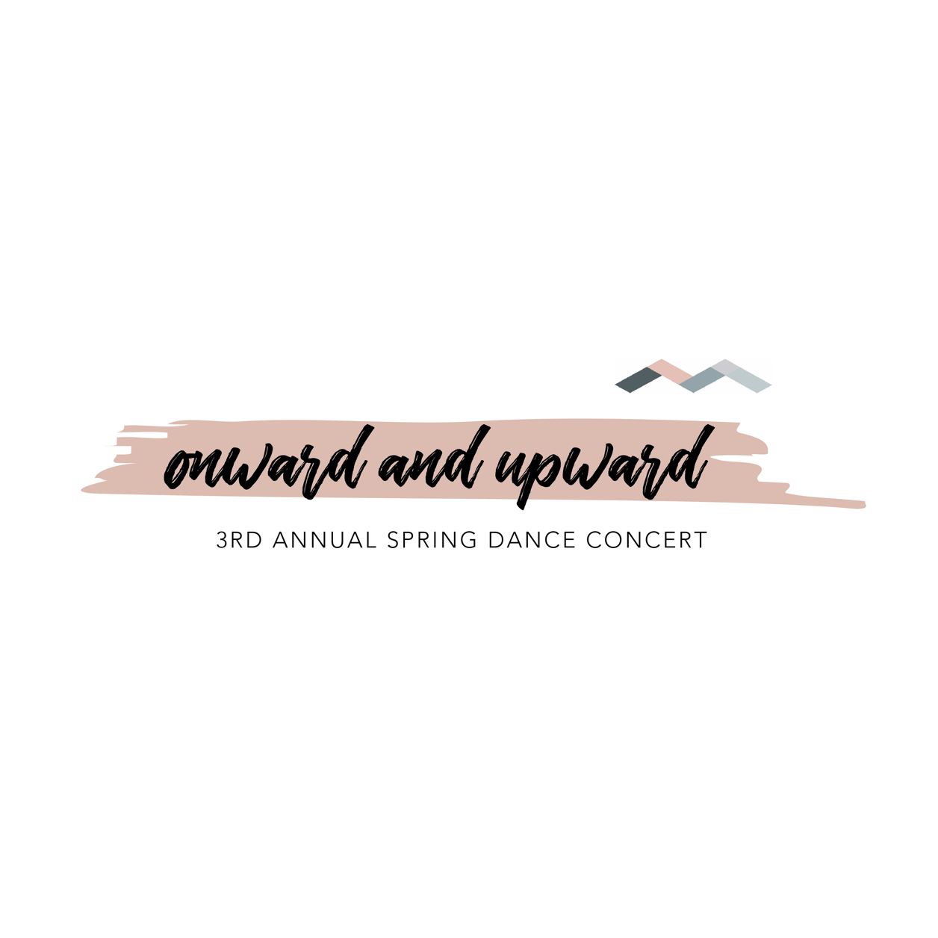

Concert Packet

Table of Contents

Need to Know Information

COVID Protocols & Contingency Plans

Costume Distribution

Tights & Shoes

T-shirts

Dress Rehearsal Week

Recital Time and Place

Show Schedule

Dancer Drop Off and Pick Up Procedures

Cast Party

Recital Items Available for Purchase

Tickets

Flowers*

Photos*

Videography*

Good Luck Items*

\**Optional*

Need to Know Information 

*COVID Protocols & Contingency Plans*

Studio of MoveMINT will follow CDC protocols and experts’ guidance for COVID protocols at the event. Some guidelines we anticipate following:

* + Limiting the number of guests per dance family. More to come on that!
  + Social distancing among audience groups.
  + Dancers will not have to wear a mask on stage during their performance(s). Dancers are more than welcome to wear a neutral/ skin-toned mask on stage if they choose.
  + Potential livestreaming option to watch safely from home. (Hopefully!)
  + Specific exit and entrance routes to control and limit crowds.

If we cannot safely hold the spring concert for an audience, dancers will still come and perform on stage, in costume for our videographer on May 22nd, and our spring concert on film will premiere at a later date**.** However, we are hopeful that we will be able to put on a safe show with an audience!

*March 8th – April 30th: Costume Distribution*

Costumes will be distributed early this spring as long as your family account balance is zero and paid in full (this excludes future charges such as birthday parties and summer classes). We do have some costumes arriving later than others. Please be patient as we prep costumes and checklists for distribution. ***Please review your costume checklist that is attached to your child’s costume upon receipt for hair/makeup needs and necessary accessories.***

*Required Tights & Shoes*

Tights have already been ordered for your dancer and will be delivered with their costume.  Your account will be charged $10-12 on April 1.

Ballet/ Jazz Combo I & II

* NEW Bloch Caramel tights (we will purchase for you!)
* Pink leather ballet shoes

Creative MoveMINT

* NEW Bloch Caramel tights (we will purchase for you!)
* Pink leather ballet shoes (girls) or black leather ballet shoes/ barefoot (boys)

Contemporary/ Kidtemporary/ Tumble Tots/ Acro

* NO tights
* Barefoot

Ballet

* NEW Bloch Pink tights (we will purchase for you!)
* Pink/ skin-colored ballet shoes (no laces please)

Jazz

* NO tights
* Tan leather jazz shoes (no laces please)
* Boys may wear black jazz shoes

Wee Hop/ Hip Hop

* NO tights
* Dark colored tennis/street shoes

*T-Shirts*

All dancers receive a compleMINTary tank or tee, but extras are available for the rest of your crew. Please complete the online order form under the 2021 Spring Concert Page by April 1st. We need to know your dancer’s size! T-shirts will be distributed at the beginning of May. Prices for extra shirts listed below.

Youth…………….………………………………………………………… Shirt $10 / Tank $12

Toddler & Youth sizes XS to XL

Adult………….……………………………………………………………. Shirt $12 / Tank $15

Adult sizes S to 4XL

*May 14th– 20th Dress Rehearsal Week*

All classes will participate in a dress rehearsal at the studio during their normal class times*. Please have your dancer arrive in costume with hair and makeup completed. Dancers will perform in the LAB (the big studio) without the help of the mirrors practicing their entrances and exits. Tentatively, friends and families are welcome and encouraged to come! Please keep it to 2 guests per student. Details to come about dress rehearsal. Bring your cameras!

*\*There are a few exceptions. The following students will receive an email with their dress rehearsal time: Faye Kiltz, Parker & Willow Trivett, Alice Serville, Evelyn McCord, Kate Tatum, Noa Taylor, Kennedy Bourassa, Macy McNeal, Palmer Pelley, Violet Dalton, McCall Lawrence, Ella Jane Neely, Mary King, Julia Ellis, Daphne Pastusek\**

Show Time & Place

**When: Saturday, May 22nd 10:00 AM (A), 1:00 PM (B), 4:00 PM (C), 7:00 PM (D)**

**Where: Southwestern Baptist**

**Theological Seminary**

**2001 W Seminary Dr, Fort Worth, TX 76115**

|  |  |
| --- | --- |
| ***Saturday, May 22nd Schedule*** | |
| 9:00 AM | Performance A Dancers’ Call Time: Please arrive and head to dancer drop off area |
| 9:30 AM | Theatre Doors Open: Dancers dressed & ready backstage, audience find seats |
| 10:00 AM | Show A Begins |
| 11:30 AM | Exit Theatre |
| 12:00 PM | Performance B Dancers’ Call Time: Please arrive and head to dancer drop off area |
| 12:30 PM | Theatre Doors Open: Dancers dressed & ready backstage, audience find seats |
| 1:00 PM | Show B Begins |
| 2:30 PM | Exit Theatre |
| 3:00 PM | Performance C Dancers’ Call Time: Please arrive and head to dancer drop off area |
| 3:30 PM | Theatre Doors Open: Dancers dressed & ready backstage, audience find seats |
| 4:00 PM | Show C Begins |
| 5:30 PM | Exit Theatre |
| 6:00 PM | Performance D Dancers’ Call Time: Please arrive and head to dancer drop off area |
| 6:30 PM | Theatre Doors Open: Dancers dressed & ready backstage, audience find seats |
| 7:00 PM | Show D Begins |
| 9:00 PM | Exit Theatre |

*Dancer Drop Off and Pick Up Procedures*

Upon arrival, please park in front of the theatre. You will enter the main entrance and find signage for dancer drop off to the right of the entrance.

One parent representative will need to head through the green room entrance and find the security check in station. Dancers will come ready for their first dance. Parents will stop at the dancer check in, receive a wristband with their child’s name, and the dancer will be sent to their class area where faculty and assistants will take care of them. The boys will have their own assigned dressing room. Parents are then encouraged and able to go and view our recital vendors before theatre doors open. Signage will be at the event for assistance. *Please* take your tiny dancers to the restroom before dropping them off.

After your dancer has danced in their final dance, please head back to the security station to show your wristband and pick up your dancer. We would love for you to finish watching the show! There are loads of fun surprises. If your dancer is only in the second act and checked in, they can sit and watch the first act before being dropped off at intermission. Because of our limited capacity and social distancing, if your dancer wants to watch any part of the recital and take up a seat, you must purchase a ticket to reserve their seat.

FAQ

Can my child watch some of the show?

*Yes! Please! If your child is watching any part of the show, you must purchase a ticket to reserve their seat. If they are only in the first act, they can join you at intermission. If they perform in the second act- have them head back at intermission. Please be mindful we are limiting the amount of parents backstage for NUMEROUS reasons- to minimize traffic, distractions, and toddler meltdowns! Please visit with faculty to check them in or out regardless.*

Can we leave after my kid performs?

*Yes. But please don’t. We have exciting stuff planned for your babes and we don’t want them OR you to miss a thing.*

*Cast Party*

We invite our dancers and families to stick around and celebrate *onward & upward*!

In an effort to keep the event safe, our recital vendors will be in the area outside the theatre. We invite you to celebrate *outside* after the show so we can prepare for the next show. Don't miss out on the fun! Feel free to visit with our vendors on site and partake in the merriMINT that follows the production.

Recital Items Available for Purchase

*Tickets*

Tickets will be $10 and must be purchased online before the show. All seating is reserved. Anyone over the age of 2 that requires a seat will require a ticket, including performers if watching part of the show. If you have a lap child, a ticket is not necessary. Tickets go on sale May 1st and can be printed from home and scanned at the door on the day of the performance. Link will be provided closer to ordering time.

*Flowers by Farphanoogen’s*

Want to shower your star performer with some love? We’ve got you covered. One of our studio family businesses, **Farphanoogen's** flower truck, will be on site selling a limited about of beautiful bouquets and flower crowns for you to shower your dancers. Pre-order yours today to lock in discounted pricing and pick up your order upon arrival.  Please complete the online order form (under 2021 Spring Dance Concert) by**April 30th**. There will be a limited number of bouquets available for purchase the day of. All pricing is listed online.

*Photos*

The amazing **Bree Perez** will be available to take photos of your individual dancer. These photos are completely optional but highly encouraged—they are stunning! Your lifestyle photo shoot must be scheduled with Bree via her website. For your convenience, a link to book your session is on our website under 2021 Spring Dance Concert.  You have multiple locations and times to choose from and you can decide if you want your dancer in costume or in classic dance attire (our fave!).

An online gallery of your images will be available 4 weeks after recital and can be purchased directly from her site and will be mailed to your home.

*Videography*

Personal photography and video recording will not be allowed during the performance. A professional videographer will be on site to capture your dancer’s performance as a digital download of the show will be available for purchase. Our vendor is not yet decided as we work to find the best option for our families. More information to come!

*Good Luck Pop Up Shop*

There will be a “Pop Up Good Luck Shop” by the coolest kids' boutique in Fort Worth: **B Kids**! Stop by their table at recital to purchase some good luck goodies for your dancer.

Got questions? Send us an email to info@studioofmovemint.com!