Asking Questions… Seeking Answers
Extension Activities Grades K-3
www.HeatherLMontgomery.com

My goal in this presentation is to encourage student questioning skills. Back in the classroom, you can take advantage of the momentum generated by the presentation by conducting the following extension activities.
ASK MORE QUESTIONS
Model the technique:
- Project the image on a screen. As a class, spend time studying the attached image. [FYI, the image is of a male eastern Hercules beetle which can be found in Alabama. They can grow to 2 inches and may be the largest beetle in the US. The males use their “horns” to fight. Females do not have any. But, don’t share that with the students as it will quench their curiosity.]
- Create columns of the board for each of the following words: What? Where? Why? When? How?
- As a class, have the students brainstorm questions and write them on the board in the appropriate column.
Working in small groups (writing activity):
- Put the students in small groups
- Give each small group a real item from nature. It does not have to be something extremely unique, a pine cone or rock will do.
- Have groups develop questions for each question word and record on the chart. (Note, the chart is legal size paper)
Working in small groups (students not ready to write)
- Put the students in small groups
- Give each small group a real item from nature. It does not have to be something extremely unique, a pine cone or rock will do.
- Call out one question word at a time. Have groups verbalize questions for each question word.
Conclusion
- Student groups can share their favorite question about their item and one way that they might be able to find an answer.
Questions? Email me at sipsey21@hotmail.com

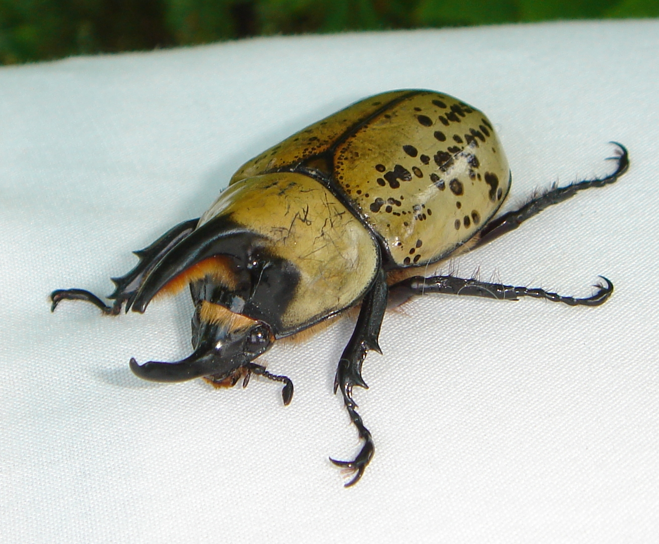
Ask More Questions Chart
Can you write a question for each question word? Can you write more than one for each?
WHAT? | WHERE? | WHEN? | HOW? | WHO?

Heather L. Montgomery

