A Visit with Author

Heather L. Montgomery

Wild About Animals!
www.HeatherLMontgomery
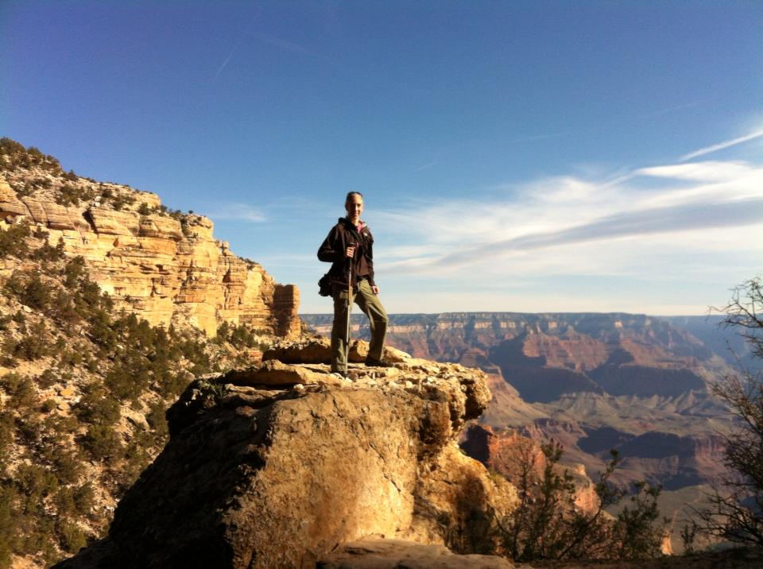

Date:-----

Bring your questions & your curiosity!

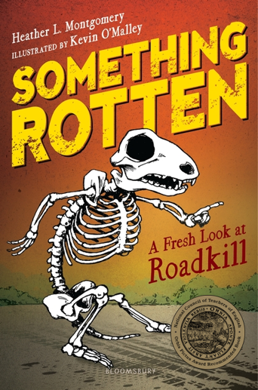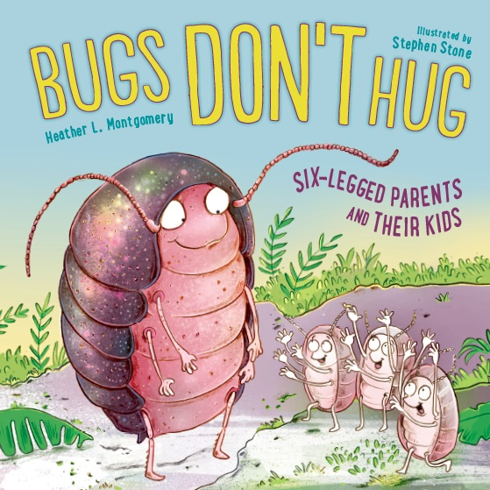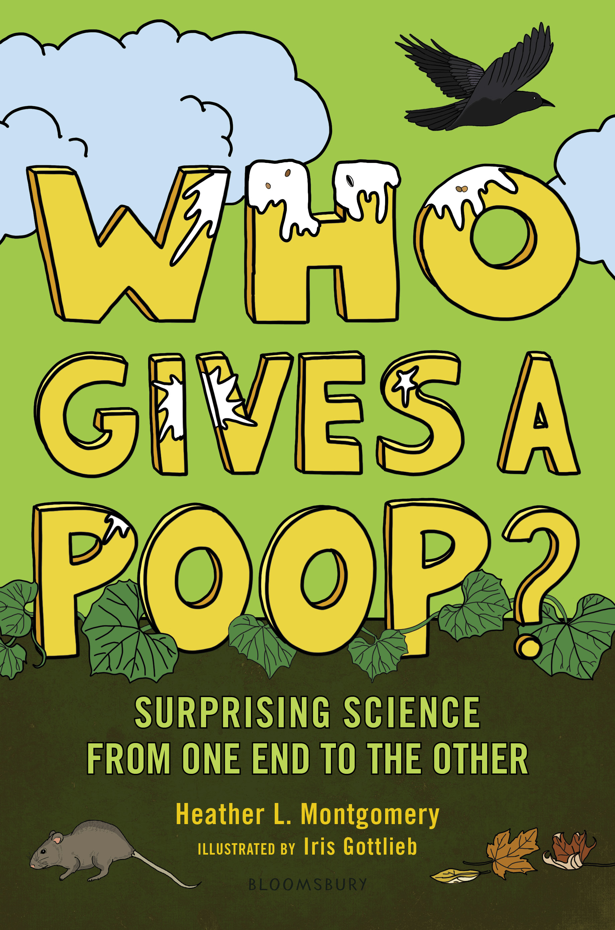
www.HeatherLMontgomery.com

