



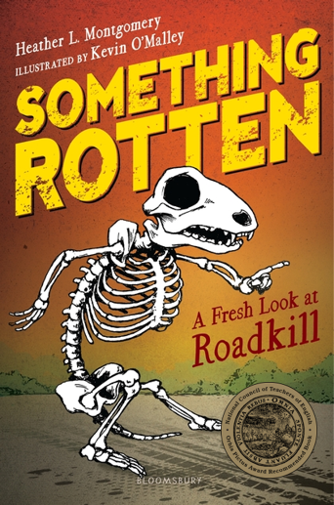



Dear Parents,

Science and nature writer, Heather L. Montgomery will visit on ________________. If you would like to purchase an autographed book, please return this form with payment.

ORDER FORM DUE BY: ______________________________

Make Checks Payable To:______________________________

**Author Visit with Heather L. Montgomery**

#### www.HeatherLMontgomery.com

|  |  |  |  |
| --- | --- | --- | --- |
| TITLE | PRICE | # | COST |
| *What’s In Your Pocket? Collecting Nature’s Treasures* (Picture book) | $12.05  Hardback |  |  |
| *Bugs Don’t Hug: Six-Legged Parents & Their Kids* (Picture book) | $9.95  Hardback |  |  |
| *Something Rotten: A Fresh Look at Roadkill*  (Chapter book) | $10.95  Paperback |  |  |
| *Who Gives a Poop? Surprising Science from One End to the Other* (Chapter book) | $12.05  Hardback |  |  |
| *TOTAL* |  |  |  |

Teacher:_____________________________________________________ Grade:_______________

NAME (for autograph, PRINTED):_________________________________________________

**Author Visit with Heather L. Montgomery**









Dear Parents,

Science and nature writer, Heather L. Montgomery will visit on ________________. If you would like to purchase an autographed book, please return this form with payment.

ORDER FORM DUE BY: ______________________________

Make Checks Payable To:______________________________

#### www.HeatherLMontgomery.com

|  |  |  |  |
| --- | --- | --- | --- |
| TITLE | PRICE | # | COST |
| *What’s In Your Pocket? Collecting Nature’s Treasures* (Picture book) | $12.05  Hardback |  |  |
| *Bugs Don’t Hug: Six-Legged Parents & Their Kids* (Picture book) | $9.95  Hardback |  |  |
| *Something Rotten: A Fresh Look at Roadkill*  (Chapter book) | $10.95  Hardback |  |  |
| *Who Gives a Poop? Surprising Science from One End to the Other* (Chapter book) | $12.05  Hardback |  |  |
| *TOTAL* |  |  |  |

Teacher:_____________________________________________________ Grade:_______________

NAME (for autograph, PRINTED):_______________________________________________

Author Visit

Children’s Author

Author Visit

Children’s Author