Write Like a Scientist
Extension Activity for grades 2-6
www.HeatherLMontgomery.com

The goal of my presentation is to help students see how the fun of the scientific/inquiry process can be carried over into writing. You can take advantage of the momentum generated by the presentation with the following activity. Depending on how much time I had with the students, I may have covered some aspects of this. If I conducted the tree building role play with them, you can use this worksheet as review, allow them time to do additional research and challenge them to write the best possible paragraph.

TREE GUTS
If you want to repeat the demonstration that I conducted:
- Wet your tree cookie slightly.
- Rub one drop (you don’t want any more) of dish soap, hand soap or other liquid soap onto one side of the tree cookie.
- Press your lips tightly to the other side of the tree cookie and blow hard. Be sure that you don’t allow air to escape to the sides. You are trying to blow through the cookie. This can be hard and varies with the tree cookie. (different trees grow at different rates)
Challenge the students
- Pass out the worksheet.
- Ask students to add lines and text (like a concept map) to describe what they observed. Have them add their questions. For grades 4 and up, ask them to color code (or mark in some other way) which are “scientist” and which are “writer” observations and questions.
- Project the tree guts image on a screen. Have them record more observations.
- If you wish, project the microscopic image of the lime tree stem image. [FYI, the tree cookie you have is from a Tulip poplar tree, not a lime tree, but it works in a similar manner. You may want to hide the caption so that they are not confused.]
- At this point, you may want to read from Gail Gibbons’ Tell Me Tree, beginning at page 9, or a similar book.
- Explain that the holes they see are tubes which have been cut. The tubes run all the way up and down the tree.
- Ask the students to make a hypothesis about the bubbles.
- What liquid might a tree need to move up and down its trunk? [Water]
- Tell the students that the tubes are called “xylem” and carry water from the roots to the tips of the branches, providing water to all parts of the tree.
Conduct additional research as time allows:
- Read Tell Me, Tree by Gail Gibbons, or use select pages which illustrate the tree cookie and parts. Some websites for research include: http://www.realtrees4kids.org/sixeight/stemsrings.htm, http://www.realtrees4kids.org/sixeight/stemsrings.htm or http://www.arborday.org/kids/graphics/poster-contest/activity-guide02.pdf (for a thorough look at this topic).
- Have the students write a paragraph using their observations, hypothesis and new knowledge about how a tree works.

Questions? email me at sipsey21@hotmail.com

Write Like a Scientist – Tree Guts!
Bubbles came out of the tree

A Tree Cookie – Tree Guts!
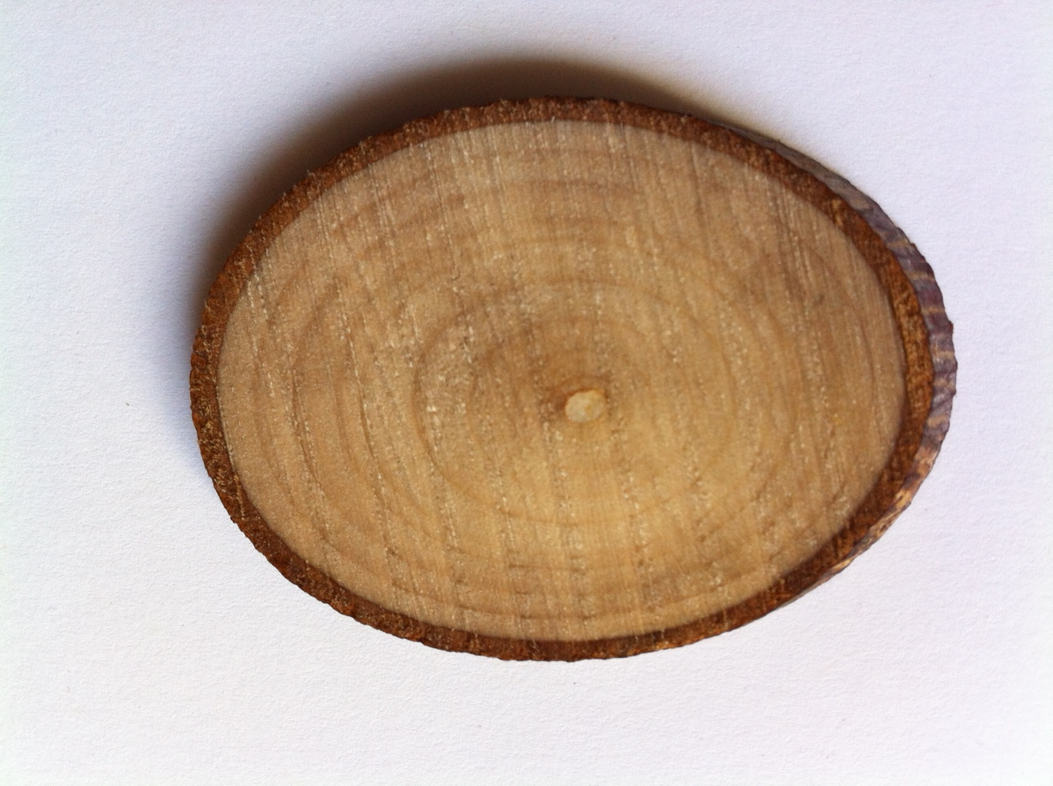
LIME TREE STEM
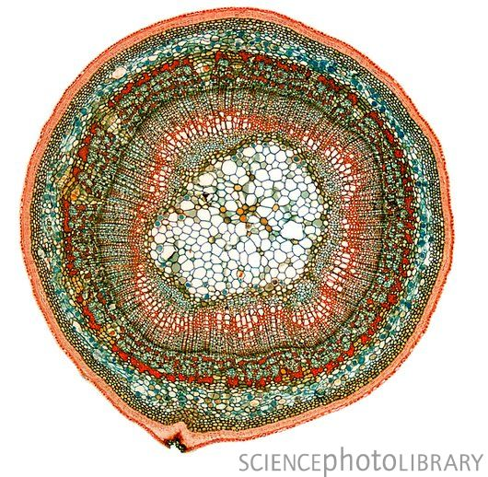
Caption: Lime tree stem. Light micrograph of a section through the stem of a lime tree (Tilia sp.). At centre is the pith, surrounded by a layer of wood (xylem). A thin cambium (growth layer) separates this from the phloem. Magnification: x30 when printed at 10 centimetres wide. Royalty Free Image, Credit: STEVE GSCHMEISSNER/SCIENCE PHOTO LIBRARY

