2026 East Coast Outlaws Sponsorship Form
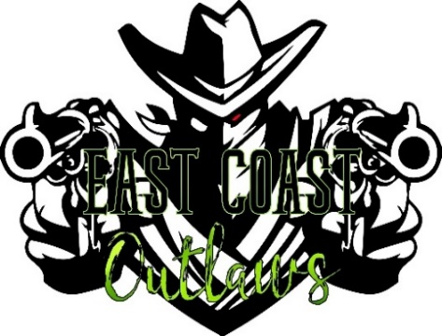
CMSA affiliated club
Cowboy Mounted Shooting Association Events

2026 Sponsors needed:

Top Business Sponsorship-$500: Top 10 Overall Winners year end awards, Wrangler (Kids 12 & under) year end awards & banquet sponsor. 3 Needed.

Overall Senior Winner Sponsorship-$250: Overall Senior highpoint winner for limited & open gender split year end awards. 2 Needed.

Overall Winner Sponsorship-$250: Overall highpoint winner for limited & open gender spilt year end awards. 2 Needed.

Class Buckle Sponsorship-$100: 1 Custom Buckle for high point class award ladies or men year end awards. Multiple Needed.
NORTHEAST REGIONAL AND STATE BUCKLE SPONSORSHIP NEEDED!

Specialty Class Sponsorship-$50: 1 custom year end award for a specialty class. Rifle, Shotgun, or Cavalry. Multiple Needed.

Sponsorship can also be products and/or services at the beginning of the season.

What’s Included: Banner to be displayed at all events & during awards, (provided by sponsor). Multiple announcements during the events, shout outs on Facebook & Website. Any promotional material to be handed out during the events in welcome bags and or/used as day end awards.

Contact Paul or Jen Treas @ East Coast Outlaws, LLC
45 Hook Lane Lewisburg, PA 17837
www.eastcoastoutlaws.com / 570-847-2344 / ecoshooters@gmail.com

Business Name:____________________________________________ Sponsorship Level: ____________________

Contact: ________________________________ Phone #:_____________________

