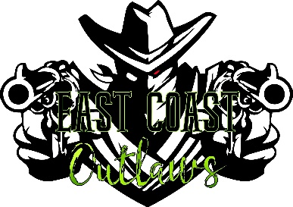
2026 East Coast Outlaws

Club Membership Application
45 Hook Lane Lewisburg, PA 17837
Ecoshooters@gmail.com – 570-847-2344

Name: ________________________________________________________________________

Address: ___________________________________ City: ___________________________

State: ____________ Zip: ______________ Date of Birth: ______________________

Phone: (_______) ____________________ Email: ________________________________

CMSA #: __________ Level: ____________

Membership is good for the CMSA Calendar Year
East Coast Outlaws Membership:
$25 Individual $50 Family (living under the same roof)

CMSA Membership is additional & required for CMSA events
$100 Family $70 Individual

Family Members: (Full name, Date of Birth, CMSA #, CMSA Level.)
________________________________________________________________________________
________________________________________________________________________________
________________________________________________________________________________
________________________________________________________________________________

Must attend HALF OF ECO Shoots to be eligible for Year End Awards***

Liability Release: Liability Release: I understand that I am participating in a sport, which contains dangers, and risks may arise, including, but not limited to, accidental injury, the forces of nature and illness. In consideration of the right to participate in these events and the services provided for me by the East Coast Outlaws’ and its agents, I have and do hereby assume the risks associated with such events. The contestant shall at his own expense, defend management and/or all sponsors, their members, or employees from any and all such claims and indemnify, from any and all liability, damage and costs arising from injuries to person or property occasioned by any act or omission of the contestant, I will agree to abide by the bylaws of this club after my application is approved.

Signature: _______________________________________ Date: ______________
Points start once membership has been paid.

Checks can be made out to East Coast Outlaws & mailed to the above address.

Paid by: Cash / Check #: _____________ Amount: ___________ Date: ____________

