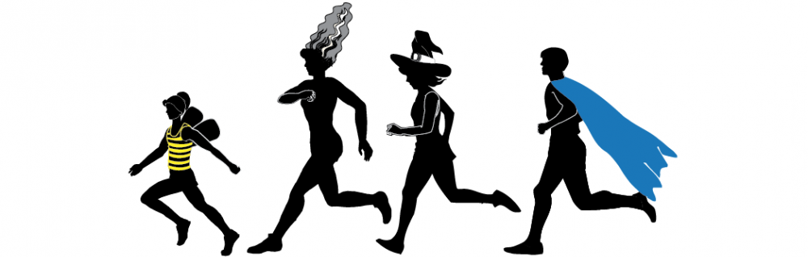

**Fall Fest Red Lion Recreation Glow Run**

Join us for a fun glow run on October 13th, 2018.! We will be running along the Red Lion Mile towards Vulcan field and back! The run is one mile long and running is not required! Walkers more than welcome! Wear your coolest Halloween costume to make it even more fun!

Race begins at 8 pm at Vulcan field (location of Fall Fest) and continues until 9:30 (or whenever you are done!)

Cost: $20 before September 21st (includes shirt and glow sticks)

$15 for kids 16 and under

$25 on October 13th (no shirt guaranteed- first come first serve)

To register please mail, dropoff at the Rec Building, or email to [rlrec@redlionpa.org](mailto:rlrec@redlionpa.org)

Red Lion Rec

PO Box 158

Red Lion, PA 17356

PLEASE FILL OUT WAIVER ON THE BACK AS WELL IN ORDER TO PARTICIPATE. THANKS!

------------------------------------------------------------------------------------------------------------------------------

NAME:

DATE OF BIRTH:

EMAIL:

PHONE NUMBER:

ADDRESS:

SHIRT SIZE:

YOUTH S____, YOUTH M____, YOUTH L___, ADULT S_____, ADULT M______

ADULT L_____, ADULT XL_____, ADULT 2XL______