Learning & Development isn’t always the best to execute a Needs Assessment. We highly recommend educating and preparing your functional area teams to execute this document for themselves to determine if perceived performance discrepancies are a Knowledge & Skills issue (the need for training) or something else which can and should be managed within the department.
Identify the Two Elements of Job Performance
For every job, you must clearly identify two elements of employee job performance:
- The performance that is expected of an employee
- The performance that is actually occurring
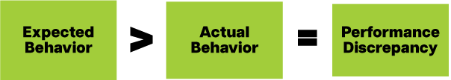
If an employee’s actual performance does not match the performance you expect, then a performance discrepancy exists. In this situation, you must follow the following steps in sequence:
- Quantify expected performance and measure actual performance, then define the performance discrepancy.
- Determine the cause(s) of the discrepancy.
- Propose performance solution(s).
- Implement the solution(s).
- Evaluate the results.

Step 1: Quantify Expected Performance and Measure Actual Performance,
then Define the Performance Discrepancy
Quantify Expected Performance
- Performance Goals focus on factors such as operational efficacy and efficiency (such as time, quality, costs, outputs, revenue, operational excellence, cash, growth, safety). Align each individual’s performance goals to the department’s goals. These goals create meaningful and engaging experiences to achieve exceptional business results.
- Professional Development Goals focus on the acquisition of the knowledge, skills, and experiences employees need to reach their performance goals and to set long-term plans for their growth. Development goals increase employees’ knowledge, experience, growth opportunities, and engagement. Use the 70/20/10 Development Framework when you create these goals.
- A Job Description is a written statement of the job activities that an employee performs. Although it is a good starting point for gathering data on expected performance, job descriptions tend to be vague and may become outdated.
- A Job Inventory contains a list of the duties and the tasks for a job. Duties are broad, general areas of a job. Tasks are specific to-do items arising from a duty.
- A Job Study is a list of the step-by-step work instructions for a specific job task. The task may be technical, interpersonal, or conceptual. A job study also defines expected performance and can be used to measure actual performance. A job study also may be called task analysis, work breakdown, or standard operating procedure (SOP).
Measure Actual Performance
- Surveys gather information on the actual performance of a specific group of employees. These are usually conducted in the form of an e-mail questionnaire or web-based survey. You can send surveys to a broad base of respondents (such as employees, supervisors, Owners).
- Interviews gather data on the actual performance of the target group of employees. You can conduct interviews one-on-one or in small groups. You can interview people face-to-face, via teleconference, or in discussion groups.
- Observations are conducted by watching employees perform their job tasks. Forms of observation include job shadowing or call monitoring.
- Audits and Work Samples provide tools for comparing employees’ actual performance to the expected performance. A work sample is a comparison of the completed work to the expected standard. Audits can be a combined form of observations, tests or records.
- Records are the most objective way of gathering data on the actual performance of a group of employees. There are typically five categories of performance records: time, outputs, costs, quality, and human element.

Define the Performance Discrepancy Worksheet
The questions below will help you define the performance discrepancy. When you ask these questions, do not speculate on the cause(s) of the discrepancy or the possible solution(s). Focus only on defining the discrepancy. You will work on solving it in Steps 2 and 3.
What work is not being performed as it should be?

Who performs this work?

When was this performance discrepancy first noticed?

Have there been any recent changes in the work environment?

What is expected performance for this work?

What are the problems arising from this performance discrepancy?

What would happen if we ignored this discrepancy and did nothing?

The Seven Factors of Job Performance

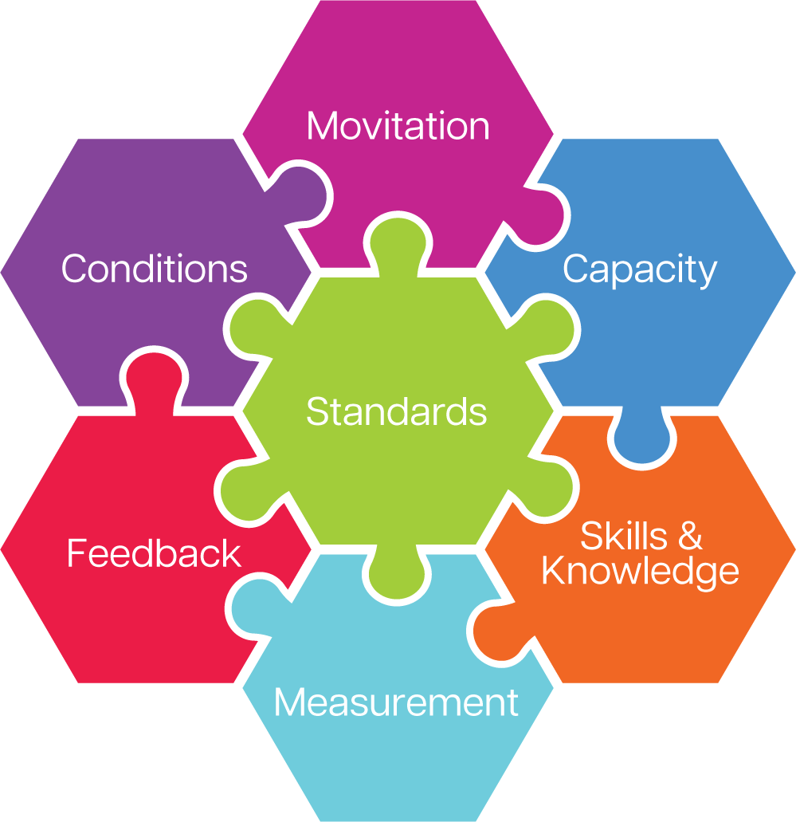

Step 2: Determine the Cause(s) of the Discrepancy
Poor job performance always has a cause(s). Whenever you discover a discrepancy between expected performance and actual performance, the cause(s) will always be one or more of these seven factors of job performance.

STANDARDS
Does a performance discrepancy exist because the employees are unclear about the standards or expectations of the job? The expectations might be poorly defined or poorly communicated. Job descriptions may be too vague. There may be no job inventory for the role. You or the employees may have emphasized the wrong tasks or priorities

Assessment Criteria | YES | NO | Readiness | ALERT
Do employees know what to do and when to do it?
COMMENTS:

Can employees clearly and accurately articulate what is expected of them?  COMMENTS: |  |  | Are these expectations changing with the training and what are the plans to communicate these to employees? (Is the training the ONLY communication necessary?)
Are there written job performance standards?
COMMENTS:

Are the written job performance standards current, relevant, and achievable?  COMMENTS: |  |  | Do the written job performance standards align with the requested training and desired behaviors and business outcomes?
Is there agreement in the company about what is to be done, when, and how?  COMMENTS: |  |  | Is there agreement in the company on the new, desired behaviors and business outcomes for the learners delivered by the requested training?
SUMMARY:

CAPACITY
Does a performance discrepancy exist because the employees lack the capacity to perform as expected? Do they have the natural ability? Are the employees right fit for the job they are performing?
Assessment Criteria | YES | NO | Readiness | ALERT
Does the employee have the physical capacity to perform as expected?  COMMENTS: |  |  | Do the current job description, skills, and competencies align with the desired behaviors and business outcomes expected from this training request?
Does the employee have the computational capacity to perform as expected?  COMMENTS: |  |  | If current employee(s) do not have the computation capacity to deliver the behaviors and expected business outcomes from the requested training, do we need to address personnel?
Does the employee have the interpersonal capacity to perform as expected?  COMMENTS: |  |  | If current employee(s) do not have the interpersonal capacity to deliver the behaviors and expected business outcomes from the requested training, do we need to address personnel?
Does the employee have the analytical capacity to perform as expected?  COMMENTS: |  |  | If current employee(s) do not have the analytical capacity to deliver the behaviors and expected business outcomes from the requested training, do we need to address personnel?
Does the employee have the capacity to work with minimal supervision?  COMMENTS: |  |  | If this is required after the requested training and current employee(s) do not have the capacity, do we need to address personnel?
SUMMARY:

MOTIVATION
Does a performance discrepancy exist because the employees lack motivation to perform as expected?
Assessment Criteria | YES | NO | Readiness | ALERT
Does the employee focus on all the tasks in their job inventory, or just on the tasks they enjoy?
COMMENTS:

Are reinforcements in place that encourage the employee to perform well and that discourage poor performance?
COMMENTS:

Does the employee demonstrate pride in their work, team, or company?  COMMENTS: |  |  | Is there an issue with Employee Engagement that needs to be addressed that will otherwise impact the success of this training initiative?
Does the employee believe they will be recognized fairly and/or rewarded for performing well?
COMMENTS:

Does the employee value the potential recognition and/or rewards of high performance?  COMMENTS: |  |  | Does the current rewards and recognition program align with the new behaviors and business outcomes expected from this training initiative?
SUMMARY:

MEASUREMENT
Does a performance discrepancy exist because you are not measuring employees’ performance objectively? Are the metrics used to measure performance specific? Are the measures communicated well? Are the measures consistent?
Assessment Criteria | YES | NO | Readiness | ALERT
Am I measuring my employees’ performance?  COMMENTS: |  |  | Are there measurements in place to objectively quantity the impact of this training initiative?
Are performance measurements based on the job performance standards?  COMMENTS: |  |  | Do the current job performance measurements align with the behaviors and business outcomes expected from this training initiative?
Am I capable and equipped to measure employee performance?  COMMENTS: |  |  | If measurements or performance assessment changes due to this training initiative, what are the plans to retrain the individuals measuring employee performance?
Do the employees believe the performance measurements are objective?
COMMENTS:

Do the employees believe that the performance measurements are consistent?
COMMENTS:

SUMMARY:

KNOWLEDGE & SKILLS
Does a performance discrepancy exist because the employees lack the knowledge and skill to perform as expected? Have the employees been trained to the performance standards?
Assessment Criteria | YES | NO | Readiness | ALERT
Have employees been trained on the task?
COMMENTS:

Did they ever perform the task properly in the past?
COMMENTS:

Are job aids and other forms of performance support available, current, and relevant?
COMMENTS:

Have there been any recent changes to how the task is performed?
COMMENTS:

Do employees perform the task frequently enough to remember the skill?
COMMENTS:

SUMMARY: |  |  | If the issues causing the performance discrepancy fall within the other Factors of Job Performance, the department may need Organizational Alignment or training for the leaders rather than the proposed training initative.

FEEDBACK
Does a performance discrepancy exist because the employees are not receiving supportive or constructive feedback on their performance? Is feedback based on things the employee can control? Is feedback based on objective standards or measurements? Is the person delivering the feedback skilled in the task?
Assessment Criteria | YES | NO | Readiness | ALERT
Do the employees receive feedback from their direct supervisors?
COMMENTS:

Do they receive the feedback in a timely manner ?
COMMENTS:

Is the feedback based on the actual job performance measures/standards?
COMMENTS:

Are the supervisors providing specific, actionable feedback?
COMMENTS:

Are the supervisors capable and trained on how to deliver feedback?  COMMENTS: |  |  | Is the manner or procedure for delivering training timely and effective to support the employee in delivering the behaviors and business outcomes in a manner that meets measurements and expectation?
SUMMARY:

CONDITIONS
Does a performance discrepancy exist because the employees lack the conditions to perform as expected? Do they have the time, tools, resources, information, empowerment, etc.?
Assessment Criteria | YES | NO | Readiness | ALERT
Are current job procedures clear, realistic and performable?
COMMENTS:

Are employees given sufficient time to perform their tasks as expected?
COMMENTS:

Are tools and equipment in good working order?
COMMENTS:

Are distractions and interruptions minimized?
COMMENTS:

Are employees empowered to perform as expected?  COMMENTS: |  |  | Are the current working conditions conducive to the behaviors and expected business outcomes from the proposed training initiative?
SUMMARY:

Steps 3 & 4: Propose Performance Solution(s) and Implement Performance Solutions
Once you have identified the cause(s) of the performance discrepancy, you can consider possible solutions. Use the Cause-Solution Guide below to prescribe interventions to correct the performance discrepancy.
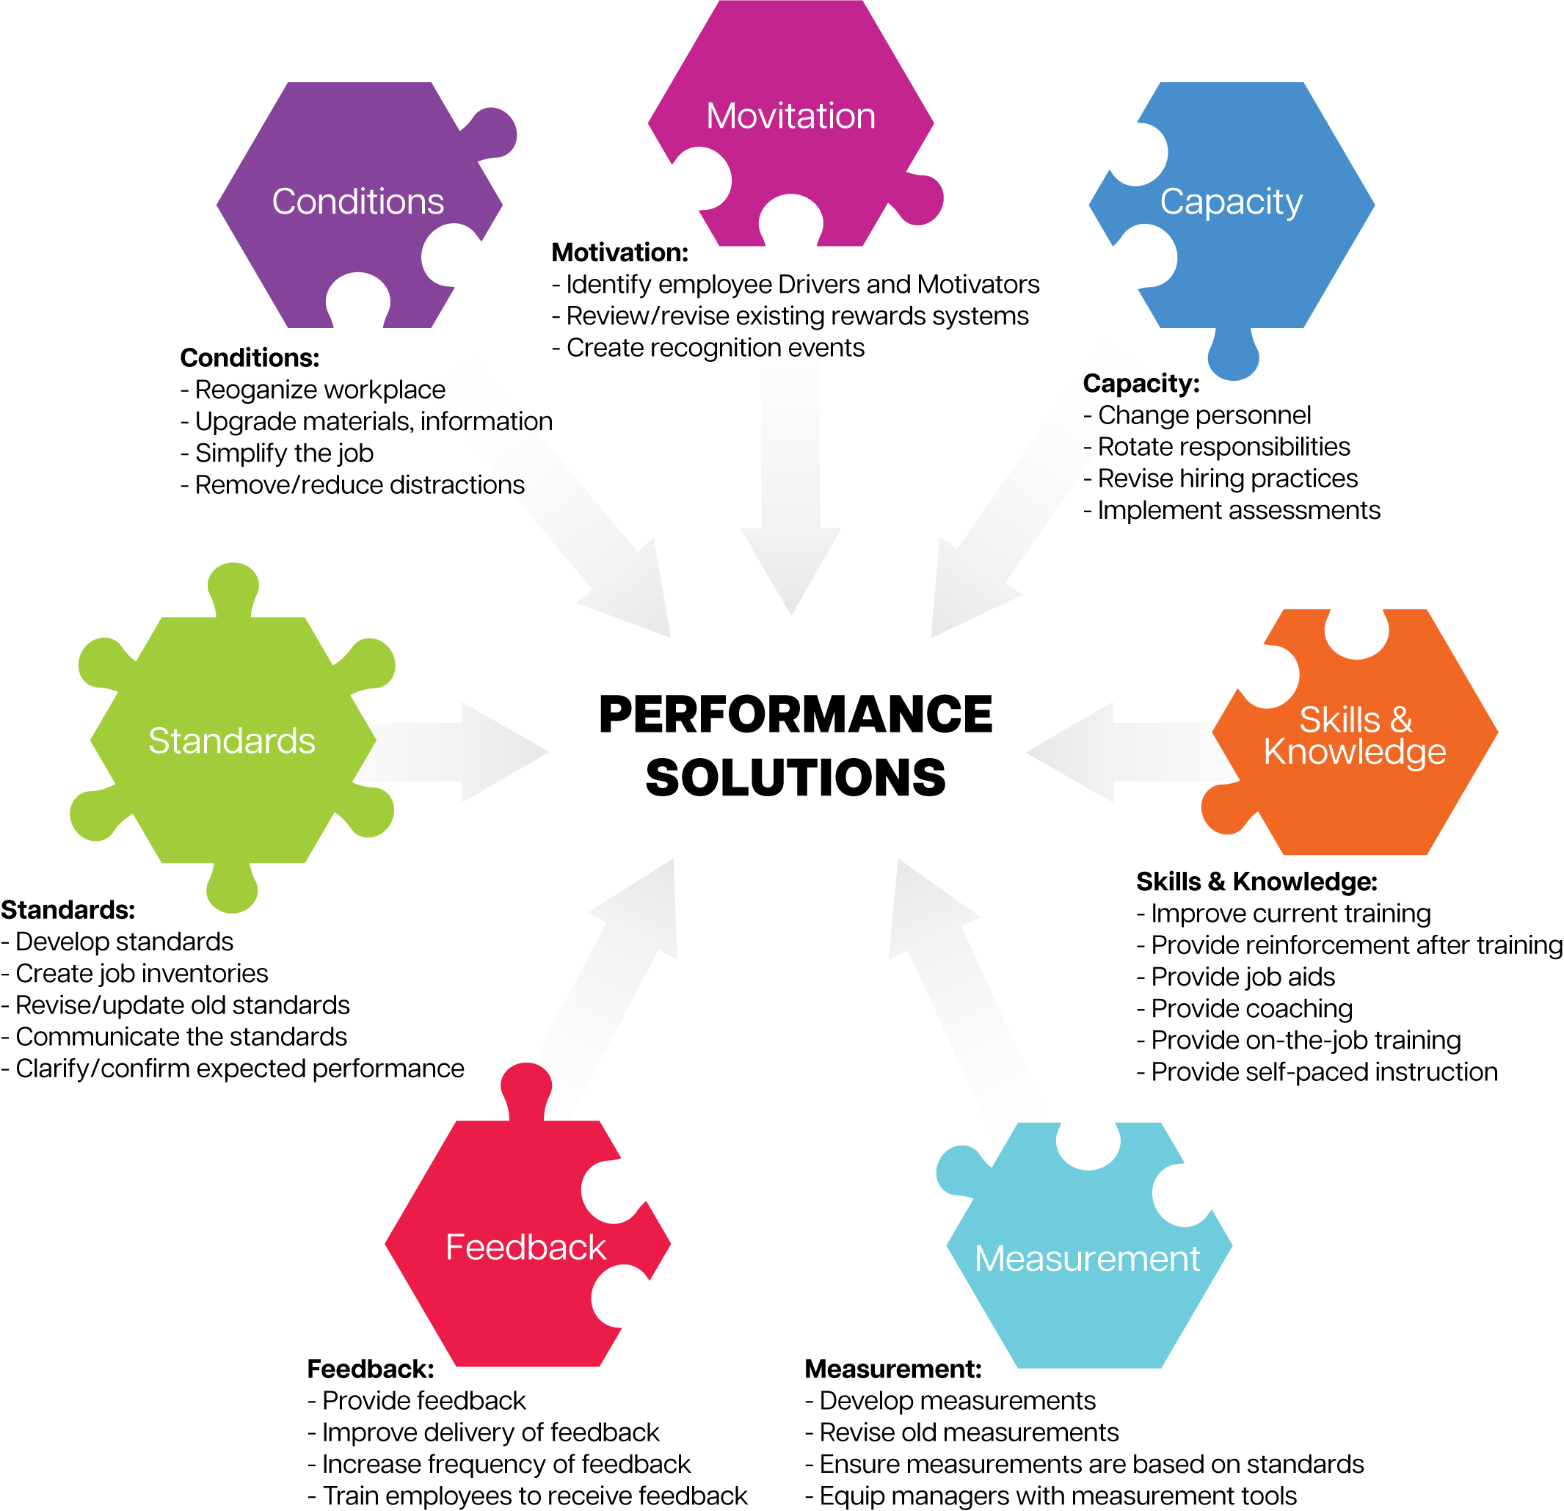

Steps 5: Evaluate the Results
Commit to a specific period of time that you will evaluate the results of your suggested performance solution. Check back in with the employee after that agreed upon period of time has passed to evaluate if the performance discrepancy has been resolved or needs additional intervention.
Re-visit pages 1-2 to use the methods outlined for quantifying expected performance and measuring actual performance to evaluate the results.
Instruction: Think of a time where you were aware that there was an employee or group of employees who was/were not performing to expectations. Use the Seven Factors of Job Performance Operating System to work through steps 1-5 below.
1. Define and quantify expected performance and actual performance.
What did you use to quantify expected performance? (Circle all that apply)
Performance Goals Professional Development Goals Job Description Job Inventory Job Study Other: _________________
What did you use to measure expected performance? (Circle all that apply)
Surveys Interviews Observations Audits and Work Samples Records
2. Write the cause(s) of the discrepancy (use the questions on pages 3-9).
Standards
Capacity
Motivation
Measurement
Skills & Knowledge
Feedback
Conditions
3. What performance solution(s) will you propose (use the job aid on this page)?
4. How will you implement the solution(s)?
5. How will you evaluate the results?
6. What Organizational Readiness issues did you identify?
7. If you have Organizational Readiness issues, how will you address them?
Share with the Change Management team?
Share with Department as conditions for the success of training?
Work directly with the Department on Organizational Alignment plan?
Make Organizational Alignment changes yourself.

