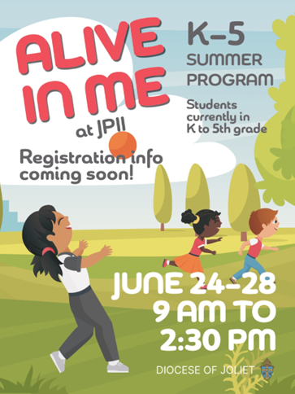

**REGISTRATION AND PERMISSION FORM**

**FOR ‘*ALIVE IN ME’*** ***(K-4)* Monday,June 9 – Wednesday, June 11, 9:00 am - 12:00pm**

**FAMILY LAST NAME:** __________________________ ADDRESS: ____________________________________________CITY: ___________________

**PARENT INFORMATION**:

Mother: ______________________________ Work/Cell Phone: ­­­­___________________ Email: ___________________________________________

Father: _______________________________ Work/Cell Phone: ___________________ Email: ___________________________________________

*GUARDIAN/S ALLOWED TO PICK UP CHILD*: _____________________________________________________________________________________

**EMERGENCY CONTACT**: Name: ______________________________________ Relationship: __________________ Telephone: ________________

**CHILD/CHILDREN INFORMATION**

|  |  |  |  |  |  |  |  |  |  |  |
| --- | --- | --- | --- | --- | --- | --- | --- | --- | --- | --- |
| **FIRST NAME** | **SEX** (M/F) | **GRADE**  (Fall 2024) | **AGE** | **\*ALLERGIES/MEDICAL CONDITIONS**  (Include ADD, ADHD, possible reactions, etc. Please be specific). | | **DID FIRST HOLY COMMUNION?** | **REGISTRATION FEE** | | **VOLUNTEER DISCOUNT** | **TOTAL PAID** |
|  |  |  |  |  | |  |  | |  |  |
|  |  |  |  |  | |  |  | |  |  |
|  |  |  |  |  | |  |  | |  |  |
|  |  |  |  |  | |  |  | |  |  |
| *Volunteers don’t administer medication. Contact Parish Coordinator with concerns. | | | | | | | | **GRAND TOTAL** | |  |
| **FEE: $30/1 Child - $60/2 - $75/3 or more** | | | | | **Include cash or a check payable to: “ST. JOHN PAUL II PARISH”** | | | **DATE PAID** | |  |

**ALIVE IN ME NEEDS YOUR HELP!!**

**Please volunteer in our summer program**

**There are a variety of ways you as a parent can help.**

**___ Contact me! I would like to help!**

**Name: ___________________________________________**

**Phone: ___________________________________________**

**\*\*Release form required (attached)**

**I have completed the required, separate release form and signed this parental consent below for the child/children listed above to participate in the Alive in Me program.**

**Parental consent for child(ren) to participate in the Alive in Me program:**

_________________________________________ _______________

Parent Signature Date

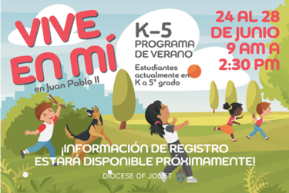

***FORMULARIO DE INSCRIPCIÓN Y AUTORIZACIÓN***

**PARA *‘VIVE EN MÍ’ (K-4)* del Lunes, 9 – Miércoles, 11deJunio, 9:00 am -12:00pm**

**APELLIDO DE LA FAMILIA:** __________________________ DIRECCIÓN: ______________________________________CITY: ___________________

**INFORMACIÓN DE LOS PADRES:**

Madre: __________________ Teléfono de trabajo/celular: ­­­­__________________ Correo electrónico: _____________________________________

Padre: ___________________ Teléfono de trabajo/celular: __________________ Correo electrónico: _____________________________________

TUTOR/ES AUTORIZADO/S A RECOGER AL NIÑO: ________________________________________________________________________________

**CONTACTO DE EMERGENCIA**: Nombre: __________________________________ Relación: ___________________ Teléfono: __________________

**INFORMACIÓN SOBRE EL NIÑO/LOS NIÑOS**

|  |  |  |  |  |  |  |  |  |  |  |
| --- | --- | --- | --- | --- | --- | --- | --- | --- | --- | --- |
| **NOMBRE** | **SEXO** (M/F) | **GRADO**  (Otoño 2024) | **EDAD** | \***ALERGIAS/CONDICIONES MÉDICAS**  (Incluya TDA, TDAH, posibles reacciones, etc. Por favor, sea específico). | | **¿HIZO SU PRIMERA COMUNIÓN?** | **CUOTA DE REGISTRACIÓN** | | **DESCUENTO DE VOLUNTARIO** | **TOTAL A PAGAR** |
|  |  |  |  |  | |  |  | |  |  |
|  |  |  |  |  | |  |  | |  |  |
|  |  |  |  |  | |  |  | |  |  |
|  |  |  |  |  | |  |  | |  |  |
| *Los voluntarios no administran medicamentos. Póngase en contacto con el Coordinador Parroquial si tiene alguna duda. | | | | | | | | **GRAN TOTAL** | |  |
| **CUOTA: $30/Niño - $60/2 - $75/3 o más** | | | | | **Incluya dinero en efectivo o un cheque a: “ST. JOHN PAUL II PARISH”** | | | **FECHA DE PAGO** | |  |

**¡¡VIVE EN MÍ NECESITA TU AYUDA!!**

**Por favor sea voluntario en nuestro programa de verano.**

**Hay una variedad de formas en que usted puede ayudar.**

**___ ¡Contáctenme! ¡Quero ayudar!**

**Nombre: _______________________________________________**

**Teléfono: ______________________________________________**

**\*\*** **Formulario de autorización requerido (adjunto)**

**He completado el formulario de autorización requerido, por separado, y he firmado este consentimiento parental a continuación para que el/los niño(s) arriba mencionado(s) participe(n) en el programa Vive en Mí.**

**Consentimiento de los padres para que los niños participen en el programa Vive en Mí:**

_________________________________________ _______________

Firma del Padre Fecha