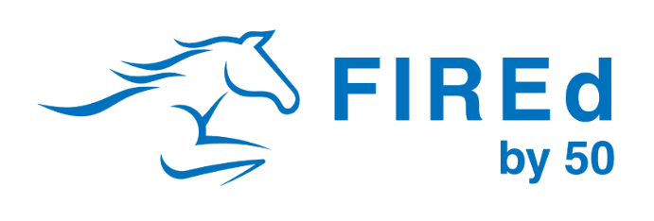
ABC Construction’s
FIREd by 50 Culture Differential
This resume uses the 3 C approach to Company Culture that the State of Tennessee teaches in its Construction Pathway.

Compound Interest: Benefits That Build Stability
Our 401(k) program and medical benefits help employees build long-term financial security. However, our employee education of those benefits is what makes the real difference. When our employees understand their benefits better, their financial stress is reduced. This leads to a calmer, safer and more productive employee, and a smoother project.
Career Planning: Processes That Support Professional Growth
We meet with every associate annually to discuss their career goals and identify the support they need to move forward. This level of engagement builds trust and reinforces that we genuinely care about their growth. The result is low turnover, a highly committed workforce, and teams who show up each day ready to perform. This leads to a smoother, more predictable project for our clients.
Continuous Process Improvement: A Culture of Safety and Efficiency
Our risk management program goes far beyond basic compliance. Through proactive training, data tracking, and structured risk management, we elevate jobsite performance. With tools like (insert your tech stack), we refine projects using real-time feedback and safety metrics, allowing us to catch issues early. The outcome is a safer site, fewer surprises, and a cleaner punch list for our clients.

