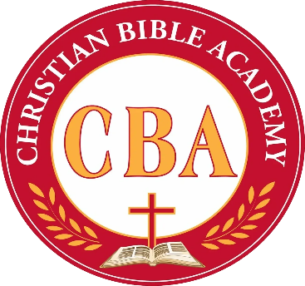
Christian Bible Academy (CBA)

Summer Day Camp Registration

June 1, 2026 – August 7, 2026 | Ages 18 Months – 12 years
Spots are limited—secure your child’s place today!
Summer Day Camp Details:
Hours of Operation | 6:00 AM – 6:30 PM
Registration Fee | $50
Weekly Rate (Schoolers: Kinder – 12 yrs) | $165
Weekly Rate (18 Months – PK4) | Age-appropriate rates apply. Contact us!
*Field trips will require additional consent and fees.

Adventure Weeks
Sports & Games • Arts & Crafts • Splash Days • Field Trips* • Literacy Time • STEM • Bible Lessons • Culture & Arts Week • Vacation Bible School • Kids’ Choice Week

Registration:
Child’s Full Name
Age
Grade (2025–2026)
School Attended
Physical Address
Parent/Guardian Name
Phone Number
Email Address
Entire Summer | Yes ☐ No ☐
Specific Weeks
(only list dates your child will NOT be attending)
Parent Signature (manual signature required)
Date
How did you find out about us? | ☐CBC member ☐ Family/Friend ☐ Flyer ☐Social media ☐ Website ☐ Church marquee ☐ Other: __________
Registration Fee Paid (Staff ONLY) | Yes ☐ No ☐
Staff initials (STAFF ONLY)
Note: A full CBA School Application including Emergency Card must be completed. Please give one (1) week notice if your child will not attend Summer Day Camp.
3222 Texas Parkway, Missouri City, TX 77489 | Phone: (281) 835-8027 ext. 12716
Email: CBacademyoffice@gmail.com | Website: www.christianbibleacademy.org

