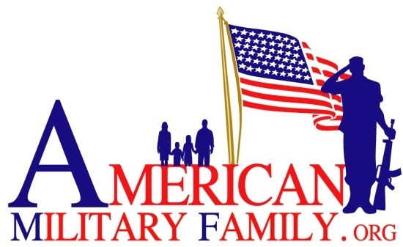
P. O. Box 238
Firestone, Colorado 80520

Parental Consent

I, the parent or guardian of __________________________, give my voluntary consent to his/her participation in American Military Family “Got Your Six” event.

I hereby release American Military Family, the State of Colorado, the Board of Directors of American Military Family and their officers, employees and agents from any and all liability resulting from events beyond control.

In the event of an accident, injury, or illness, the above stated and its agents do not assume any responsibility or obligation to provide financial assistance or other assistance, including but not limited to, medical, health, or disability insurance, in the event of an accident, injury, illness, death or property damage.

Furthermore, I release American Military Family, the State of Colorado, the Board of Directors of American Military Family and their officers, employees and agents and volunteers for any loss, personal injury, accident, misfortune, or damage to the above name or his/her property, with the understanding that reasonable precautions shall be taken to ensure the health and safety of the above name.

________________________________________________________________
Signature of Parent/Guardian Date

________________________________________________________________
Printed Name of Parent/Guardian Phone Number

