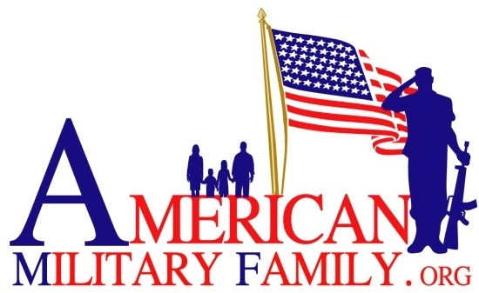
P. O. Box 238
Firestone, Colorado 80520

Liability Release Form

In consideration of my desire to serve as a volunteer/attendee in The American Military Family Got Your Six Program Outing. I hereby assume all responsibility for any and all risk of property damage or bodily injury that I may sustain and I hereby release American Military Family, the State of Colorado, the Board of Directors of American Military Family and their officers, employees and agents from any and all liability resulting from events beyond control. .

Further, I, for myself and my heir, executors, administrators and assigns, hereby release, waive and discharge American Military Family and its officers, directors, employees, agents and volunteers of and from any and all claims which I or my heirs, administrators and assigns ever may have against any of the above for, on account of, by reason of or arising in connection with my participation therein, and hereby waive all such claims, demands and causes of action.

In the event of an accident, injury, or illness, the above stated and its agents do not assume any responsibility or obligation to provide financial assistance or other assistance, including, but not limited to: medical, health or disability insurance, in the event of an accident, injury, illness, death or property damage. I currently have no known mental or physical condition that would impair my capability for full participation in any of the activities provided for me this date, Sunday, May 7, 2017.

I have carefully read the foregoing release and indemnification and understand contents thereof and sign this release of my own free will.

_______________________________________________________________________
Signature: Date:

_______________________________________________________________________
Signature: Date:

