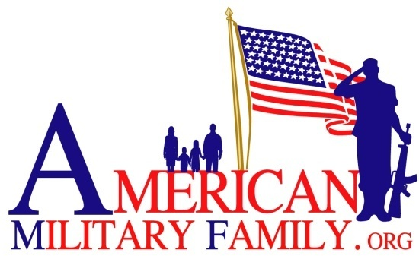
P. O. Box 238
Firestone, Colorado 80520

Acceptance letter for American Military Family
Family Counseling Therapy

American Military Family is honored to provide counseling services for you and your family
*(Family is defined as spouse, child / children, parent(s) of the veteran being treated)

You will be given one (1) intake session and six (6) counseling sessions. In addition, your family will also be given six (6) counseling sessions during your treatment. By signing below, you understand that American Military Family will pay for these counseling sessions. You further understand that:

As part of the American Military Family Got Your Six (GY6) Program, we are offering

Name of Veteran or service member: _________________________________

Branch of Service: _________________________________________________

Family members’ names: ___________________________________________

I/We, _____________________ and ___________________________, hereby acknowledge that we will be receiving Counseling Services provided by Combat Vets Helping Combat Vets Inc. (CVHCV). If we wish to continue with additional counseling sessions, we agree to coordinate with Combat Vets Helping Combat Vets Inc. (or another mental health agency) for additional treatment.
American Military Family will not responsible for any additional treatments. Further, as evidenced by my signature below, I/We hereby grant permission for Combat Vets Helping Combat Vets (CVHCV) to release any/all pertinent information to American Military Family, as may be necessary for billing and/or administrative purposes.

Signature of Veteran (service member):__________________________________

Signature of Spouse/Significant Other : __________________________________

Date: _____________________________________________________________

