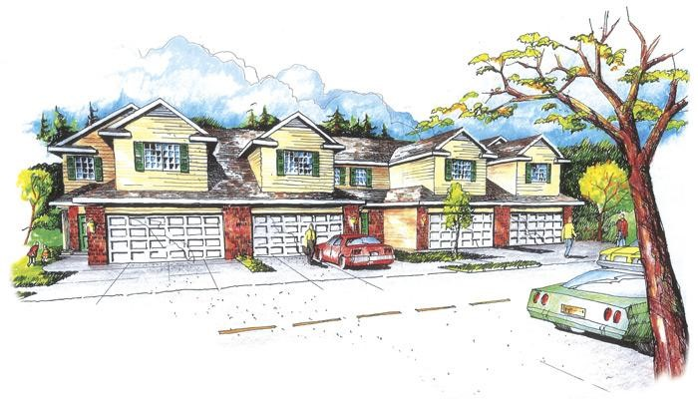
August 2, 2022
Homeowners/Residents:
Allo Information
ALLO is excited to get this project rolling and allow you and your neighbors to enjoy the Exceptional ALLO service! ALLO proposed this project in phases. Phase I will include all residences north of Northern Lights Dr. on Connor, Oshel, and Sawyer St. Phase II will be Sawyer St., south of the roundabout to Holdrege St. Hoping the project goes quickly, barring any interruptions, should be approximately 6-8 weeks with 2-3 weeks after that for any cabling/splicing/testing.

The plan is to have the contractor start generating locate requests the week of 8/1/22 and start the construction process during the week of 8/8/22 (pending another project already scheduled). It would be best to start along Connor on the east side and would pothole (dig down to have an idea of depth) water lines along the east side of the sidewalk and pothole any other utilities that will be crossed. The idea is to fill all open potholes immediately after pulling the conduit for safety purposes. Where there will be structures placed, those holes could stay open but secured with fencing, for a few days or until the end of the week.

The hours worked during the day should be between 7:00 AM and 5:30 PM give or take. Mon-Fri with some restoration possibilities on Saturdays.

ALLO will be sending representatives door-to-door to answer any questions or concerns. Our point of contact will be Stephen Holmes. He is an ALLO FTTH Quality Technician II. For any questions or concerns, please call Stephen, leave a message at 402-904-1941 and he will answer as soon as he is able. Thanks again and feel free to call with any questions or concerns!! Have a great rest of your week!

Thank you,
Northern Lights HOA Board

