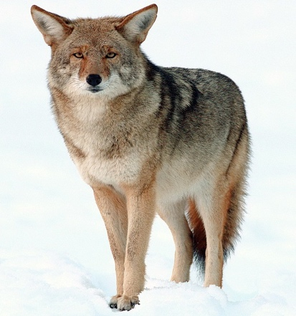
This Photo by Unknown Author is licensed under CC BY-SA

THE COYOTE
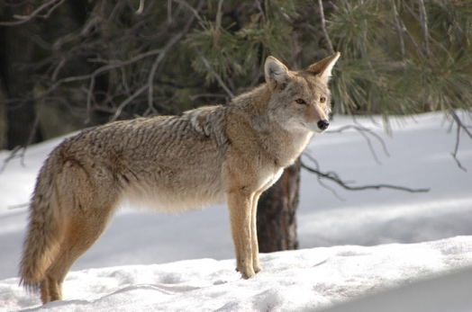

January 2025
A monthly publication distributed after the 1st of the month
GV Estates, 25 W Duval Rd, Green Valley, AZ 85614
Clubhouse address: 1834 N Stony Knoll Ln
Green Valley Estates Website:
https://gveactivities.com
Green Valley RV Resort Office Email: info@greenvalleyresort.com
Please send any Coyote submissions to: coyote@gveactivities.com





1/3 Daniel Aguilar
1/5 Bonnie Decker
1/9 Cindy Fletcher
1/12 Jane Stiner
1/27 Stephanie Fischer
1/30 Robert Bill
1/30 Terry Nealey
1/31 Margie Betts



1/1 Wes & Terry Beehler

REMINDER:

THE BIRTHDAY AND ANNIVERSARY PARTY WILL BE THE 2ND SUNDAY OF THE MONTH AT 1:00. COME CELEBRATE, GET TO KNOW YOUR NEIGHBORS AND HAVE TREATS.

December Birthday Fun
12/2 Bob Elfers
What season did you dream of getting married and did it happen? Didn’t think about it. Got married in the Summer ~ June
What is your favorite Book in the Bible and why? Joseph, he persevered again all that was going against him.

Share a time when you were most embarrassed. When I was a youth Pastor, I was upfront on the platform with the Pastor and fell asleep. Pastor had to nudge me to wake me up.

12/14 Clay Dowsett
What is your favorite food? Sizzling Steak Fajitas
What crazy food combination do you enjoy? Pickles & Rainbow Sherbert
Funniest place you have ever fallen asleep? On the dock in the summer on Lake Wapesi

12/26 Jack & Bonnie Decker
What would your partner say is your worst habit? Bonnie takes up too much space in bed, Jack is messy never cleans up after himself.
If you had to take one thing to a deserted island, what would you take? Bonnie would take water, Jack would take another woman 😂
What is your proudest moment? Bonnie, our 3 beautiful daughters, Jack Santa’s drawers falling down.

December Events:

Christmas Ball Painting was on the 12th. Thank you to Bonnie for providing the balls, paint, and decorations. All painted balls were so unique to each painter.

The lunch out on December 13th at Taco Giro had mixed reviews. Most importantly, the food was good! They had a little trouble with service. (they were short of help and the restaurant was packed). They are not equipped for a large group.

The recipe of the month was Lasagna Roll-ups. December 17th, we made our own roll-ups and then flash froze and wrapped them for the freezer. Lori’s recipe is so good and easy to make. She also made a pan for us to sample. Mary brought some home baked bread.

December 18th was the White Reindeer gift exchange. Exchange went well. There was a great variety of food. Going forward we need to be mindful of the $15 limit. Possibly look into a way to make it not take such a long time.

Christmas Dinner was wonderful! Thank you so much to everyone who helped. We served 60 dinners. The Ham was perfect, the twice-baked potatoes were a big hit, and of course the infamous grape salad! Dessert was pound cake with whipped cream topping with crushed candy cane on top. We collected $137 in donations.

- Bingo is back on Mondays 6:30 sharp
- Mexican Train will be played on Mondays at 1:00 in the fireplace room.
- Game night is back on Tuesdays 6:30 sharp
- Cribbage is back on Thursdays 6:30 sharp
- Crafters Corner will be 1st & 3rd Monday at 12:00. We have assembled all the tablescapes, so there will no longer be a focused craft on the 3rd Monday, unless someone wants to do special crafts.

January events:

Park Meeting/Decorating Clubhouse ~January 4th. Park Meeting will start at 8:30 and decorating immediately after the meeting. We will be leaving the tree up through January.

CRAFTER’S CORNER ~January 6th, 12:00 noon. This is free crafting time with no set craft project.

Celebration of Life Luncheon~ January 9th at 1:00 pm. We will be having Hot Dogs, Chips, Drinks and chocolate fountain for dessert for $5.00. We will be remembering every resident that has passed away during 2024.

MONTHLY BIRTHDAY AND ANNIVERSARY CELEBRATION~ January 12th, 1:00pm

Spaghetti Dinner~ January 16th at 4:00 pm. We will be serving Spaghetti (meat sauce and plain marinara), salad, rolls, and lemon gelato for dessert. Cost will be $10.00

CLEO~ January 21st, 12:00 noon. We will be going to the Golden Corral. We have gotten quite a few reviews saying it was really good. Rideshare will leave clubhouse at 11:30.

ROMEO~ January 22nd, at 12:00 noon. We will be going to Lin Grand Buffet. Rideshare will leave clubhouse at 11:30.

Activities committee meeting~ January 29th, 3:00pm. If you have ideas, please join us at the clubhouse.

Be sure to check your calendar for events and the website for additional events or changes.

- Event sign-up sheets along with volunteer sign-up sheets will be posted two weeks in advance of an event.

- Please make sure to sign-up by the deadlines. Most of the time we can accommodate adding you to the event, but some events we are not able to add guests at the last minute.

- Thank you to those who volunteer to help. As a committee, we appreciate it, it helps us keep things going.

RECIPE OF THE MONTH:

Grape Salad from Connie Benson

1 8 oz cream cheese
1 cup sour cream
½ cup sugar
½ tsp vanilla
1.5-2 cups grapes red or green or mix

Cream together the first four ingredients. Cut the grapes in half, then fold into the cream mixture. Top with brown sugar and chopped pecans

FOOD BANK REPORT

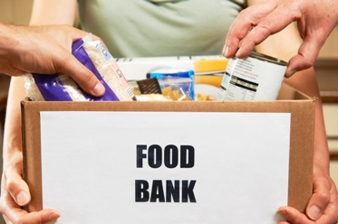

We can't give you a total for the food poundage in December yet, as the food bank was closed when we tried to deliver the final load for December. Let's just say it is over 125 lbs. We will let you know the total next year, as we won't be able to deliver the rest of the food until then. We would like to express a big thank you to anyone who participated in December with donations and will let you know the final total later.

Thank you for contributing
Brian and Wendy Konopka

FINANCIAL REPORT

TREASURERS REPORT 11/27/24 - 12/24/24
Beginning Balance as of 11/27/2024 |  | 1033.36
Event Income- $55 Thanksgiving Donations |  | 55.00
Coffee Income |  | 83.00
Donations - $235 Donation |  | 235.00
TOTAL |  | 1406.36
Expense Meals Christmas |  | 373.03
Misc Business Expenses |  | 237.57
December Birthday/Anniv Event |  | 42.98
TOTAL EXPENSES |  | 653.58
ENDING GV ESTATES Balance as of 11/26/2024 |  | 752.78
ENDING BANK Statement as of 11/26/2024 |  | 752.78
PETTY CASH as of 11/26/2024 |  | 78.17

We are always accepting cash donations to make sure that we have enough money to put on events. We would like to do more things that are free for you. If you would like to donate, you can drop it off at any of the committee members homes or bring it to any function and put it in the donation box. It costs money every time we send people home with food, we use supplies for events other than planned meals (like happy hour).

Donation collected at the Christmas dinner will be reflected in January’s expense report.
Questions can be directed to: Connie Benson, Activities Club Treasurer.

Current GVE Activities Committee:

Activities Chair: Robert Bill
Activities Asst. Chair: Jane Stiner
Activities Treasurer: Connie Benson
Activities Secretary: Terry Beehler
Activities Coordinator: Lori Goff
The Coyote Publisher: Lori Goff

