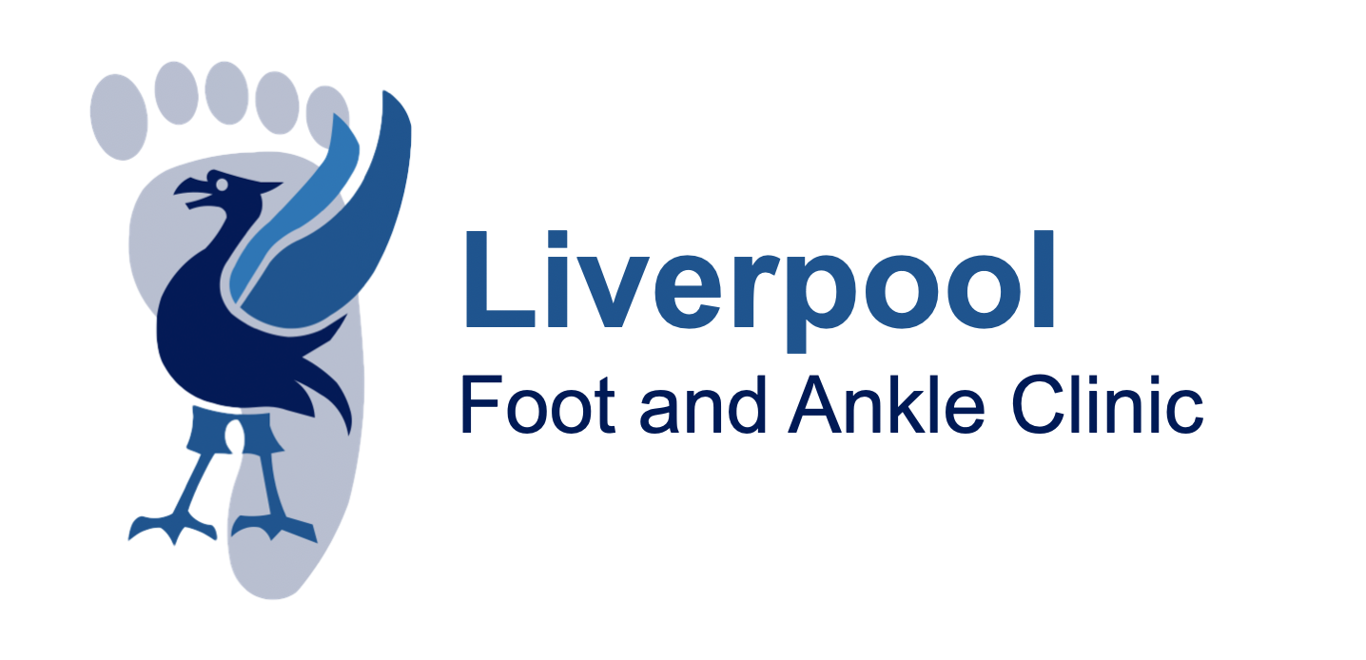

Consent Information for Mortons Neuroma Surgery

Reason for Surgery

Your treating clinician is offering surgery, as they believe the benefits outweigh the risks. Your treating clinician will always try less invasive treatments first when available (see alternatives section). The benefit of surgery to you is individual, although in general the benefits of surgery can be multiple. These include long-lasting pain relief, greater mobility and function of the foot and ankle, improving skin and/or bone healing and sometimes even an improved appearance of the foot. In most severe cases, surgery can sometimes prevent progression or further problems. In cases of trauma, surgery can be required to return the foot and/or ankle to as near its pre-injury state as possible. Nevertheless, there will be cases where things go wrong (see risks below). Most patients will benefit from surgery but only you know the problems you are suffering with in regard to your foot and/or ankle and how it affects your life. So only you can make the decision whether to have or not have surgery.
On average about 80% of people experience good to excellent results following foot and ankle surgery. The surgical outcomes for specific foot and ankle surgeries vary depending on the type of surgery and the individual patient.
ALTERNATIVES to Morton’s Neuroma Excision

Morton’s neuromas are swellings of nerves that go to the toes. Sometimes these nerve swellings can cause pain on walking and can be accompanied by swelling (bony and soft tissue) and separation of the toes. The nerve swellings can also cause trouble when walking and with wearing certain types of shoes (especially narrow fitting). Surgery should only be considered if you have symptoms and have already tried the following measures:

- Footwear modification (lower heels, wider fitting shoes, rocker soles)
- Weight loss (if necessary)
- Insoles or other shoe inserts
- Simple analgesia (pain killers)
- Physiotherapy

Other non-surgical treatments for Morton’s neuromas include injections of steroid around the nerve to reduce the swelling, or other methods to stop the nerve working like alcohol injections or freezing the nerve.

RISKS of Morton’s Neuroma Excision
- All operations have risks
- Any underlying medical conditions may worsen due to the operation.

COMMON RISKS (occur in up to 5 in every one hundred forefoot surgeries)

- Pain – Most surgeries are carried out under a local anaesthetic block to minimise the
postoperative pain, but you should be prepared to have some pain or discomfort,
which usually responds to simple analgesia.

- Swelling ‐ Due to the effects of gravity, feet tend to swell, and this can last several
Months.

- Scarring – any type of surgery will leave a scar, occasionally this will be painful and inflamed.

- Minor wound redness – as with all invasive procedures there is the risk of infection, and some minor redness of the wound can occur and in some cases the wound edges not heal fully. In some cases you may require antibiotics to get this to settle. Risks are higher in diabetics, those on immune suppression medication (eg steroids or rheumatoid medication) and smokers.

- Numbness – as the surgery involves removal of a nerve that supplies the sensation between the toes, there will be permanent numbness in this area after surgery.

- Recurrence of nerve swelling – treatment of Morton’s Neuromas involves removal of the nerve. Unfortunately, sometimes the nerve regrows causing symptoms to return.

LESS COMMON RISKS (occur one in every one hundred forefoot surgeries)

- Blood clots – because you will be allowed to walk on your heel after the surgery blood clots are not common, but can occur, and can lead to swelling of the leg (deep vein thrombosis) or chest pain (pulmonary embolism)

RARE RISKS (occur in less than one in every one hundred forefoot surgeries)

- Deep infection – Although the operation is performed under sterile conditions and all precautions are taken to prevent this, deep infection can happen, and if the infection does not settle on antibiotics, you may require a further operation to clear the infection.

- Complex regional pain syndrome – this is where the “fight or flight” nerves that supply the foot go on strike and can cause swelling, stiffness, pain, and colour and temperature changes to the foot. Treatment requires counselling and physiotherapy and it could take several months to improve.

- Tendon injury – during the operation, inadvertent tendon injury can occur or can be caught in the scar leading to reduced movement. Rarely this requires further surgery.

- Blood vessel damage – if the blood supply to a toe is damaged it could lead to an area of permanent damage where the toe is no longer viable.

- Loss of toe – although extremely rare, loss of toe can result from surgery especially if deep infection or blood vessel injury occurs. The risk for this complication is increased in diabetics and smokers.

- Death – whilst this is extremely rare for forefoot surgery, can occur especially if there are pre‐existing medical conditions.

