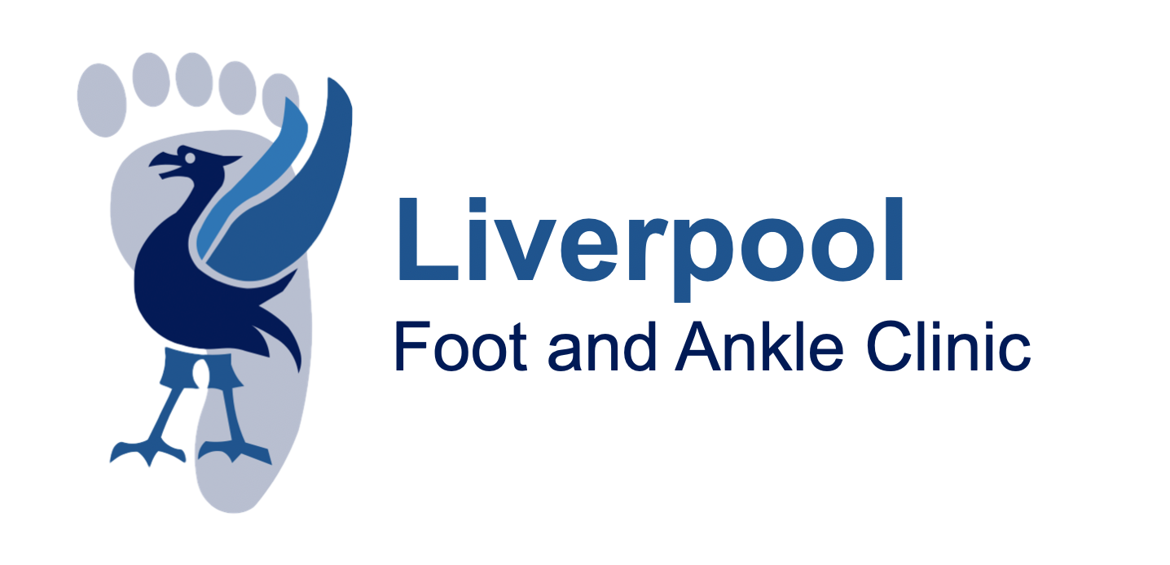

Consent Information For Triple (Subtalar, Talonavicular and Calcaneocuboid Joint) Fusion

Reason for Surgery

Your treating clinician is offering surgery, as they believe the benefits outweigh the risks. Your treating clinician will always try less invasive treatments first when available (see alternatives section). The benefit of surgery to you is individual, although in general the benefits of surgery can be multiple. These include long-lasting pain relief, greater mobility and function of the foot and ankle, improving skin and/or bone healing and sometimes even an improved appearance of the foot. In most severe cases, surgery can sometimes prevent progression or further problems. In cases of trauma, surgery can be required to return the foot and/or ankle to as near its pre-injury state as possible. Nevertheless, there will be cases where things go wrong (see risks below). Most patients will benefit from surgery but only you know the problems you are suffering with in regard to your foot and/or ankle and how it affects your life. So only you can make the decision whether to have or not have surgery.
On average about 80% of people experience good to excellent results following foot and ankle surgery. The surgical outcomes for specific foot and ankle surgeries vary depending on the type of surgery and the individual patient.
ALTERNATIVES to Talar-navicular, Calcaneal-cuboid and Subtalar Joint Fusions (the Triple Fusion)

Hindfoot arthritis can cause pain on movement, accompanied by swelling (bony and soft tissue) and deformity. This can cause trouble with walking and with wearing certain types of shoes. Surgery should only be considered if you have symptoms and have already tried the following measures:

- Footwear modification (ankle splint, rocker soles etc)
- Weight loss (if necessary)
- Insoles or other shoe inserts such as bunion pads
- Simple analgesia (pain killers)
- Physiotherapy

Other non-surgical treatments include injections with steroid to reduce inflammation, and may also be used to diagnose the problem.

RISKS of Talar-navicular, Calcaneal-cuboid and Subtalar Joint Fusions (the Triple Fusion)
- All operations have risks
- Any underlying medical conditions may worsen due to the operation.

COMMON RISKS (occur in up to 5 in every one hundred surgeries)

- Pain – Most surgeries are carried out under a local anaesthetic block to minimise the postoperative pain, but you should be prepared to have some pain or discomfort, which usually responds to simple analgesia.

- Swelling ‐ Due to the effects of gravity, feet tend to swell, and this can last several months.

- Scarring – any type of surgery will leave a scar, occasionally this will be painful and inflamed.

- Minor wound redness – as with all invasive procedures there is the risk of infection, and some minor redness of the wound can occur and in some cases the wound edges not heal fully. In some cases you may require antibiotics to get this to settle. Risks are higher in diabetics, those on immune suppression medication (eg steroids or rheumatoid medication) and smokers.

- Prominent metalwork – in some cases the screws or plates can be prominent under the skin, requiring a second procedure to remove them at a later date. On occasions plates and screws are required to bridge joints temporarily, and will need planned removal after the bone has healed.

- Numbness – after surgery you are likely to have some minor numbness and tingling around the scar as the hair like nerves have been cut.

- Problematic weight distribution – because foot surgery changes the shape of your foot and shifts the balance of load across the foot, pains can appear in areas of the foot that previously did not have pain. Most cases settle with physiotherapy and management with insoles, but further surgery might be necessary.

- Delayed bone healing ‐ this may occur in operations where the bone is cut or fused. Some people heal slower than others and those who smoke are at a greater risk of this occurring. You may have to remain non weight bearing for longer or in some cases, where the bones don’t appear to be uniting, require further surgery.

LESS COMMON RISKS (occur one in every one hundred surgeries)

- Blood clots – after the surgery blood clots are not common, but can occur, and can lead to swelling of the leg (deep vein thrombosis) or chest pain (pulmonary embolism)

- Non-union – This is when the bones do not heal to one another. Uncommonly, this does not occur. Factors that have been shown to prevent bone healing include smoking, vitamin D deficiency, thyroid disease and diabetes.

- Malunion – This is when the bones do not heal in the desired position. Sometimes this can cause discomfort and predispose to developing arthritis in another joint. Rarely, a secondary procedure may be required to correct this.

- Implant loosening –The metal work used to fix the bone can loosen on occasion. This can form bone cysts. Although the cause can be unknown, it can be related to infection or rejection of the implant.

- Recurrence of deformity – Reconstructing a hindfoot deformity involves balancing a foot (akin to balancing table legs). On occasion, the balancing fails. If this was to happen, further surgery may be required.

RARE RISKS (occur in less than one in every one hundred surgeries)

- Deep infection – Although the operation is performed under sterile conditions and all precautions are taken to prevent this, deep infection can happen, and if the infection does not settle on antibiotics, you may require a further operation to remove the metalwork and clear the infection.

- Intraoperative fracture or broken metalwork– rarely could a fracture occur during surgery or a metal pin or screw could break. The surgeon will act in your best interests at the time of surgery to give you the best outcome.

- Complex regional pain syndrome – this is where the “fight or flight” nerves that supply the foot go on strike and can cause swelling, stiffness, pain, and colour and temperature changes to the foot. Treatment requires counselling and physiotherapy and it could take several months to improve.

- Nerve injury – if a larger nerve supplying the toe becomes damaged or caught in scar tissue, it could lead to ongoing pain, numbness and tingling. Such damage is seldom permanent and the sensation usually returns over a period of time but it can be permanent.

- Tendon injury – during the operation, inadvertent tendon injury can occur or can be caught in the scar leading to reduced movement. Rarely this requires further surgery.

- Blood vessel damage – if the blood supply to a limb is damaged it could lead to an area of permanent damage where the limb is no longer viable.

- Compartment Syndrome – this is a rare condition where the muscles in either the lower leg or foot swell. If this did occur it is very painful and would likely require emergency treatment. The most common cause if a tight cast which would need to be removed, however if this did not resolve the problem surgery would be required.

- Amputation – although extremely rare, loss of limb can result from surgery especially if deep infection or blood vessel injury occurs. The risk for this complication is increased in diabetics and smokers.

- Death – whilst this is extremely rare, can occur especially if there are pre‐existing medical conditions.

