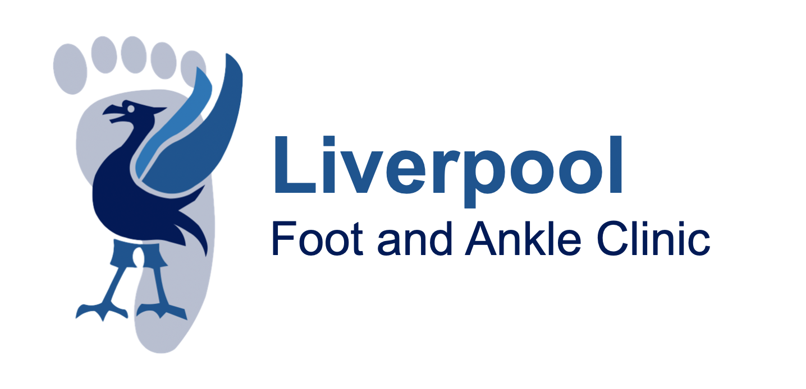

Consent Information for Foot and Ankle Lump Excision Surgery

Reason for Surgery

Your treating clinician is offering surgery, as they believe the benefits outweigh the risks. Your treating clinician will always try less invasive treatments first when available (see alternatives section). The benefit of surgery to you is individual, although in general the benefits of surgery can be multiple. These include long-lasting pain relief, greater mobility and function of the foot and ankle, improving skin healing and sometimes even an improved appearance of the foot. In most severe cases, surgery can sometimes prevent progression or further problems. Nevertheless, there will be cases where things go wrong (see risks below). Most patients will benefit from surgery but only you know the problems you are suffering with in regard to your foot and/or ankle and how it affects your life. So only you can make the decision whether to have or not have surgery.
On average about 80% of people experience good to excellent results following foot and ankle surgery. The surgical outcomes for specific foot and ankle surgeries vary depending on the type of surgery and the individual patient.
ALTERNATIVES to Surgery

Surgery for a ganglion should only be considered when it is symptomatic and when non-surgical options have been explored. Many ganglions are harmless, fluctuate in size, and may settle without intervention. Before choosing surgery, the following measures are usually recommended:
Non-surgical management options include:
• Footwear modification – soft, wide shoes, avoiding pressure on the lump, low heels
• Insoles or orthotics – to reduce joint stress or offload pressure areas
• Simple pain relief – such as paracetamol or anti-inflammatories if appropriate
• Physiotherapy – to optimise foot mechanics and reduce irritation
• Observation ("watch and wait") – appropriate if symptoms are mild and manageable
Other conservative treatments:
• Aspiration (fluid drainage) – may temporarily reduce size, although recurrence is common
• Steroid injection – can reduce inflammation and discomfort for some patients
• Activity modification – reducing repetitive loading or swapping footwear types
• Compression or padding – to reduce shoe rubbing
These approaches can help manage symptoms and may avoid or delay the need for surgery. Ganglion excision is usually considered when pain persists, footwear remains difficult, or the lump repeatedly returns after conservative treatment.

RISKS of Lump Excision Surgery
- All operations have risks
- Any underlying medical conditions may worsen due to the operation.

COMMON RISKS (occur in up to 5 in every one hundred forefoot surgeries)

- Pain – Most surgeries are carried out under a local anaesthetic block to minimise the
postoperative pain, but you should be prepared to have some pain or discomfort,
which usually responds to simple analgesia.

- Swelling ‐ Due to the effects of gravity, feet tend to swell, and this can last several
Months.

- Scarring – any type of surgery will leave a scar, occasionally this will be painful and inflamed.

- Minor wound redness – as with all invasive procedures there is the risk of infection, and some minor redness of the wound can occur and in some cases the wound edges not heal fully. In some cases you may require antibiotics to get this to settle. Risks are higher in diabetics, those on immune suppression medication (eg steroids or rheumatoid medication) and smokers.

- Numbness – Surgery near a nerve may cause irritation or damage to the nerve. This may result in numbness that can be temporary or permanent.

- Recurrence of lump – even with removal of the lump, recurrence can occur.

LESS COMMON RISKS (occur one in every one hundred forefoot surgeries)

- Blood clots – because you will be allowed to walk on your heel after the surgery blood clots are not common, but can occur, and can lead to swelling of the leg (deep vein thrombosis) or chest pain (pulmonary embolism)

RARE RISKS (occur in less than one in every one hundred forefoot surgeries)

- Deep infection – Although the operation is performed under sterile conditions and all precautions are taken to prevent this, deep infection can happen, and if the infection does not settle on antibiotics, you may require a further operation to clear the infection.

- Complex regional pain syndrome – this is where the “fight or flight” nerves that supply the foot go on strike and can cause swelling, stiffness, pain, and colour and temperature changes to the foot. Treatment requires counselling and physiotherapy and it could take several months to improve.

- Tendon injury – during the operation, inadvertent tendon injury can occur or can be caught in the scar leading to reduced movement. Rarely this requires further surgery.

- Blood vessel damage – if the blood supply to a toe is damaged it could lead to an area of permanent damage where the toe is no longer viable.

- Loss of toe or limb – although extremely rare, loss of toe can result from surgery especially if deep infection or blood vessel injury occurs. The risk for this complication is increased in diabetics and smokers.

- Death – whilst this is extremely rare for forefoot surgery, can occur especially if there are pre‐existing medical conditions.

