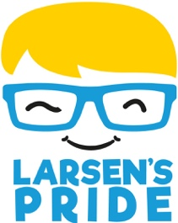

www.larsenspride.co.uk
hello@larsenspride.co.uk

Reg Charity No 1197746

Dear Parents and Carers,

At school today, your child has heard the inspiring story of 5-year-old Larsen, who used his imagination to dream up an amazing way to make a difference in a big, grown-up world:

Larsen’s Super Slideathon – a marathon of 26 slides in a day!

Larsen’s first ‘Slideathon’ raised money for the hospital where he was being treated for his poorly eye (a brain tumour) in 2019. And since then, the challenge has grown year on year, with more families, schools and nurseries getting involved. The event now raises money for Larsen’s Pride, our charity, set up in memory of Larsen and with the aim of improving the lives of other children with brain tumours in England and Wales.

This year marks the Slideathon’s 5th anniversary and we are hoping to make it the biggest and best year yet!

We are so pleased that (name of setting) has signed up to take part this year. Your child is taking on the challenge with their class / invited to take on the challenge over the Easter holidays (delete as appropriate). You will find a sponsorship sheet on the back of this letter and details of our JustGiving campaign.

If you would like to know more about our charity, what we do and how your fundraising will make a difference, please check out our website at the top of this page.

Thank you so much – and super sliding!

Larsen’s Pride

