KS1 Activities
Draw a picture of yourself taking part in the Slideathon:

Use the 5 senses to describe your Slideathon – can you remember sights, sounds, smells, tastes and how it made you feel?
………………………………………………………………………………………………………………………………………………

………………………………………………………………………………………………………………………………………………

………………………………………………………………………………………………………………………………………………

………………………………………………………………………………………………………………………………………………

………………………………………………………………………………………………………………………………………………

Numeracy challenge: if you stopped for a snack after every two slides, how many snacks would you need?

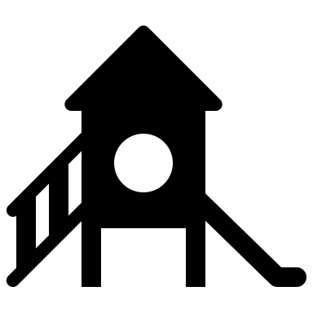

KS2 Activities
Creative writing menu – choose one or more!

Write a newspaper report about the  Slideathon | Write an acrostic poem starting with each letter of SLIDEATHON | Write a diary entry describing your slideathon day – can you include the 5 senses?
Design and write a postcard to a friend or family member, telling them about the slideathon | Design a poster to advertise the slideathon and tell other children how they can take part | Write the story of the slideathon. You could start with Larsen and end with you!

Numeracy quiz
- How many numbers go into 26?
- Half of 26 is 13. 13 is a prime number. What does this mean?
- What is the similarity between a marathon and a Slideathon?
- Can you work out the 26 times table up to 10x26?
- If you did the Slideathon challenge once a month for a whole year, how many slides would you do?
- If there are 10 steps to climb up each slide, how many steps would you have to climb altogether to do the Slideathon?
- What if there were 12 steps?
- If each slide is 2 metres long, how far will you have travelled down slides by the end of the Slideathon?
- What if each slide is 1.5 metres long?
- If 10 children in your class do the Slideathon and in total they raise £130, what is the average amount raised by each child?

Answers:
- 2 (2 and 13)
- It can only be divided by 1 and itself
- 26 – 26 miles for a marathon, 26 slides for a slideathon
- 26, 52,78,104,130,156,182,208,234,260
- 312 slides
- 260
- 312
- 52 metres
- 39 metres
- £13

EYFS Activities
Draw a picture of yourself taking part in the Slideathon:

Trace the letters:
Slideathon
Count how many slides you went down on your Slideathon challenge:
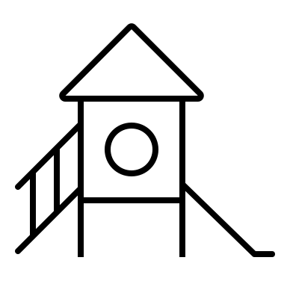

Circle the correct number: 24 25 26

