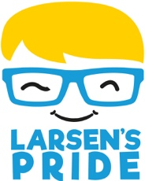
NAME:

Slideathon Sponsorship

My Challenge:
I will be taking on a marathon number of 26 slides in a single day to raise money for Larsen’s Pride: improving the lives of the youngest brain tumour patients in England and Wales.

Name | Amount | Cash or JustGiving | Collected?

Our JustGiving campaign page can be found here:
Slideathon 2024 - JustGiving

