13080 Hwy 28
Odessa, WA 99159
509-982-0093
2022 Golf Season
Dear Members,
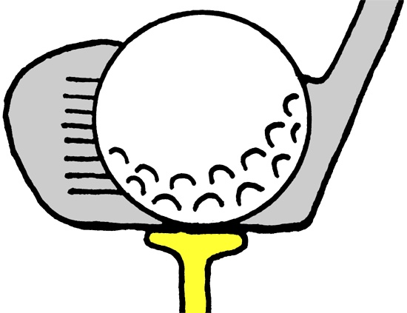
We want to thank you for all of your support last season and for making our first year a great one! Unfortunately, because of price increases across the board, we had to increase some of our prices. We hope you understand that it was not an easy decision for us to make. We will still offer 10% off of your memberships if paid with cash or check on or before March 1st. You can mail your memberships with your 10% off discount to the address above or stop in to see us on Tuesday, March 1st anytime from 11-2! After March 1st, memberships will be full price. Please note, this discount is for memberships only and does not include cart storage or trail fees. If you have a cart in storage, dues will also need to be paid by March 1st in order to avoid a finance charge. If you plan to remove your cart from our storage, we ask that you do so by March 1st so we can open your space to others. If you are looking for cart storage, call the clubhouse at the number above and leave a message.
Season Opening
Monday March 21st!
We are extremely excited for our 2022 leagues! With Men’s League kicking off in April, Swingers Club kicking off in May, and Women’s League starting in June it should be an eventful year of golf and good times! We also have a season full of tournaments planned. A full events calendar is available on our website at www.golfodessawa.com. Check often, it is updated weekly! You can also see updates and weekly food specials on our Facebook page - Odessa Golf & RV. Go gives us a like and follow
Thank you for your continued business!!
~Odessa Golf & RV Crew

